The Ambassador engagement and request document


Thank you for asking us to support you. We would like you to think about a number of things before you involve us in your project. Of course, we will consider every application and see where we can help and which ambassador is the most appropriate based on our skills and experiences.

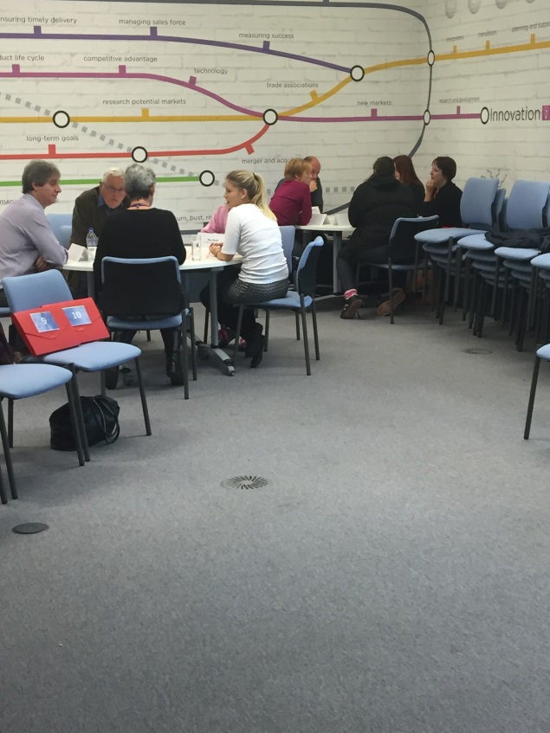
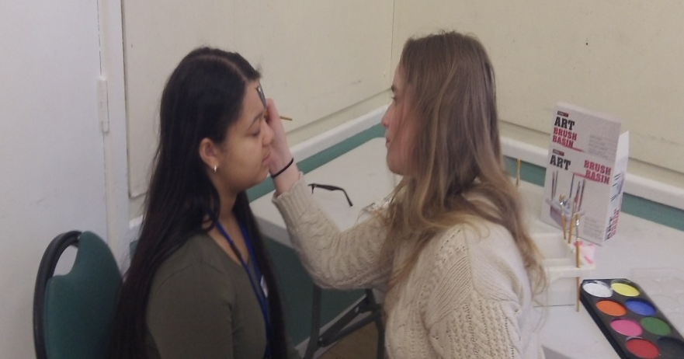

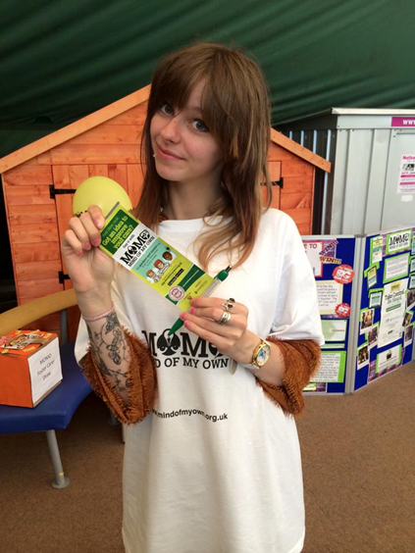
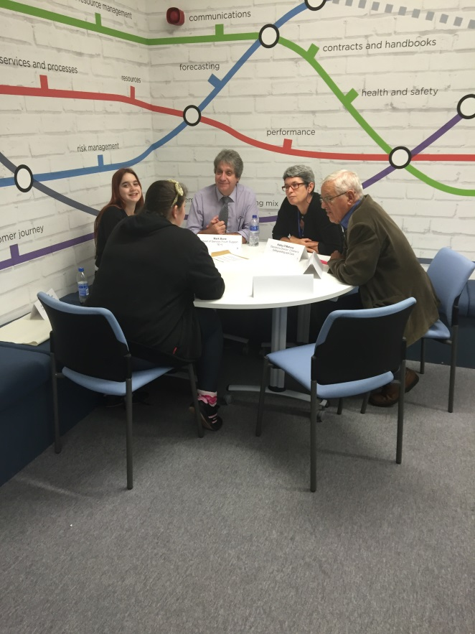

.

How will we work with you | What we can’t do
- We will work together in partnership.  - We will plan and meet the project objectives.  - We will help you agree the outcomes and evaluate the work.  - Availability – we will try to be there when needed and as agreed by the Participation Team. | - An emotionally impacting project.  - Travel long distances without transport provided.  - Be treated differently – we want to be on the same wavelength.  - Any project that is not YP related.
Things you will need to consider
- Projects with no mentoring/ monitoring may be difficult.
- There must be disability access.
- We are willing to try anything that will develop our skills and experiences as well as help young people in need.
- All of us are different.
- In case the project or task given is too hard or uncomfortable we may appoint another ambassador.
- We should have an ability to withdraw from the project within given reason.
- Notice: Please give us as much notice as possible.
- You may need to provide information to help us understand everything.
Please fill in the form below
Your contact details (including: name, team/organisation, phone number and email)
Are there any particular groups you are seeking to consult with? (provide the age range)
How many ambassadors will you need?
Name, start and completion date of the project:
What are the project objectives?
Timescale – please attach a rough timescale estimating the dates when the ambassadors will be required – need it to be estimated prior starting the project or event.
Possible locations / will transport be provided?
Is there disability access?
How will the information be fed back to young people?
Please provide some context about the project and work carried out so far.
Agreed timescale for feedback (approx) to children and young people.
Do you have consent forms from the children/ young people involved?
What impact will our work have and what difference will it make?
How are you going to evaluate the work?
Once completed please send your application to:
cypvoice@gloucestershire.gov.uk

Admin use only
Received date | Click here to enter a date. | Name of Participation Lead | Choose an item.
Meeting date | Click here to enter a date. | Name of ambassador to be involved | Choose an item.
Request confirmed? | Choose an item. | Date confirmed | Click here to enter a date.
Evaluation form returned/completed? |  | Choose an item.

