


Project Bulletin - Whitminster Canal Bridge
As the project continues to progress, recent weeks has seen the binder tarmac course (initial layer) put down on the South side of the roundabout and traffic now traversing the new southern bridge.
We have also undertaken excavation work of the carriageway on the north side of the roundabout and installed the bridge base and towpath wall units for the North Bridge. (photo below)

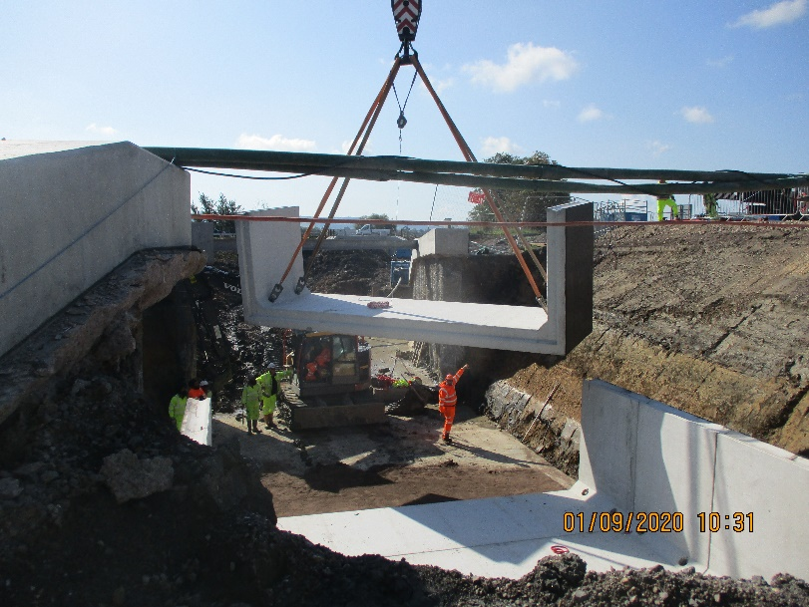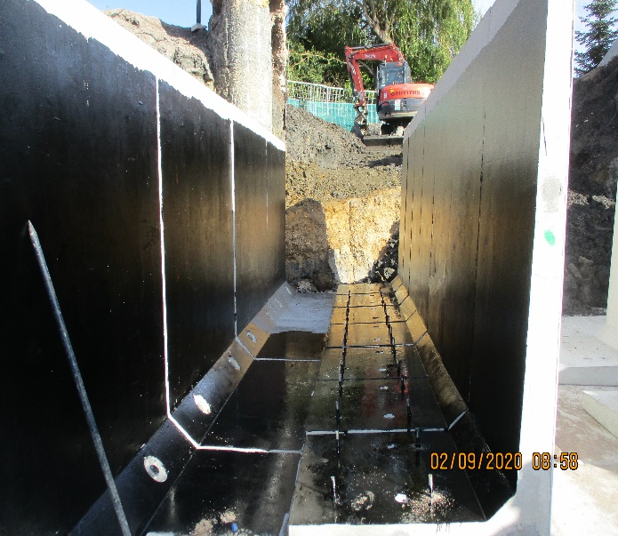
As we progress with these important improvements, your continued patience is greatly appreciated.
If you have any concerns or issues regarding the road improvement scheme, please contact me on 0300 041 4635*. I will be available throughout the construction phase to provide continuous engagement with businesses and residents within the local area.
Further information about the scheme can be found at
https://www.gloucestershire.gov.uk/highways/major-projects-list/a38-canal-bridges/
Neil Evans
Contract Liaison Officer
Alun Griffiths (Contractors) Ltd
0330 041 4635*

*Calls to this number are charged at national call rates and included in inclusive minute plans from landlines and mobiles

