Employer Forum Meeting minutes
Thursday 21st September 2023, 10:30 – 12:00
Council Chamber, Shire Hall

- Tom & Kirsten welcomed everyone and did quick fire introductions around the room and covered the agenda.
- Housekeeping – Toilets, fire alarms, merchandise, voice recording

Ice breaker
- What was your first job/ Worst Job?
- Explain your current role to a 5 year old

Recap and roundup of Forum 1
- People don’t want the jobs on offer – A way for people to try the jobs on offer, working towards their ideal career – 50:50!

- Person specification – Too specific at times? A more molded approach to train a person, to get the type of candidate they are looking for. Look for passion to work within potential employees, skills can be worked on, attitudes are a vital spark which can be nurtured and developed.

- Non-attendance at interview – The cost behind it! One employer noted a figure of approx. £2,200 before someone has even started! – Kirsten posed the question is It more for different businesses and sectors and some employers agreed with this

- Perceptions –
  - Of the job - Assumptions of what the job could entail – Job Analysis!

  - Of the employer – Being seen as a poor employer perhaps because of constant recruitment – For example – Supermarket drivers – The demand for home delivery had increased dramatically and they are always needing more drivers to manage the workload.

  - A couple of employers mentioned that people they met at recent job fairs weren’t interested in the wages being offered or not interested in work.

  - Tom mentioned we are trying to get customers to give things a try because if things don’t work out then there’s the hub to help.

  - An employer mentioned that sometimes we are looking in the wrong places, advertising in places where people they are trying to recruit don’t use ie LinkedIn.

  - Another employer mentioned about not just putting your advert on social media – go out to employment events, jobs fairs and get yourselves known out there.

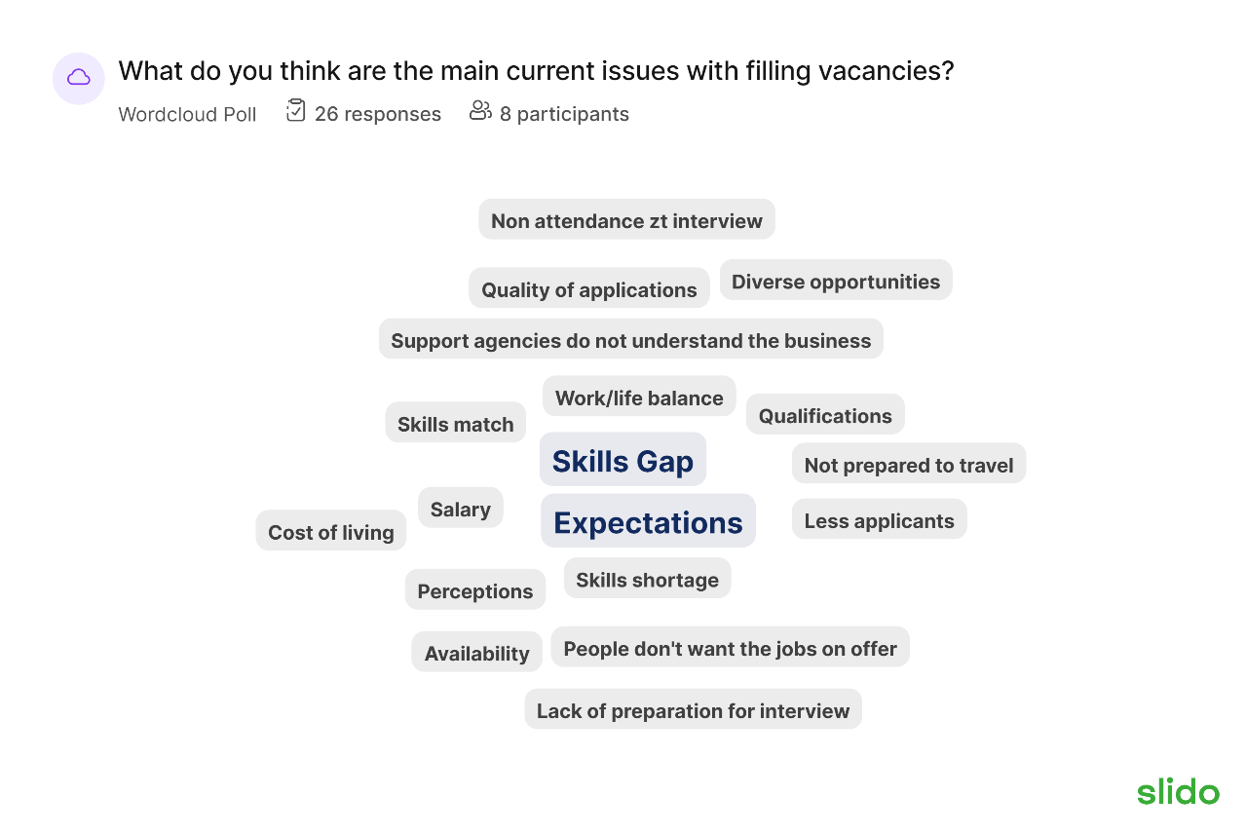

Accessible Recruitment Processes

- Online Applications - Could be difficult for individuals to access/use the typical recruitment process, especially with larger organisations, can instantly rule out good people if they consider it too much and not continue with application – Shortened Applications Forms!

- New Approaches – Informal chats before even completing applications – A very different approach, meeting face-to-face, to establish quickly if someone might be the right fit for the team – If so, encourage and support with application process.
- Work Trials/Work Samples – Opportunity for the employer and potential employee to get to know one another more – Almost try before you buy. However, not always possible in certain industries.
- Myths - Around disabilities, health, age, attitudes and lots more.
- Interview Space – Room deconstructed (anti-boardroom!) - Taken tables away, 2 sofa-like chairs with a coffee table in between (coffee shop vibe) for a more relaxed and real feeling.

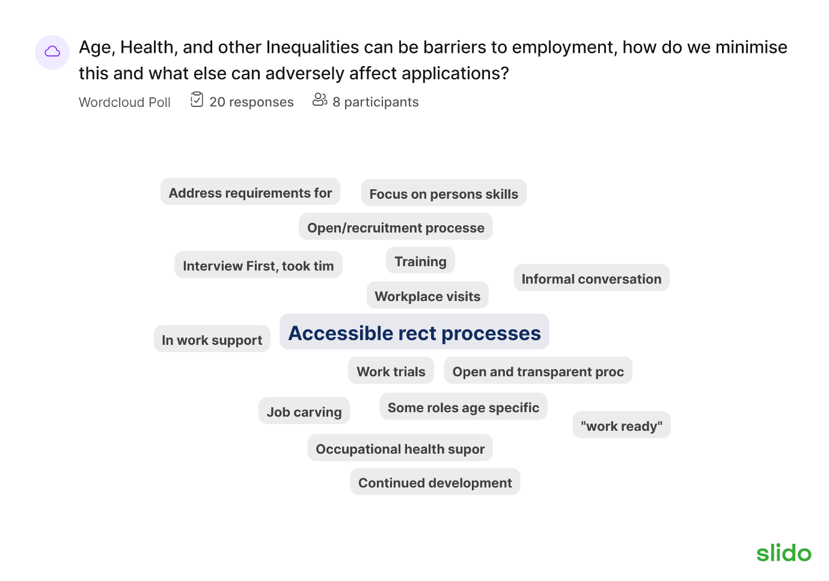

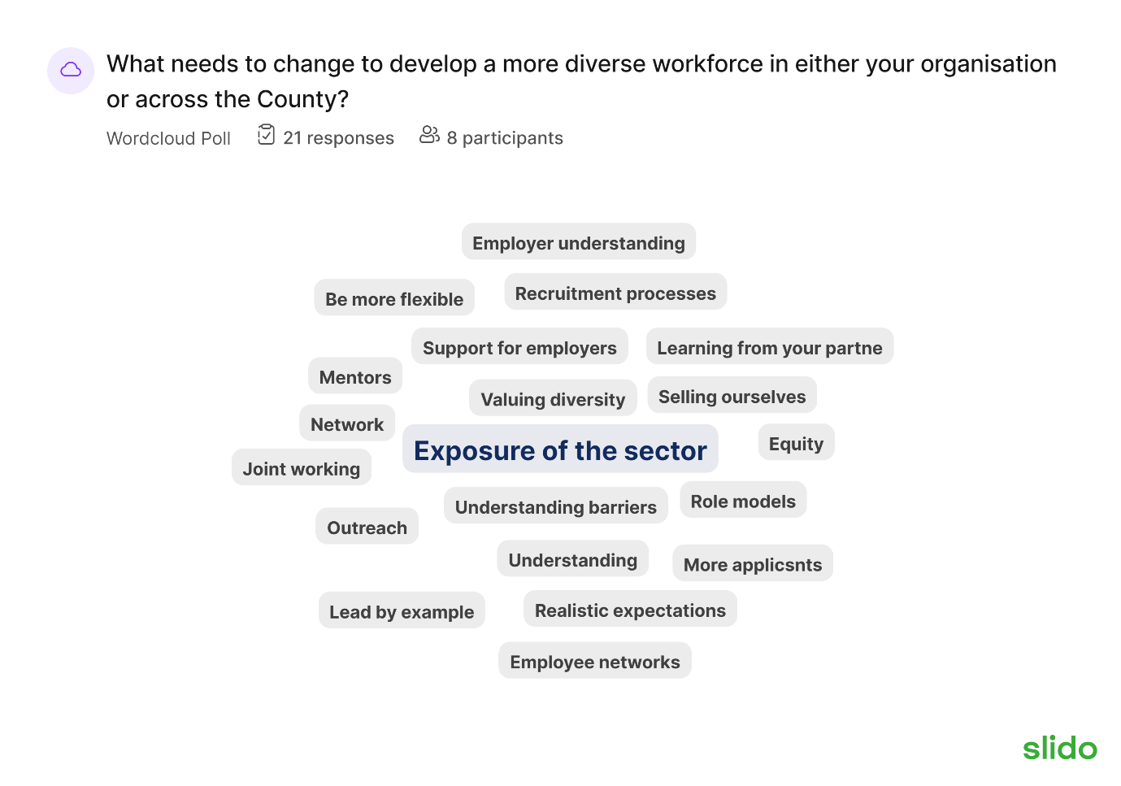
- Tom mentioned about a shorter application form being rolled out in the NHS and works quite well but may not work across the board.

Tom & Kirsten mentioned about a group of customers going to a taster day at a large employer in Tewkesbury.

Employment Fun facts & Stats

- 61% of employees are more productive when the dress code is relaxed – An employer said this may vary with other employers.
- The average office chair with wheels travels about 8 miles per year
- Almost half of UK workers will be aged 50+ within the next two years.
- 42% of over 55’s would consider retraining/reskilling. This increases to 57% of the unemployed over 55’s – Tom mentioned this is what we are aiming to achieve from 50:50 – An employer mentioned it would be good to show how covid has changed everything
- 21% would select an employer based on their clear and transparent diversity policy, including age.
- Age is the number one barrier to job opportunities in the UK according to LinkedIn.

50:50 Launch event

- Tom invited employers to the 50:50 Launch event on October 11th, 2023 in the Council Chamber with the aim of connecting participants with employers.
- 3 sections – people who have signed the pledge, employers who haven’t signed the pledge and also participants.
- Kirsten suggested some participants may struggle with talking to employers.
- An employer mentioned that it would be good to hear about those who have completed the process.
- An employer mentioned about live matching and making an announcement when matches have been made.
- An employer asked whether data is being captured to know who is applying for what – Tom mentioned that we are recording information.
- Belinda asked if we wanted the promotion to go on glosjobs and this is something the EE team would like once the comms team have approved the poster.

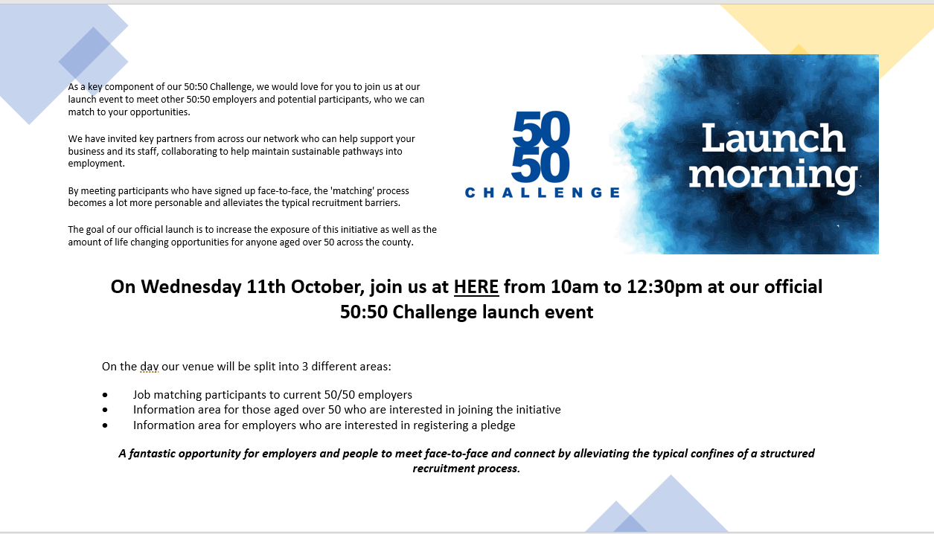

- Break – 15 minutes to chat, Eat & Drink

Slidos – Disability confident
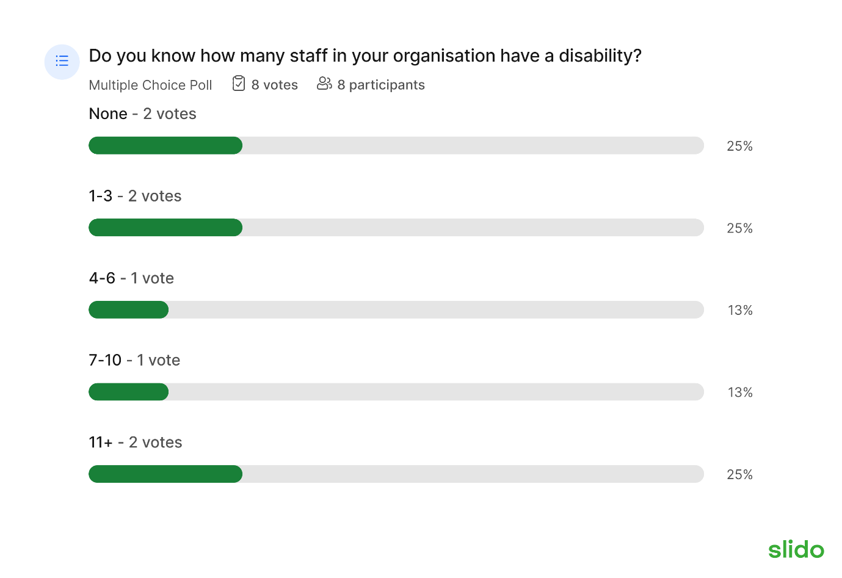
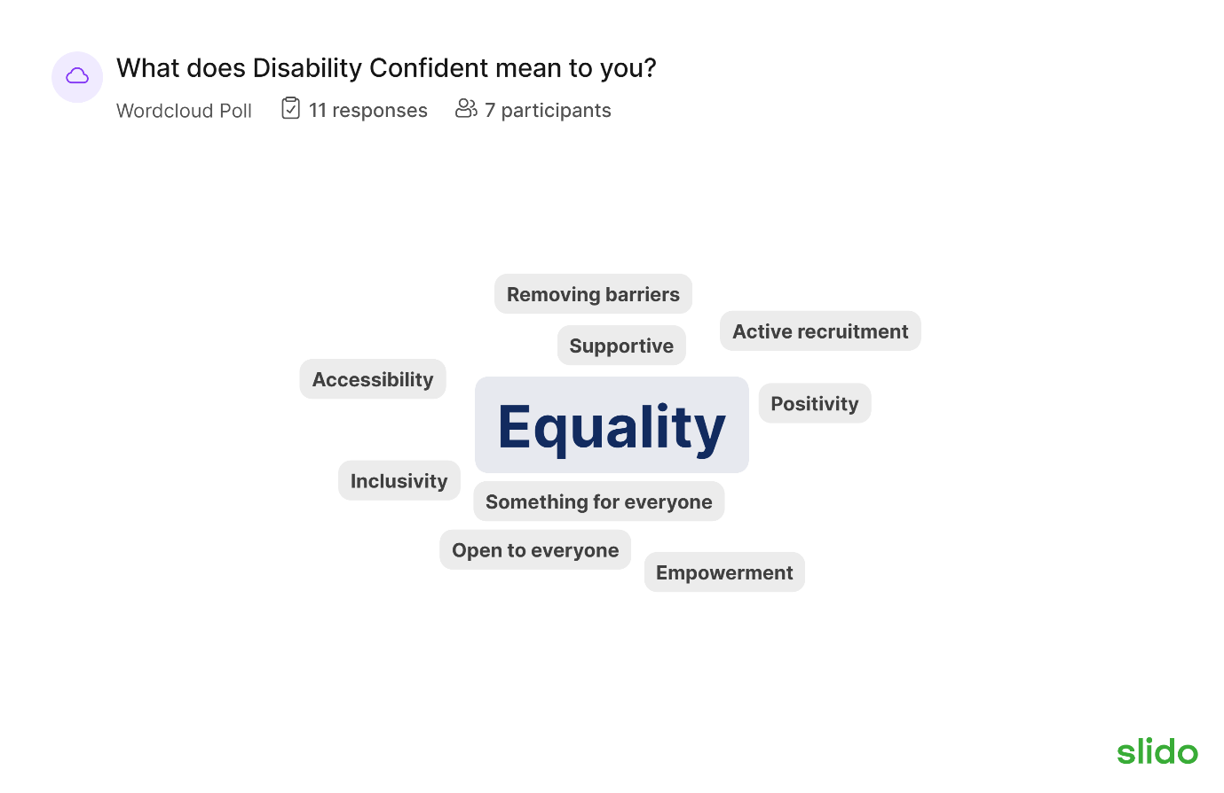
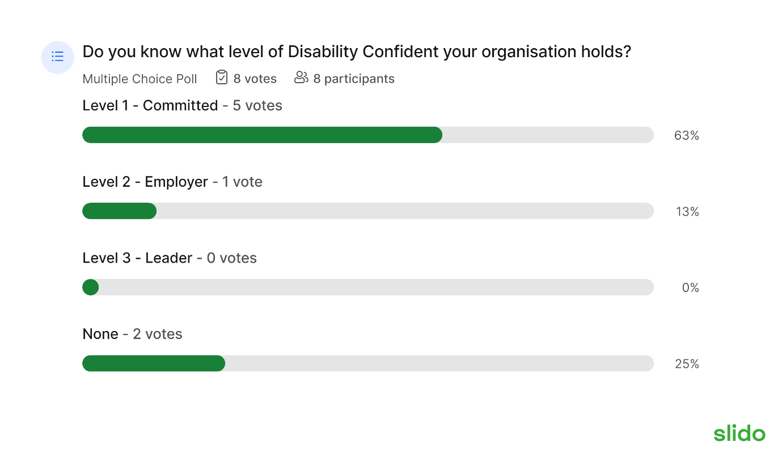
Level 1 – committed to disability confident

Level 2- Show evidence that your recruitment processes have changed and you have put adjustments in place to accommodate disabilities.

Level 3 Leader – you do everything and more

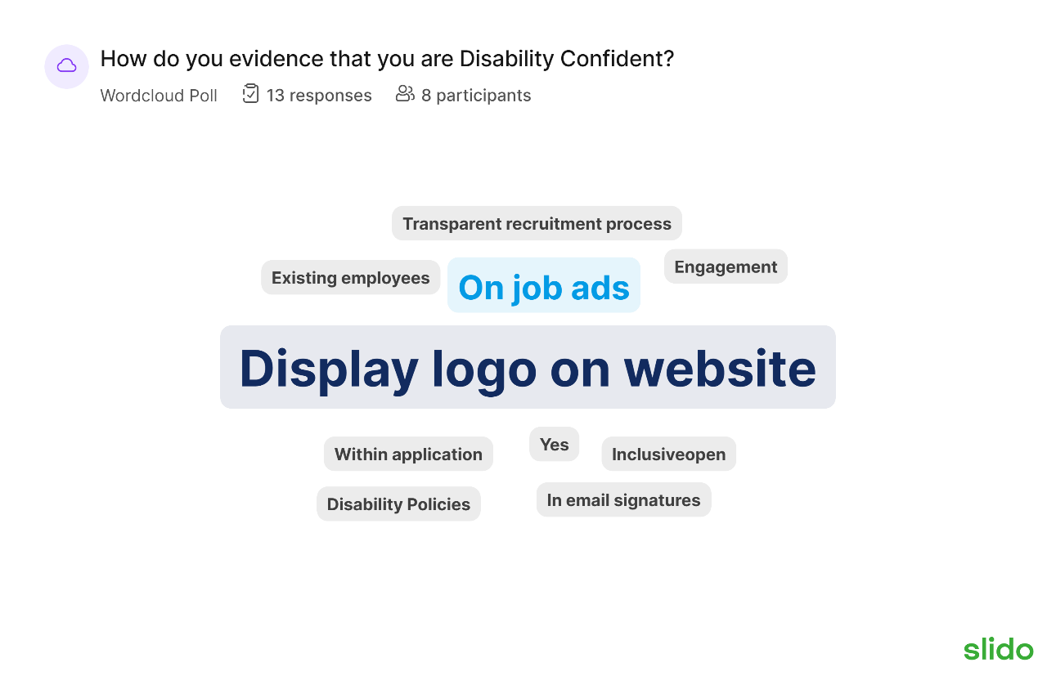

- Engagement: Engagement with your workforce
- Existing employees – people already within our business and also evidencing in their recruitment process.
- Another employer mentioned about word of mouth and other businesses promoting them.
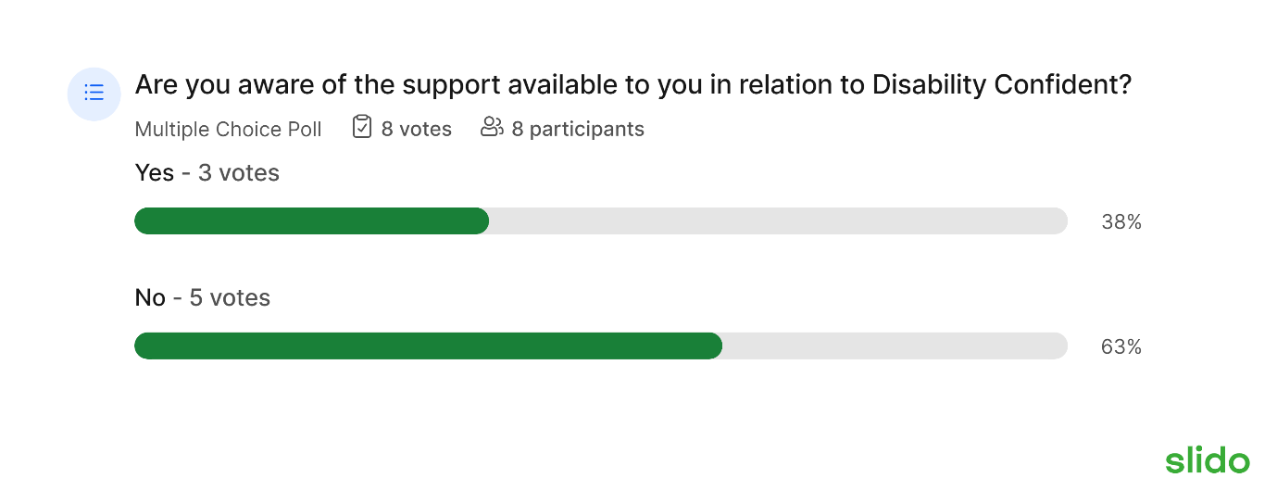
    - Kirsten mentioned the hub can work with employers to build their disability confident level and encouraged employers to speak to us for help.
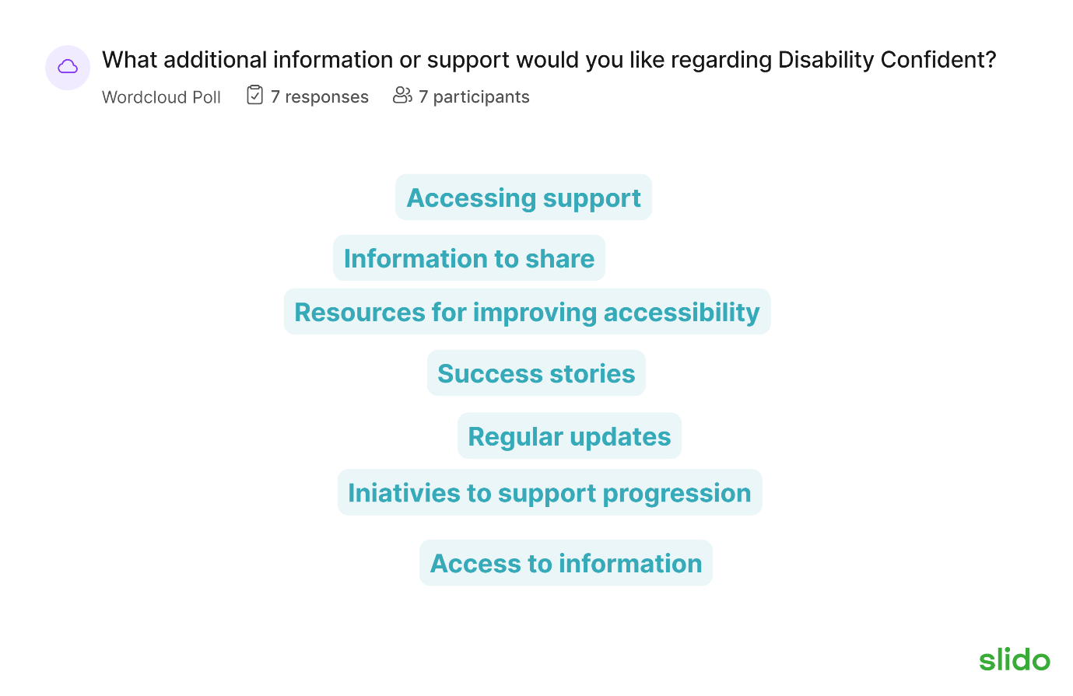

    - Kirsten has the idea of an Employer Engagement letter for information such as LMI reports, 50:50 updates, disability confident ideas and more.

Slidos - Employer Engagement strategy review – To gain feedback on recruitment and retention.

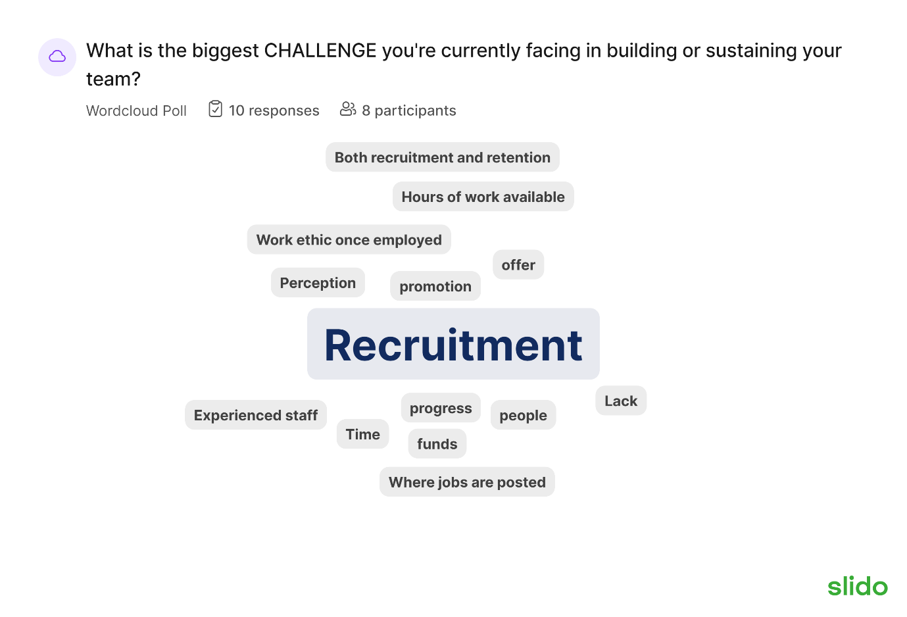

- Work ethic once employed – turning up late, being on your phone, dress well. The basics.

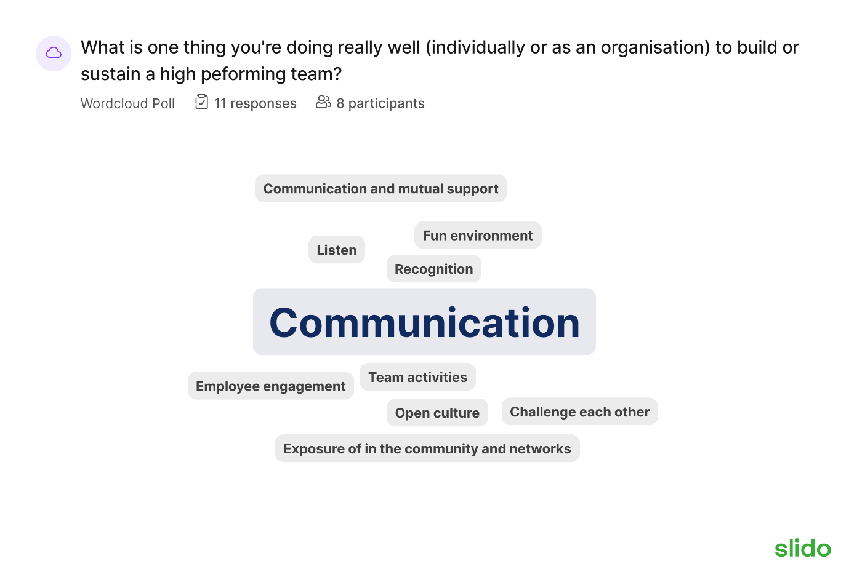
- Communication – one employers team works from home a lot so they said that communication is key to them being a high performing team and they meet as a team over zoom regularly

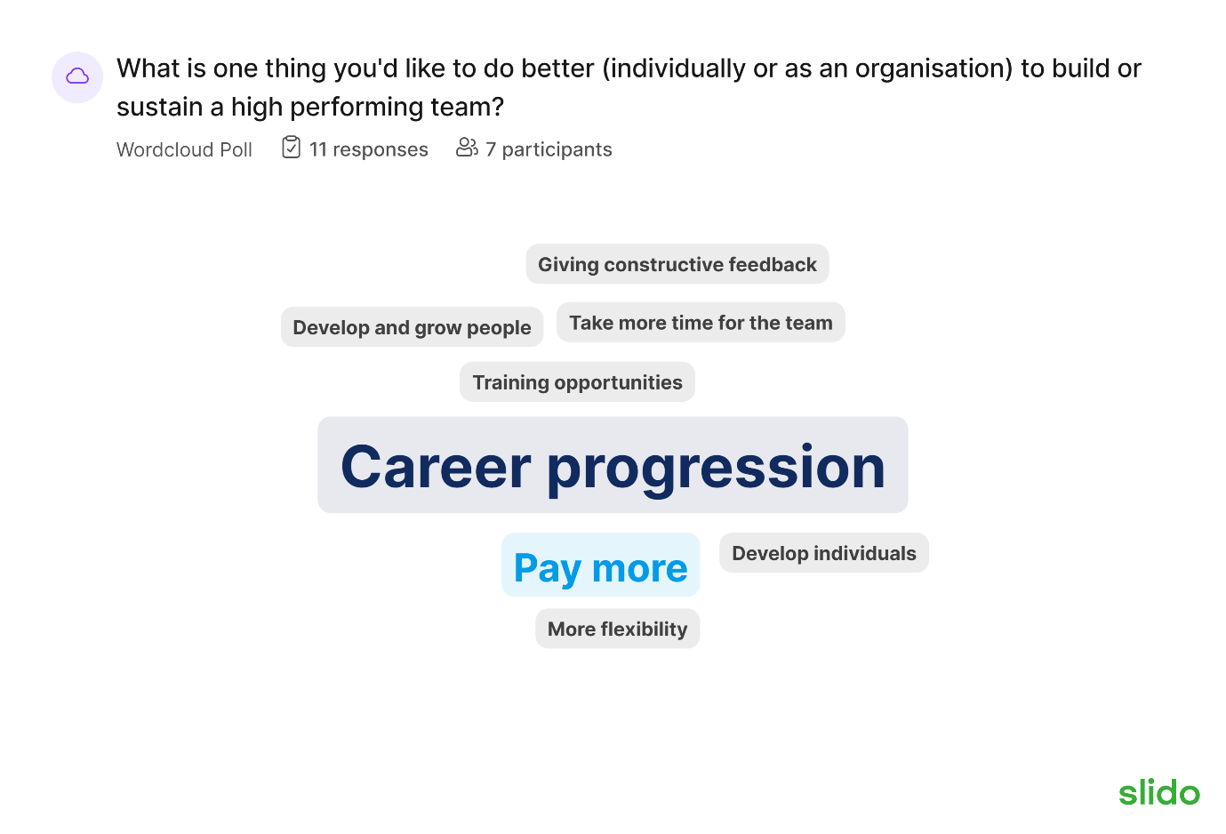

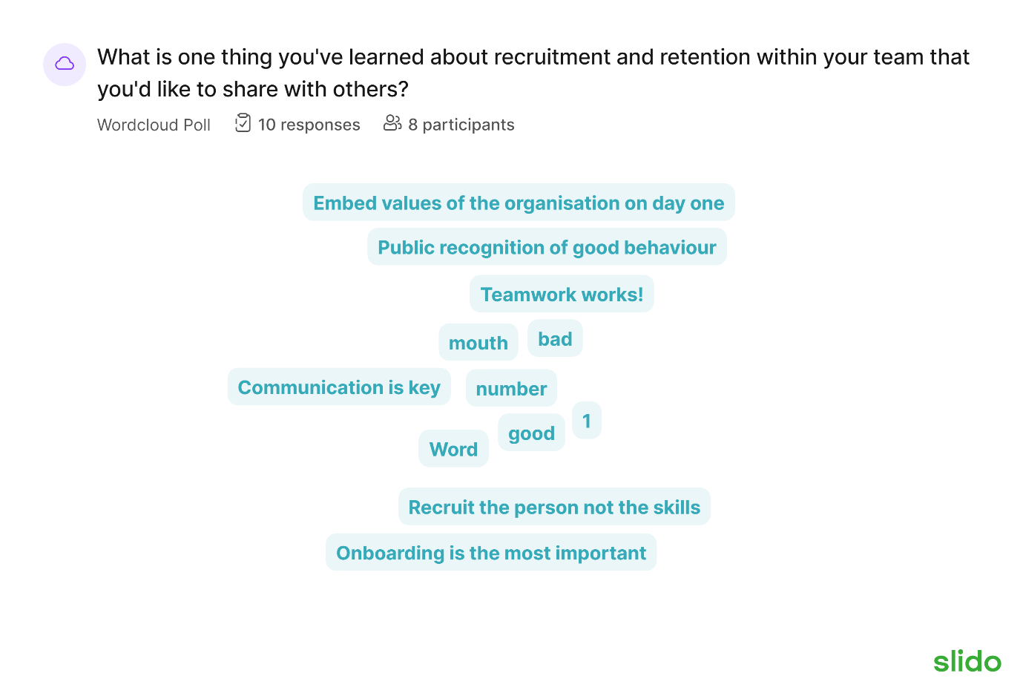
- Tom posed the question whether employers do much as a team outside of work, but most employers said this was difficult.

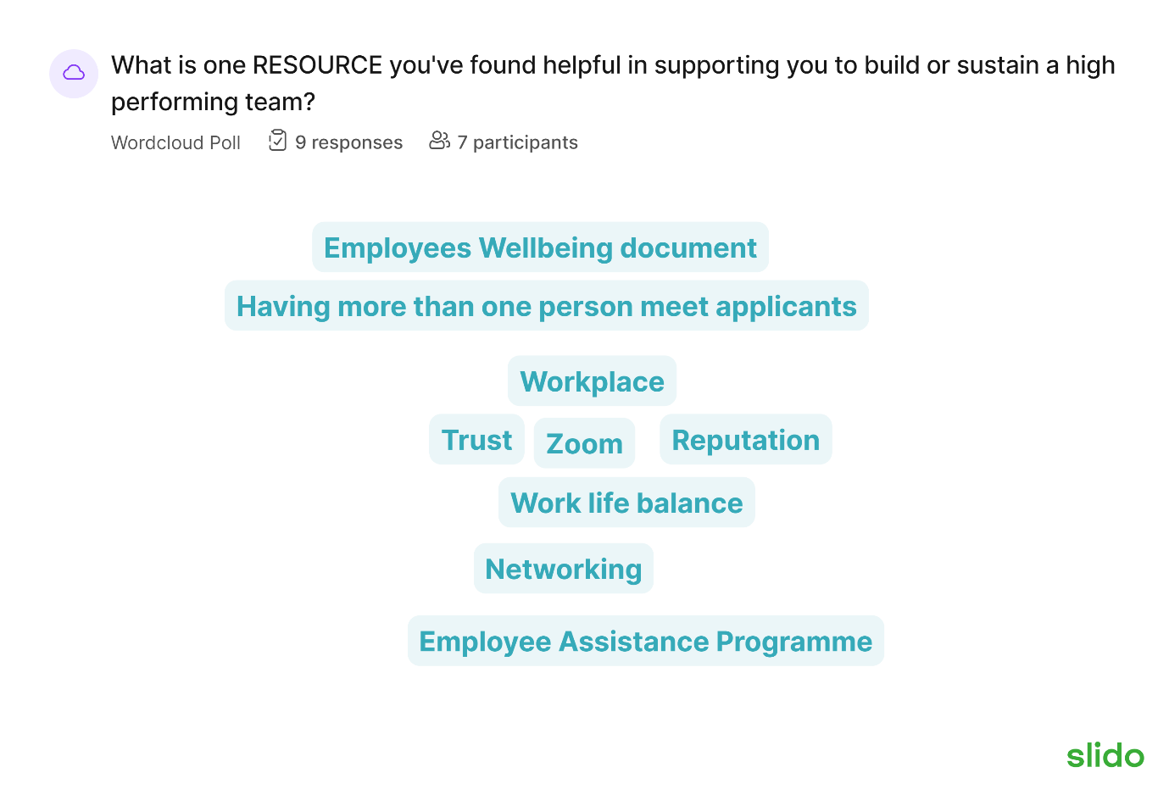
- An employer mentioned about having a team wellbeing champion.

Future Forums & next steps
- Idea of a roving forum – Tom put the idea out to employers if they are keen to host.
- Keeping connected – LinkedIn not possible. If employers have other ideas, please let us know.
- Creation of employer ambassadors – more information to be shared in first newsletter.

Q&A
- An employer asked how many customers we are working with – Kirsten replied around 150 + across the board.

Next forum: January 2024 – further details to be shared in due course.

