Information on the GCC website: www.gloucestershire.gov.uk/chelt-special-school

Establishment of a new special school in Cheltenham

Frequently Asked Questions (FAQs) document

The need for a new special school

1.1 Why is a new special school needed?

Gloucestershire County Council has a duty to make sure there are enough school places within the county for those children and young people who have complex special educational needs that cannot be met within a mainstream school setting.

We don't currently have enough special school places locally to meet demand and the number of children with Education Health and Care Plans (EHCPs) has risen steadily year on year.

Year | Number of children and young people with an EHCP
2022 | 4906
2023 | 5467
2024 | 6120
2025 | 6540

Of the 6540 children and young people in Gloucestershire with EHCPs, 32% have needs that cannot readily be met in mainstream school and are placed at special schools (and colleges) in and outside of the county. There is a growing number of children who are being assessed as having their needs best met in a special school and a considerable proportion of the children for whom a special school is the best option, live in and around Cheltenham and Gloucester. Plans are well developed for the establishment of a new 200 place special school in Gloucester, and this new school will help to address the demand in and around Cheltenham.

There continues to be a projected increase in demand over the coming years and when we do not have enough special school places within county, some children travel to special schools out of county or go higher cost independent schools, often some distance from home, for their needs to be met.

The need to increase the number of special school places is underpinned by Gloucestershire’s Special Educational Needs and Disabilities (SEND) Strategy 2022-25 and the SEND Commissioning Strategy 2019-2024.

1.2 Will this benefit children and families who live in the area of the school?

Yes. There are children living in Arle and the surrounding areas that require special school provision of this type.

The map below (figure 1) shows the location (as blue triangles) of the existing state funded special schools in Gloucestershire, and the location (as a green triangle) of the special school that is set to open in Gloucester. It also shows the location of the proposed new school (as a yellow star).

The map shows the concentration of children and young people who have been assessed as needing a special school and who, early in 2025, were waiting for specialist provision to become available.

It is important to note that the numbers vary month to month, but there is a projected increase in demand and there continues to be a significant number of children living in and around Cheltenham in this category.
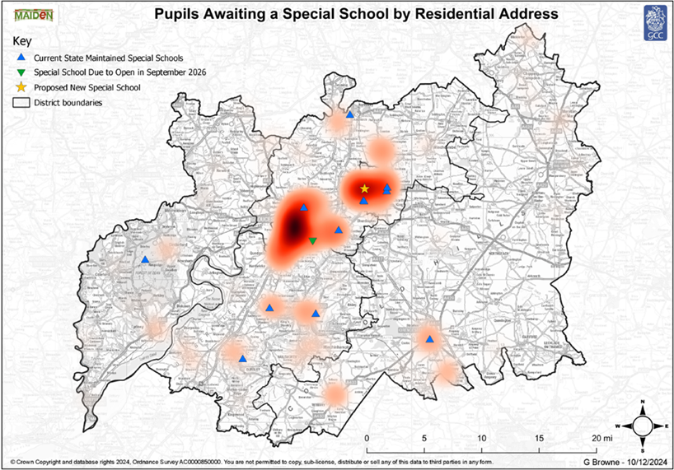
Figure 1: Map showing the distribution of need across the county: children and young people with EHCPs awaiting special school placements

Some of the mainstream schools close to the intended site also have a sizeable number of children with identified special educational needs. The new special school will definitely benefit children who live nearby, and the intention is that the new special school will offer outreach support to local schools to share their skills and experience.

Type of special school

2.1 What type of special school is being proposed?

The intention is to establish an ‘all through’ 200-place special school to accommodate the age range 4-16 years for children and young people with Complex Learning Difficulties (CLD). Subject to the necessary approvals, Gloucestershire County Council will be working towards the school opening during the academic year 2028/29.

2.2 What are Complex Learning Difficulties (CLD)?

Children and young people with Complex Learning Difficulties (CLD) need additional learning support as they learn differently to their peers. They may have much greater difficulty than their peers in acquiring basic literacy and numeracy skills and in understanding concepts as a result of their learning differences. They will have difficulty understanding instructions and the requirements of tasks, have difficulty understanding how they affect and relate to their immediate surroundings, find personal organisation difficult, and may have difficulties with those visual and auditory memory skills which help us process information and instructions. Some will benefit from a mainstream curriculum but require the smaller group setting and the more individualised approach that a special school offers. Others will require a curriculum more tailored towards children with moderate to severe learning difficulties.

Children and young people who will attend the school are likely to present:

- Significant barriers to learning:
- Complex speech language and communication needs (SLCN);
- Neurodiversity and Autism spectrum conditions (ASC);
- Challenging behaviour, arising from social emotional and mental health (SEMH) and/or conditions that impact on emotional regulation; and or
- Physical, sensory and medical needs.

They may have needs in more than one area, which (taken together) presents a complexity of needs. We anticipate that many pupils will be neurodiverse and/or have autism spectrum conditions.

In a special school context, children are typically taught in small classes of approximately ten to twelve children with two adults supporting them. There is a greater flexibility to group learners with similar needs and by stages of development rather than by age or year group alone.

2.3 What other schools are there in Gloucestershire are similar to this?

Whilst all special schools have their own unique character, the other state funded special schools in Gloucestershire similar to this are Alderman Knight School in Tewkesbury, Sladewood Academy in Stroud and Belmont School in Cheltenham. It is envisaged that this new special school will cater for a broader range of needs.

2.4 Are the children who will attend the new school children who have been excluded from mainstream schools?

No, the new school is not alternative provision for pupils who have been excluded from mainstream schools; rather it is a special school for children with complex and significant special educational needs. Pupils will have significant barriers to learning that makes their inclusion into mainstream schools challenging. Some children could be transferring from a mainstream school following assessment that their needs will be better met in a specialist setting and some may have spent a period of time out of school.

2.5 Is this new school similar to the special school that is in the pre-opening phase in Gloucester?

It is similar and it is envisaged that this school will cater for a broader range of needs. Many of the facilities that are being provided at the new Gloucester special school will also be required at this school.

Location

3.1 Where is it proposed to locate the school?

The intended site for the school, subject to the necessary approvals, is on land owned by Gloucestershire County Council accessed via Arle Road in Cheltenham. The overall site is approximately 2.1 hectares and has a long-standing history of educational use, as it formed part of the St Benedict Catholic School (now closed).

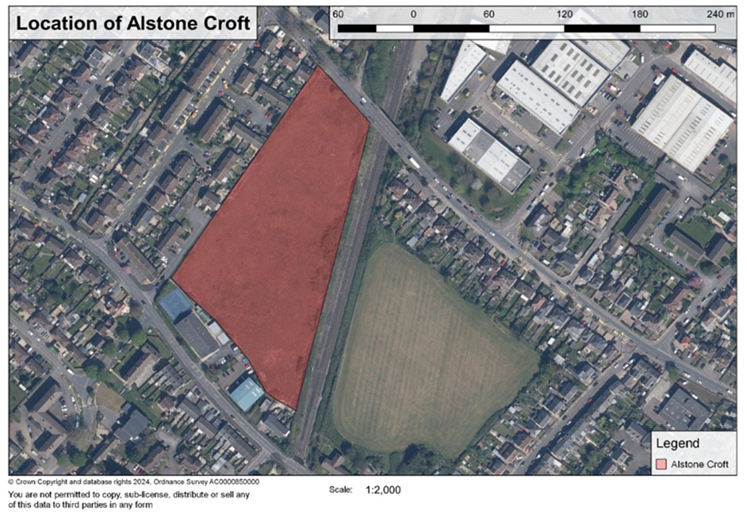

Figure 2: Land west of Alstone Croft

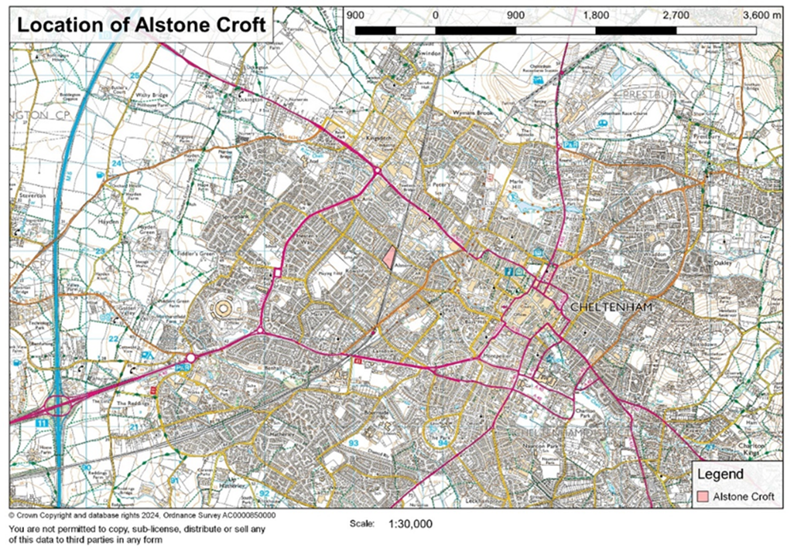

Figure 3: location of the site within Cheltenham (pink section in the middle of the map)

3.2 Why locate the school in Cheltenham?

When considering the county wide picture of where there is a demand for special school places, as can be seen from the map in figure 1, there is a high concentration around Gloucester and Cheltenham. There is a new special school in the pre-opening phase set to open in Gloucester and this proposal helps to meet sufficiency demands in this part of the county and the surrounding areas. Cheltenham is centrally located within the county.

3.3 Why locate the school on this specific site?

A search was undertaken for suitable sites within Cheltenham that were already in Gloucestershire County Council ownership. It is a much more efficient use of public funds to select a site already owned by the council rather than to purchase additional land, which would likely cost several million pounds. The timescales involved in finding and purchasing a suitable site would significantly delay the school from opening when we need it to and there is a pressing need to provide special school places.

The site is well situated within the county and has a long history of educational use, having previously been allocated to St Benedict Catholic School, which closed many years ago. The Catholic Diocese of Clifton, in liaison with the Secretary of State for Education, returned the land to the Council in 2023 on the understanding that it will be used for the purposes of education.

The size and topography make it a suitable site on which to build a school of this type and, its adjacency to the existing St George’s Centre (a base of the Altus School who provide alternative provision for children and young people who have been, or at risk of being excluded from school) offers opportunities for sharing of facilities and joint working. It is intended to assign a portion of the site to the St George’s Centre if possible.

  - Will the proposals affect the Alstone Croft playing field to the east of the railway line and will there be changes to the use or access arrangements for that field as a result of these proposals?

The proposals for the new special school relate solely to the land on the west of the railway line accessed from Arle Road. There are no plans to change the current arrangements for the Alstone Croft playing field at this time. It should be noted that Gloucestershire County Council only owns part of the field to the east of the playing field.

  - Will the site continue to be maintained by the Council whilst plans are being developed and before construction work commences?

Yes. The Council remain responsible for the site and will continue to maintain the site while the proposals are being developed. Whilst owned by the Council, the site is private property.

Early Years and Post-16 provision

4.1 Will this new school include Early Years provision?

The new special school will be for children with EHCPs who are of statutory school age (ie from the Reception Year upwards). Most children who have yet to reach statutory school age, including those with additional needs, are successfully included within their local mainstream Early Years and childcare settings, with additional support where required. There are six other special schools across the county who are registered to admit children in the Early Years phase who have the most complex needs and with an EHCP and Gloucestershire County Council has commissioned the provision of two Ofsted registered early years SEND centres for children whose needs cannot be met in a mainstream setting. There is the potential, subject to the necessary approvals, to expand the provision available at the proposed new school in the future. Information about the SEND Early Years Offer for children with Special Educational Needs and Disabilities, and the support offered by Gloucestershire County Council’s Early Years team, can be accessed here.

4.2 Will this new school include Post-16 provision?

There is very positive data to show that the vast majority of young people successfully transfer from special schools of this type to Further Education (FE) settings at the end of Year 11. There is sufficient specialist provision available at 16, if students aren’t yet ready to join mainstream education, and Post-16 vocational options include a well-developed supported internship programme. FE colleges work with the special schools in Gloucestershire to provide students with regular taster days in Year 11 so they become familiar with a Post 16 learning environment, so their transition is well planned. Some colleges have also developed longer transitions for students up to a year before they start their course.

There is the potential, subject to the necessary approvals, to expand the provision available at the school if the demand for onsite specialist Post-16 provision increases in the future. Information about the options available for children and young people with Special Educational Needs who are entering Post 16 education can be accessed here.

Expansion and future special school places

5.1 Will the school expand in the future?

The school is being designed and built to cater for 200 pupils when full. However, it would grow to this number over time, and it will likely take two to three years to reach its capacity. The school might admit in the region of 70-80 pupils in its first year. If the demand for special school places of this type increases, and site and accommodation constraints allow, it is possible that the school will be asked to admit a greater number of pupils, and the potential to expand the building, within the existing boundaries of the site, will be factored into the design where possible. Any significant future expansion of the building will be subject to planning approval.

5.2 Given the Council is building a new school of a similar type in Gloucester, why not make that big enough so as not to build two schools?

The reasons why an option of creating the required number of special school places all on one site has not been progressed include:

- that there is a demand in both the urban settlements of both Gloucester as well as Cheltenham and we want to make provision available across the county whilst also as close to where a concentration of pupils live as possible
- It would be an over-development of the site in Gloucester to create a 400-place special school. The planning approval that was obtained for that development (in November 2024) was based on a 200 place school, which can comfortably be accommodated within the space available and by the surrounding highway infrastructure.
- special schools are, in their nature, intended to offer a smaller, less overwhelming and more nurturing environment. We would therefore not be considering a campus on one site catering for up to 400 pupils.

5.3 Why not just expand the other similar special schools that are in the county?

A number of the existing schools have already expanded in recent years, and it is considered that most of the existing sites are now at full capacity with only limited potential for further expansion. Special schools are, in their nature, intended to offer a smaller, less overwhelming and more nurturing environment. This, alongside factors around practical site constraints and where in the county the places are needed, needs to be taken account when considering increasing the number of places available at existing special schools.

How the school will be run

6.1 Who will run the school?

The school will be established as a special free school, which means that under current legislation, it will be an academy. Gloucestershire County Council will run a nationally promoted competition to identify a suitably qualified and experienced Multi Academy Trust (MAT) to run the new school and will make a recommendation to the Secretary of State as to which one should be appointed. A competition launches on 28th April to invite trusts to apply to run the school, and that appointment is likely to be confirmed in the autumn of 2025.
6.2 Why will the new school be established as an academy?

When the county council identifies the need for a new school in its area, it must (under current legislation) ask for applications to establish an academy (free school) from academy trusts ad other sponsors. This is why we need to invite academy trusts to apply to run the new school rather than establish a local authority-maintained school. The role of the council is to establish the new school and hand it over to the academy trust to run once it has been set up and this approach is informed by central government policy. It should be noted that The Children’s Wellbeing and School Bill, introduced in December 2024, seeks to remove the requirement for most new schools to be academies, and restore local authorities’ and other bodies’ powers to propose opening new maintained schools and pupil referral units (PRUs). If the bill is passed, and Section 6A of the Education and Inspections Act 2006 (the ‘free school presumption’) is superseded, the opportunity, subject to further approval, is created for the school to be established as a Local Authority maintained school.
6.3 Will the term times be the same as other schools in Gloucestershire?

Whilst it will be for the academy to set its own term dates, we anticipate they will likely follow the same pattern as the majority of other schools and academies in Gloucestershire.

6.4 How will access to and from the site be managed?

The safety of the pupils is of paramount importance to the council and will also be for those who run the school. Therefore, the intention is to provide a site that has a secure boundary fence and a situation where entry to and exit from the site is carefully controlled. This will allow the children and young people to be able to benefit from the whole site, in the knowledge that they are kept safe and not able to leave the school site unaccompanied or encounter unauthorised visitors to the site.

6.5 Will the facilities at the school be available for community use?

The school will look to make the facilities available for community use if that is something that people who live locally would like.

Traffic and parking

7.1 Will 200 pupils mean 200 cars dropping pupils off?

No, the majority of children and young people who attend special schools travel to and from school using council-arranged multi occupancy minibuses and taxis. Single occupancy vehicles for school transport are used only where necessary and, where possible, children will be grouped so that they can share vehicles. We regularly undertake work across all our special schools to review and combine routes where this is practical. The way home to school transport is organised in a special school produces much less traffic than a mainstream school where many more children are dropped off and picked up on the roadside by their parents.

We will use a transport consultant to assess and report on the likely impact on traffic from the pupil journeys to and from the new school and this assessment will be submitted as part of the formal planning application. All stakeholders will have the opportunity to review that document. When undertaking the traffic and journey generation assessments, a worst-case scenario position is usually planned for, i.e. that there will be a higher number of single occupancy vehicles than is likely to be the case.

Experience shows that the design of the new school should include provision for taxis and minibuses to enter the school grounds and drop off and pick up pupils within the school site, avoiding roadside drop off and pick-ups. This aspect of the school’s operation will be carefully planned to make sure vehicles are not queuing onto the road at the start and end of the school day and a lot of careful planning will go into this specific aspect of the design.

Where pupils live locally there are opportunities for children and young people to be supported to walk to school or utilize public transport. Training and support for the development of independent travel skills will be high on the agenda for this group of pupils.

7.2 Will some pupils be dropped off by their parents?

There will be some children who will be driven to and from school by their parents. This is either because they have not been awarded an entitlement to LA arranged home to school transport or because parents have chosen to undertake this themselves rather than accept the transport assistance. This is not expected to be a sizeable number, but allowance for this will be made in the transport assessment.

7.3 Will the site be accessed solely via the existing gates on Arle Road, or will Bryanstone Close and Arle Gardens be utilised as additional entrance and exit points?

The main access to the site will be from Arle Road. There may be a need for a secondary access which could be for emergency or maintenance/service vehicles or for discharging vehicles at certain points in the day. There will be a full highways impact assessment undertaken as part of the development of the scheme. Any plans/options will be shared with residents and stakeholders as part of pre application engagement consultations. Any plans will be assessed through GCC Highways to ensure they are acceptable and will not have a detrimental impact on the existing road network.

7.4 How many staff will there be at the school and where will they park?

Special schools have a high staff to pupil ratio, and there are usually additional staff not commonly found in a mainstream school such as therapists. Whilst it is for the academy trust to determine their own staffing model, based on comparisons with similar schools we should plan for in the region of 100 staff, but not all of these would be in at the same time. For example, cleaners are not usually in at the same time as cooks and lunch time support staff. Some staff will choose to travel to work by sustainable modes such as walking, cycling and public transport, reducing the demand for parking on site, however the importance of sufficient parking for staff and visitors is well understood.

7.5 What will be the impact on surrounding roads and will traffic calming measures be introduced locally?

Decisions in this regard will ultimately be that of GCC Planners who will review the results of the traffic assessment and surveys submitted and weigh them up against the tests of planning obligations and the advice of the GCC Highways Officers. Should GCC planners consider that the results warrant changes to the existing highway structure they may decide to make them a condition of any planning approval.

The design and build

8.1 How will the design, build and ongoing running of the school support a reduction in carbon emissions?

In line with Gloucestershire County Council’s Climate Change Strategy to reduce the Council’s emissions to net zero by 2030, the building will strive for net zero emissions associated with the running of the building. We will use a specialist consultant to help make decisions about the range of different approaches that can be taken to ensure the design and operation are as sustainable as possible. Examples from previous similar projects have included:

- A building that is orientated and formed in a way that is intended to reduce heat loss and also limit solar gains without causing overheating.
- Night cooling which will limit overheating, along with automatic CO2 sensors to support ventilation and cooling, without the use of air conditioning.
- A building with insulation and air tightness levels that will well exceed requirements and help to make this an energy efficient building.
- Building services which are fossil fuel free and where all heating and hot water generation will be by air source heat pumps.
- Energy efficient LED lighting is planned for throughout with automatic on/off motion controls and daylight linking to avoid lights being left on unnecessarily.
- A 100% offset of regulated energy consumption through on-site electrical generation from PV (solar) panels on the roof.
- A resulting EPC rating for the building of A+.

  - How many storeys will the building have?

There is a strong commitment to ensure a high level of on onsite parking, so this means that there will need to be a two-storey element to the building but the building may not need to be two storey throughout.

8.3 Will the school take up the whole of the site?

There is a lot to accommodate within the site in terms of the necessary outdoor learning, recreation and play spaces for pupils alongside the necessary parking. However, as the designs have progressed, it has become clear that it possible to provide the school with everything it needs as well as to portion a section of the site to the south to the St George’s Centre which has only a very limited amount of outdoor space currently.

  - Will measures be put in place to ensure the necessary habitat areas for wildlife?

A dedicated habitat area is likely to feature in the design. This is to encourage and attract wildlife generally but also to help us achieve the biodiversity net gain that the planners will look to see. Outside play and recreation areas and being able to learn outside of the classroom will be important for this group of children, and we will look (in addition to the dedicated wildlife area) to include features such as bird boxes for common and widespread species, swift boxes, sparrow boxes, hibernation spaces and bat boxes. We will also be looking to retain as much of the existing vegetation as possible around the perimeter of the site, supplementing this and filling any gaps. A full ecological impact assessment will be carried out as part of the design process. The results of this will be available to review as part of the planning approval process. We will be seeking to achieve as much of the biodiversity net gain as possible onsite and nearby.

8.6 Who will build the school?

Gloucestershire County Council invited the contractors who are on its major works framework to bid for the opportunity to be principal contractor for this design and build project and Kier Construction were subsequently selected. They will in turn appoint architects to lead the design process. Kier Construction have worked on several projects on behalf of the Council and bring recent considerable relevant experience in the delivery of public buildings.

8.7 Has the planning application been submitted?

A planning application is likely to be submitted towards the end of the year and all of the assessment reports and associated documents will be available to view on Gloucestershire County Council’s public access planning portal. The Council will arrange for a public engagement event to be held locally to the proposed site ahead of the planning application being submitted in order to share the plans and hear feedback.

Previous proposals for the site

9.1 Are there still plans to use part of the site for housing?

Whilst the Cheltenham Local Plan (adopted in July 2020) shows an allocation for residential dwellings on this site (dating from when the site was under previous ownership), an analysis of the space that is required to provide the necessary amount of classroom and external space is indicating that the whole site will be required for the school. The site is committed for development in the Local Plan, so if not used for a school, proposals for a mixed housing development will likely be developed.

Keeping up to date with the project.

10.1 How will interested parties be involved as the project develops?

A dedicated webpage will provide updates as the project develops. www.gloucestershire.gov.uk/chelt-special-school. In addition, a number of drop-in information sessions will be arranged as the project progresses

The first of these will on Wednesday 21st May 2025 3.00pm – 6.30pm at The St George’s Centre on Alstone Lane. It provides an early opportunity for residents to learn more about the next steps in the process, and the timeline involved. It also gives an opportunity for people to give their views as to the most important factors for the team to consider when designing the building and grounds. As the process will still be at an early stage, there will not be any detailed plans to review and comment on. That opportunity will be provided later in the year and prior to a planning application being submitted.

Further events will provide an opportunity to meet the Trust that will be running the school (when selected) and for interested parties to be updated generally on the progress of this project.

The Academy Trust will also undertake further formal consultation and face to face information sessions with residents and other interested stakeholders before opening the school and before the Department of Education enters into a funding agreement with them.

We have kept, and will continue to keep, the locally elected council representatives, as well as the Member of Parliament for Cheltenham up to date as the project develops. The Divisional GCC Councillor for the area in which it is proposed to locate the new school (County Councillor Dr David Willingham) is regularly briefed and he intends to work closely with council officers in relation to the development of more detailed proposals for this specific site and in ensuring that local residents have every opportunity to be fully involved and comment at all stages of the project.

In February 2025 a letter was delivered to a number of homes surrounding the site west of Alstone Croft. A copy of the letter can be found on at http://www.gloucestershire.gov.uk/chelt-special-school.

10.2 Who can I contact if I would like to ask a question about this proposal?

Any comments or questions can be raised by e-mailing: universalcommissioning@gloucestershire.gov.uk

or by calling Nathan Roe, Education Planning Manager, on 01452 427262

- Securing a place at the school

11.1 Who can I contact about securing a place at the school?
If you are seeking a place at the school for your child, please contact your named SEND Casework Officer in the EHCP Team or ring 01452 427535, or email sengenenq@gloucestershire.gov.uk

Version 1: March 2025

Version 2: April 2025

