Employer forum minutes
30.01.2024
11:00 – 13:00
Royal Agricultural University

- Kirsten welcomed everyone and started the forum at 11am and thanked Paula for hosting the event.
- Kirsten ran through the agenda for the morning and also talked through the housekeeping such as toilets & fire alarms.

There were a few new faces at this forum and so we started off with introductions around the room followed by an ice breaker of ‘which animal would you be? to help everyone to settle down and get to put names to faces.

Ice breaker
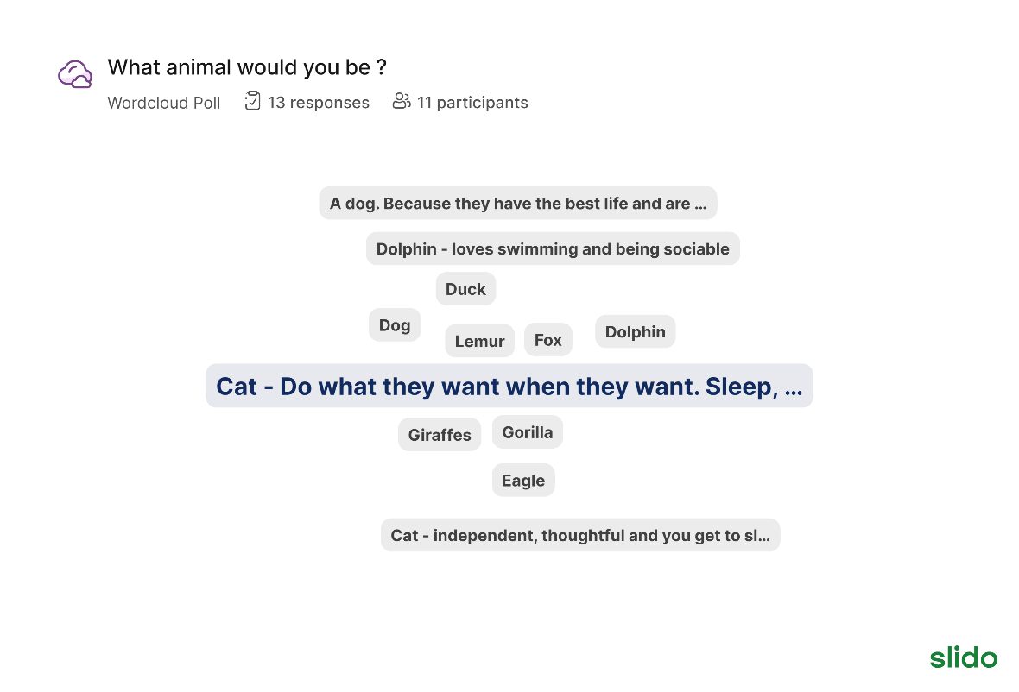

Updates
- There were some updates on numbers around the 50:50 Challenge as well as Proud to Care

Inclusivity Works
- Kirsten explained to the attendees about Inclusivity Works and it’s current website content, she also explained the plan to redevelop this into an online Toolkit for Gloucestershire’s Employers and there was a question posed around what they would like to be included on this.

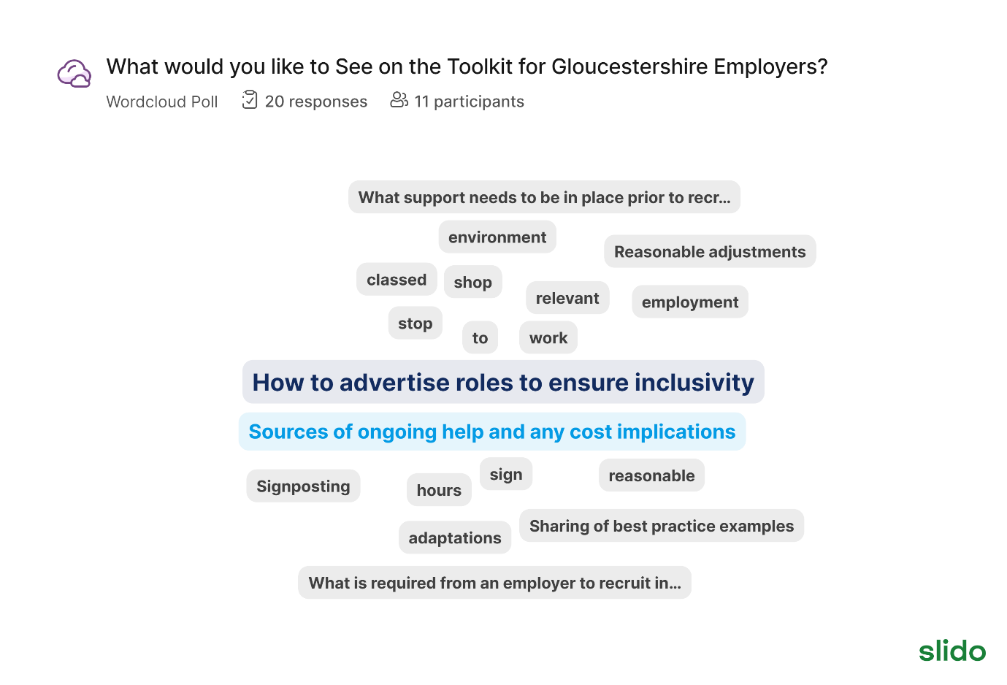
Neurodiversity in the workplace
- There was a discussion around neurodiversity in the workplace and 3 questions were posed:

- Do you know how many of your employees have been diagnosed/identify with autism?

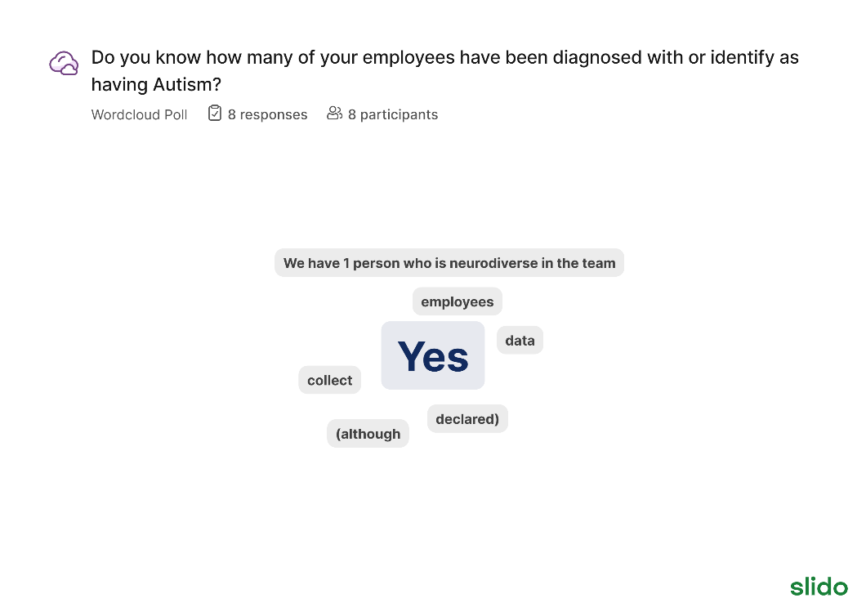

- Do you know what tools are available to you to support employees who have a diagnosis/identify with autism?

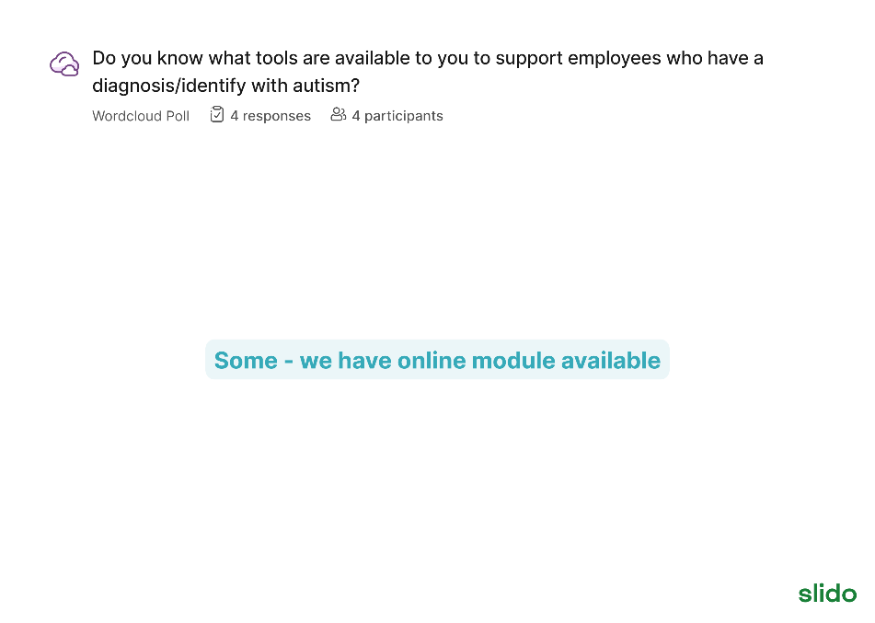

- How do you adapt your interview process to meet the needs of the candidates who have declared that they have autism?

- It was mentioned by an employer that their neurodiverse team are interview trained so they can support those who have declared they have autism.
- Suggestion of doing interviews online / in person depending on preference of the candidate
- Support at the interview/ give them the questions in advance.
- Kirsten asked employers to share any case studies to employers@gloucestershire.gov.uk
- 88% of employers in Gloucestershire have 8 or less employees.

- Kirsten introduced the lunch & learn sessions for employers where they can join the sessions on teams, have their camera off and eat their lunch whilst learning about autism in the workplace

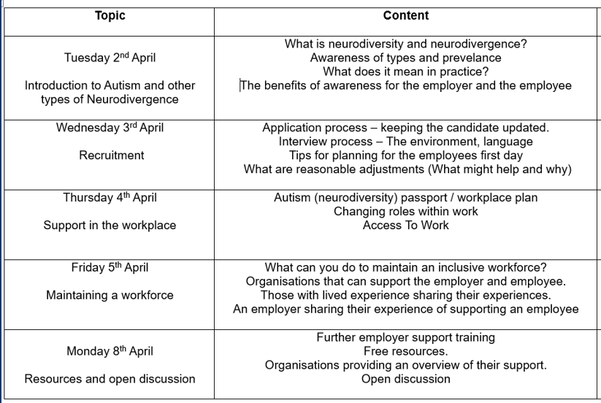

- Meetings will be recorded and uploaded to the website.

Coming soon
Jobs fair – Thursday 4th April (10:30-2pm) at the Employment & Skills Hub for those who have been diagnosed with/identify as having autism. Further information coming soon.
Lunch & learn sessions.
50:50 Talent Matching coming to Cheltenham
50:50 Matching event (meet & complete?) – matching participants to employers (potentially at Skillzone) (more information to come)

Next forum – 30th April, please let us know If you would like to host. Morning is best for most

Meeting ended 1pm

