- Open the link to SAP Cloud from Staffnet, your favourites or Search from your homepage. Then select My Travel & Expenses.
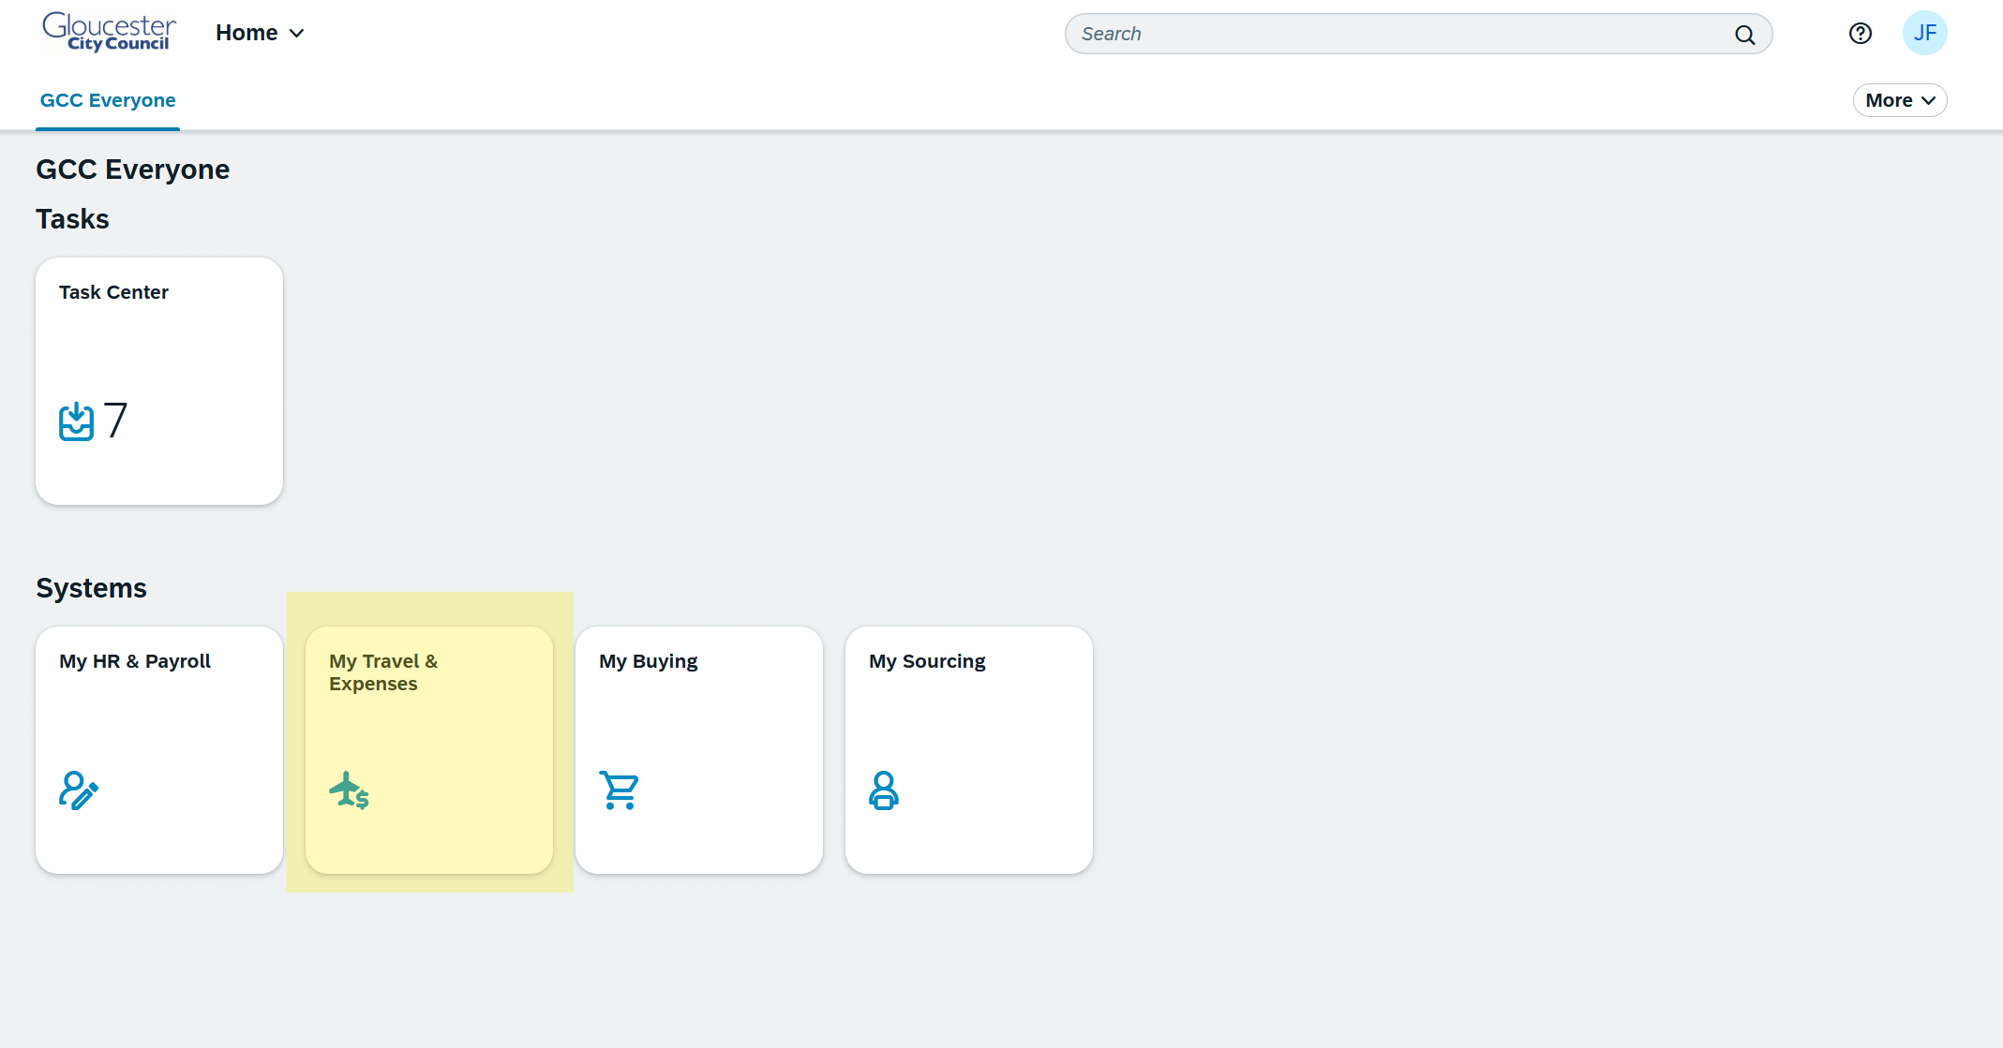
- This will open the Concur homepage. You may be asked to enter your email address to sign in.
