


Project Bulletin - Whitminster Canal Bridge
At the end of last month, we completed a temporary reinstatement of the North carriageway which allowed us to switch traffic management and commence works on the South side of the site.
Since our TM switch, we have managed to temporarily divert drainage runs, construct a temporary piling platform, and complete the installation of the south piles. In addition to this, we have commenced excavation works in the centre of the roundabout and started moving material to our site in North Leach.

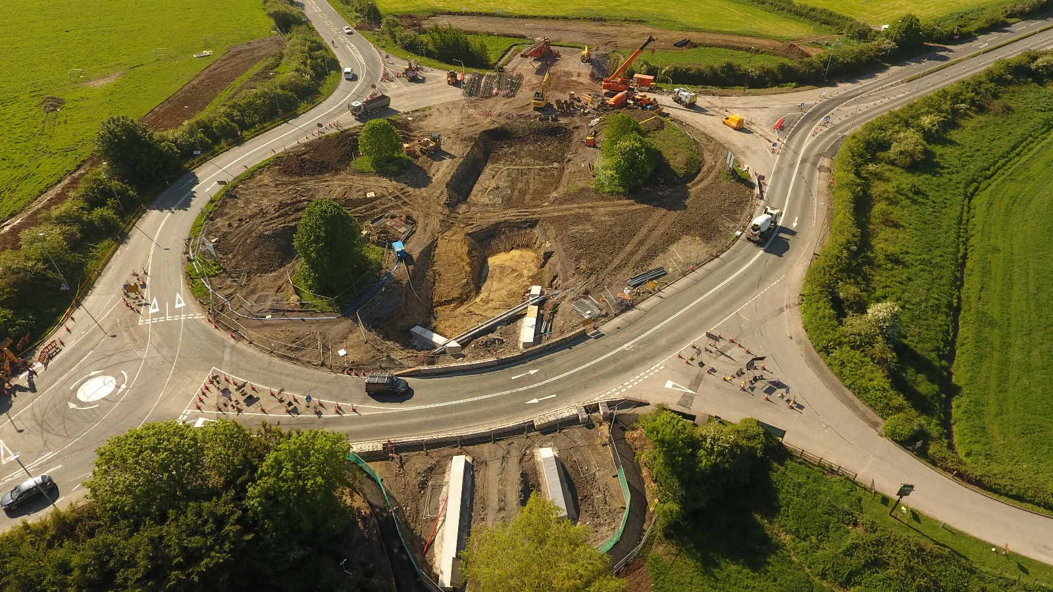

As we progress with these important improvements, your continued patience is greatly appreciated.
If you have any concerns or issues regarding the road improvement scheme, please contact me on 0300 041 4635*. I will be available throughout the construction phase to provide continuous engagement with businesses and residents within the local area.
Further information about the scheme can be found at
https://www.gloucestershire.gov.uk/highways/major-projects-list/a38-canal-bridges/
Neil Evans
Contract Liaison Officer
Alun Griffiths (Contractors) Ltd
0330 041 4635*

*Calls to this number are charged at national call rates and included in inclusive minute plans from landlines and mobiles

