

Personal Impact Statement: Area Manager Application

Name of Applicant_________________________________________________________________________
The personal impact statement relates to each of the four quadrants of the NFCC Leadership Framework as well as operational and professional expertise. Your impact statement should focus on demonstrating your impact at ‘leading the Service’ level.
Your response must focus on the personal impact you have made, the outcomes achieved supported by clear objective and subjective measures/evaluation, such as performance levels, savings/efficiency, demonstrable improvements to morale and productivity or more effective ways of working. You are limited to 500 words per question.
All information must be accurate and relate to your own actions as they may be triangulated. Any information later found to be deliberately false may lead to your removal from the selection process.
Leadership Framework - NFCC

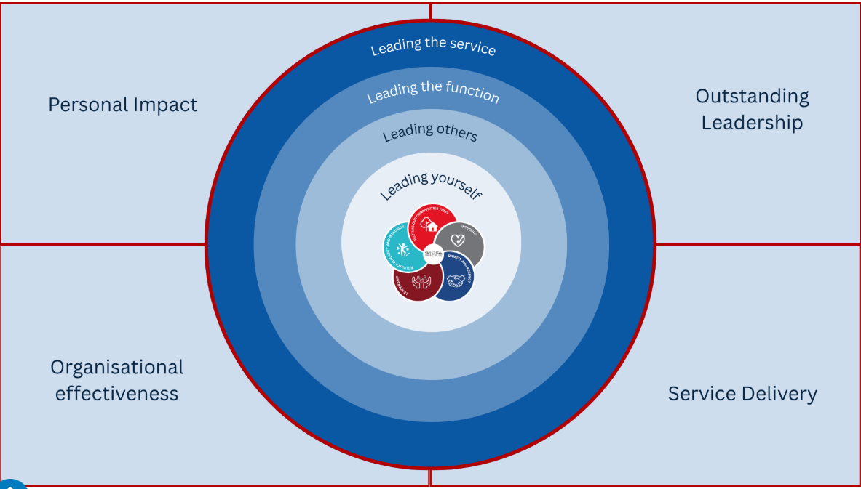

Personal Impact - Leading the Service
This area is about the self. (500 words)
Click or tap here to enter text.

Word count: Click or tap here to enter text.

Please provide name and contact details of a person who can verify this information:
Click or tap here to enter text.

Outstanding Leadership – Leading the Service
This area is about others. (500 words)
Click or tap here to enter text.

Word count: Click or tap here to enter text.

Please provide name and contact details of a person who can verify this information:
Click or tap here to enter text.

Service Delivery – Leading the Service
This area is about the task. (500 words)
Click or tap here to enter text.

Word count: Click or tap here to enter text.

Please provide name and contact details of a person who can verify this information:
Click or tap here to enter text.

Organisational Effectiveness – Leading the Service
This area is about the organisation. (500 words)
Click or tap here to enter text.

Word count:Click or tap here to enter text.
Please provide name and contact details of a person who can verify this information:
Click or tap here to enter text.

