Employer Forum meeting minutes
Thursday 8th June 2023, 14:30 – 16:30
Council Chamber, Shire Hall

- Andy welcomed everyone to the forum and shared the agenda for the day and introduced Slido
- Ice breaker – who are you and your favourite cartoon Character

Andy posed the question of what effects recruitment and how to make a positive change – carbon footprint, travelling.

Multiple agencies offering support to employers

Tom lead Slido polls

1st slido – What do you think are the main current issues with filling vacancies? 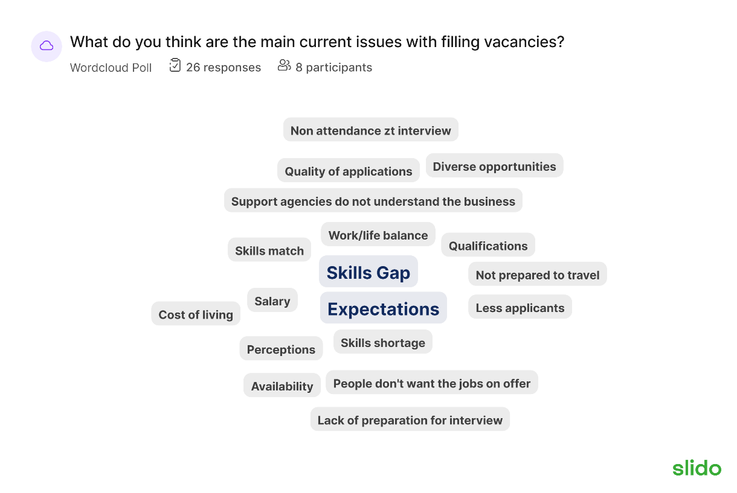
- People don’t want jobs on offer – a way around could be to encourage people to try the jobs on offer rather than looking for their ideal job
- An employer mentioned that employers have a very specific idea of the type of person they are looking for – suggested employers shouldn’t have such broad expectations and could train a person up to get the exact person they are looking for
- Non attendance at interview – perhaps employers would expect DWP to step up and find out why there was a non attendance at the interview.
- Perceptions – when a vacancy becomes available, people could make perceptions about that employer, what the job could be like/entail. Tom posed the question of how do we change this?
- Pam mentioned that they could sometimes be seen as a poor employer perhaps because they are always recruiting for drivers – she explained this was because the demand for home delivery has increased dramatically and needed more staff to be able to manage the demand.

Slido 2 – Age, Health & other inequalities can be barriers to employment, how do we minimise this and what else can adversely affect applications?
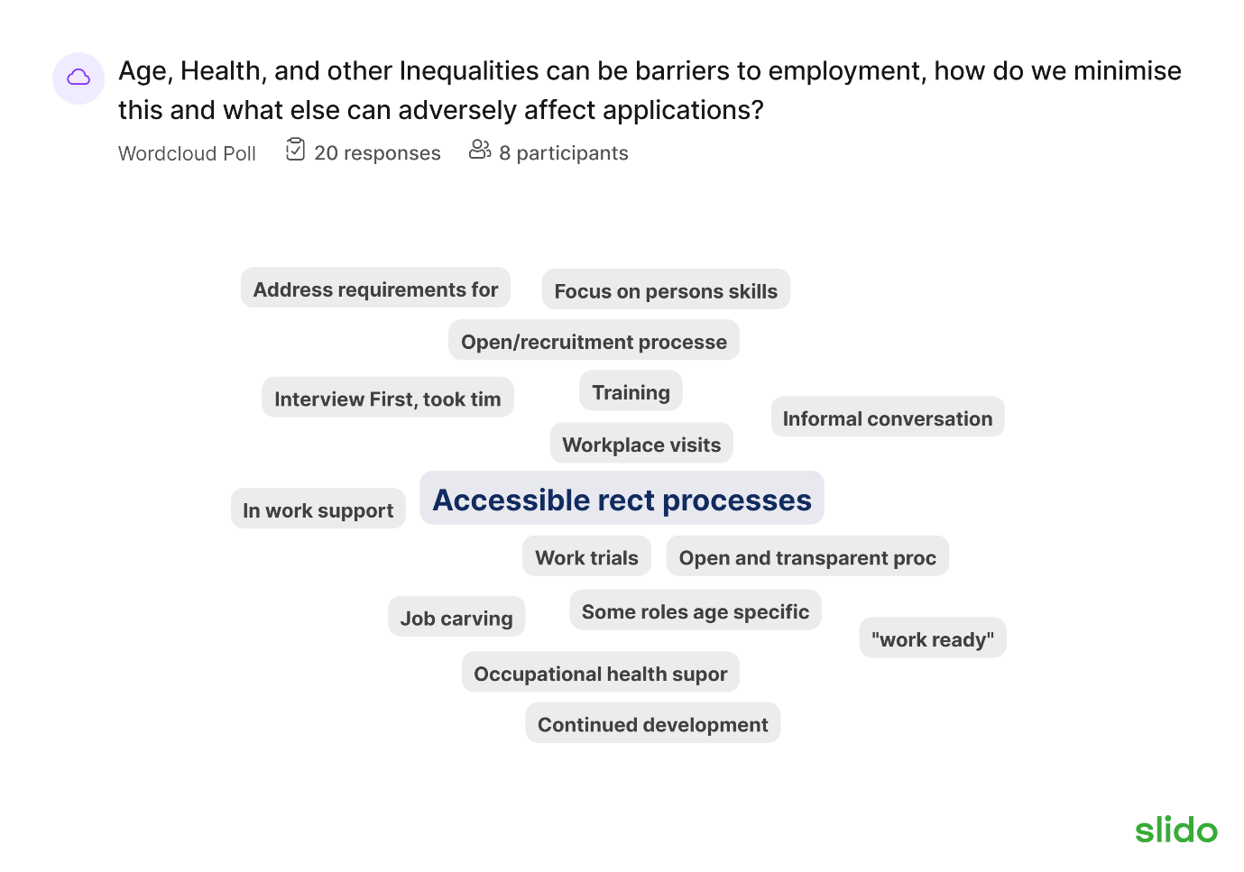
- Work trial – discussed that this is a really good opportunity for the employer and potential employee to get to know one another more – try before you buy. Pam mentioned that these don’t tend to get used very much in retail as you need to have multi fluid skills to be able to help around the business for example, your contract might have said checkout worker In the past but would now say customer service assistant as it would require more help from the employee. However, they do offer a work sample depending on capability. Everyone acknowledged that some processes don’t work in certain industries.
Vikki mentioned that a number of larger national businesses will not offer work experience because they feel it is free labour – Viki mentioned the struggle for GCC around this at the moment with a few businesses pulling out of supported internships – GCC uses things like this a working interview for people with disabilities.

- It was raised by an employer about Job shadowing – Vikki shared her views on this and said the problem is you don’t get as much out of job shadowing as you do from work experience.

- It was mentioned that during interviews in the charity sector, they ask interviewees about their strengths and then this adds value to the work they are already doing (Tom mentioned they were almost carving a job out for the employee)

Accessible recruitment processes

- Could be difficult for individuals to access the recruitment process, especially with larger organisations and some people might think it’s too much and not continue with the process.

- Pam mentioned she sometimes felt let down by agencies because some people aren’t “work ready” – haven’t got their right to work documents or don’t have the basic skills of the job required. Tried a different approach, wrote a list of names, got them in for interview and then got them to apply online if they were successful at the interview.

- Vikki answered a question of how many clients are the hub working with currently (200-300) plus ESHO with customers at different stage of journey.

Slido 3 – Myths exist around employment; for example, someone with a health condition will always take more sick leave. What other issues concern employers? 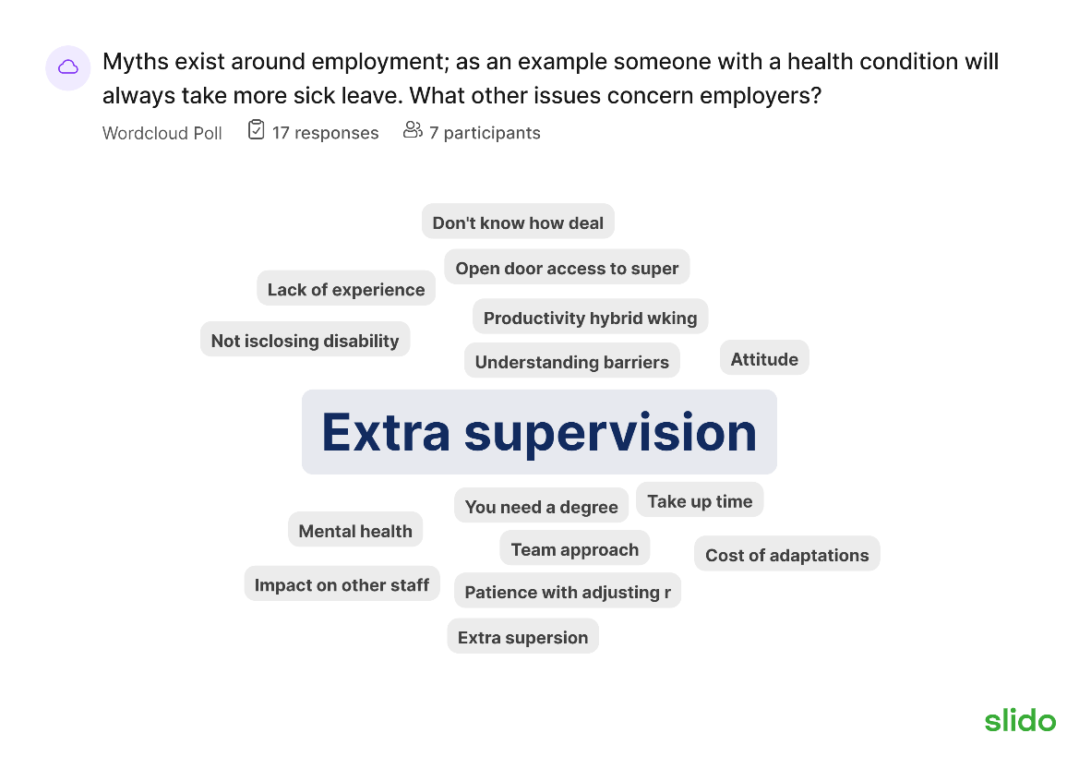
- Vik mentioned there weren’t just myths around disabilities, there’s myths around health, age, attitudes and lots more.

- Pam has got a new room for interviews – taken tables away, 2 chairs with a table in between with a lavender pot on and offers tea and coffee – more relaxed feeling.

Slido 4 – what additional support do you think employers want when they have an aging workforce?

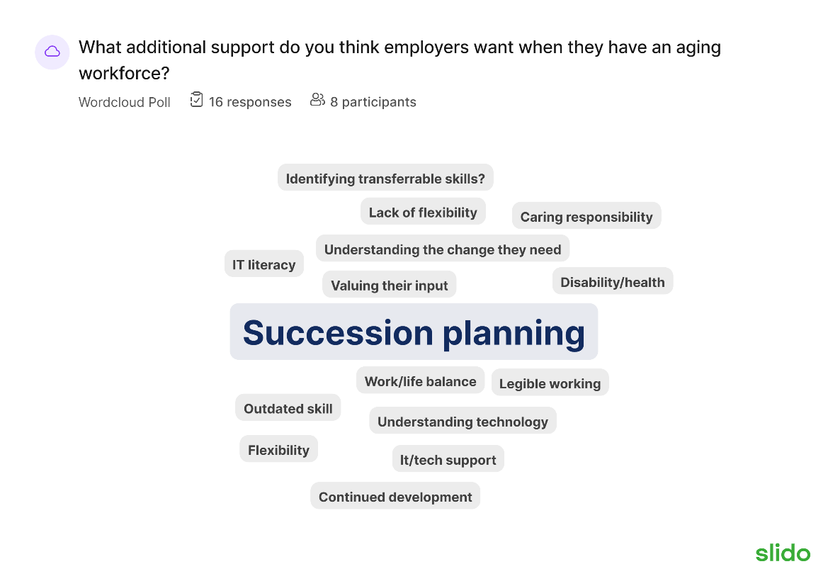
- Spoke about disclosures and what carers can disclose and what they might expect if they were to tell you

Slido 5 – What needs to change to develop a more diverse workforce in either your organisation/business or across the county.
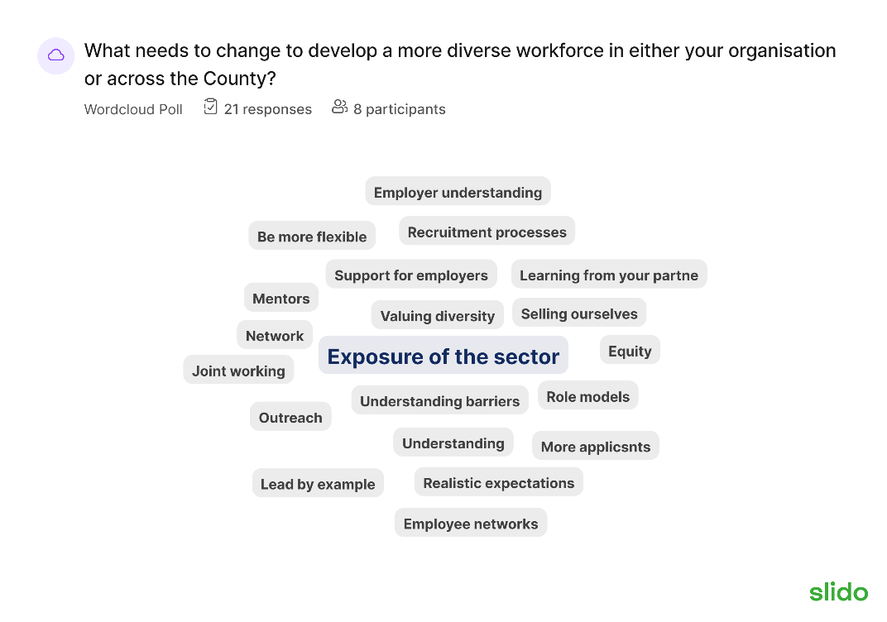
- Organisations have a wide range and diversity of jobs which people don’t think about. Broad outreach. Vik mentioned about other employers sharing vacancies with us and then the hub shares these with our network

Slido 6 – What skills & attitudes do you want to see on applications and in potential employees?
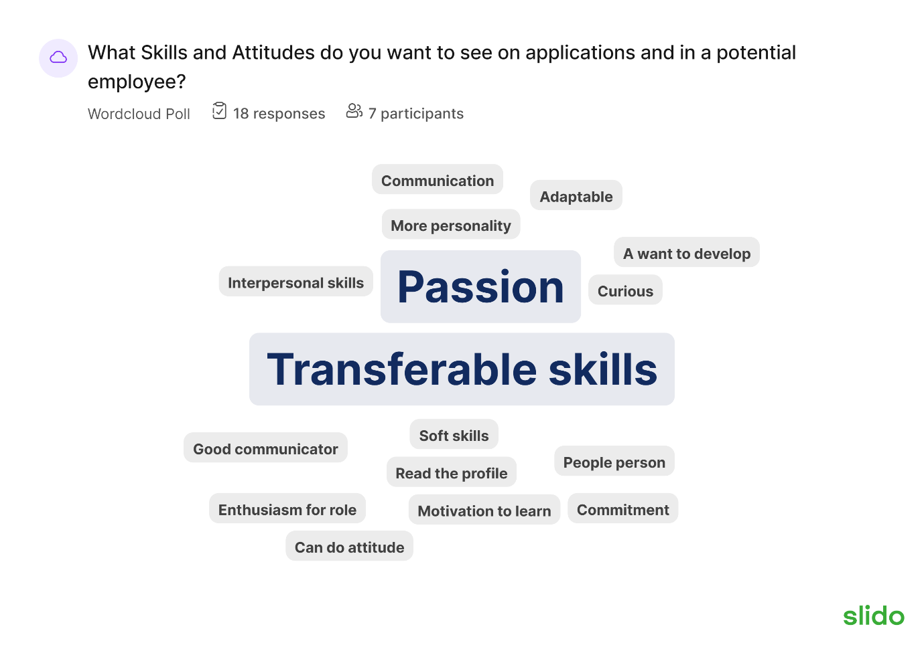

- Look for passion for work within potential employees
- Skills can be worked on – attitudes are a spark someone sees in a person
- Pam mentioned recruiting someone costs in the region of £2,200 before they’ve even started

50:50
- People involved aren’t necessarily economically inactive but have a wealth of experience
- Do people just take a job until their ideal jobs perhaps pops up or are they happy with their job and proud of their work?
- Discussed difficulty of driving someone with a barrier – could be something as simple as a career gap

- When someone has a scope of an opportunity they want to have a go at – they register an interest

- Employer will then informally meet them

- Was mentioned how much the Social side of a job is very important

- Talk of turning an interview around – what can I offer you rather than past experience – give examples

- Mentioned about days/workshops where partners could bring people along to have a go at working In an organisation

Future Forums & next steps
- Would we have a hybrid presence in future forum
- Roving employer forum suggested
- Hub wants to work with employers – be honest
- Pam struggles with afternoon - best mid morning late morning. Thursday/Friday afternoon not ideal
- There was encouragement for face to face in future
- Idea for pledge to be on employer forum.
- Andy proposed having 3 forums a year ?
- Idea of a linkedIn or WhatsApp employer forum group for continued connectivity

Meeting ended at 16:30

