SCHOOL SIMS APPLICATION - USER GUIDANCE

What is the App for?
The new School SIMS Application is accessed via a Fiori tile on your Workzone and will look like this:
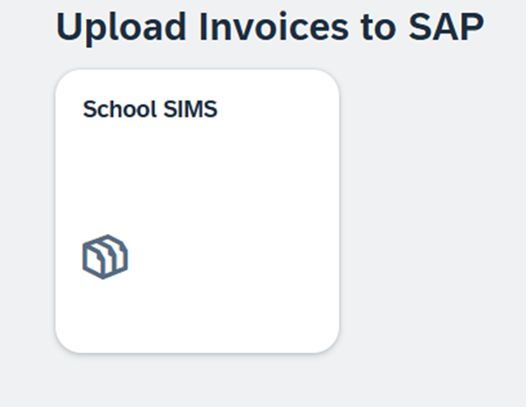
The application isn’t to be confused with the SIMS system that you load pupil and staff data into. This new application is purely for uploading your FMS/Bromcom files containing invoices directly into SAP for payment by GCC. This was done previously by sending the FMS files to GCC via Perspective Lite. Perspective Lite isn’t going anywhere and can still be used for transferring sensitive information and data etc. (All further references for FMS include Bromcom).

How do I use the new App?
Once you have loaded your invoices into FMS save your file on your hard drive as normal and print off your Payment Authorisation Control Log (PACL).
When this has been authorised and you are ready to continue, go to Workzone and open the School SIMS Application.
Your screen will look like this:
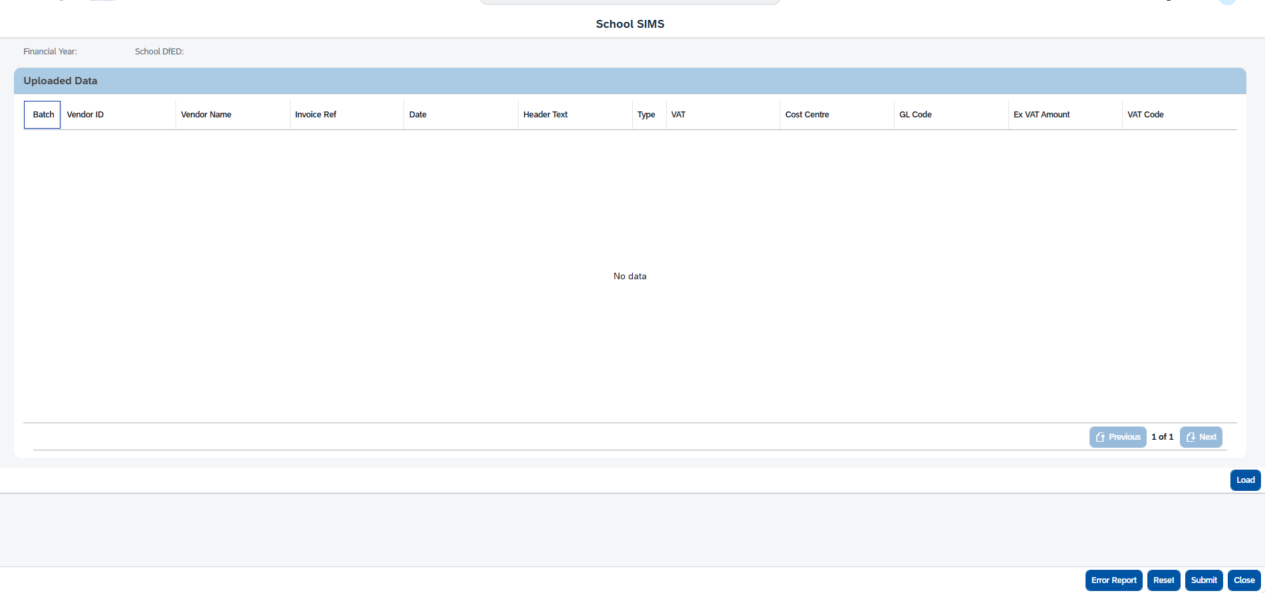

Select the Load button on the right hand side of the screen. This will take you to your File Explorer where you will initially need to browse to your FMS folder where your files are stored:
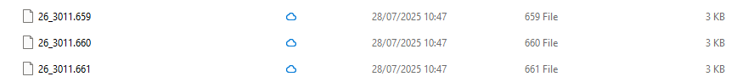
In this instance there are 3 files with the financial year/school DfE No/Batch No. We are going to double click on the first file. This will then load the information onto your screen. It is really important that you always load the file with the lowest batch number first, otherwise you will not be able to load the ones below that batch No!
Your screen should then look something like this:
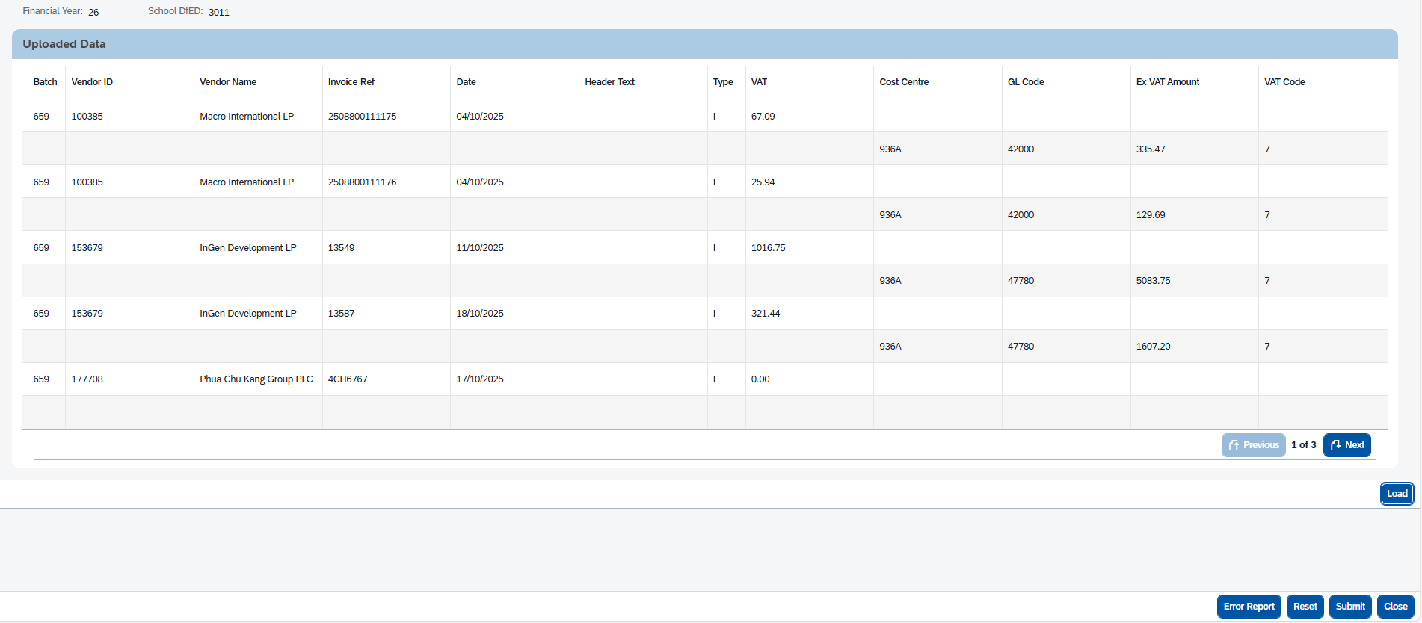
You will see at the top left is the Financial Year and the DfE No as per the file name. You will then see the Batch No in the Batch column down the left hand side next to the invoice detail. It is important at this point to check you are happy with the invoice detail in each line. Other things to note are the ‘Header Text’ column is empty. If there was a PO (purchase order) then this would be in here. In the ‘Type’ column you can see these are all I for Invoice. If it was a credit, there would be a C in this column. You can also see on the right hand side that this is 1 of 3 pages, simply click next to review all the pages.
In this instance there are no errors, which would be in red, but it is best practice to click on the Error Report button at the bottom of the page to double check. The only thing mentioned here is one of the invoices is over 2 months old and as this is in amber it is just a warning in case you have entered an incorrect date:

This is what the Error Report showed:
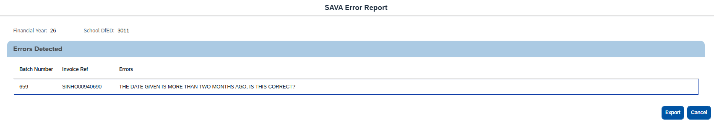
That particular invoice will still go through and be posted to SAP. If you do have any other errors then you have 2 choices:
- Abort the file submission by clicking on the ‘Reset’ button on the bottom right-hand side of your screen. You will then need to go back into FMS to make your corrections and create a new file for submission. To enable a smooth correction process, if there are several errors then export the Error Report first.
- The other option is to continue with the submission. This will enable you to load the ‘good’ invoices and go back into FMS to correct your errors on the other invoices. You will then have to create a new file in FMS.
In this instance we are now ready to submit the file.
Go to the blue ‘Submit’ button at the bottom and click on it. You will then be presented with a ‘Submission Report’ that looks like this on your screen:
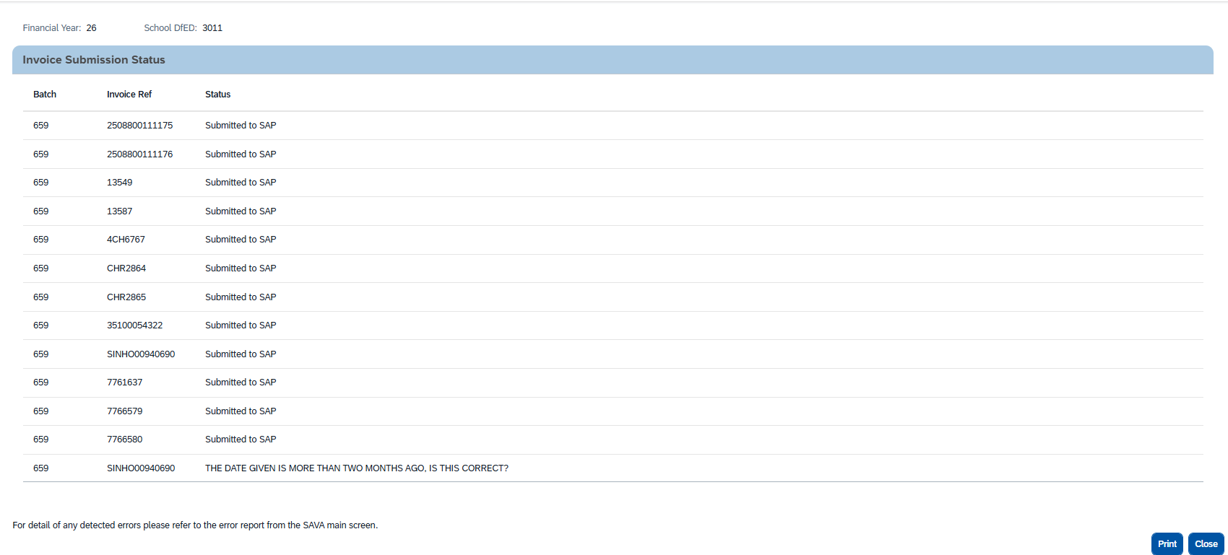
It is this print that will replace your Batch processing report (BPR) and should be kept alongside your PACL and the invoices it refers to. It is vital you print or save it now as you can’t go back and do it later!

This is what your print will look like:
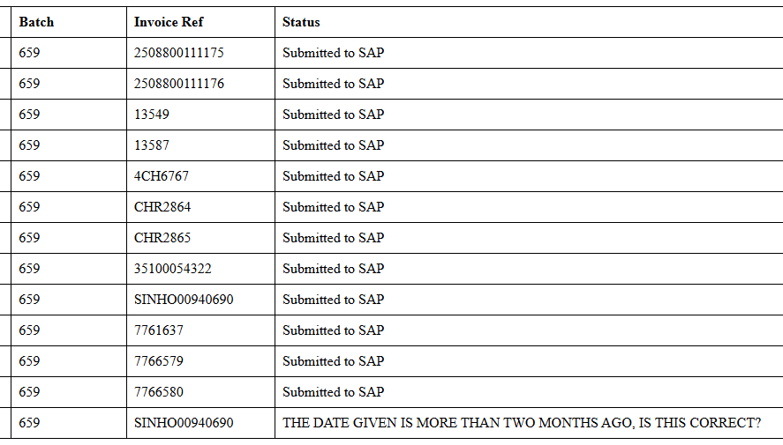
This can then be used when you receive your FMGL01 print from GCC to carry out your monthly reconciliation. There is no option to go back and print it once you exit this stage. Once you have done this you will go back to your main School SIMS App screen. The final thing to do is to click on close to exit the App or click on Reset to continue to load further FMS files. It is best practice to then move the file you have loaded to a separate folder containing uploaded files.
The file you loaded is now sitting on the School SIMS interface at GCC where it will be posted overnight into SAP to pay your vendors.

