
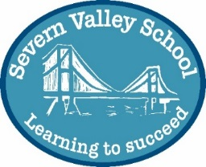

A proposal to make further changes to Alternative Provision in Gloucestershire (Pupil Referral Units): seeking your views
Gloucestershire’s Alternative Provision Development Project was launched in June 2020 and is part of the Joint High Needs Transformation Programme. Linked to this we are seeking to further improve the arrangements that are in place for the children and young people in Gloucestershire who have been, or are at risk of being, excluded from school.
Following the coming together of The Stroud and Cotswold Alternative Provision School (SCAPS) and The Cheltenham and Tewkesbury Alternative Provision School (CTAPS) in January 2022 (which resulted in the closure of CTAPS and the expansion of SCAPS) as a single Pupil Referral Unit called Severn Valley School, there are now two local authority maintained Pupil Referral Units in Gloucestershire who work with children and young people who have been, or are at risk of being, excluded from school.
- The Gloucester and Forest Alternative Provision School (GFAPS)
- Severn Valley School
These Pupil Referral Units operate from a number of sites across the county

The Gloucester and Forest Alternative Provision School (GFAPS):
- Russet House, Russet Close, Gloucester, GL4 0RQ
- The Raikes Centre, Horton Road, Gloucester, GL1 3PX
- Rutherford House, Olympus Park, Quedgeley, Gloucester, GL2 4NF

Severn Valley School:
- St George’s Centre, Alstone Lane, Cheltenham, GL51 8HH
- The Ryeleaze Centre, Ryeleaze Road, Stroud, GL5 1JR
- Belle Vue Centre, Belle Vue Road, Stroud, Gloucestershire, GL5 1JP

In addition to the six formal centres listed above, the Pupil Referral Units work with a range of other education providers to offer outreach and partnership services based on mainstream school sites and other venues.
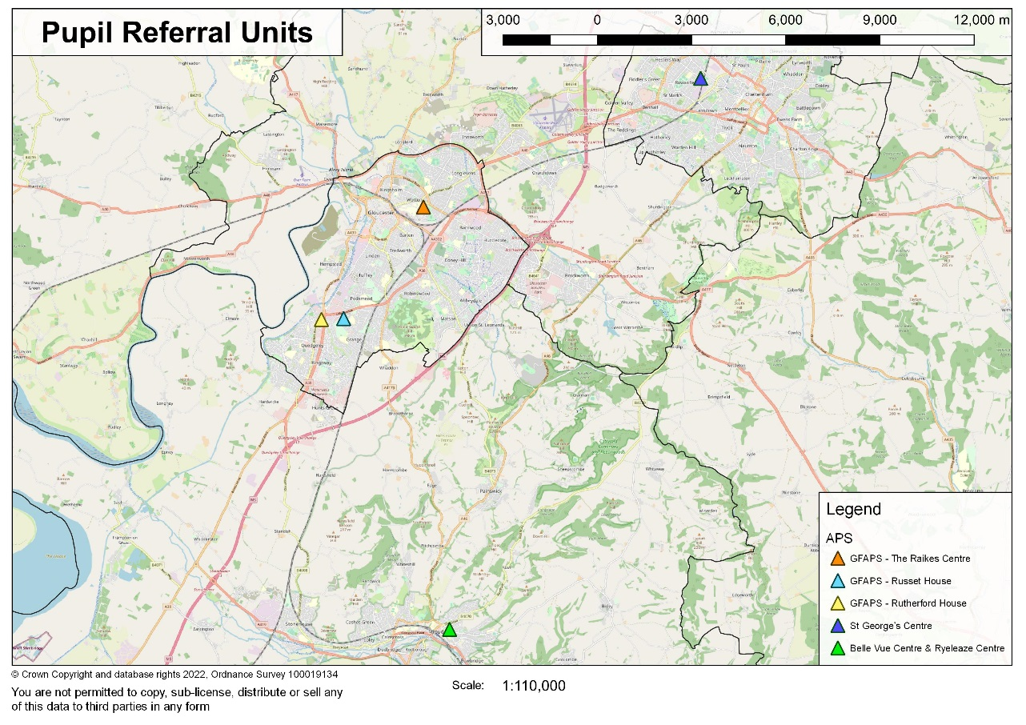
Figure 1 Location of the Pupil Referral Unit centres within Gloucestershire
Gloucestershire County Council has worked in partnership with the Management Committees of these two Pupil Referral Units to develop a joint proposal to bring these two Pupil Referral Units together to form a single institution with effect from September 2023. We believe this will better enable them to continue to provide high quality education for pupils at the right time and in the right way as well as create a greater consistency of offer to Gloucestershire’s schools and the vulnerable children and young people we serve, so that they can achieve the best possible outcomes.

We now invite comments on this proposal from all stakeholders and this opportunity is extended to parents and carers, pupils, staff, all members of the management committees, and other interested parties. This includes the relevant trade unions. Gloucestershire County Council will consider all views put forward during the engagement period before a final decision is made by Gloucestershire County Council’s Cabinet Member for Education, Skills and Bus Transport in 2023.

In addition to comments on the specific proposal to bring the two schools together, we would like to provide stakeholders with an opportunity to contribute more widely, at the earliest stage, towards the process of considering future options for structures, organisation, use of the sites and services offered. This will help inform future work that the management committees will lead around shaping the vision for the school from September 2023. This future work and planning will involve considerable consultation and liaison later in the year and into 2023.
What is the proposal?
To bring The Gloucester and Forest Alternative Provision School (GFAPS) and The Severn Valley School together as a single Pupil Referral Unit governed by a single management committee with effect from September 2023.
Technically, and working together, this requires one of the Pupil Referral Units to cease to be separately registered and the remaining one to expand and offer the pupil places and services provided by the one that has ceased to be registered. This coming together is not the formation of a new school as the remaining PRU retains its existing registration but is expanded to include the accommodation, responsibilities and pupils from the existing centres.
This proposal has the strong support of the management committees of both PRUs who share the council’s aspiration to see this coming together, achieved through due process and proper engagement, with effect from September 2023.
All pupils on the roll of the PRU that ceases to be separately registered will transfer to the roll of the PRU that remains and is enlarged (and where pupils are dual registered with another school this would continue).
As GFAPS and Severn Valley School are Local Authority maintained PRUs it falls to Gloucestershire County Council to administer the statutory processes involved with this proposal and make the final decision. An important part of that process is this early engagement with key stakeholders so that everybody who might be affected has the opportunity to understand what is being considered, to offer an opinion and to provide comment on any alternative ways of approaching this this that could be considered.
However, working with all stakeholders, the management committees will lead the process of shaping the strategic vision, and of identifying any important operational and structural changes for the school. This early engagement activity provides an important opportunity to capture thoughts and views that can feed into the development of these future proposals which will be widely consulted on later in the year and in to 2023.
Background
Severn Valley School was last inspected by Ofsted in October 2019 (under its previous name of The Stroud and Cotswold Alternative Provision School) and The Gloucester and Forest Alternative Provision School (GFAPS) was last inspected in January 2022. Both PRUs have an Ofsted judgement of ‘good’, improving on previous Ofsted judgements of ‘Requires Improvement’.
GFAPS has benefited from stability of leadership and seen a steady improvement in standards over recent years. Severn Valley School has experienced (and successfully managed) a greater level of change in more recent times as a result of expanding in January 2022 when it enlarged following the de-registration of CTAPS. CTAPS had experienced significant changes in leadership and personnel in the preceding years. An interim headship is in place at Severn Valley School from September 2022, following the departure of the substantive Headteacher in August 2022. However, early dialogue between the LA and the Management Committees around this specific proposal pre-dates this and the leadership change, in itself, has not been the catalyst for the development of the proposal to bring these two PRUs together.
It is considered that the coming together of these two strong PRUs will ensure that both settings are well placed to continue to provide the high-quality education which we aspire for this group of vulnerable learners and that, in joining together, a more consistent offer of support can be developed across the county for Gloucestershire’s schools and its pupils.
It will also provide an opportunity to create more flexibility in the way that the provision is structured and delivered. This is particularly important as Alternative Provision schools are required to support children with a broad range of needs, including very complex behavioural needs and social emotional mental health needs, which manifest in anxiety and 'school phobia’. The coming together of the two schools provides us with a unique opportunity to consider how the sites and provision can be best structured to meet these needs.
This full ‘coming together’ is proposed over other possible options that were considered, which included a collaborative agreement between the two PRUs or a federating of the two management committees. Both of these would result in two separately registered schools continuing to be maintained, with two associated Ofsted inspections, and it is considered that the full range of benefits and efficiencies would not be fully realised, and sustained, though a collaborative or federated model alone and without a full ‘coming together’ and the formation of a single institution.
Creating Opportunity for All (March 2018)
Creating Opportunity for All sets out the government’s vision for alternative provision and to provide high quality education for those children and young people educated in this important and valued sector. This vision calls for these types of opportunities to collaborate and work in partnership to be secured where they have the potential to improve outcomes and bring about positive change.
SEND Green Paper (March 2022) Right support, right place, right time
The SEND Green Paper (March 2022) Right support, right place, right time also sets out an ambition for a more dynamic and innovative alternative provision offer across the country for the benefit of our most vulnerable learners. Additionally, bringing the two schools together provides us with an opportunity to make better use of the existing funding to support a more innovative and creative Alternative Provision offer, that can respond better to the needs of the system and provide a much greater emphasis on early intervention, through outreach and partnership working.
What will this mean for the pupils and their families?
In practice, and on a day-to-day basis, the coming together of these two PRUs as a single institution, in itself, may change things very little for the majority of the children and young people who are educated at GFAPS and Severn Valley School and pupils are likely to experience the same continuity of teaching and support staff. The age range will continue to be 5-16 yrs. Class sizes will continue to remain small and the different centres and sites the schools run will remain operational with a strong focus on supporting pupils to transition to their next, longer term, school placement or to return to the school they are registered at. Where pupils are registered at another school, this dual registration arrangement will continue. Leadership at a local level will, prior to September 2023 and following extensive consultation, separately review the remit and function of the different centres and will consider the types of need and age ranges catered for at the different bases. The outcome of these subsequent proposals may result in a more obvious change to the day-to-day arrangements that are in place for pupils.
What will it mean for staff?
The remaining, enlarged, Pupil Referral Unit will continue to be a Local Authority maintained PRU and, whilst that continues to be the case, staff will continue to be employed by Gloucestershire County Council. Whilst the main terms and conditions of employment will not be affected, as part of any consultation with staff regarding the proposals, consideration may be given to the need for staff to be able to be deployed to any of the school sites. New staff will be appointed with the expectation they may have to work at any of the sites. The larger staff base will provide greater opportunities for staff development, progression and collaboration. Leadership at a local level will, prior to September 2023 and following extensive consultation, separately review the staffing structure for the single school. There can only be one Designated Headteacher post.
What will it mean for the management committees?
There will be one management committee rather than the existing two, so fewer committee members will be needed. The committee will need to be reconstituted and the membership determined in accordance with the appropriate statutory regulations and will operate under the same scheme of delegation as is currently the case. Close collaboration between the two existing management committees during 2022 and in to 2023 will shape the vision for the single institution and it is envisaged that a ‘chair designate’ for the single management committee will be identified well before the implementation date of September 2023, although it may not be possibly for this person to officially elected until much nearer the implementation date.
What will it mean for the schools in Gloucestershire who commission places at these PRUs?
Schools in Gloucestershire will continue to be able to enter into the same partnership arrangements as are currently available. Gloucestershire County Council will still commission places at these settings for children and young people who reside in Gloucestershire who have been permanently excluded from school. The Management Committee will seek Headteacher membership from across the county in recognition of this being a PRU that has a remit of county wide support.
Will there need to be a change of name?
The single PRU will operate under the same DfE number of one of the two existing PRUs as a new institution is not being established. It does not automatically follow that there needs to be a change of name. However, in practical terms it may be necessary for the management committee to consider a change of name if retaining a name that has close geographical associations has the potential to lead to confusion and does not adequately describe wide geographical area it serves. It may also be considered desirable to bring about a name change if it helped to mark a positive ‘new chapter’ in the history and evolution of these institutions. This will be a matter for the Management Committee to consider and take forward during 2023, taking in to account the views and opinions of staff, parents and pupils.
Will the schools’ facilities change?
The existing centres will be retained. Rutherford House and the base at Dean Academy have been acquired only relatively recently, and the council has been working with the two PRUs to make improvements to the longer established bases GFAPS and Severn Valley run services from. There continues to be a longer-term aspiration to seek more appropriate accommodation for the services that run from The Raikes Centre and Russet House as well as seeking increased space for the pupils at Belle Vue and Ryeleaze. However, these aspirations pre-date and are separate to this specific proposal to bring the two PRUs together as a single institution. Leadership at a local level will, in due course and following consultation, separately review the remit and function of the different centres and will consider the types of need and age ranges catered for at the different bases.
What are the options for achieving a single institution?
There is a strong preference on the part of the County Council for the two PRUs to come together. This is strongly supported by the Management Committees of both schools.
Technically the coming together of the two PRUs results in one ceasing to be separately registered and the other (retaining its existing DfE registration number) enlarging. However, with sensitive, skilled and careful collaborative planning, the efficiencies, opportunities and the benefits this formalised and sustainable ‘joining of forces’ brings should outweigh any perception of a ‘takeover’ of one of the institutions by the other and enable all stakeholders to be appropriately focussed on the benefits this will bring to the pupils.
There are two options that could be pursued in order to achieve the coming together of the two Pupil Referral Units.
Option A.
The Gloucester and Forest Alternative Provision School ceases to be separately registered and Severn Valley School enlarges.
Option B.
Severn Valley School ceases to be separately registered and The Gloucester and Forest Alternative Provision School enlarges.
We wish to invite comments on these two options as well as provide you with an opportunity to comment and offer an opinion on other options that could be considered. In addition to comments on the specific proposal to bring the two schools together we would like to provide stakeholders with an early opportunity to contribute more widely towards the process of considering future options for structures, organisation, use of the sites and services offered. This will help inform future work that the Management Committees will lead around shaping the vision for the school from September 2023.
Gloucestershire County Council will consider all views put forward during the engagement period and share with the Management Committees the wider comments and ideas that are put forward that in relation to structures, organisation and operating models at this early stage.
What happens next?
This engagement period starts on Wednesday 7 September 2022 and ends on Friday 7 October 2022. This is the opportunity for anyone to give their views to the County Council on the specific proposal to bring the two PRUs together and how this is to be achieved.
Following the engagement period, the Gloucestershire County Council Cabinet Member Education, Skills and Bus Transport will consider the comments received and decide whether to progress to the next stage of the process and publish statutory notices. After that, there is a further statutory representation period to consider any implications before a final decision is made in the spring of 2023.
How do I give you my views?
You can give us your comments by completing the attached questionnaire which can be sent to:

Alternative Provision Proposals
Nathan Roe, Universal Commissioning Team
FREEPOST NAT10062
Shire Hall
Gloucester, GL1 2BR

You can also give us your comments through the dedicated e-mail address:
alternativeprovisionproposals@gloucestershire.gov.uk

or by contacting: Nathan Roe, Education Planning Manager (GCC):
01452 427262 or Nathan.Roe@gloucestershire.gov.uk

The questionnaire is also available online at:
https://haveyoursaygloucestershire.uk.engagementhq.com/a-proposal-to-make-further-changes-to-alternative-provision-in-gloucestershire with the facility to submit your responses via a web form.

Your views and comments must reach us by 12.00 noon on Friday 7 October 2022 to be considered. Parents and staff are also invited to raise any questions with the Headteacher and/or the following members of the management committees.

- Michelle Stone, Interim Headteacher, Severn Valley School – 01453 767293 / 01242 581519
- Dave Alexander or Colin Belford, Management Committee members, Severn Valley School - 01453 767293/ 01242 581519
- Lyn Dance, Management Committee Chair, GFAPS – 01452 782050

The e-mail address alternativeprovisionproposals@gloucestershire.gov.uk can also be used to reached any of those listed above.

Please complete this response form and return by 12.00 noon on 7 October 2022

The proposal we are seeking your views on is: To bring The Gloucester and Forest Alternative Provision School (GFAPS) and Severn Valley School together as a single Pupil Referral Unit operated by a single management committee with effect from Sept 2023.
Q1. About you: are you a …. (please tick all that apply)
Parent/carer of a child at GFAPS
Parent/carer of a child at Severn Valley School
A member of staff at one of the Pupil Referral Units above
A member of the management committee of one of the Pupil Referral Units above
An elected representative
A head teacher of a Gloucestershire School
Trade union representative
Other (please specify)

Q2. Do you agree that the two Pupil Referral Units should come together as one?
Strongly  agree | Agree | Neither agree  Or disagree | Disagree | Strongly disagree

Q3 Please give your main reasons for your answer to Q2 above and any other comments.

Q4 Do you have a preference for Option A set out in the document you have read?
Strongly agree | Agree | Neither agree or disagree | Disagree | Strongly disagree

Q5 Please give your main reasons for your answer to Q4 above and any other comments.

Q6 Do you have a preference for Option B set out in the document you have read?
Strongly agree | Agree | Neither agree or disagree | Disagree | Strongly disagree
Q7 Please give your main reasons for your answer to Q6 above and any other comments.

We would like to invite you make any comments that can be shared with the Management Committees ahead of them embarking on work to shape the vision of the single PRU. These could include, but are not limited to, how the services might be configured, the staffing structure and the use of the different sites.

Equality questionnaire: some information about you

The following questions are to ensure we take the views and needs of differing people into consideration and to understand your responses to the previous questions a little better. It is a legal requirement for us to ask these questions, but you are not obliged to answer any you do not wish to. The data acquired is used for this consultation only and cannot be used to identify you (unless you choose to put your contact details on the form).

Q1 – What gender do you identify as?
Male Female Another gender – please identify: …………………………………………
Prefer not to say

Q2 – Is the gender you identity with the same as your sex registered at birth?
Yes No Prefer not to say

Q3 – How old are you?
16-17 18-24 25-34 35-44 45-54 55-64
65-74 75 or older Prefer not to say

Q4 - Which race or ethnicity best describes you?
Arabic
Asian/British Asian: Bangladeshi
Asian/British Asian: Chinese
Asian/British Asian: Indian
Asian/British Asian: Pakistani
Asian/British Asian: Other
Black/British Black: African
Black/British Black: Caribbean
Mixed Race: Black & White
Mixed race: Asian & White
Mixed Race: Black & Asian
Mixed Race: Other
Traveller: Gypsy or Roma
Traveller: Irish
White: British
White: Irish
White: European
Another race or ethnicity – please identify: …………………………………………
Prefer not to say

Q5 – Do you have a disability, long-term illness, or health condition?
Yes No Prefer not to say

Q6 - Which of the following terms best describes your sexual orientation?
Asexual Bisexual Gay man Gay woman or lesbian
Heterosexual or straight Other – please identify: …… Prefer not to say

Q7 - What do you consider your religion to be?
Buddhist Christian Hindu Jewish Muslim Sikh
No religion Other religion – please identify:……….… Prefer not to say

Further information can be found in our privacy notice, available at https://www.gloucestershire.gov.uk/council-and-democracy/data-protection/service-specific-privacy-notices/.

Would you like to be kept informed about this consultation and/or be invited for further opportunities to have your say and be involved? If yes, please provide your contact details below.

Yes, I would like to be kept informed Yes, I would like to be further involved

I give permission for Gloucestershire County Council to contact me in relation to my above preferences (please tick all that apply):
By email
By post
By phone

Name
Address 1
Address 2
City/Town
Post Code
Email Address
Phone Number

