Gloucestershire Intervention Decay Model (IDM)
Programme or project being assessed:
Date completed:
Contact person:

IDM Stages | Issues to consider | Response
Stage 1:  Agree pathway or intervention for review. | Think about a specific pathway (a journey through a service) to focus on for IDM. Be focused.  - Consult with others to make this initial decision. You might be choosing a priority pathway, a pathway that is due to experience some change/re-design or you could base your choice on local intelligence (or a combination of all!).  Agree an initial working group with stakeholder representation across the pathway: service delivery (primary and secondary care if appropriate), community partners, commissioning, service re-design/development, data/business intelligence.  - It is important that everyone is signed up to the purpose of the IDM model and understands why the pathway is being reviewed from this perspective.
Stage 2:  Undertake baseline data collection and analysis at each ‘stage’ of pathway. | Engage data/business intelligence to provide a data pack for your chosen pathway area, looking at each component of the IDM model A-D (see Figure 1) and the characteristics of the service users.  Data could be broken down by:  - Rural/urban  - Age Groups  - Gender  - Disability  - Deprivation  - Ethnicity Groups  - Remember the purpose of the data pack is to understand where ‘losses’ occur across the pathway, and the characteristics of those most likely to be lost OR have suboptimal outcomes.  - Remember that this data pack will draw on prevalence, service, AND outcome data, as it is all of these data sources that will provide a full picture of pathway losses and opportunities for intervention.  - Remember that you will need to discuss the criteria for each component as you go along and come to a consensus as a group.
Stage 3:  Work with service leads and place-based partners to consider the factors at play at each stage. | Go through the data pack with your working group, and review for A-D (see Figure 1).  - Discuss what the data shows at each stage for different population groups  - Are there any reasons to explain why that might be? Does the information presented surprise anyone?  - Discuss how you might dig into what the data is showing more e.g., surveys, interviews, focus groups, workshops. How do you delve into the data?  Think about collaboration opportunities using the spheres of influence (see Figure 2) i.e., who might be some of the key stakeholders involved in the stages you are investigating further?  - Do you need to identify anyone different to work with at this point?  - Are there different points of view relating to ‘losses’ depending on where stakeholders work/can influence?  - You may want to think about process mapping at this stage to help systematically identify the potential causes of ‘decay’ at each stage.  - Make sure you consider operational AND social/wider determinants of health factors when you consider this decay.
Stage 4:  Agree collaborative action to address the factors identified – consider where you can have greatest or most rapid impact | Decide what areas you are going to focus on and address in your working group.  - Consider the issues that you have found – are there any where you think you could have greatest or most rapid impact? Is there a priority order?  - Agree who will take the work forward – is there anyone else who needs to be engaged at this point?  Agree how to take this work programme forward  - Consider running a workshop to generate ideas for next steps.  - Make sure you decide what your objectives are – what does good look like?  - Decide how long it will take you to develop, implement and then test whether the change has had the desired outcome (you may want to employ some ‘Plan, Do, Study, Act’ techniques here).  - Agree how to report back to the working group on progress/get advice about unblocking any issues.
Stage 5:
Repeat step 2 to review impact for ‘whole’ target population and subgroups.

Figure 1

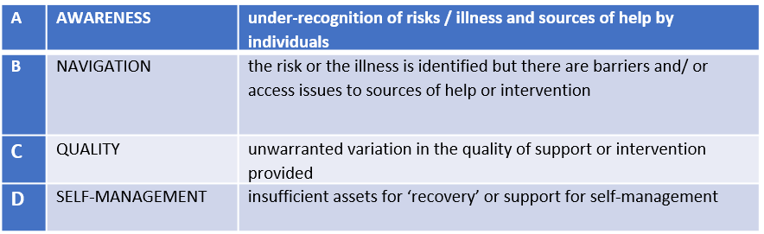

Figure 2
 | Lead Service |  |  | Place-based partners

