Promoting Good Health and Well-Being in Early Years
As practitioners we want the children in our care to develop good health and well-being as part of their development. To encourage this we have to explain how they can achieve this. Good health care practice should happen naturally each day.
Exercise
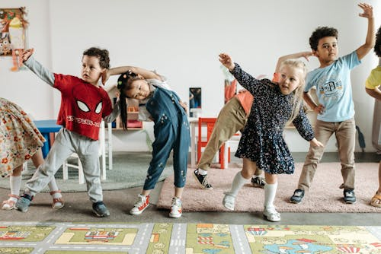
Physical activity is vital in children’s all-round development, enabling them to pursue happy, healthy and active lives.
Young children need opportunities both indoors and outdoors starting with babies exploring their environment through sensory play.
Gross motor skills provide the foundation for developing healthy bodies and social and emotional well-being.
Ideas for babies - Tummy time to strength their core and arms.
Ideas for toddlers - Opportunities to trial and error with a variety of activities, e.g. climbing, balancing, running, hopping and fun games to be physical.
Ideas for preschool - Games that encourage them to run around, use big movements, and small to complete fine motor activities. Preschoolers to learn about risk while being physical, especially outside when climbing and building.
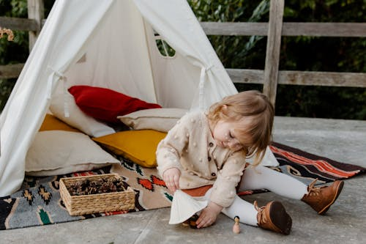
Quiet time
All children need time to take time out to rest and relax.
Ideas for babies - The use of soft music to encourage the mind and body to rest.
Ideas for toddlers - Comfy cushions, mats and familiar toys.
Ideas for preschool - Time to look at a book, listen to stories on a devise, or listen to music while resting.
Emotional well being
Each child, no matter what age needs to feel secure, loved, accepted and a sense of belonging.
Ideas to support - Share information with parents/carers about attachment, and the importance of this. Be aware of how to Adverse Childhood Experiences (ACEs) so you can recognise.

Food and snacks
All providers must offer meals, snacks and drinks that are healthy, balanced and nutritious. Before a child is admitted to the setting the provider must obtain information about any special dietary requirements, preferences, and food allergies. Fresh drinking water must always be available and accessible to children.
Dietary requirements and allergies
Providers must record and act on information from parents and carers about a child’s dietary needs.
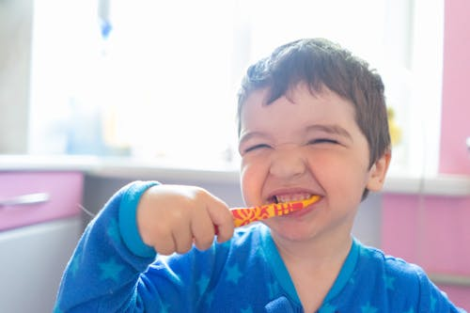
Teeth
The government have pushed good oral health in young children in recent years to avoid problems with tooth decay in later life.
A practical guide to children's teeth

