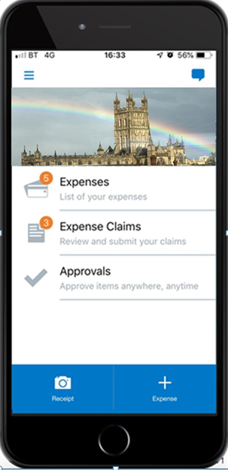
What is SAP Concur?

SAP Concur is an intuitive cloud-based system that is replacing Employee Self Service in SAP, or paper claims for claiming Mileage and Travel expenses.
It is available to use as an app on smart devices and on any PC through its website.
Those of you who claim for business mileage in your personal car will have the option to use ‘Drive’ which helps you automatically keep track of your mileage throughout your working day.

How does SAP Concur benefit Councillors?
You can use any device and can compile and submit your claims remotely at any time of day without the need to visit the office.
The claims process is much simpler with Concur, and you can build claims as you go throughout the month. Experience has shown us that once you are familiar with Concur you should find it much quicker to submit your claims than before.
There are policy reminders built in that help reduce common mistakes that might otherwise delay claims being processed.
The Drive feature can automatically and accurately capture journeys regardless as to how remote you may travel or the route you may have to take.
You can easily upload pictures of receipts which means you don’t need to hold on to the paper receipts for 6 years.

How does SAP Concur benefit the County Council and Fire Service?
Automating the entire travel and expense process from both a web and mobile standpoint for GCC is an important step in meeting our corporate objectives and will provide data which will inform future council strategy about business travel and carbon reduction initiatives.
Being a Cloud based solution it has a much lower IT overhead.
Less time on admin allows colleagues to focus more on the critical services we provide.
Implementing Concur will also result in significant savings to the council through improved accuracy and security around travel and expense claims, including:
- VAT reclaims for business mileage which is a significant sum towards Council budgets
- Improved accuracy of mileage reimbursement
- Accurate use of HMRC rules around travel

What happens next?
SAP Concur has already been rolled out across the County Council and Fire service with just a handful of individuals left to adopt Concur for their claims. The systems that support the old claims mechanisms are being phased out towards the start of 2024.
There are two online briefing sessions with Q&A available for Councillors to find out more about Concur on the 5th July at 10:00 or 16:00. There will also be the option to stay on for more detailed instruction for those keen to start using Concur straight away and we would encourage you to do so.
Further online training sessions will be available on these dates:- 10th, 17th and 24th July
We would encourage members to take advantage of the support available and start using Concur as soon as possible to become familiar with submitting claims via Concur regularly before the end of 2023.

