The Learning Environment: The Physical Environment
Defined spaces
A well-planned learning environment, indoors and outside, is an important aspect of every early years provision. Defined spaces, or ‘zoning’ could be used to maximise learning opportunities and ensure the safety of all children.
Why are defined spaces important?
- Gives each area a clear purpose.
- Encourages children to focus, with minimal distractions from other areas of the room.
- Helps children feel more settled, they will quickly decide if they want to stay and play in a space!
Things to consider
Creating defined spaces - Use a variety of dividers to define your learning ‘zones’. You could use rugs to section floor space, which are easy to clean and can be used flexibly when changing your room layout. Carefully positioned furniture such as shelving, and storage units can be used to divide larger spaces. Transparent fabrics could also be used to create ‘soft’ barriers between spaces. Don’t forget to use the centre of your room, not just around the edges to maximise space usage!
Positioning of zones - Think about where in your space areas of learning would be best suited. For example, the book area may be best suited in a quiet area of the room to allow for conversation. Children’s sleeping areas should be positioned away from spaces where toddlers may be engaging in physical play. Consider how easily children can move and transport resources between zones to ensure their play is fluid.
Which zones may work well, or not so well next to each other? -
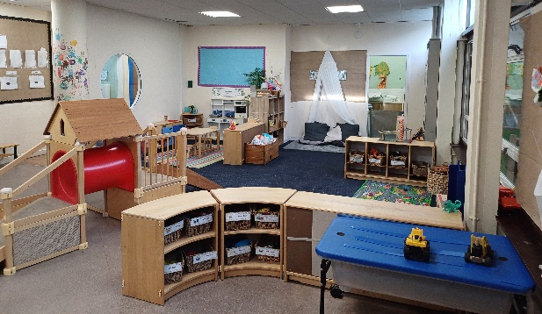
Areas that may work well alongside each other- Role play and Construction can work well together, as children may role play going to work. Role play can also work well next to your mark-making space, as someone may have a genuine reason to write, e.g. a shopping list. Construction may work well alongside small world play as children may create role play scenarios using their creations!
Areas that may not work well together – The busy construction area may be too distracting and noisy next to your calm, quiet space. The Water play may be too risky next to your precious books!
Group times - Do you have plenty of space for larger groups to sit comfortably alongside adults for group times? Are these spaces located near power points if interactive whiteboards/sound systems are being used?
Mealtimes – Consider having a pre-agreed space/s for mealtimes. If you have rolling snack, ensure you have an area dedicated to this so children know where to find it.
Don’t provide too much furniture - Research tells us children associate play with being on the floor, rather than sitting at tables. Do not include more tables and chairs than practically needed. When using tables, consider round tables, they can fit easily into small spaces and have more versatility than rectangular shaped ones.
Provide an empty space - Think about including a space that could be for anything! You could ask the children ‘What is this space going to be today?’.
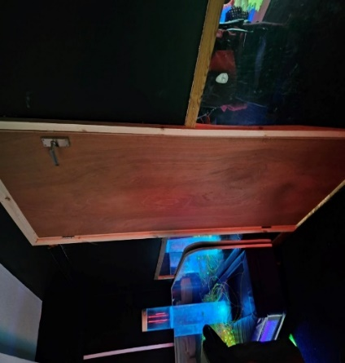
Create a ‘Workshop’ - Could you create a workshop space to host your messy play, water play, junk modelling and scientific explorations! You could ensure the flooring in this space is hard-wearing and easy to clean! This allows all the above activities to take place in close proximity and offer an overlap of learning opportunities.
Don’t waste your ‘snug’ spaces - Transform your old storage cupboard into a cosy, sensory space. Or utilise tricky corridor spaces for overflow resource storage, or child-level wall displays.
What next?
Time to reflect
- Ensure to regularly reflect on the environment, assess what works well, and any ways to improve it.
- Consider the unique needs of your current cohort when making any reflections.
- Look around your setting (at child height) and see if there are identifiable zones.
Time to plan
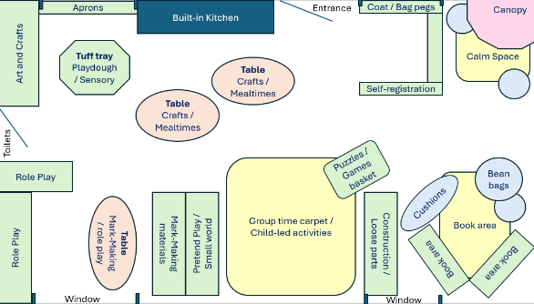
- Use a large piece of paper to draw a plan of the room.
- Add in permanent fixtures, such as windows, doors and radiators.
- Discuss how many and what play spaces you should have in your room.
- Use scaled photographs or shape cutouts of coloured paper to represent your furniture and resources.
- Move these around on your plan to test out your ideas in a visual way!
- Look at the areas you’ve placed alongside each other and think about how they will work together.
- Look at the traffic flow between play spaces making sure children can move freely from one activity to another.
- Involve all the team! It is important to review your space together as a team so all staff can build an understanding of how your environment supports children’s learning.
Top tips for inclusion
- Including children in the planning process promotes a sense of belonging and ownership of their learning environment.
- When deciding on your layout, think about the needs of your cohort of children. Do you need to offer additional ‘corridors’ of space around your zones and activities for children with physical disabilities to be able to move around safely?

Helpful links and resources
OAP resource: adequate-quantity-of-play-resources-and-space-to-play
OAP resource: learning-areas-resources-are-positioned-appropriately

