The Learning Environment: The Social and Emotional Environment
Places to talk
Creating spaces where children can explore and talk freely without pressure of adult intervention can encourage and promote speaking and listening skills, emotional well-being and engagement. It is important that children feel safe and secure to be able to share their thoughts.
Things to consider
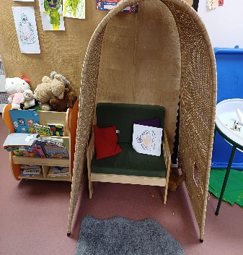
Create small, cosy areas both indoors and outdoors – Quiet spaces can give children opportunity to think and talk together. You could create a space by securely draping material to create ‘dens’ or by using canopies, arches, or pop-up tents to provide spaces where children can sit ‘inside’ together
Role play areas – offer space for children to use their imaginations and discuss ideas together, creating role play areas with undefined resources can increase the creativity of the children’s play. Keep the areas relevant to what the children know and have experienced.
Educators communication - commentating on and expanding on children’s play will encourage them to talk. Use open-ended questions.
Props and puppets – offering resources relating to books and rhymes can encourage children to act out events from these and practise using words and phrases they have heard.
Floor books and displays – create a book of the cohort’s learning journey or displays at child height. Include photographs of activities and experiences the children have engaged with to allow opportunity for children to recall their memories together using the book as a prompt.
Group times – offer planned talking activities during group times
Time – give the children time to respond – allow 10 seconds for processing, time with their peers and time for activities they are involved in.
Visual distraction – young children can be easily distracted which makes it difficult for them to keep their attention or use their listening skills effectively. Lots of visual distraction can impact on their communication skills. Displays should be minimalistic with plain or neutral-coloured backgrounds as this allows the children to focus on the work that is displayed. Hanging things from the ceiling should only be done in specific areas and there should be areas free from clutter.
Minimal background noise - young children are still developing their attention and listening skills and so they find it hard to filter out background noise and tune into listening. If you are offering background noise, such as the radio or songs on Alexa, consider the appropriate use of these. Environments where sound travels or creates an echo can be disrupting to a child’s communication. Creating spaces where sound can be absorbed, or children can access some quiet time is vital in supporting their communication development.
Creating opportunities – offer areas of open space to encourage children to extend their play whilst working together and using their problem-solving skills. This type of play encourages good communication and language building skills.
Helpful links and resources
ECAT
Elizabeth Jarman
Creating a communication supportive environment: Early years - Speech and Language UK: Changing young lives
Top tips for inclusion
- Offering a Total Commuincation environment

Partnership with Parents
- Do you provide a safe and confident space to talk with parents

