


Project Bulletin - Whitminster Canal Bridge
As the project progresses the past weeks have seen both the installation of ducting and drainage to roundabout.
We have also completed the installation work to the North Bridge and are now preparing for further installation work capping beam.
Topsoil has been stripped on the south side of the site ready for the installation of the diverted Severn Trent Water main.
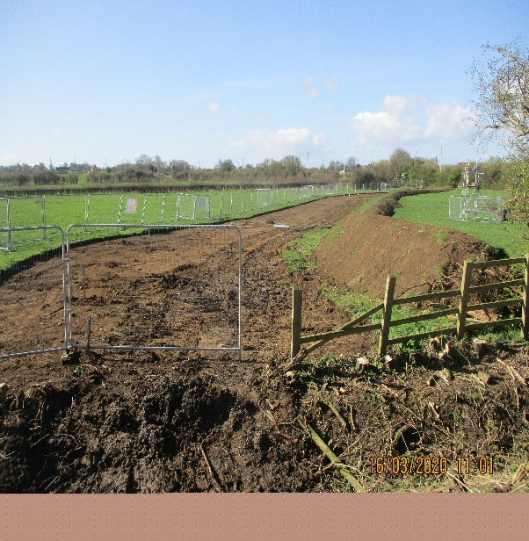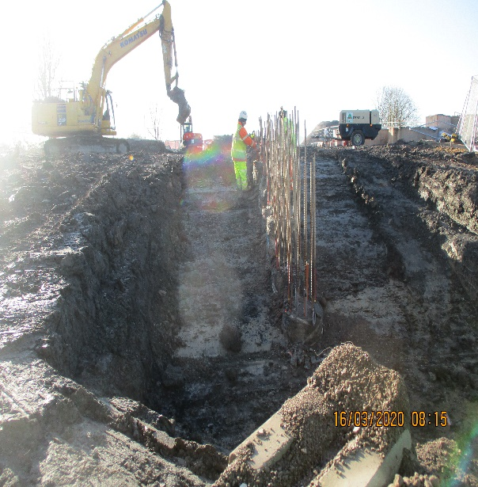
As we progress with these important improvements, your continued patience is greatly appreciated.
If you have any concerns or issues regarding the road improvement scheme, please contact me on 0300 041 4635*. I will be available throughout the construction phase to provide continuous engagement with businesses and residents within the local area.
Further information about the scheme can be found at
https://www.gloucestershire.gov.uk/highways/major-projects-list/a38-canal-bridges/

Neil Evans
Contract Liaison Officer
Alun Griffiths (Contractors) Ltd
0330 041 4635*

*Calls to this number are charged at national call rates and included in inclusive minute plans from landlines and mobiles

