Disability, Neurodivergence and Mental Health in Gloucestershire
Autumn 2026 - Issue 12
Incorporating news and updates from Gloucestershire’s Partnership Boards & Partners

Cover image: autumn landscape.
About this accessible version: The newsletter has been linearised for screen-reader use, with a clear heading structure, live links and meaningful alternative text for retained images. Repeated decorative logos, section banners and page furniture have been omitted. Image-based flyers are also transcribed as text so their information is available without seeing the image.
Welcome to the Autumn 2026 edition of Disability, Neurodivergence and Mental Health in Gloucestershire.
There is a lot to explore in this issue, with contributions from across Gloucestershire’s Partnership Boards, community organisations and people with lived experience. A theme running through many of the articles is the move from simply hearing people’s experiences to using those experiences to shape services and make practical changes.
There are updates on co-production within Adult Social Care, the One Plan for children and young people, and work across the Mental Health, Neurodivergence, Learning Disability and Physical Disability and Sensory Impairment Partnership Boards. We also look at important national developments affecting disabled and neurodivergent people.
The neurodivergence section is particularly substantial this time, with an extended article on AuDHD, young people’s lived experience in Gloucestershire, and the overlap between neurodivergence and mental health.
A particular thank you to Katie Peacock and Zaphira Cormack. Katie contributed both her reflections on Gloucestershire’s co-production work at the Community Hospital Conference and a practical article on how voice-controlled technology can support independence. Zaphira gave us her thought-provoking article on sensory needs in adulthood, challenging the assumption that sensory support somehow becomes less important once people reach adulthood.
Elsewhere you will find people’s experiences of Occupational Therapy, employment stories, information for unpaid carers, training and events, accessible transport developments, resources and more from around the county.
Thank you, as always, to everyone who has contributed, shared their experiences or helped shape this edition.

Accessible contents
News for all
- Patient Centred Co-production
- Adult Social Care Co-production
- Navigating Social Care
- Children and Young People News - The One Plan
- In the News - June to August
- Voice controlled assistants
- Big Survey 2026
- Healthwatch surveys
- Training dates
Neurodivergent news
- Partnership Board update
- Employment
- Sport Neuroinclusivity resources
- What about: AuDHD
- Selected resources
- ND Hub Creative Strategy Sessions
- Young People’s News
- Sensory Observations
- Improving Inclusivity
- In the National News - June to August
- Dates for your diary
Learning Disability News
- Partnership Board update
Mental Health & Wellbeing News
- Partnership Board update and Mental Health Forums
Physical Disability & Sensory Impairment News
- Partnership Board update: Occupational Therapy
- Neurology Subgroup update
(Unpaid) Carers News
- Peer Navigator Support
- About the Carers Hub

News for all

Patient Centred Co-production
Original newsletter page 2

Championing the Proactive, Positive and Patient-Centred Co-productive Work of the Gloucestershire Partnership Boards. Community Hospital Conference 2026 by Katie Peacock The Conference
The Conference took place in Swindon back in May. A number of esteemed speakers, including Professor Sir Chris Whitty and many other professionals from the world of health, spoke very passionately about the importance of Community Hospitals.
There were a vast number of training sessions that explored how Community Hospitals support person-centred care, strengthen neighbourhood teams and play an important part in delivering the aims set out in the NHS 10 Year Plan. They also highlighted the value of partnership working, local leadership and the practical innovations that help services meet the needs of their communities.
Myself and Jan (Marriott) were asked to speak/facilitate a training session around co-production in Gloucestershire, showcasing the positive work of the Partnership Boards, of which you all play a major part. Thank you. Without you, co-production can’t happen.
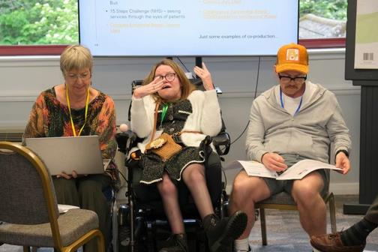
Community Hospital Conference co-production session.
Original newsletter page 3

What are the Community Hospitals
Community Hospitals are small local hospitals that provide a range of services to their local community. These can include community beds, maternity, clinics, minor injuries units, X-ray departments and much more.
Community Hospitals have been part of our healthcare system for over 150 years and offer a strong tradition of care that local populations have known over generations. There are over 500 Community Hospitals throughout the UK.
Originally established as converted cottages offering inpatient beds, they have developed into hubs of services that have evolved to meet changing needs. These services range from health promotion, diagnostics, treatments, rehabilitation and end-of-life care. The Community Hospital plays a particular role in intermediate care and is a focus for integration for many staff and services in both health and social care.
Community Hospitals vary considerably, as they have adapted to the needs of their local populations. They are typically highly valued by local people, and this support is shown through actions such as volunteering, fundraising, promoting and campaigning.
Gloucestershire has Community Hospitals in Cirencester, the Forest of Dean, North Cotswolds, Tewkesbury, Stroud and the Vale.Tetbury Hospital - it is a charity set up when it was threatened with closure and provides a range of community hospitals.

Some of what we highlighted:
The influential work of the Neurology Group, co-producing with those with Myalgic Encephalomyelitis/Chronic Fatigue Syndrome to improve patient experience in line with NICE guidelines.
The development of the Co-production Charter, which is going to influence the work of Adult Social Care moving forward.
Co-production alongside colleagues from Inclusion Gloucestershire to produce and deliver the Oliver McGowan training.
The development of a citizen-led panel to help decide the fate of a local community provision, and the list goes on…
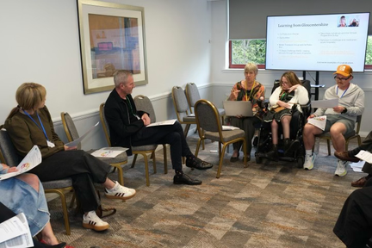
Conference workshop discussion.
Original newsletter page 4
We asked participants to place themselves and their organisations where they thought they were starting from with this rainbow.
I am very proud to be able to go further afield and share the excellent work we are all doing, trailblazing for a brighter and more inclusive future for everybody in this county.
For me, the most resounding takeaway from presenting at the conference is that we are beginning to make real strides towards our ambitions of embedding co-production in all of our structures and ways of working.
Together we are stronger, putting those who use services at the heart of creating, adapting, championing and changing them, to shape the best possible environment for individuals and organisations to thrive.
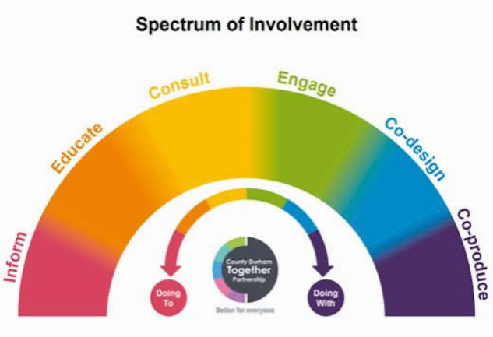
Spectrum of Involvement diagram.
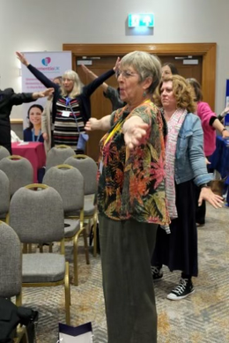
Activity Session

Adult Social Care Co-production
Original newsletter page 5

What We Heard at the Co-Production Roadshows Amy Rees – Co-Production Lead Adult Social Care
Over the summer, more than 300 colleagues, partners, carers and people with lived experience joined us at a series of Co-Production Roadshows across Gloucestershire and online. Together, we explored how we can continue to work alongside people and communities to improve Adult Social Care.
The Roadshows brought together people with a wide range of experiences, including many already involved through Partnership Boards, community groups and improvement projects. This was important because co-production does not happen in a single event. It happens every day through conversations, relationships and shared decision making. Partnership Boards are a key part of that picture, bringing together people with lived experience, carers, community organisations, providers and public services to influence the issues that matter most to Gloucestershire communities
Katie Peacock (Partnership Board Co-Chair)
The conversations focused on several areas where we are currently working in co-production. People shared their views on our Listening to People project and how we gather and respond to feedback, what matters most as plans develop for the new care home in the Forest of Dean, and the values and experiences that should sit at the heart of our Adult Social Care Practice Framework. We also shared our ambitions for co-production moving forward and invited people to consider their own commitment to working alongside people with lived experience, using the Co-Production Charter as a starting point for those conversations.
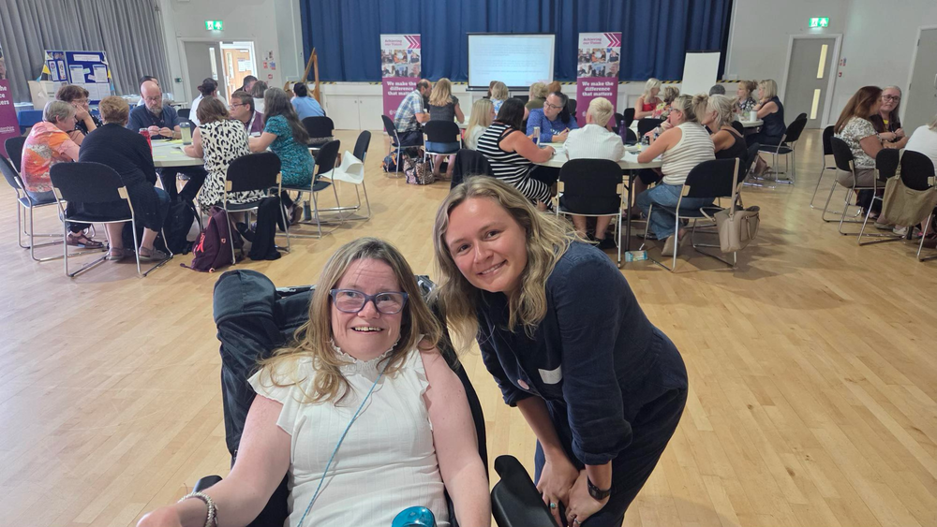
Katie and Amy At the Roadshow
Original newsletter page 6
Across the five events, people shared almost 700 comments and pieces of feedback about what Adult Social Care is doing well and where we still need to improve.
This insight is already helping to shape improvement work across the directorate.
Sarah Scott - Executive Director of Adult
Emily White – Director of Quality, Performance,
Social Care, Wellbeing and Communities
and Strategy (GCC Adult Social Care)
A particular thank you goes to Andrew Cotterill, Chair of the Autism and Neurodivergence Partnership Board, and Katie Peacock, Co-Chair of the Physical Disability and Sensory Impairment Partnership Board, who helped to co-chair sessions during the Roadshows.
Thank you also to Jo from Gloucestershire Health and Care NHS Foundation Trust, who shared her experience as a Lived Experience Practitioner helping to shape the development of Gloucestershire's Complex Emotional Needs Service. Their contributions, alongside those of many other Partnership Board members and Experts by Experience, helped ensure lived experience remained at the heart of the conversations.
Thank you to everyone who attended, shared their experiences and challenged us to think differently. Whether you contribute through a Partnership Board, a project group, a community organisation or in another way, your insight helps shape how we learn, improve and move forward together.
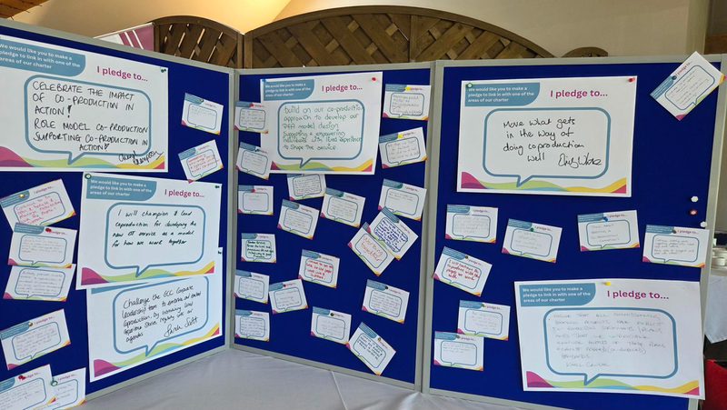
Roadshow feedback and pledges.
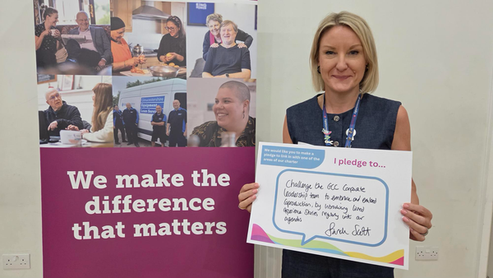
Sarah Scott Co-production Pledge
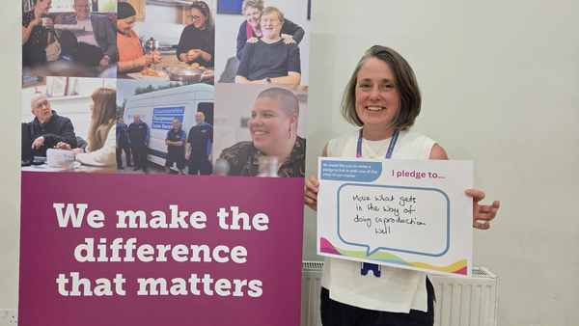
Emily White Co-production Pledge

Navigating Social Care
Original newsletter page 7

from Dave Evans Peer Navigator and Sharon Sharman from Access Social Care Making SocialCare Easier to Understand and Navigate
The Care Act, which lays out what people can expect to receive through adult social care, can be confusing and difficult to understand if you don’t have a social care or legal background. This means that, many people who have or develop social care needs, are often unaware of what support they can ask for, what they are entitled to and how to go about asking for it. The charity, Access Social Care, has worked hard on making this difficult path easier to navigate:
For organisations:
Access Social Care has a team of legal advisors to support with extreme and complex cases, which organisations can use for reference and direct help through membership agreements

For Professionals, groups and individuals:
Access Social Care has developed an award-winning online legal chat bot (AccessAva) to support people to identify, understand and achieve their rights (and the rights of the people they care for), in relation to adult social care services. The tech team ensure that all resources and information – including legal language template letters-are up-to-date and accurate. AccessAva is available online 24/7 and is completely free to use: AccessAva support

For Unpaid Carers of Adults
Access Social Care recognises that, for some people, it can be difficult to use online tools and / or they may not be able to access the internet. Over recent years, the charity has gathered information and data relating to people who care for others who have / develop social care needs. They recognise the challenges of daily life experienced by unpaid carers who look after family, friends or neighbours, and acknowledge the impact on the carers’ lives and wellbeing. They have found that many people don’t actually recognise themselves as being a carer and, if they do, often are not aware of their rights.
To support carers to access social care support for themselves and / or the people they care for, the charity provides a FREE service for carers through their Peer Navigation Project. See in the Carers section for details
All Peer Navigators have lived experience of accessing social care support and / or navigating the social care system either for themselves or for people they care for. They are highly trained in the Care Act, Carers Rights and in using AccessAva to empower carers in their own local communities and remotely online. The Peer Navigators connect with carers, support them to communicate with and understand adult social care entitlements and remain in contact with carers until their entitlements have been achieved. The Peer Navigators do not provide legal advice; their main focus is to support carers to use AccessAva for information, resources and template letters for people to submit to their local authorities.
In Gloucestershire there are Peer Navigators working locally and remotely online who can offer help and support to unpaid carers.
If you would like further information or to make a referral for somebody needing such help, then please contact enquiries@accesscharity.org.uk or the Peer Navigator Coordinator, Sharon Sharman sharon.sharman@accesscharity.org.uk

Children and Young People News - The One Plan
Original newsletter page 8

Delivering the One Plan for All Children and Young People in Gloucestershire

A great place to grow up where children and young people thrive and live lives of choice and opportunity
Gloucestershire’s One Plan for All Children and Young People was launched in November 2024, setting out a shared vision for how partners across the county will work together to improve outcomes for children, young people, and families. The plan is built on four guiding principles: Equity, Access, Inclusion, and Quality.
💬 Listening, Learning, and Acting
The One Plan was shaped through extensive engagement with partners, families, and young people. Their voices helped identify priorities that will guide action through to 2030, ensuring that every child and family can access the right support at the right time.
🎯 Our Shared Priorities
The strategy groups its ambitions into three key areas:
Age‑specific priorities – helping children to start well, grow well, and be well. Joint priorities – shared goals that cut across all age groups. Family priorities – supporting families to live well, even beyond the direct reach of children’s services.
🏛️ The Role of Locality Steering Groups
Locality Steering Groups are at the heart of delivering the One Plan in every community. They bring together local leaders, practitioners, and partners to:
Coordinate delivery of the plan’s priorities within each district. Share data, insights, and best practice to identify what works locally. Ensure that services are joined‑up, inclusive, and responsive to local needs. Champion the voices of children, young people, and families in shaping local action.
Each group acts as a bridge between county‑wide strategy and local delivery, ensuring that the One Plan’s vision is realised in every part of Gloucestershire.
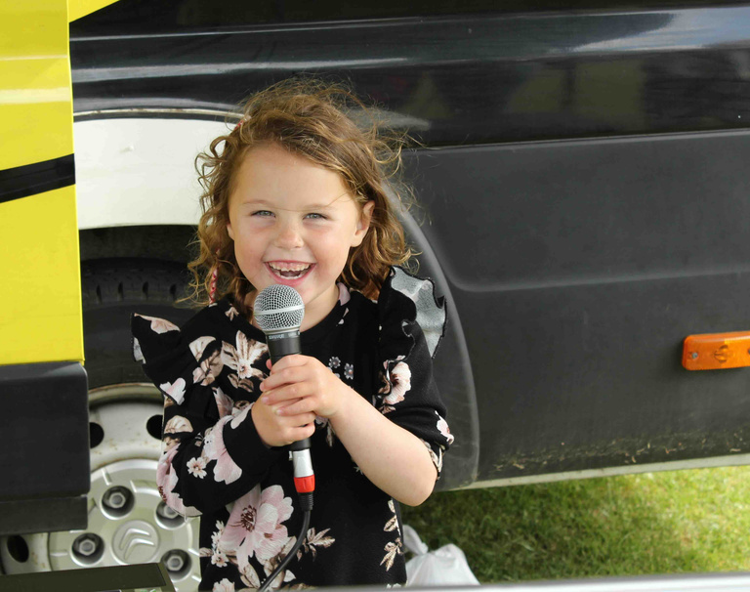
Child with Microphone
Original newsletter page 9
🌱 Starting Well, Growing Well, and Being Well
The One Plan’s delivery is guided by three interconnected stages of development:
1.Starting Well – giving every child the best start in life through early support, nurturing environments, and
strong foundations for learning and health.
2.Growing Well – supporting children and young people as they develop independence, confidence, and
skills for their future.
3.Being Well – promoting wellbeing, resilience, and inclusion so that every young person can thrive and
contribute to their community.
Together, these stages ensure that the plan supports children and families at every step of their journey.
🤝 Working Across the System Partners in education, health, social care, and community services are aligning their efforts to deliver the One Plan. This joined‑up approach ensures that Gloucestershire’s children and young people receive consistent, high‑quality support wherever they live.
💡 What Difference Is the One Plan Making? The One Plan is already making a real, measurable difference across Gloucestershire. By working collaboratively partners are improving outcomes and reducing inequalities.
Earlier support for families through joined‑up local services, reducing waiting times and improving access. Better coordination between schools, health teams, and community organisations, ensuring children get the right help at the right time. More inclusive opportunities for young people to shape decisions and lead local projects. Improved wellbeing outcomes, with more children reporting feeling safe, supported, and confident in their communities. Shared accountability among partners, creating a stronger, more responsive system that learns and adapts together. These changes are helping to build a county where every child and young person can reach their potential — wherever they live and whatever their circumstances.
Original newsletter page 10
🌟 An Example of How the One Plan Is Changing How We Work Under the Being Well pillar of the One Plan, partners recognised the need for a shared understanding of neurodiversity to make Gloucestershire an inclusive and supportive place for all children, young people, and families.
Together, they developed the Neurodiversity Guidelines, drawing on good practice, lived experience, and feedback from across the county. This collaborative, evidence‑based approach produced guidance that is practical, respectful, and celebrates different ways of thinking, learning, and communicating.
The guidelines set out clear principles to reduce barriers, improve understanding, and promote adjustments so that neurodivergent children and young people can participate fully and confidently in their communities. They emphasise affirming, person‑centred support, recognising that help should be available without needing a formal diagnosis. By encouraging peer support, co‑production, and joined‑up working across education, health, and social care, the One Plan is helping create a county where differences are valued and every young person can thrive.
🌟 Looking Ahead Implementation is already underway. Local teams are embedding the plan’s principles into everyday practice, focusing on collaboration, accountability, and continuous improvement. Together, we’re building a county where every child and young person can thrive.
📣 Get Involved Families, professionals, and community partners are invited to join the journey. Visit the Gloucestershire County Council website to explore the full One Plan and find out how you can help make a difference.
One Plan Website: Gloucestershire One Plan

Other useful infromation:
The Gloucestershire County Council SEND Families in Partnership Newsletter for September 2026 can be found here: SEND Families in Partnership Newsletter

In the News - June to August
Original newsletter page 11
Good news for disabled bus pass holders: From 1 April 2027, people with a disabled person’s bus pass in England will be able to use their pass for free bus travel at any time of the day, seven days a week. The Government has announced that the current national weekday time restriction, which generally limits free travel to between 9.30am and 11pm, will be removed. Some local areas already offer travel outside these hours, but the change will make unrestricted travel available across England. This is a welcome improvement for disabled people who need to travel early in the morning or later in the evening for work, education, healthcare, social activities or other everyday reasons. Removing the time restriction should give people greater flexibility and independence, as well as reducing the additional cost that can arise simply because a journey needs to be made outside the existing concessionary hours. Every local transport authority in England will have to produce a Bus Network Accessibility Plan. New Department for Transport guidance published on 28 August 2026 says authorities must publish their first plan by 1 April 2027. Importantly, they must assess whether disabled people can travel independently, safely and in reasonable comfort, set out proposed improvements, and consult disabled people or organisations representing them. The guidance goes further and encourages genuine co-design, consideration of the whole journey and clear accountability about what will improve and by when. This requirement therefore applies locally in Gloucestershire as well.
More government information is being made available in British Sign Language. Figures published on 15 July showed a 41% increase in BSL translations across government departments in the previous year, and a 161% increase compared with 2023. Departments are now publishing annual progress against their five-year BSL plans. The work includes areas such as passport guidance and access to government services.
New funding is being made available to test better employment support for disabled people. On 14 July, the Government launched a Pathways to Work Innovation Fund of up to £60 million, inviting charities, businesses and other organisations to propose new approaches to helping disabled people and people with health conditions enter or remain in employment. It sits within a wider £3.5 billion employment-support programme.
A new cross-government plan for unpaid carers was published in July. The action plan is intended to identify unpaid carers earlier and connect them with support sooner, including health services and support around employment and education. Although this is a carers story rather than exclusively a disability story, there is obviously considerable overlap with your readership.
Gloucestershire has completed a significant change to adult social care services. From 1 September 2026, the Mental Health Supported Accommodation Service and Community Reablement Service moved under Gloucestershire County Council's direct management. That followed the return of Mental Health Social Work in June and Occupational Therapy services in August. The council says the intention is to provide more joined-up support, improve community access and help people maintain independence.

Bus travel image.

Voice controlled assistants
Original newsletter page 12

Ask Alexa! by Katie Peacock

My Top 5 Helpful Hints and Tips to Support Daily Life
I’ll admit it — for years, I was pretty anti-technology! But over time, I’ve learned to appreciate just how useful technology and artificial intelligence can be, particularly for disabled people. Alexa has become something I confidently use to support my independence and make everyday tasks that little bit easier.
Alexa itself is a voice-controlled virtual assistant created by Amazon that runs using a compatible smart speaker, an active internet connection, and the Alexa app on a smartphone or tablet.
Similar alternatives include Google Assistant, which powers Google Nest smart speakers, and Apple’s Siri, which operates on Apple HomePod devices
Here are five Alexa commands (used with such as the Alexa smart spearker) I use regularly — and why I find them helpful.
🌟 1. “Alexa, remind me…”
Alexa can set reminders for specific times, dates and days — and you can even create repeating reminders.
For me, it can essentially become a talking diary.
Whether it’s remembering an appointment, taking something out of the oven or reminding yourself about a regular task, you don’t have to rely on physically writing something down or remembering to check your phone.
🌟 2. “Alexa, set a timer…” This one is incredibly simple, but incredibly useful!
Timers and alarms can help you manage activities throughout the day, particularly when you’re multitasking. And, most importantly, they can help make sure you don’t burn the roast potatoes!
You can also ask, “Alexa, how much time is left?” at any point.
I use alarms in the morning too, and while I’m having my first coffee of the day, I can ask Alexa for the news and weather — a hands-free way to get ready for the day ahead.
🌟 3. “Alexa, announce…” If you have Alexa devices in different rooms, you can make an announcement that plays across them. “Dinner’s ready!” “Can someone come and give me a hand?”
For disabled people, this can be much more than a convenient gadget. Being able to communicate with somebody elsewhere in the house using only your voice can provide an additional way of asking for assistance when you need it.
Original newsletter page 13

Ask Alexa! continued by Katie Peacock
🌟 4. “Alexa, call…” Alexa can also help you make calls using your voice.
Once everything is set up (youll need to search for instructions), you can ask Alexa to call a friend, family member or somebody who provides you with support.
For somebody who finds physically using a phone difficult, being able to initiate communication through a simple voice command can be a really useful accessibility tool.
I🌟 5. “Alexa, play…” Music can completely change the atmosphere of a room. Depending on what I’m doing, I might ask Alexa for relaxing music, meditation sounds or something much more energetic and motivating.
If you use a compatible music service, you can also set up your own playlists and ask Alexa to play them without needing to navigate a screen.
AI can be about independence.
When people hear the words Artificial Intelligence, they might immediately think of robots, complicated computers or something belonging to the future. But AI is already in many of our homes.
For disabled people in particular, voice-controlled technology can remove small barriers throughout the day. Something that might require reaching for a device, typing, navigating a screen or asking another person for assistance can sometimes be achieved with a few spoken words.
It won’t meet everybody’s access needs, and technology certainly isn’t perfect — believe me, I know how frustrating it can be when it decides not to work! But when it does work, it can be another useful tool for choice, accessibility and independence.
These are just five of the features I use — there are plenty more!
Now it’s over to you…
Do you use AI or smart technology in your home? Has it helped make something more accessible or independent for you? And what Alexa commands or accessibility tips should we add to the list?
Let’s share our ideas — your tip might make somebody else’s day that little bit easier.

Big Survey 2026
Original newsletter page 14
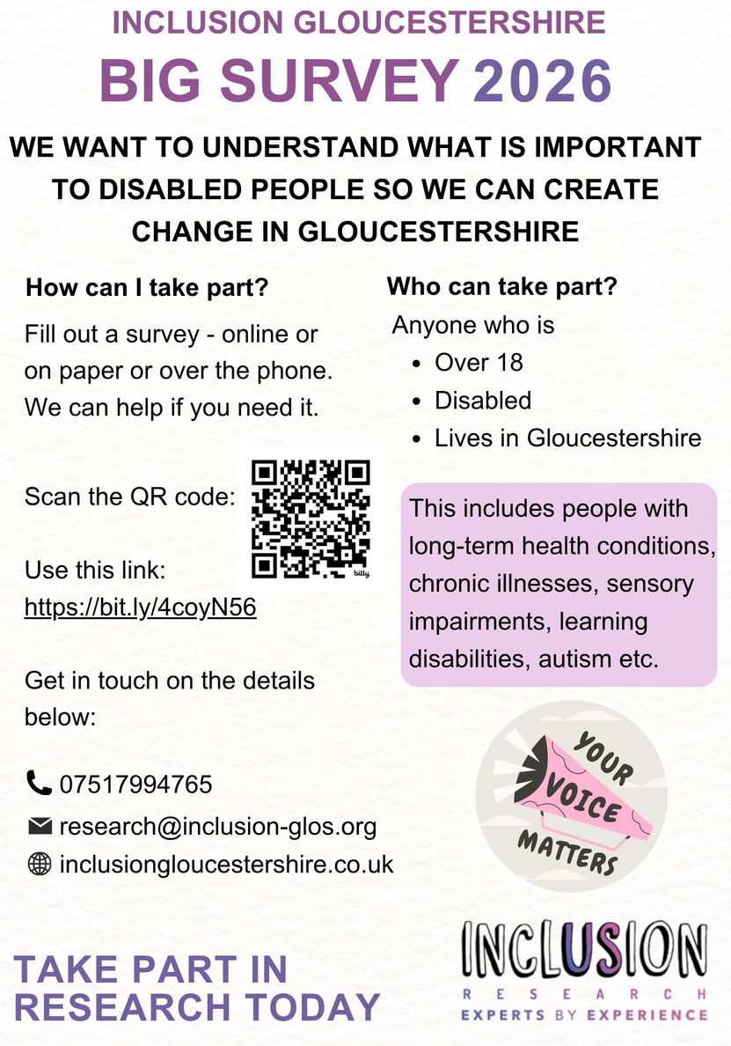
Inclusion Gloucestershire Big Survey 2026 poster.

Inclusion Gloucestershire Big Survey 2026
We want to understand what is important to disabled people so we can create change in Gloucestershire.

How can I take part?
Fill out a survey - online, on paper or over the phone. We can help if you need it.
Use this link: Big Survey 2026 online survey
Telephone: 07517994765
Email: research@inclusion-glos.org
Website: Inclusion Gloucestershire website

Who can take part?
- Anyone who is over 18.
- Anyone who is disabled.
- Anyone who lives in Gloucestershire.
This includes people with long-term health conditions, chronic illnesses, sensory impairments, learning disabilities, autism, etc.
Take part in research today. Your voice matters.

Healthwatch surveys
Original newsletter page 15
Health Watch currently has the following two surveys running that you are invited to participate in. It would be really good if you as a key representative of your community provide your thoughts.

1. Use of AI in health and social care
Artificial intelligence is becoming an increasingly common in health and social care. Regardless of whether you have used or experienced AI, we want to know what you think about this, including whether AI is improving access, communication and understanding, as well as any concerns around accuracy, trust, privacy or the impact on human interaction. Complete our survey and tell us your thoughts and experiences around the growing use of artificial intelligence (AI) by both patients and professionals. Healthwatch survey on AI in health and social care
2. GP referrals In the last 12 months, have you been referred to a specialist for tests, diagnosis or treatment by your GP practice? In 2025, we heard that health care referrals were often delayed, lost or rejected, leading to delays in diagnosis, care and treatment. Communication while waiting was unclear, people are unsure about appointment timelines, and they were not always offered provider choice. We are also told what a difference it makes when people are able to get the support and treatment they need. Please help us improve the referral process for everyone by clicking on the link below and sharing your experience. Healthwatch GP referrals survey

Training dates
Original newsletter page 16
This is a new section highlighting training events that may be of benefit. The events may be for organisations or individuals. If you have any to raise awareness of for next newsletter, please let us know.

Active Gloucestershire and some of their partners
Thanks for the information to Ida Pöschel, Senior Project Officer - Health & Disability.
- 21 September, 12:00-13:00 - DBS Changes: What your clubs needs to know (online)
- 22 September, 10:00-12:30 - Coaches Catch-Up: Championing A Child First Approach to Coaching (Gretton Village Hall)
- 1 October, 18:00-20:30 - Coaches Catch-Up: Championing A Child First Approach to Coaching (Churchdown)
- 10 October, 18:00-20:30 - Coaches Catch-Up: Championing A Child First Approach to Coaching (Tewkesbury)
- 14 October, 19:00-21:00 - Conflict Resolution (online).
- 15 October, 13:00-14:00 - Making Every Conversation Count: Suicide Prevention for Sports Clubs
- 4 November, 18:30-19:30 - The Hidden Mental Side of Injury in Sport (Tewkesbury, to be confirmed)
- 18 November, 18:30-19:30 - Safeguarding - Everyone's Responsibility (online)
Two free Physical Activity Clinical Champion training sessions are coming up for healthcare professionals working in Stroud, Gloucester and the Forest of Dean.
- 21 September, 12:00-13:30 - Physical Activity Clinical Champions (PACC) Training (online)
- 28 September, 12:00-13:30 - Physical Activity Clinical Champions (PACC) Training (online)
- 20 October, 08:30-16:00 - Active Schools' Conference 2026/2027 (Cheltenham)
This is a free conference for primary school educators. There will be many opportunities for networking and to listen to a variety of different speakers. The event is organised by Move More and Active Gloucestershire.

Making Walks Sensory
We would like to invite you to attend a bespoke Making Walks Sensory workshop specifically for those in the South West region. The workshop will take place on Wednesday 30 September, 6.00-8.30pm, online via Zoom.
Book the Making Walks Sensory workshop

Who is this workshop aimed at?
This workshop is designed to support anyone over 16 years working with disabled people with complex needs who want to create meaningful and engaging nature activities. This may include but is not limited to parents, carers, support staff, teachers, walk leaders and nature-based workers.

What to expect
The workshop will involve information sharing from the tutors using PowerPoint slides, whole-group discussions and breakout-room activities. The workshop will cover:
- An introduction to working with disabled people with complex needs.
- What Sensory Walks are and what they might include.
- How to effectively plan walks that are person-centred and appropriate to ensure they meet participants needs and desired outcomes.
- Tips for ensuring walks are accessible, safe and inclusive.
This training is endorsed by CIMPSA and, upon completion, delegates can obtain proof of 2 CPD points by requesting a certificate. For questions, contact Alice.Turner@sense.org.uk.
Sense information on Sensory Walks

Neurodivergent news

Partnership Board update
Original newsletter page 17

From your Chair: Andrew Cotterill

The Neurodivergence Partnership Board 2 of June

Mental health and neurodivergence – joining up the conversation
As you known a very large proportion of neurodivergent people experience co-occurring mental health issues. The second round of Gloucestershire’s Mental Health Locality Forums focused specifically on this overlap and on people’s experiences of accessing mental health services across the county.
The June Neurodivergence Partnership Board was, in practice, a joint session with the Mental Health and Wellbeing Partnership Board. Simon, Co-chair of the Mental Health and Wellbeing Partnership Board, introduced the findings from the Forums, which had identified both immediate practical improvements and wider priorities for system change. CASA also brought the issues to life through three powerful lived-experience case studies, showing how barriers within services can affect people in practice.
NPB members then discussed the findings in breakout groups. They were asked to test the Forum findings against their own experience, highlight anything that might be missing, identify changes that could be made in the shorter term, and consider what needed to feed into future planning and strategy.
The Board strongly recognised the picture presented and added further perspectives from members’ own knowledge and experience. This provided an opportunity not simply to endorse the Forum findings, but to test, develop and add to them before they were taken into the wider mental health partnership discussion.
The combined learning was then fed into the Mental Health and Wellbeing Partnership Board. If you turn to the Mental Health and Wellbeing Partnership Board pages in this newsletter, you will find a brief summary of the original Forum findings, together with the additional feedback from the Neurodivergence Partnership Board and the wider discussion that followed.
The most recent Neurodivergence Partnership Board meeting took place on 8 September and focused on children and young people. A fuller write-up will be included in the next issue of the newsletter.

The next Partnership Board meeting
The next meeting will take place in person at Shire Hall on 1 December.
Want to join out partnership board or recieve partnership board related correspondance? Please email: neurodiversity@gloucestershire.gov.uk.
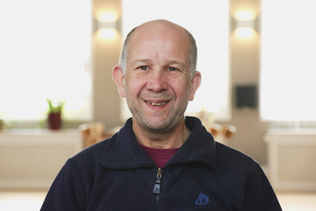
Andrew, Partnership Board Chair

Employment
Original newsletter page 18
Forwards Education Team, from Kirsten Lloyd
The Education team support young people on their post 16 journey into further education and employment and enables them to become active members of their community. We work closely with education establishments, training providers, GCC education team and community organisations to support young people onto a positive path.
Here are two case studies that exemply some of the work the team do.

Case Study #1
Cameron is 20 and has never had a paid job. He has Autism, ADD, Aspergers and feels very uncomfortable with crowds. He attended meetings with his mum but afterwards, he was confident to attend independently while mum waited at the reception. I completed his Vocational Profile and took him through careers coach. He was very sure he wanted an outdoor job preferably in the woods. I created a CV for him which he used for applications.
When a tree surgeon apprenticeship role came up in GCC, I encouraged him to apply. He was happy with the idea as that suited his career aspiration. He was invited for an interview. We had some interview prep session and Cameron was confident to attend. It was unsuccessful but he was quite happy to get that far even though he was not provided feedback as he had never been for an interview. This really boosted his confidence.
Cameron applied for admission into MIAG Ltd which is an alternative education provision in Cheltenham. He attends for 3 days a week which helps to prepare and support him for independent living, as well as guide him towards future employment. The provision is helping him to build confidence, develop functional skills, and gain experience in areas he is passionate about. As well as some independent classroom learning (which is what Cameron needed to re-engage with, after so long away) they have access to a meadow and a forge for practical outdoor work.
Cameron is also getting excellent unpaid woodland work experience at Voltaires Wood in Stroud for 2 days a week. This is good experience for him and his week is now busy again, which he likes, after a very quiet year.
Recently, an opportunity came up for a paid work experience at Cotswolds National Landscape. I passed on this opportunity to Cameron and he applied for it. He was selected as one of the 8 young people selected for this opportunity which he started yesterday, 29th June 2026.
In addition, Cameron has been offered college admission at Skylark starting in September.
Original newsletter page 19
Case Study #2 A young person was referred to the Forwards Service by their mother ahead of a move from Essex to Gloucester. Although they had not been formally diagnosed, their mother suspected they were autistic and was seeking support to access appropriate services and education. Intervention
The Personal Adviser (PA) provided information about SENDIASS Gloucestershire and the local Autism Referral Pathway, supporting the family to access the right assessment and support services following their move. Also liaising with an online provision Player Ready to meet the educational wants, wishes and needs to move forward in future aspirations.
Outcomes The young person successfully received an Autism diagnosis and was later awarded an Education, Health and Care Plan (EHCP), recognising their individual needs and strengths. Impact
Through the EHCP process, the young person secured a place at Player Ready, an online alternative provision tailored to their interests and aspirations in gaming and coding. They are now accessing education in a setting that meets their needs, supports their engagement, and enables them to work towards their future goals.
Conclusion This positive outcome highlights the value of timely signposting and support, helping a young person move from undiagnosed needs to receiving the right educational provision and specialist support to succeed.
Further Details More information and how to contact the Forwards education and team can be found in the following web pages Forwards Education

Sport Neuroinclusivity resources
Original newsletter page 20
Thanks to Ida Pöschel of Active Gloucestershire for highlighting the following resources.
Making Sporting Activities more Neuroinclusive Neurodiverse Sport has produced some useful resources looking at practical ways organisations can make activities more welcoming and accessible to neurodivergent people.
Neurodiverse Sport offers A Blueprint to Neuroinclusion in Community Sport, a free online course providing a practical introduction for organisations and activity providers wanting to become more neuroinclusive.
Registration is required, but the course itself is free. Find out more: Blueprint to Neuroinclusion in Community Sport
In addition, their Joining a New Sports Club – A Day in the Life of Maya case study follows a young person through the whole process of joining an activity: looking for information, signing up, preparing for the first visit, taking part and reflecting afterwards. It gives practical examples of relatively small changes that can make a significant difference, such as providing clear information about what to expect, asking about individual support and communication needs, offering opportunities to visit beforehand, considering the sensory environment and normalising the use of breaks.
Although written around a sports club, many of the ideas could equally apply to community groups, activities and services more widely.
Read the case study: Joining a New Sports Club case study

What about: AuDHD
Original newsletter page 21
An introduction to AuDHD Apology: This is necessarily a long article. There is much to explain! To fit everything in, this article assumes some familiarity with autism, ADHD and their characteristics. This requested topic article is a very personal topic to me and highly relevant to many in the community. I am diagnosed autistic but clearly also ADHD (for which I have chosen not to go for a formal diagnosis as I am currently not wanting to go for medication for which formal diagnosis is necessary). In the other direction: a meaningful proportion of people diagnosed with ADHD have significant autistic characteristics or are also autistic. AuDHD Over the past few years, the term AuDHD has become increasingly visible. Combining autism and ADHD, it is used to describe someone who is both autistic and has attention deficit hyperactivity disorder. AuDHD is not a separate formal clinical diagnosis. The term appears to have emerged informally from neurodivergent communities rather than being invented by one clinician or researcher. Although some people dislike the term, many find it useful because it recognises that autism and ADHD do not simply sit beside one another. Their characteristics may interact in complex ways, such as adding characteristics or sometimes pulling a person in different directions. Someone may depend on familiar routines but become restless when every day is the same. They may seek movement, noise or excitement but also become overwhelmed by sensory input. They may carefully plan something and then struggle to begin it, or impulsively agree to an activity before realising how socially or sensorily demanding it will be. These are not signs of someone being awkward or inconsistent: different needs may be operating at the same time.
From “either/or” to “both” Recognition of AuDHD represents a major change from only a few decades ago. Older diagnostic systems treated autism and ADHD as alternatives rather than conditions that could occur together. Clinicians were often expected to decide whether someone was autistic or had ADHD. Research commonly separated the two groups, while services and professional training developed along different pathways. People showing characteristics of both certainly existed; the diagnostic system simply did not adequately describe them thus sometimes making it difficult to get any diagnosis.
Since 2013, co-occurring autism and ADHD have been formally recognised in diagnostic manuals, allowing both to be diagnosed in the same person. The actual assessments though for autism and ADHD, tend to be assessed in different sessions.
How common is the overlap? Figures vary considerably depending on whether research involves children or adults, community or clinical populations, and diagnosed conditions or broader characteristics. Pooled research suggests that roughly four in ten autistic people may meet criteria for ADHD at some point, while some studies of autistic children referred to specialist services have found rates approaching or exceeding half. The overlap also works in the other direction: a meaningful proportion of people diagnosed with ADHD have significant autistic characteristics or are also autistic. Despite this, many people still receive only one diagnosis, leaving another important part of their experience unidentified and unsupported.
Not simply autism plus ADHD Research has identified some commonly occurring patterns, but the variation within AuDHD is very large. For some characteristics, autism and ADHD may have cumulative effects. For others, they interact more complexly. A need for predictability may conflict with a need for novelty. Stimulation-seeking may increase sensory overload. Impulsivity may affect how autistic social differences appear. Intense focus may coexist with great difficulty beginning or switching tasks. The safest conclusion is that co-occurrence can create a particularly complex profile, but not one that looks the same in everyone.
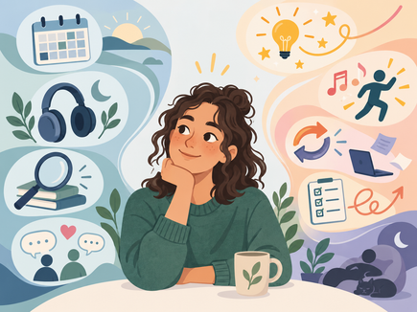
AuDHD person looking happily at Autism Leanings
Original newsletter page 22
Here are five aspects of common notable interaction between Autism and ADHD in AuDHD.
1. Everyday executive functioning Executive functioning covers processes such as beginning activities, remembering what needs to be done, organising steps, managing time, controlling impulses, changing direction and completing tasks. Autism and ADHD can both affect these processes. People with both often report greater everyday difficulties than autistic people without recognised ADHD, particularly with attention, impulsivity, working memory, organisation and task initiation. Compared with ADHD alone, they may also experience greater difficulty with uncertainty, sensory demands, change and shifting away from strongly focused interests. Interestingly, difficulties may be clearer in questionnaires about daily life than in short structured tests. Someone might perform well in a quiet assessment room yet struggle considerably with organising ordinary life. High intelligence, knowledge or specialist ability can therefore mask substantial everyday support needs. 2. Independence and adaptive functioning Research also suggests greater difficulty with adaptive functioning: using abilities effectively in everyday life. This can involve such personal care, preparing food, appointments, money, household management, travel, education, employment and others. Someone may be highly capable in a specialist area while struggling with tasks that appear much simpler. This can be misinterpreted as laziness, carelessness or immaturity when, in reality, the task may require attention, memory, planning, sensory processing and transitions all at once. Among autistic adults, greater ADHD characteristics have been associated with lower independence in daily living and poorer quality of life. This does not apply to everyone, but it suggests that the combined demands can be significant. 3. Emotional regulation and mental health People with both autism and ADHD often show higher levels of anxiety, depression, emotional lability, irritability and overall mental-health difficulties. There are several possible reasons. Autism and ADHD may each contribute vulnerabilities, while sensory overload, social misunderstanding, sleep problems, difficulty meeting expectations and frustration when intentions do not translate into action can add further strain. A person’s experiences and support also matter. Some distress may arise not directly from autism or ADHD but from years of being misunderstood, criticised or expected to function without suitable support. Research has not yet established exactly how much of the additional burden comes from neurodevelopmental differences themselves and how much from these wider experiences and circumstances. 4. Sensory processing Sensory differences are well established in autism and increasingly recognised in ADHD. People with both may have a particularly broad or mixed sensory profile. Someone may seek movement, music or pressure in one situation while becoming overwhelmed by unpredictable noise, touch or visual activity in another. The important question is therefore not simply someones level of sensitivity. Sensory experience can depend on whether input is chosen, predictable and controllable, as well as its intensity and duration and how tired, anxious or overloaded the person already is. 5. Social communication AuDHD does not necessarily make someone appear more visibly autistic during a formal observation. ADHD-associated spontaneity, humour, talkativeness or impulsive social engagement may make autistic social-processing differences less obvious. Someone may nevertheless struggle with unspoken expectations, knowing when to enter a conversation or managing friendships. They may interrupt, lose track of their point or share more than intended, while needing considerable recovery afterwards. Compared with ADHD alone, AuDHD usually involves clearer autistic differences around social understanding, sensory processing, predictability, intense interests or adapting to change.
Original newsletter page 23
This more complicated presentation may help explain why autism is sometimes missed in someone already diagnosed with ADHD, or ADHD overlooked once autism has been recognised. It may actually impact on the ability to apparently meet the diagnostic criteria for each individually. Other possible differences Some studies also suggest greater motor-coordination difficulties, sleep disturbance, educational difficulties and behavioural dysregulation, although evidence is less consistent than for executive functioning, mental health and adaptive functioning. Positive aspects are less thoroughly researched. People commonly describe creativity, originality, intense curiosity, enthusiasm, persistence and strong pattern recognition.

What can AuDHD feel like?
Research describes patterns across groups; it cannot tell us exactly what AuDHD feels like for an individual. One useful way of understanding it is through the push and pull between different needs. Here are some examples. Routine and novelty Predictability can reduce uncertainty and processing demand, while ADHD may bring a strong need for interest, novelty, urgency or stimulation. Someone may therefore create detailed routines because structure helps them function, yet struggle to keep following them. Unexpected change may be distressing while excessive sameness also becomes difficult. In this latter case, some find a flexible structure with predictable anchors with choice and variation built in can help. Attention and intense focus ADHD does not mean an inability to pay attention. It often involves difficulty controlling where attention goes, how strongly it is held and when it can be moved. An AuDHD person might spend hours absorbed in an interest while finding it almost impossible to begin a routine five-minute task. Autistic focused interests and ADHD hyperfocus may combine into exceptionally deep engagement, which can be rewarding and productive while also making switching, resting or attending to other needs difficult. Sensory protection and stimulation Someone may be unable to filter unpredictable conversation in a crowded room but concentrate better with familiar music. They may dislike unexpected touch yet seek strong pressure or movement. A quiet environment may reduce overload while leaving them insufficiently stimulated to remain alert. This is why statements such as “you cannot be sensitive to sound because you play loud music” miss the point. Chosen and unpredictable sensory input are very different experiences. Planning, social contact and recovery Someone may plan something meticulously but struggle to begin it, or act impulsively and recognise the demands only afterwards. Likewise, they may genuinely want friendship and social activity while finding the processing demands exhausting. They might enthusiastically agree to an event and later realise that the travel, noise, unfamiliar people and disruption to routine are too much. The desire for connection and the need for recovery can both be real.
In simple terms, commonly reported tensions include:
predictability and novelty; reduced sensory input and stimulation; detailed preparation and impulsive action; deep focus and difficulty starting or switching; time alone to recover and social connection; clear expectations and freedom and flexibility; careful rule-following and resistance to external control; strong intentions and difficulty turning intentions into action.
These are just some examples and of course not everyone experiences all of these.
Original newsletter page 24

Does AuDHD change with age?
For both autism and ADHD, how characteristics appear can change with development, circumstances and the demands placed on the person. In a very rough outline, Early childhood: high activity, impulsivity, sensory differences, sleep difficulties and strong emotional responses may be visible, although distinguishing ADHD from ordinary developmental variation can be difficult. Autism can also be less obvious in a highly verbal or socially active child. Primary-school years: increasing demands around sitting still, instructions, organisation, transitions, classroom sensory input and relationships may make difficulties clearer. Adult structure can sometimes conceal them until greater independence is expected. Adolescence: academic, social and organisational demands increase. Anxiety, low mood, masking, exhaustion and identity difficulties may become more prominent, alongside a desire for independence despite continuing practical support needs. Adulthood: physical hyperactivity may become less obvious or turn into internal restlessness, while difficulties with time, organisation, task initiation and switching may remain. University, employment, relationships, parenthood or independent living may expose difficulties previously supported by family or education. Older adulthood: very little research exists. Changes in health, energy, memory, routine and support networks may alter how autism and ADHD are experienced. Many older people may also have spent most of their lives unidentified.

Why AuDHD can be difficult to recognise
Someone already identified as autistic may have attention, organisation or impulsivity differences attributed entirely to autism, while someone diagnosed with ADHD may have sensory, social or predictability needs explained as anxiety or inattentiveness. This is sometimes called diagnostic overshadowing, where one diagnosis becomes the explanation for everything.
One set of characteristics can also partly conceal the other. Autistic rule-following or extensive preparation may disguise impulsivity and organisational difficulties, while ADHD-associated spontaneity, humour and talkativeness can make autism less obvious. Masking, perfectionism, family support and carefully constructed routines can also maintain an appearance of coping until demands increase or those strategies stop working.
Of course, as with autism alone, some AuDHD groups, including women and girls, older adults and people whose presentation does not match traditional stereotypes, have been particularly vulnerable to missed or late identification, although anyone can be overlooked. Masking and burnout are frequently discussed and reported by AuDHD people, but research specifically comparing these experiences with autism or ADHD alone remains limited.

Recognising overlap in Gloucestershire services
Although NHS diagnostic services do not use AuDHD as a formal clinical term, Gloucestershire’s NHS diagnostic services recognise that someone presenting for assessment of one condition may show indications of the other. This happens in both adult and children’s services.
With the individual's agreement, an internal referral can be made so that the other condition can also be assessed. This is an important practical change. Rather than treating autism and ADHD referrals as entirely separate populations, it recognises that someone may arrive through one door while needing both autism and ADHD to be considered as part of their neurodevelopmental profile. It does not assume that everyone assessed for one condition has the other; it means credible indications are less likely to be overlooked.
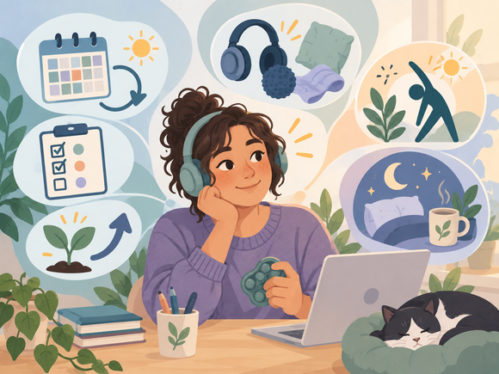
AuDHD person looking happily at ADHD Leanings
Original newsletter page 25

Why identifying both can help
Recognising both can provide a more coherent explanation for experiences that previously appeared contradictory. It may explain why rigid routines repeatedly fail, why reducing stimulation helps in one situation but makes concentration harder in another, why strong abilities do not always translate into everyday independence, or why autism-only or ADHD-only advice has never quite fitted. Recognising both can also improve the fit of support. ADHD medication may help some people with attention, impulsivity or restlessness, but it does not remove autistic needs and is not suitable or wanted by everyone. Support and adjustments should respond to the person’s actual needs rather than waiting for every label to be formally confirmed.

What can help?
Support often works best when autistic and ADHD-related needs are considered together rather than choosing between them. Flexible structure can provide dependable anchors while allowing enough choice and variation to avoid excessive rigidity or boredom. Making organisation external and visible can reduce demands on working memory. Written instructions, reminders, timers, calendars, checklists and breaking tasks into a manageable first step can all help. Difficulty starting a task is not necessarily evidence that someone does not care about completing it. Balancing stimulation and protection may mean providing access to quiet spaces and sensory adjustments while also allowing chosen movement, sound, fidgeting or other useful stimulation. The aim is often to give the person greater control over the type and amount of input rather than simply reducing everything. Supporting transitions and recovery can be equally important. Warning before changes, clear next steps and time to disengage from one activity before beginning another may help. Social, sensory and executive demands can also accumulate, making recovery time necessary for someone to continue functioning effectively. Clear, direct communication and written follow-up can support all of these approaches by reducing demands on social interpretation, attention and memory.

Seeing the whole profile
As indicated, for years diagnostic systems encouraged clinicians to choose between autism and ADHD. We now know that this was a false choice for many people, and recognising only one condition may have left important needs misunderstood and unsupported. Research suggests that people with both may experience greater difficulties with everyday executive functioning, emotional regulation, mental health, independence and quality of life than people recognised with only one condition, while also showing considerable variation from one individual to another. The value of the term AuDHD is therefore not that it creates another narrow box. It can help us understand interactions that might otherwise appear contradictory: structure and novelty, protection and stimulation, intense concentration and difficulty getting started.
Recognising both allows us to ask a more useful question: “What combination of support will enable this particular person to function, participate and live well?” More broadly, once someone is recognised as potentially neurodivergent — whatever the eventual mix of autism, ADHD or other differences — the immediate priority should not simply be a long, medicalised diagnostic process. It should also be to understand what difficulties the person is experiencing, what their strengths and needs are, and what practical changes or support might help. Formal diagnosis can still be important for understanding, treatment (such as ADHD medication) and access to some services, but useful support should not have to wait until every diagnostic question has been settled. For many people, early recognition of their needs and access to the right support may be sufficient without pursuing a formal diagnosis. In many cases, recognising and responding to those needs early may also reduce the longer-term harm that can arise when support is delayed, including avoidable distress and mental-health difficulties.

Selected resources
Original newsletter page 26
Here you’ll find some related AuDHD resources that may be of interest.
Please be aware that content linked to from this page is not necessarily provided by us; we cannot guarantee that all the content is perfect - merely that we hope you might find it of interest!

YouTubers of the issue!

AuDHD Hub
Her Intro: I'm Karen, and I'm AuDHD. I was diagnosed with ADHD at 38 and autism at 40. I created AuDHD Hub for late-diagnosed adults who are just starting to make sense of a lifetime that never quite made sense.
YouTube Channel: YouTube channel

Yo Samdy Sam
Her Intro: Hi there, my name is Sam and I've been making content about autism and neurodiversity since 2019, with a goal to help more people understand their autistic and ADHD brains. I'm a late-diagnosed AuDHDer myself, having struggled my way through life for decades before I understood WHY everything was so hard all the time.e.
YouTube Channel: YouTube channel

Theme based resources of the issue!
Heres an additional link to resources on AuDHD
Autistica: For a shorter (than earlier), perhaps simpler, introduction and further reading, Autistica, the UK autism research charity, has a useful page on ADHD and autism. It provides a concise research-informed overview of how the two can overlap, some of the characteristics they share and the sometimes competing needs experienced by people with both. It also includes links to further research and practical information.
It complements the more detailed discussion in this newsletter rather than repeating it: Autistica ADHD and autism page

Selected resources image.

ND Hub Creative Strategy Sessions
Original newsletter page 27
From the ND Hub for your diary:

ND Creative Strategy Sessions
These are inclusive calm, structured creative arts sessions designed specifically for ND adults. Their aim is creativity as a practical tool for neurodivergent wellbeing.
The sessions use art-making as a practical tool for discovering:
- Nervous system regulation.
- Emotional processing.
- Reducing overwhelm.
- Building self-awareness.
- Increasing self-trust.
They are run as themed creative peer support sessions led by Amabel and Zaphira, with occasional visiting artists, where people can explore strategies to support their neurodivergent experience and belonging.
Sessions are free and all materials are supplied, but people are welcome to bring their own along too.
In September's session we will be exploring: Containment & Boundaries - externalising overwhelming thoughts into a contained space or learning how we set boundaries, by creating small story boxes or bordered artwork.
Book the September Creative ND Strategies session

Future sessions
- Wednesday 21 October 2026 - 7.00-9.00pm.
- Wednesday 18 November 2026 - 7.00-9.00pm.
- Wednesday 16 December 2026 - 7.00-9.00pm.
- Wednesday 20 January 2027 - 7.00-9.00pm.
- Wednesday 17 February 2027 - 7.00-9.00pm.
- Wednesday 17 March 2027 - 7.00-9.00pm.
ND Hub Gloucestershire - details and bookings
For more information contact Zaphira at info@adhdhubglos.org or Amabel at amabel@ndhubglos.org.

Young People’s News
Original newsletter page 28

Children & Young People: Lived Experience Insights
In January 2026 we invited neurodivergent adults, children and young people to share their lived experience. We did this because words like neurodiversity and neurodivergence are often used interchangeably, and we want to make sure local planning uses language that reflects real life. Respondents didn’t require a ‘formal’ diagnosis to take part.
The questionnaire was anonymous. We did not collect names, email addresses, phone numbers, or any contact details. We are sharing themes only, so nobody can be identified.

Who responded
We heard from people across the lifespan, for the purpose of this report we have collated responses from:
Children (under 12) Young people (12–17) Some parents responding on behalf of their children

Insights
Results from Children and young people made up a significant proportion of responses to the questionnaire, with 44% coming from those under the age of 18. Their contributions provide a clear and powerful picture of how neurodivergence is currently experienced by younger people in Gloucestershire.

Feeling unheard and misunderstood
The most consistent message from children and young people was the need to be listened to and believed.
Many responses used very simple and direct language such as “listen to me”, “being heard”, and “be kind”. This repetition highlights that young people often feel their distress, needs, and communication are dismissed or misunderstood by adults and professionals.

Distress treated as behaviour
A strong theme was the experience of being punished rather than supported, particularly in school settings.
Young people described being given detentions or isolation when they were overwhelmed, anxious, or unable to regulate their emotions. Sensory overload, especially noise and busy environments, was frequently mentioned as a trigger for distress that was not recognised or accommodated. This suggests that neurodivergent distress is often interpreted as poor behaviour, rather than as a signal that a child is struggling and needs support.
Original newsletter page 29
What this tells us The lived experiences shared by children and young people show that neurodivergence is not just an individual difference, but something that is shaped by how schools, services, and adults respond. Early understanding, flexibility, and listening are critical to preventing harm and supporting neurodivergent children and young people to feel safe, valued, and included.
What happens next:
We will use these findings to:
Support a lived-experience-informed understanding of neurodivergence Inform local planning and improvement work (including the Gloucestershire One Plan) Share a summary with partners to encourage more inclusive, accessible services
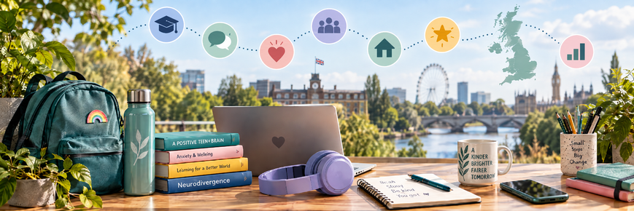
Young people and neurodivergence illustration.

Sensory Observations
Original newsletter page 30

CEO ND Hub Glos/NC4ND

Sensory Needs Don’t Expire at 18
A sensory space for adults? Yes. More of this, please.
At Barnwood Trust’s recent Access to Nature event, ND Hub Gloucestershire provided a pop-up sensory and quiet space with a difference: it was outdoors, nature-themed, wheelchair accessible and, most importantly, designed on the assumption that adults have sensory needs too.
Radical.. we know!
There were places to sit and places to get cosy. Space to move. Balance boards. Natural objects and textures to explore. Mirrors, flowers and light. Cooling equipment for anyone struggling with the heat. A quiet space with beanbags and a giant “people pocket” for anyone who needed to retreat.
And there was something else which mattered just as much as all the equipment:

Permission.
Permission not to talk. Permission to move. Permission to sit differently. Permission to touch things, or not touch anything. Permission to come and go. Permission to regulate without having to explain why.
That shouldn't feel radical. But sometimes it still does.

Please don't call our regulation tools “toys”
There is something we need to talk about in professional spaces. An adult reaches for a fidget and somebody says, often quite cheerfully:
“Oh, you brought your toys!” It might be intended as a joke. It might even be intended affectionately. But please don't.
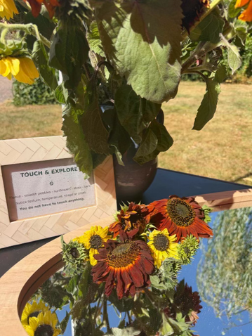
Nature-themed sensory space.
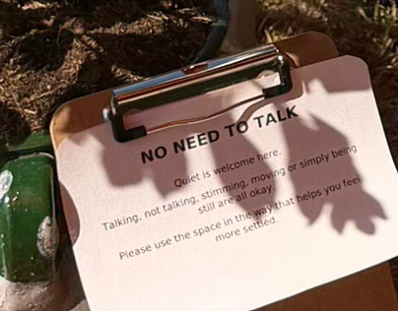
No need to talk sign in the sensory space.
Original newsletter page 31

Please don't call our regulation tools “toys”
When you describe an adult's regulation aid as a “toy”, you risk infantilising them. Suddenly one professional is positioned as the sensible adult observing another person's quirky behaviour. The power balance changes.
A fidget might be the very thing allowing someone to stay in the meeting. Movement might be what allows someone to listen. Doodling might support concentration. Looking away might make it easier to process what you're saying. Sitting on the floor, rocking, standing up, pacing or holding something in our hands does not tell you how intelligent, interested or professional we are.
Visible regulation is not the same thing as disengagement. For some of us, the opposite is true. I can concentrate, listen, create, debate and contribute better when I am moving. If I have to devote my energy to making my body sit still and look conventionally attentive, that's energy I'm no longer using to think.
And isn't the thinking the bit we actually invited people into the room for?

We didn't leave our nervous systems at school
Sensory provision is still too often associated with children. We make sensory rooms in schools. We give children movement breaks. We accept ear defenders, wobble cushions, fiddle objects and quiet corners. And then adulthood arrives and somehow the expectation changes.
The sensory need hasn't necessarily disappeared. The permission has.
Adults learn to suppress things. To sit on their hands. To stop rocking. To tolerate the light. To endure the noise. To make eye contact. To stay seated. To wait until afterwards to recover. We often call the successful performance of those things “coping”. Perhaps we should ask what they cost.
A genuinely neurodivergent-affirming environment doesn't measure inclusion by how successfully neurodivergent people can imitate the regulation style of everybody else. It asks: what would enable this person to participate as themselves?
There is no standard neurodivergent person and of course, there isn't one sensory space that will work for everyone. One person's regulating movement is another person's sensory nightmare. Someone might seek sound while somebody else needs silence. One person wants deep pressure; another cannot tolerate being touched. Somebody wants to lie down; somebody needs to pace. One person finds fairy lights soothing; someone else may find them distracting.
Every neurodivergent person is different. That's why we love creating different possibilities within the spaces we create and hold rather than deciding what “sensory regulation” should look like.
Rest here. Move here. Cool down here. Explore this. Look at that. Or simply sit underneath a tree and do absolutely nothing.

Sensory objects outdoors.
Original newsletter page 32
No compulsory interaction. No prescribed activity. No expectation to perform gratitude for the provision. Just options.
And crucially, the spaces we create are designed so that wheelchair users and people using mobility aids can be part of them too. Because a sensory space that excludes people from entering it isn't particularly inclusive.
Maybe access starts with giving up a little control
One of the most important things we took away from our recent pop-up sensory and quiet space at Barnwood's Access to Nature event was a wider point about accessibility. We should be cautious about announcing that somewhere is “fully accessible”.

Accessible to whom?
Instead, we can provide clear, useful information, photographs, descriptions, measurements and video walk-throughs showing what somebody will actually encounter. Tell people about the surfaces. The distances. The toilets. The seating. The noise. The lighting. The slopes. The crowds. The quiet spaces. The shade. The things that might be unpredictable.
Then we can enable disabled and neurodivergent people to make their own decision about whether that environment is accessible to them.
That is a subtle but important transfer of power, and perhaps we could apply the same thinking to sensory needs.
Instead of professionals deciding what appropriate adult behaviour looks like, we could trust adults to know what helps their own bodies and brains.
Instead of asking: “Why are they doing that?”
perhaps ask: “What is that enabling them to do?”
That person pacing at the back of your meeting might be listening intently. The colleague doodling might be processing every word. The person avoiding eye contact may be concentrating. The adult with a fidget isn't suddenly five years old. And somebody taking ten minutes in a sensory space hasn't stopped participating.
They may all be doing exactly what they need to do so that they can participate.
Barnwood's event reminded us what can happen when access is approached with curiosity rather than assumptions. Our sensory needs don't expire when we become adults. Maybe our expectations need to grow up instead.

Improving Inclusivity
Original newsletter page 33

A local counselling provider working to improve inclusivity
Note from Editor: Warning, This is not an endorsement!
However, from time to time, we want to highlight local organisations that are taking practical steps to improve access and inclusivity for those who are experiencing barriers accessing services, and here in particular neurodivergent people. Gloucestershire Counselling Service is one example of a provider reflecting on barriers to talking therapies and looking at how its services can be made more accessible.
Gloucestershire Counselling Service is an independent local charity providing counselling and psychotherapeutic support across the county. Its work is funded through a mix of client fees, charitable grants and public-sector contracts, including support from organisations such as NHS Gloucestershire ICB, the Office of the Police and Crime Commissioner and Barnwood Trust. Here they explain more about their approach, including work to improve access for neurodivergent people and those with co-occurring mental health needs, and the availability of lower-cost counselling sessions.

The following is an introduction From Ed Weir, CEO
Here at Gloucestershire Counselling Service we are proud to provide affordable counselling to people across Gloucestershire. For people seeking to find a fresh understanding of their emotional relationship to their experiences, or seeking support processing distressing and traumatic events, psychotherapeutic support can be life-saving and life changing
We have been listening intently to perspectives from people experiencing barriers to accessing talking therapies, including those shared in the excellent Inclusion Gloucester report on Talking Therapies (2025) and the recent work arising from the Rethink Mental Health Forums on co-occurring mental health needs and neurodivergence.
Alongside highlighting the need for progress in our collective understanding of how the social model denies equal access to vital support, it is also clear that affordable access is out of reach for many people who might otherwise benefit from psychotherapeutic support.
Our work aims to contribute to addressing both of these challenges. There is no easy solution on affordability, but we are pleased to be able offer subsidised counselling for sessions from £20, subject to availability, and we often have sessions available for £30.
We work with experienced accredited counsellors specialising in a number of different areas of psychotherapeutic support as well as trainee counsellors building experience whilst being closely supported by our experienced training team. Our ethos is to meet-people-where-they-are, whatever their life circumstances.
Our doors are always open to people with co-occurring mental health needs and neurodivergence. We also support family members, carers, colleagues and people working in specialist neurodivergent support roles. For more information, visit us at www.gloscounselling.org.uk.

In the National News - June to August
Original newsletter page 34
“Experts at Hand” moved SEND reform towards needs-led support without waiting for diagnosis
On 5 June, the Government published detailed plans for the new Experts at Hand offer. From September, local authorities and Integrated Care Boards are expected to begin expanding access to specialists including speech and language therapists, occupational therapists, educational psychologists and specialist teachers in mainstream settings. Importantly, the policy explicitly says children should be able to receive support without needing to wait for a diagnosis. The programme is backed by £1.8 billion over three years. [Source: Department for Education / GOV.UK]

The Fonagy review pointed towards earlier, needs-based support — but its final report was delayed.
During the summer the Government continued to say that Professor Peter Fonagy's independent review of mental health conditions, ADHD and autism would make recommendations on how services should respond to rising need. The next phase was expected to consider earlier intervention, community-based support, more integrated pathways across health, education and other public services, and the role of private diagnostic providers. Although ministers repeatedly said the final report was due in the summer, it was not published during June–August. [Sources: Department of Health and Social Care; UK Parliament]

Mainstream SEND inclusion started moving from policy into implementation
In June, the Government issued detailed guidance for the new Inclusive Mainstream Fund, alongside guidance for schools on developing inclusion strategies. The fund is worth more than £500 million a year and is intended to help mainstream schools and colleges remove common barriers, provide universal inclusive provision and intervene earlier when pupils have additional needs. In July, the Government also consulted on allowing local authorities to move more high-needs funding directly into mainstream school budgets through a new local SEND inclusion formula. [Sources: Department for Education / GOV.UK]

New national guidance was issued for inclusion bases and inclusive school environments
On 25 June, the Department for Education published national guidance on inclusion bases within mainstream schools, aimed at pupils with additional needs, SEND, low attendance or risk of exclusion. Separate guidance was also issued on making mainstream education buildings and outdoor spaces more inclusive and accessible. This gives considerably more substance to the inclusion-base proposals highlighted earlier in the year. [Source: Department for Education / GOV.UK]

The new Autism Strategy was not ready when the 2021–26 strategy reached its expected end point
The Government confirmed in July that it would produce a revised cross-government autism strategy, but that the existing strategy would remain in force until its replacement was published. Ministers also said the new strategy would draw on the Fonagy review and other evidence and that they would consider whether it should be extended to include ADHD. This means the anticipated July transition to a new strategy did not happen. [Sources: Department of Health and Social Care; UK Parliament]

National news illustration.
Original newsletter page 35

New ADHD figures showed the scale of demand had become enormous
NHS England's August data estimated that there were up to 959,662 open referrals that might be for an ADHD assessment in June 2026. Up to 37,105 new possible ADHD referrals were received during June alone — 46.7% more than in June 2025. NHS England cautions that the figures are management information and can include referrals other than ADHD, but they nevertheless demonstrate the extraordinary scale of pressure on services. [Source: NHS England]

Autism assessment waits remained exceptionally high
NHS England figures published in August showed 294,792 people with an open suspected-autism referral in June, of whom 256,017 — 86.8% — had been waiting at least 13 weeks. Only 3.8% of people whose referral had been open for more than 13 weeks had received a first appointment within the recommended timeframe. NHS England warned that changes to ICB boundaries affected some of the June figures, so the apparent reduction from May should not be interpreted straightforwardly as an improvement in waiting lists. [Source: NHS England]

A Channel 4 documentary intensified the national argument over ADHD diagnosis
The Great ADHD Myth?, broadcast on 18 August, questioned whether ADHD should be understood as a neurodevelopmental disorder or partly as a social construct and challenged current diagnosis and medication practices. It triggered strong criticism from ADHD organisations, researchers and the Royal College of Psychiatrists. The College said ADHD remains under-recognised and under-treated in the UK and warned that questioning the legitimacy of the condition could increase stigma and discourage people from seeking support. [Sources: Channel 4; Royal College of Psychiatrists; Science Media Centre]

The Health Ombudsman found major systemic problems in ADHD and autism services
In August, the Parliamentary and Health Service Ombudsman published Improving ADHD and autism services: commissioning with confidence. Drawing on around 3,000 complaints, it identified long waits, fragmented care, inconsistent acceptance of diagnoses and confusion around patients' Right to Choose. Complaints relating to ADHD and autism had risen from 410 in 2021–22 to 1,257 in 2025–26 — more than 200%. The Ombudsman called for clearer national guidance, more consistent commissioning and stronger regulation of assessment-only providers. [Source: Parliamentary and Health Service Ombudsman]

NHS leaders warned that the present ADHD and autism commissioning model was becoming financially unsustainable
At the end of August, NHS leaders warned that expenditure on ADHD and autism assessment and support was increasing extremely rapidly in some areas, with some ICBs reporting several-fold increases in spending. Particular concerns included large variations in provider prices, rapid growth in independent providers and the difficulty of reconciling patient choice with locally planned NHS services.
This added another dimension to the national debate: not whether support is needed, but how a sustainable national assessment and support system should be organised. [Sources: NHS Alliance reporting; The Guardian]

Dates for your diary
Original newsletter page 36
Here are support groups, meet ups or events happening around Gloucestershire. Let us know if you need anything relevant adding.

Churchdown Autism Group
Meets at Churchdown community centre on the first Thursday of the month from 14:00-15:30. Contact rachel.hodges-cox@nhs.net or cashmir.martin@nhs.net.

Community Autism Support and Advice (CASA) support groups and drop-ins
For weekly updates about our Drop-in Groups and full details of drop-in venues and times, see our pages on Instagram and Facebook: CASA on Instagram and CASA on Facebook

Gloucestershire ND Hub Events
Various events and activities for young and adults. See ND Hub Gloucestershire website

Gloucestershire Parent Carer Forum “Listen To Me” Social Meet-ups
Various locations - for more information visit Gloucestershire Parent Carer Forum website.

Your next Neurodivergence Partnership Board
Tuesday 1 December 2026, 10.00am to 12.30pm. Venue: in person, Shire Hall.

Want to join the Partnership Board?
We meet once per quarter. If you would like to come to our next meeting, email neurodiversity@gloucestershire.gov.uk.

More information
To find out more, as well as read previous newsletters, visit: Autism and Neurodivergence Partnership Board webpage

Dates for your diary image.

Learning Disability News

Partnership Board update
Original newsletter page 37

From your Chairs: Tammy Flook and Jan Marriott
In June we had Caoimhe Sheelan who is from Gloucester Community Learning Disabiliity Team who talked about training for staff to help people manage emotions. She asked us to give some feedback about how this could be better.
We also thought of questions we would like to ask the Direct Payments team to understand more about how this works.
Amy Rees gave us an update on Working Together and asked for our ideas about what makes a good life. This is helping to make a new Practice Framework for Adult Social Care.
In August we watched a video from Camphill about using the bus safely. This is part of a series of films about keeping safe.We recommend people take a look! Camphill Keeping Safe films
Lucy Park from GCC Direct Payments Team also came to answer our questions and share information about direct payments.
Inclusion Gloucestershire’s Health Research Team told us about some research about women health which is happening. They would like to talk to any woman with a learning disability about it.
Rosie had an update about the Health Action Group. Rosie is hoping to hear from lots of people with lived experience. We are looking forward to it starting later this year.
Amy told the board about an event her team had at Camphill. Leo and Jon explained what they did. They drew social workers and wrote ideas about what they wanted social workers to do and be like. They shared lots of ideas to help with the new Practice Framework and looked like they had fun too.
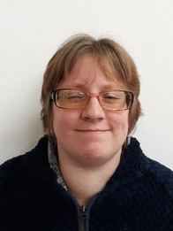
Tammie, Learning Disability Partnership Board co-chair.

Mental Health & Wellbeing News

Partnership Board update and Mental Health Forums
Original newsletter page 38

From your Co-Chairs: Jan Marriott and Simon Price
With thanks to Rhiannon for the partnership board notes.
The July meeting of the Mental Health and Wellbeing Partnership Board focused on co-occurring mental health needs and neurodivergence.
The meeting brought together learning from the Gloucestershire Mental Health Forums, feedback from the Autism and Neurodivergence Partnership Board, findings from recent Healthwatch research, and detailed lived-experience examples from Community Autism Support and Advice (CASA).
Although these sources approached the subject in different ways, they painted a remarkably consistent picture. Neurodivergent people continue to experience significant barriers when trying to access mental health care and support, and many of these issues have been raised repeatedly over a number of years. What people are telling us
The Mental Health Forums had previously explored mental health and neurodivergence with 79 participants, including Experts by Experience and representatives from voluntary, community, faith and social enterprise organisations and statutory services. The Autism and Neurodivergence Partnership Board subsequently considered the findings and strongly recognised the experiences described.
Some of the recurring themes were:
Barriers to mental health support, including inaccessible processes, information and environments. Isolation and loneliness, and their impact on people's mental health. People reaching significant distress or crisis, particularly young people. Masking, which can make people's difficulties less visible and delay recognition and support. Long waits for diagnosis, while access to some forms of help or reasonable adjustments can still depend upon having a diagnosis. The need for better advocacy, particularly for people who find navigating services difficult. Poor coordination between services, including between physical and mental health provision. The value of peer support, alongside a need for stronger co-production. The need for greater confidence and understanding across the workforce about both neurodivergence and mental health
There was also an important distinction between things which could potentially change quite quickly and issues requiring longer-term system work. Reviewing forms, improving accessible information and routinely asking people about reasonable adjustments do not necessarily require major redesign. Other problems require sustained work across commissioning, services and organisations.

Joining the Mental Health & Wellbeing Partnership Board.
If anyone is interested in the joining the Board or Network meetings please email: asc.co-production@gloucestershire.gov.uk.
Original newsletter page 39

Gender, masking and late recognition
The Board heard findings from Healthwatch Gloucestershire's work on the experiences of autistic and ADHD girls, young women and gender-diverse young people. Participants in the research described late recognition, misdiagnosis, loneliness, mental health difficulties, educational trauma, long waits for assessment and poor transition arrangements. Masking emerged as a particularly important issue. People described developing sophisticated ways of hiding or compensating for difficulties. This could mean that significant needs were not recognised by schools, professionals or sometimes even families. Diagnosis was often experienced as validating and helpful for self-understanding and self-advocacy. However, the discussion also highlighted the difficulty created when formal diagnosis becomes a gateway to help. People may wait a long time for assessment while being unable to access the support or reasonable adjustments they need in the meantime. The lived experience behind the evidence CASA brought the discussion back to the impact these barriers can have on individual lives through three detailed case studies. One young autistic man experienced severe overwhelm, distress, hopelessness and suicidal thoughts. His family were also carrying substantial caring responsibilities and experiencing significant emotional impacts. A second person had repeatedly tried to access help but encountered changing workers, inaccessible therapy pathways and missed reasonable adjustments. Despite being motivated to seek support, those repeated difficulties eventually led to disengagement. A third person, an autistic man in there early 50s, described lifelong difficulties, a traumatic diagnostic process and mental health interventions which he experienced as unsuitable and harmful. These examples reinforced an important point: barriers within services are not simply inconvenient processes. Repeated failures to understand or adjust to somebody's needs can add to distress and can damage people's trust in services.

Do therapeutic approaches fit the person?
The Board discussed whether commonly used therapeutic approaches sufficiently meet the needs of neurodivergent people, including questions around the widespread use of CBT as a first-line intervention. The discussion was not that one particular therapy either works or does not work for neurodivergent people. Instead, there was an emphasis on the therapeutic relationship and on adapting approaches around the individual rather than assuming that one standard model will meet everybody's needs. The meeting also heard about guidance on neuro-affirming support and growing evidence around adaptations to therapy for neurodivergent people.
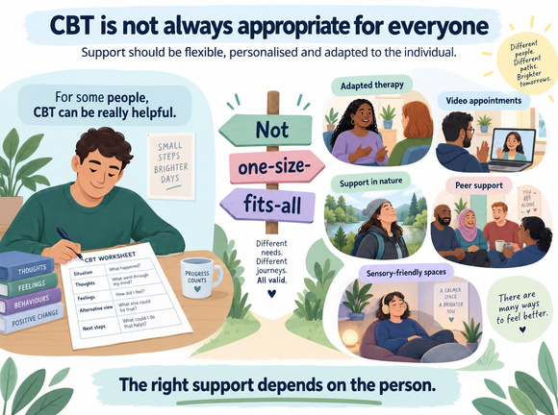
Infographic: adapting CBT and therapeutic support.
Infographic key message: CBT is not always appropriate for everyone. Support should be flexible, personalised and adapted to the individual; the right support depends on the person.
Original newsletter page 40

The transition into adulthood
Transition from children's to adult services emerged as one of the strongest concerns. CASA reported that it had not encountered a successful transition among the young people it had supported through this process in recent years. Similar experiences were raised by others. Young adults can lose support at eighteen, with families and community organisations then having to rebuild evidence and re-establish pathways which had already been in place. The transition was described as a “cliff edge”, leaving some families to coordinate complex care themselves. This led into a wider discussion about the often-hidden role of families and carers. Parents and carers may take on advocacy, coordination and navigation of complex services for many years. That can result in burnout, financial pressure and anxiety about what will happen when family members are no longer able to provide that support. Making support fit people rather than people fit services
Flexibility came through strongly in the discussion. Some neurodivergent people engage particularly well when support can be offered in nature or through video appointments. For others, a conventional clinic, busy public building or even their own home may not be the right environment. The Board discussed the value of identifying or developing neurodivergent-friendly spaces which different organisations could potentially use.
More broadly, there was strong agreement that support should be based upon people's needs and circumstances rather than diagnosis alone.
Long assessment waits mean that requiring a diagnosis before providing support can leave people without help for extended periods. Equally, the fact that somebody is receiving one form of support should not lead to an assumption that their other mental or physical health needs have been met. Diagnostic overshadowing was also raised — where physical or mental health needs can be overlooked or attributed to someone's neurodivergence rather than properly explored.
Neurodivergence and the criminal justice system Another important issue was the connection between neurodivergence, mental health crisis and the criminal justice system.
Organisations working locally described seeing neurodivergent people — particularly men — becoming criminalised during periods of mental health crisis. Examples included involvement with police and custody, prison placements and unsuccessful releases where people's neurodivergent needs had not been properly understood.
The discussion also recognised that criminal justice partners were largely missing from the meeting. One of the actions was therefore to consider bringing Health and Justice and Criminal Justice partners into future Partnership Board discussions.
Original newsletter page 41
Records, trust and people's own accounts Concerns were also raised about inaccurate medical records. People had described finding assumptions recorded as fact, or reading records which did not accurately reflect their recollection of conversations with professionals. There were also examples where recommendations following an assessment appeared disconnected from the issues the person had actually raised. The formal process for challenging or correcting records can itself be difficult and exhausting to navigate. This matters because records do not simply describe somebody's past interactions with services: they may affect how that person is understood and what decisions are made about them in the future. From lived experience to neurodivergent leadership The discussion also went further than conventional consultation and involvement. There was a call for greater investment in neurodivergent leadership — seeing neurodivergent people not only as people whose experiences should be listened to, or as Experts by Experience contributing to services, but as people able to lead, design and shape organisations and systems themselves.

Turning discussion into action
The Board identified a number of practical actions to take the discussion forward.
Partners were also encouraged to take the discussion back into their own organisations and identify practical changes they can make, even where those changes are relatively small.
These included:
Neuro-affirming therapeutic support: encouraging partners to consider, use and share relevant guidance on adapting therapeutic support for neurodivergent people. Neurodivergent-friendly spaces: exploring opportunities to identify free-to-use spaces across Gloucestershire that may be suitable for meeting and supporting neurodivergent people. Transitions from children's to adult services: exploring concerns further from a commissioning perspective and considering which other partners may need to be involved in improving transition arrangements. The role of the VCFSE sector: considering how voluntary, community, faith and social enterprise organisations can contribute to more joined-up support, and how their data and insight might be better captured and used in commissioning. Making Every Adult Matter (MEAM): sharing relevant learning about neurodivergence and system barriers through the wider MEAM network. Applying the learning locally: encouraging partners to share knowledge and resources, consider practical changes within their own work, and feed back examples of action taken. Bringing the evidence together: exploring how themes and action priorities from Mental Health Forums and Partnership Boards could be brought together, and whether this combined evidence could better inform strategic commissioning, contract monitoring, quality assurance and service planning. Children and young people's commissioning: sharing relevant findings with commissioners working across council and health services. Criminal justice links: considering greater involvement of Health and Justice and Criminal Justice partners in future discussions.
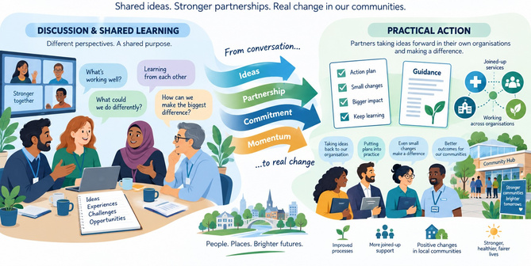
Shared ideas and practical action diagram.
Original newsletter page 42

Adult Social Care update
The meeting also heard about two areas of work within Adult Social Care: a new Pets and Property Policy and a new Adult Social Care Practice Framework.
The Pets and Property work aims to provide clearer support where somebody is admitted to hospital or detained under the Mental Health Act and arrangements need to be made for pets or property.
The Practice Framework is intended to describe what good practice should look like, clarify what people can expect from Adult Social Care and strengthen accountability through quality assurance informed by lived experience.
People with lived experience will be involved in developing both areas of work, including people with experience of hospital admission or detention under the Mental Health Act, and future drafts will be brought back to the Partnership Board.

From knowing to doing
The closing discussion returned to perhaps the most important message from the meeting. Gloucestershire already has a considerable body of knowledge from lived experience, Mental Health Forums, Partnership Boards, voluntary and community organisations and local services. The issue is increasingly not whether we know what many of the problems are. It is whether we can turn what we already know into tangible improvement and measurable change.

The Gloucestershire Mental Health Forums
The next series of forums in September are focused men's mental health in Gloucestershire.
These Forums take place on Teams, and will ask 'What do we know about men's mental health, as it relates to Gloucestershire' and 'what can we do for better outcomes for men in Gloucestershire?'
Then the output that we create from those conversations (called a Digest), will help to influence real change for men across the county.
The dates for the meetings are below - please let rhiannon.davis@rethink.org know if you'd like to attend and to obtain the teams details.

September 2026, All meeting by teams.
Cheltenham — 22 September, 12:30–14:00 Gloucester — 23 September, 13:00–14:30 Cotswolds — 24 September, 13:00–14:30 Forest of Dean & TWNS — 29 September, 11:00–12:30 Stroud & Berkeley Vale — 30 September, 13:00–14:30
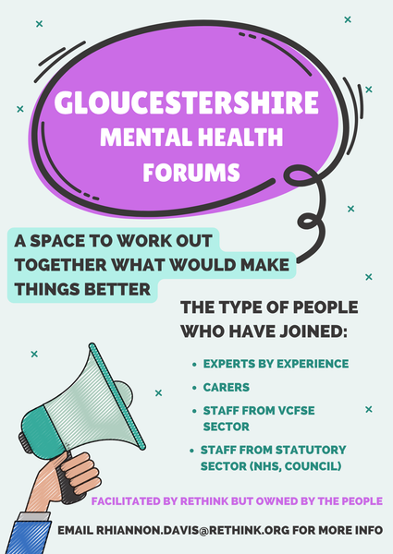
Gloucestershire Mental Health Forums poster.

Physical Disability & Sensory Impairment News

Partnership Board update: Occupational Therapy
Original newsletter page 43

From your Co-Chairs: Katie Peacock and Jan Marriott

The Physical Disabilities and Sensory Impairments Partnership Board. A Deep Dive into Individuals’ Experiences of Occupational Therapy Services
At our latest Physical Disability and Sensory Impairment meeting, we decided to break away from our traditional format of covering multiple topics and instead dedicate our time to one important conversation: people’s lived experiences of Occupational Therapy services. This discussion formed part of the early conversations with our Occupational Therapy colleagues as services prepare to come back in-house within Gloucestershire County Council. We wanted to create space for individuals with lived experience to speak directly about their experiences of Occupational Therapy — past and present — and, importantly, to explore what could be improved in the future. Rather than beginning with systems, processes or policies, the conversation began where services should begin: with the people who use them.
The Journey to Occupational Therapy Individuals shared a wide range of experiences of accessing Occupational Therapy services. The discussion highlighted both the significant difference that good Occupational Therapy can make and the barriers that people can face before receiving the right support. One of the clearest themes was that the journey itself can sometimes be difficult to navigate. Some individuals described not knowing where to go, who to contact or even what support might be available to them. When someone is already dealing with the practical impact of a physical disability, sensory impairment or significant change in their circumstances, navigating an unfamiliar system can create an additional and unnecessary barrier. Waiting times were another significant concern. Individuals spoke about extensive timeframes for assessments, equipment, adaptations or other forms of support, with some feeling that the reasons for delays were not always clearly explained. The impact of waiting can extend far beyond inconvenience. If someone is waiting for equipment or an adaptation that could enable them to complete an everyday activity independently, that delay can affect their independence, confidence and quality of life. It may also place additional pressure on family members, carers and wider support networks. This led to an important question: how do we bridge the gap while someone is waiting? Potential solutions discussed included clearer information about what happens following a referral, more regular updates during periods of waiting, better signposting towards interim support, and ensuring people know who they can contact if their circumstances change.
Original newsletter page 44

Communication That Works for Everyone
The need for clearer, more accessible and consistent communication ran throughout the conversation. Accessibility cannot be based on a single method of communication. Different people have different communication requirements, and services need to recognise and respond to those differences. Information should be available in accessible formats and individuals should be able to understand what stage they are at, what happens next, what realistic timescales might be and who they can contact with questions. Importantly, accessible communication is not simply about providing information. It is also about ensuring that people feel heard and understood.
Looking Beyond the Obvious Solution Another strong theme was the need for greater flexibility and creative, outside-the-box thinking. Disability does not affect everybody in the same way. Two people with similar impairments may have completely different homes, lifestyles, responsibilities, ambitions and definitions of independence. For that reason, solutions cannot always come from a standard list of equipment or adaptations. Individuals highlighted the importance of Occupational Therapists having the opportunity to understand the person as a whole: What are they trying to achieve? What matters to them? What barriers are preventing them from doing it? Sometimes the most effective solution may not be the most obvious one. Greater creativity, flexibility and collaboration with the individual could help identify solutions that work within the reality of somebody’s everyday life.

Continuity and Consistency
Individuals also highlighted the importance of continuity and consistency. Having to repeatedly explain your circumstances to different professionals can be frustrating and exhausting. Where possible, developing an ongoing relationship with somebody who understands the individual, their environment and what they are trying to achieve can make a significant difference. Where changes of staff are unavoidable, effective handovers and good communication can help ensure that people do not feel they are continually starting again. Continuity is not simply about convenience. It can help build trust, and trust can enable individuals and professionals to work together much more effectively.
When Occupational Therapy Works Well It was equally important that the discussion did not focus solely on the challenges. Some Organisations shared extremely positive experiences of Occupational Therapy, describing support that had significantly improved their independence and quality of life. In particular, some survivors of acquired brain injuries reported close links and very positive relationships with Occupational Therapy services. Their experiences demonstrated the difference that personalised, consistent and responsive Occupational Therapy can make. Where relationships with professionals were strong, individuals described feeling understood and supported, with Occupational Therapy helping them find practical ways to regain or maintain independence. These positive experiences are incredibly valuable because they help us understand not only what needs to change, but what is already working and should be protected, learned from and built upon
Original newsletter page 45

Turning Barriers into Opportunities
The experiences shared highlighted several areas where relatively straightforward changes could potentially make a meaningful difference:
Difficulty knowing where to start: provide clearer, accessible information explaining Occupational Therapy, eligibility, referral routes and who to contact. Long or unexplained waiting periods: communicate realistic timescales and provide meaningful updates rather than leaving individuals uncertain about what is happening. The gap while waiting: explore interim solutions, signposting, temporary equipment or other appropriate support wherever possible. Inaccessible communication: ask individuals how they prefer to receive information and make accessible communication a core part of the service. Lack of continuity: wherever possible, provide consistent professional relationships and ensure effective handovers when this cannot happen. Solutions that do not reflect everyday life: start with the individual’s goals and circumstances and encourage creative, collaborative problem-solving. People feeling that decisions happen around rather than with them: involve individuals meaningfully throughout assessment, decision-making and review.
None of these ideas can be considered properly without continuing to involve the people who actually experience the services.

From Conversation to Co-production
This is why conversations like this are so pivotal. Putting individuals at the heart of services means more than asking people what they think. It means listening to — and actively hearing — the barriers, challenges and positive experiences they describe. It means being prepared to learn from what works, acknowledge where things could work better and then bring individuals and professionals together to develop solutions. As Occupational Therapy services move into their next chapter within Gloucestershire County Council, there is a real opportunity to ensure that lived experience helps inform what comes next. Co-production should not begin once a service has already been designed. It begins with conversations like this: people with lived experience and professionals sitting together, sharing knowledge, identifying barriers and asking, “How can we make this work better?” There will undoubtedly be more conversations to come. But this discussion provided an important starting point. This is where the beginnings of co-production have a real chance of making change happen — moving from listening, to understanding, to working together to create services that work more effectively and inclusively for everybody.

Neurology Subgroup update
Original newsletter page 46

From Dave Evans
Since the last newsletter article, the neurological subgroup has met, with one of the main discussion topics being the work of the ME support group.
The group has been working with health service colleagues to ensure that NICE recommendations for ME treatment are embedded in Gloucestershire health services. Unfortunately, recent changes and reorganisation within the health service have significantly affected and delayed this important work, creating real concern about whether its positive outcomes can be achieved.
Uncertainty about responsibilities, decision-making, and communication meant that people with lived experience, who had been working together to deliver this work, suddenly found themselves without clear lines of contact as roles changed or people left their posts. This upheaval made it difficult to maintain the commitment and enthusiasm of the volunteers working to improve services for people with similar conditions.
There was a real risk that this valuable work could fall by the wayside, but the neurological subgroup and the PDSI group were able to provide support and help ensure it was not lost. When changes like this happen, it is essential to keep communicating what they mean for everyone and how they affect co-production work.
This is a strong example of the value of networking groups: by working together, we identified a way forward and the right people to speak to, helping to keep the work on track. Congratulations must go to everyone involved in the support group, who have worked so hard for so long to achieve this outcome.
For more information on the Neurology Subgroup email: asc.co-production@gloucestershire.gov.uk
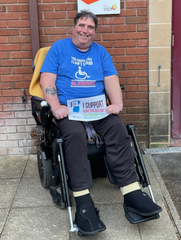
Dave, Chair of Neurology Sub-group

(Unpaid) Carers News

Peer Navigator Support
Original newsletter page 47
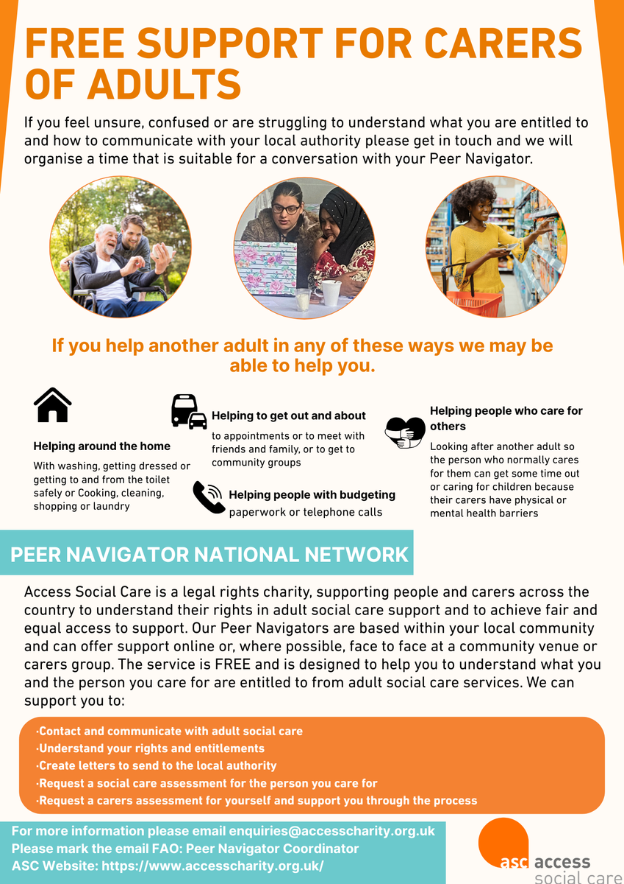
Free support for carers of adults flyer.

Free support for carers of adults
If you feel unsure, confused or are struggling to understand what you are entitled to and how to communicate with your local authority please get in touch and we will organise a time that is suitable for a conversation with your Peer Navigator.

If you help another adult in any of these ways we may be able to help you
- Helping around the home: with washing, getting dressed or getting to and from the toilet safely, or cooking, cleaning, shopping or laundry.
- Helping to get out and about: to appointments or to meet with friends and family, or to get to community groups.
- Helping people with budgeting, paperwork or telephone calls.
- Helping people who care for others: looking after another adult so the person who normally cares for them can get some time out, or caring for children because their carers have physical or mental health barriers.

Peer Navigator National Network
Access Social Care is a legal rights charity, supporting people and carers across the country to understand their rights in adult social care support and to achieve fair and equal access to support. Our Peer Navigators are based within your local community and can offer support online or, where possible, face to face at a community venue or carers group. The service is FREE and is designed to help you to understand what you and the person you care for are entitled to from adult social care services.
We can support you to:
- Contact and communicate with adult social care.
- Understand your rights and entitlements.
- Create letters to send to the local authority.
- Request a social care assessment for the person you care for.
- Request a carers assessment for yourself and support you through the process.
For more information please email enquiries@accesscharity.org.uk
Please mark the email FAO: Peer Navigator Coordinator
ASC Website: Access Social Care website

About the Carers Hub
Original newsletter page 48

Gloucestershire Carers Hub
Gloucestershire Carers Hub supports unpaid Carers throughout the county of Gloucestershire. We can support you if you live in Gloucestershire, or if you are a carer for someone who lives in Gloucestershire but you live out of county.
You may be supporting someone with physical or emotional needs. They could be living independently from you but require your support on a daily or weekly basis. This could be due to ill health, frailty, mental health or due to an addiction. They may also live in residential care or support, but you remain an active part of their support network.
There is no minimum requirement for the number of hours which you are supporting someone for.
You may be supporting them:
- Via the telephone, offering emotional support.
- Taking someone to appointments.
- Supporting with cooking, cleaning, shopping and other daily tasks.
- Assisting with dressing, cleaning and other personal care needs.
- Going in to check on someone regularly.
Whatever you do to support someone else you are a Carer even if you do not think of yourself as one.
The individual who you are supporting could be a family member, spouse, husband, wife, child, adult child or partner; a friend; a neighbour; or an ex-partner.
Whoever you are supporting, we are here to offer advice, information and support to you to enable you to think about your needs whilst offering support to someone else.
If there are a number of people supporting someone, we welcome anyone providing support to someone to register with us to access information, support and our services.
Gloucestershire Carers Hub website
Call 0300 111 9000 or email carers@peopleplus.co.uk.
Self-referral to Gloucestershire Carers Hub

Our Monthly Programmes
Gloucestershire Carers Hub is here to support unpaid carers with a range of friendly and informative sessions. Our monthly programmes include opportunities to connect with other carers, learn practical tips for managing your caring role, and take time for your own wellbeing.
For full details and booking, visit the Gloucestershire Carers Hub website or call 0300 111 9000.

