Novel Coronavirus (COVID-19)
Useful links
DHSC Twitter page which is updated at 2pm every day:
https://twitter.com/DHSCgovuk?ref_src=twsrc%5Egoogle%7Ctwcamp%5Eserp%7Ctwgr%5Eauthor

Public facing information

NHS public facing information – the first port of call for the public
https://www.nhs.uk/conditions/coronavirus-covid-19/

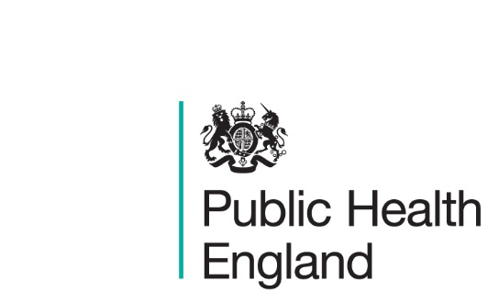
Latest information and advice:
https://www.gov.uk/guidance/wuhan-novel-coronavirus-information-for-the-public
FAQs
https://publichealthmatters.blog.gov.uk/2020/01/23/wuhan-novel-coronavirus-what-you-need-to-know/

Blog about contact tracing:
https://publichealthmatters.blog.gov.uk/2020/02/13/expert-interview-what-is-contact-tracing/

Blog about self-isolation
https://publichealthmatters.blog.gov.uk/2020/02/20/what-is-self-isolation-and-why-is-it-important/

Travel advice for those travelling and living overseas:
https://www.gov.uk/guidance/travel-advice-novel-coronavirus

Public information campaign

Resources for the public information campaign:
https://campaignresources.phe.gov.uk/resources/campaigns/101-novel-coronavirus-/resources.

Resources for universities:
https://www.universitiesuk.ac.uk/policy-and-analysis/Pages/coronavirus.aspx

Guidance

Guidance for clinical / public health stakeholders: https://www.gov.uk/government/collections/wuhan-novel-coronavirus

Guidance for healthcare providers: healthcare workers who have travelled to China and other specified areas/countries, or are contacts of possible cases:
https://www.gov.uk/government/publications/novel-coronavirus-2019-ncov-guidance-for-healthcare-providers-with-staff-who-have-travelled-to-china/guidance-for-healthcare-providers-healthcare-workers-who-have-travelled-to-china
Guidance to assist professionals in advising the public:
https://www.gov.uk/government/publications/novel-coronavirus-2019-ncov-guidance-to-assist-professionals-in-advising-the-general-public/guidance-to-assist-professionals-in-advising-the-general-public

Guidance for professionals helping people in the education, transport and other sectors
https://www.gov.uk/government/collections/covid-19-guidance-for-non-clinical-settings-and-the-public

Guidance for employers and businesses:
https://www.gov.uk/government/publications/guidance-to-employers-and-businesses-about-covid-19

Guidance for social and community care in residential settings:
https://www.gov.uk/government/publications/guidance-for-social-or-community-care-and-residential-settings-on-covid-19

Guidance to educational settings: https://www.gov.uk/government/publications/guidance-to-educational-settings-about-covid-19/guidance-to-educational-settings-about-covid-19

Guidance for boarding schools:
http://www.boarding.org.uk/media/news/article/13449/Coronavirus-disease-COVID-19-guidance-update-as-of-25-2-20

Foreign travel advice for Italy:
https://www.gov.uk/foreign-travel-advice/italy

NEW Guidance for staff in the transport sector:
https://www.gov.uk/government/publications/covid-19-guidance-for-staff-in-the-transport-sector

NEW COVID-19: Specified countries and areas:
https://www.gov.uk/government/publications/covid-19-specified-countries-and-areas

Media statements
Statement from the 4 UK Chief Medical Officers:
https://www.gov.uk/government/news/statement-from-the-four-uk-chief-medical-officers-on-novel-coronavirus

Statement from the CMO for England about the ninth case:
https://www.gov.uk/government/news/cmo-for-england-announces-ninth-case-of-novel-coronavirus

Statement from the CMO England about cases five to eight:
https://www.gov.uk/government/news/chief-medical-officer-for-england-announces-four-further-coronavirus-cases

Statement from the CMO for England about the fourth case:
https://www.gov.uk/government/news/cmo-confirms-fourth-case-of-coronavirus-in-england

Health Secretary's statement to Parliament:
https://www.gov.uk/government/speeches/coronavirus-health-secretarys-statement-to-parliament

Health Secretary announces strengthened legal powers to bolster public health protections against coronavirus:
https://www.gov.uk/government/news/health-secretary-announces-strengthened-legal-powers-to-bolster-public-health-protections-against-coronavirus

Statement about the launch of the public information campaign:
https://www.gov.uk/government/news/coronavirus-public-information-campaign-launched-across-the-uk

Statement from the Foreign Office:
https://www.gov.uk/government/news/fco-statement-british-nationals-in-hubei-province

NEW Secretary of State makes new regulations on coronavirus:
https://www.gov.uk/government/news/secretary-of-state-makes-new-regulations-on-coronavirus

NEW Health Secretary’s statement to Parliament 26th Feb:
https://www.gov.uk/government/speeches/covid-19-health-secretarys-statement-to-parliament

