


Project Bulletin June 2020 - Whitminster Canal Bridge
Since our last bulletin, works have continued to progress well on site. We have completed the installation of all required wing walls. We have also mobilised our sheet piling contractor, who has now installed 70% of the steel sheet piled walls to the canal channel within the middle of the roundabout. We have commenced excavation works at the southern end of the roundabout in preparation for delivery and installation of large precast concrete culvert units at the end of this month.

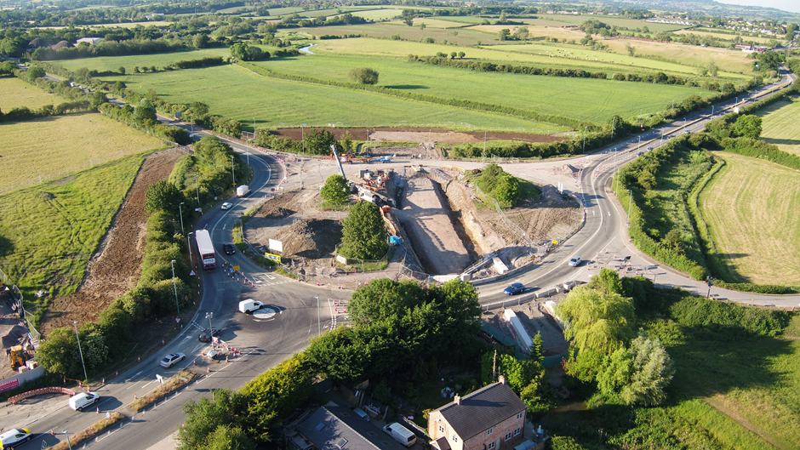

As we progress with these important improvements, your continued patience is greatly appreciated.
If you have any concerns or issues regarding the road improvement scheme, please contact me on 0300 041 4635*. I will be available throughout the construction phase to provide continuous engagement with businesses and residents within the local area.
Further information about the scheme can be found at
https://www.gloucestershire.gov.uk/highways/major-projects-list/a38-canal-bridges/
Neil Evans
Contract Liaison Officer
Alun Griffiths (Contractors) Ltd
0330 041 4635*

*Calls to this number are charged at national call rates and included in inclusive minute plans from landlines and mobiles

