Ready For Learning Guidance for Settings
The spreadsheet will look like this:
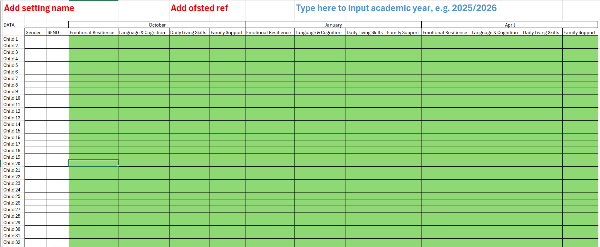

- Type in your setting’s name.
- Type in your Ofsted reference number.
- Type in the academic year you are calculating (e.g. 2025/26).
- Please add data in October, January and April for each child in all four areas as per the questionnaire.
- When you have completed inputting for April, please save your spreadsheet.
- Completed spreadsheets should be sent to the EYSadviceline@gloucestershire.gov.uk by 31st May 2026
- Data will be analysed by the EE & CD Team and providers will receive personalised information by 31st July 2026.
If you have any questions, please contact the Advice Line and speak to an Inclusion Advisor.

