

Schools OBO - Absence Form

Schools OBO - Absence Form

In this step by step guide, you will learn how to:

- Complete the Absence Schools E-Form.
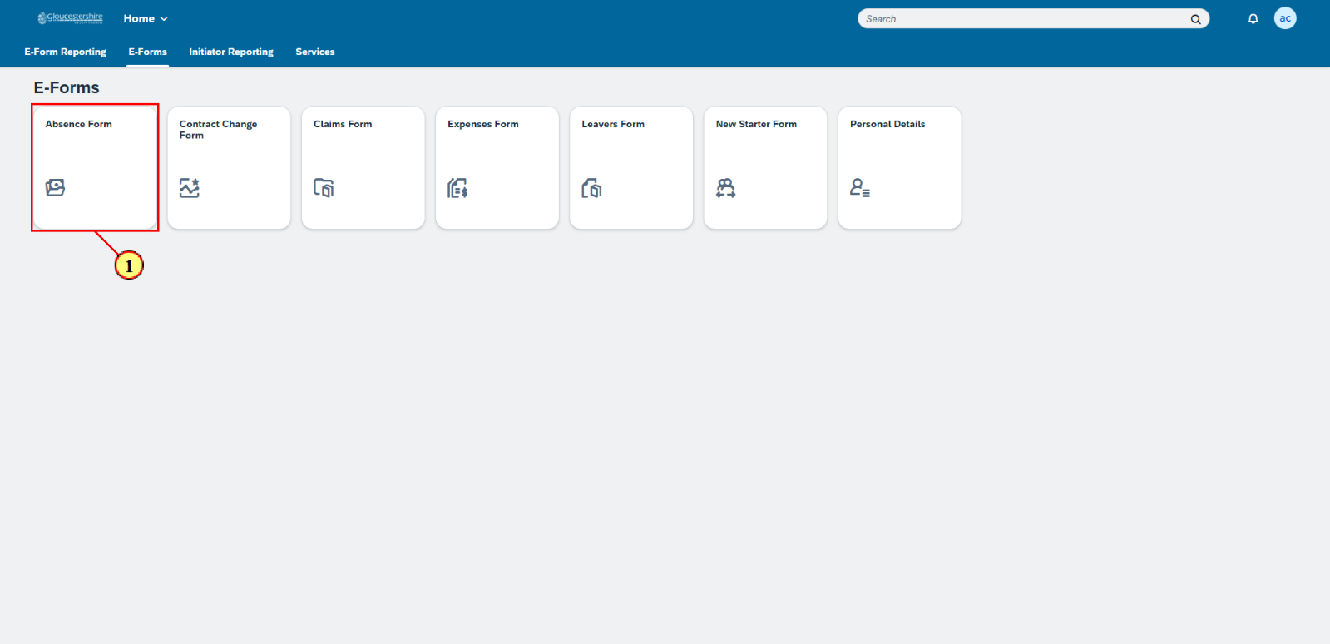
 | Absences can be updated using the Absence E-Form.

(1) Click on the Absence Form tile.
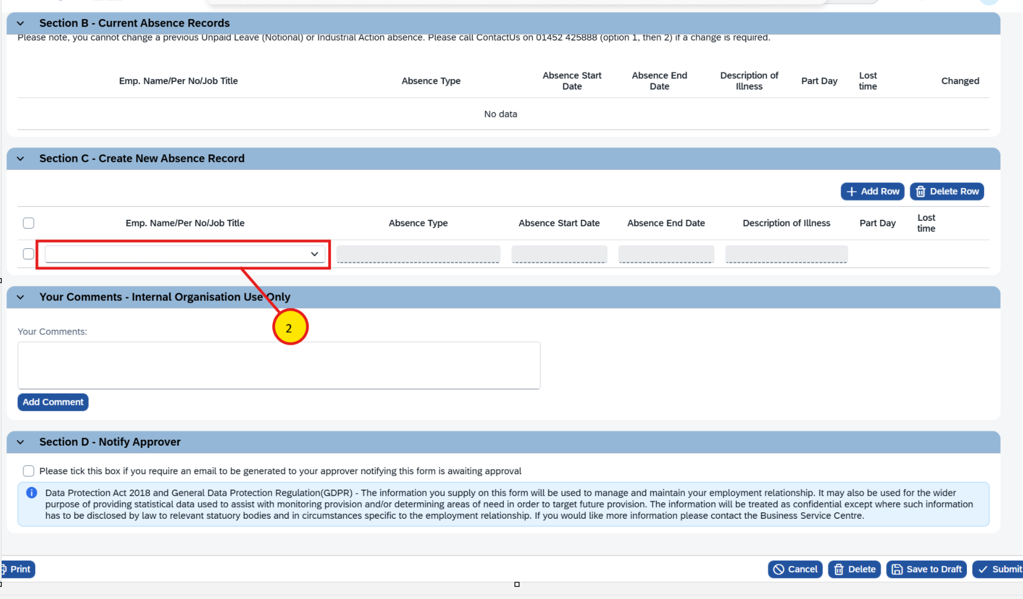
The Absence Form will open. Section A - Previous Absence Records and Section B - Current Absence Records show previous and current staff absences.

To add a new staff absence, go to Section C - Create New Absence Record.

(2) Click on the picklist in the Emp. Name/Per No/Job Title field.
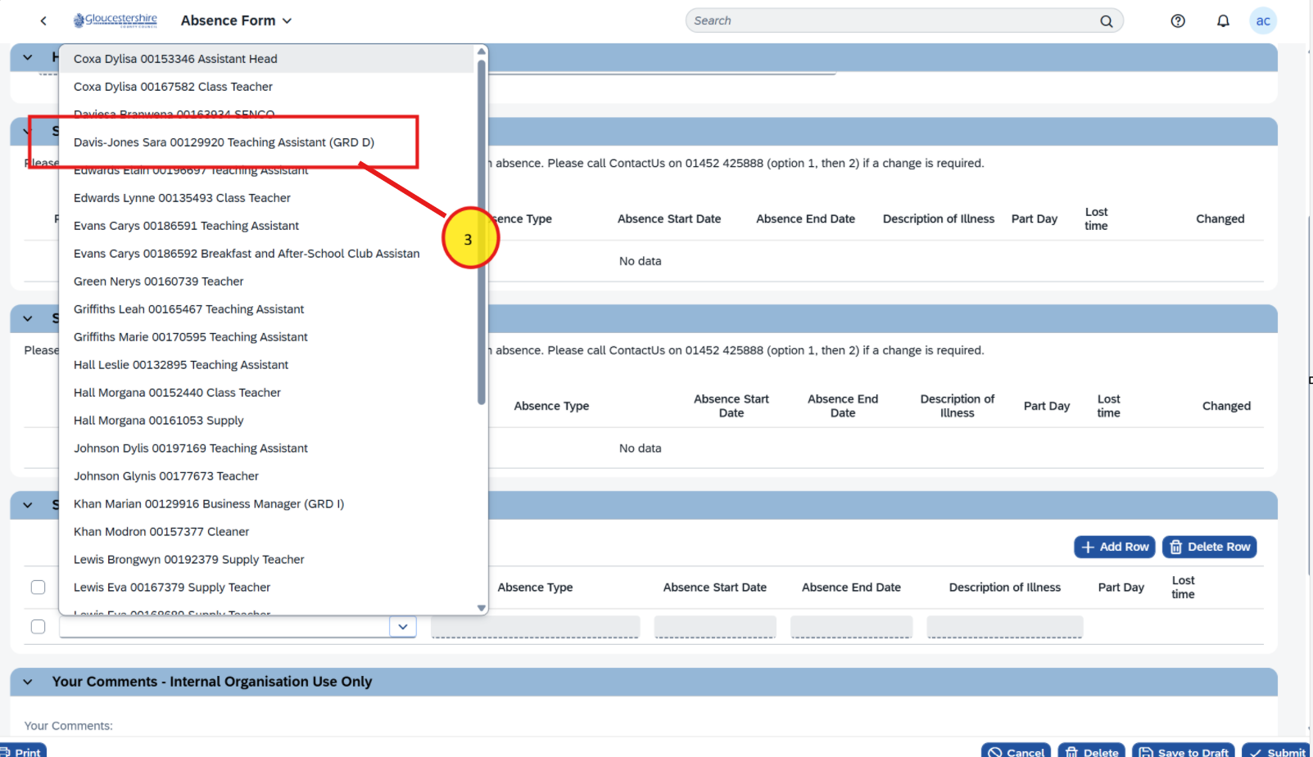
(3) The relevant staff member is then chosen from the list.

If workschedule is not added, user will get below error stating: “Please use the contract change form to create a work schedule prior to creating an absence for these employments: <emp no>”

If work schedule is previously added, user will not see this error and should be able to select Absece Type.

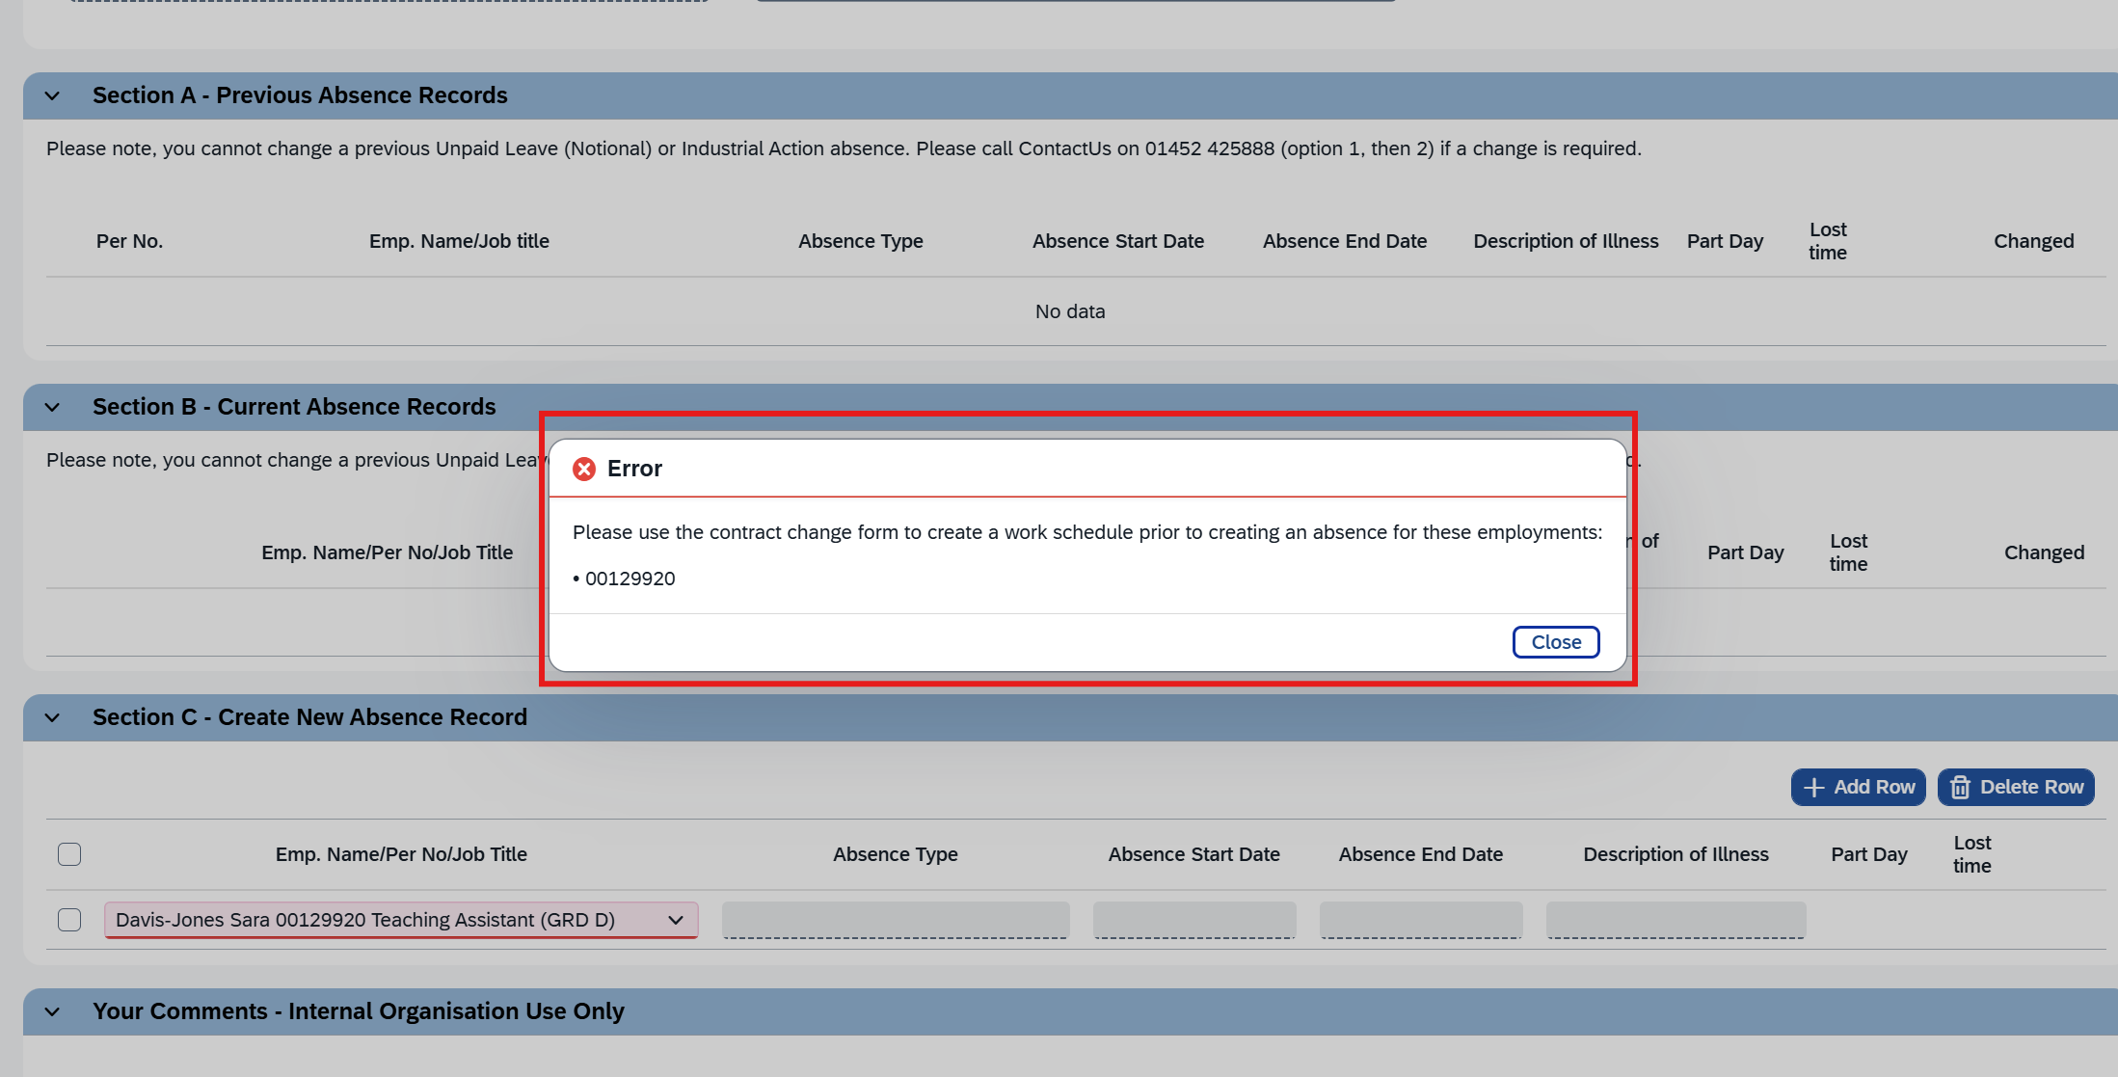

Note: At this stage user can save the form using Save to Draft button and come back to form after work schedule is added using Contract Change form.

After Workschedule is added through contract change form, user can open the Save to Draft form and continue.
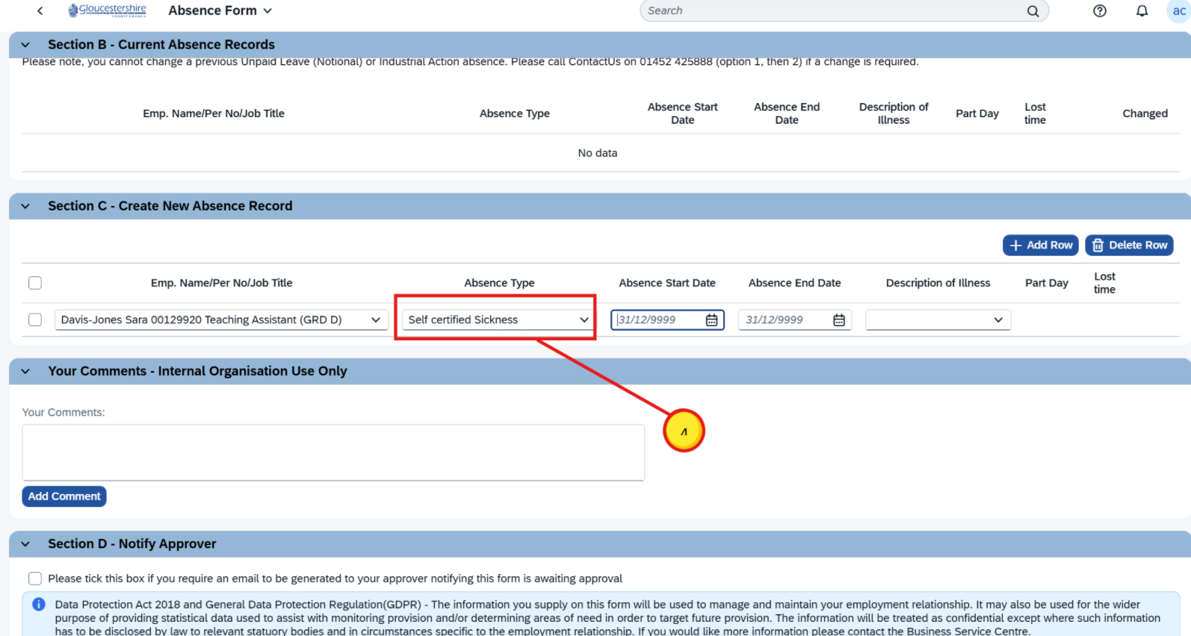
(4) Picklists can also be filtered by typing part of the required option. In this example we typed self in the Absence Type field.
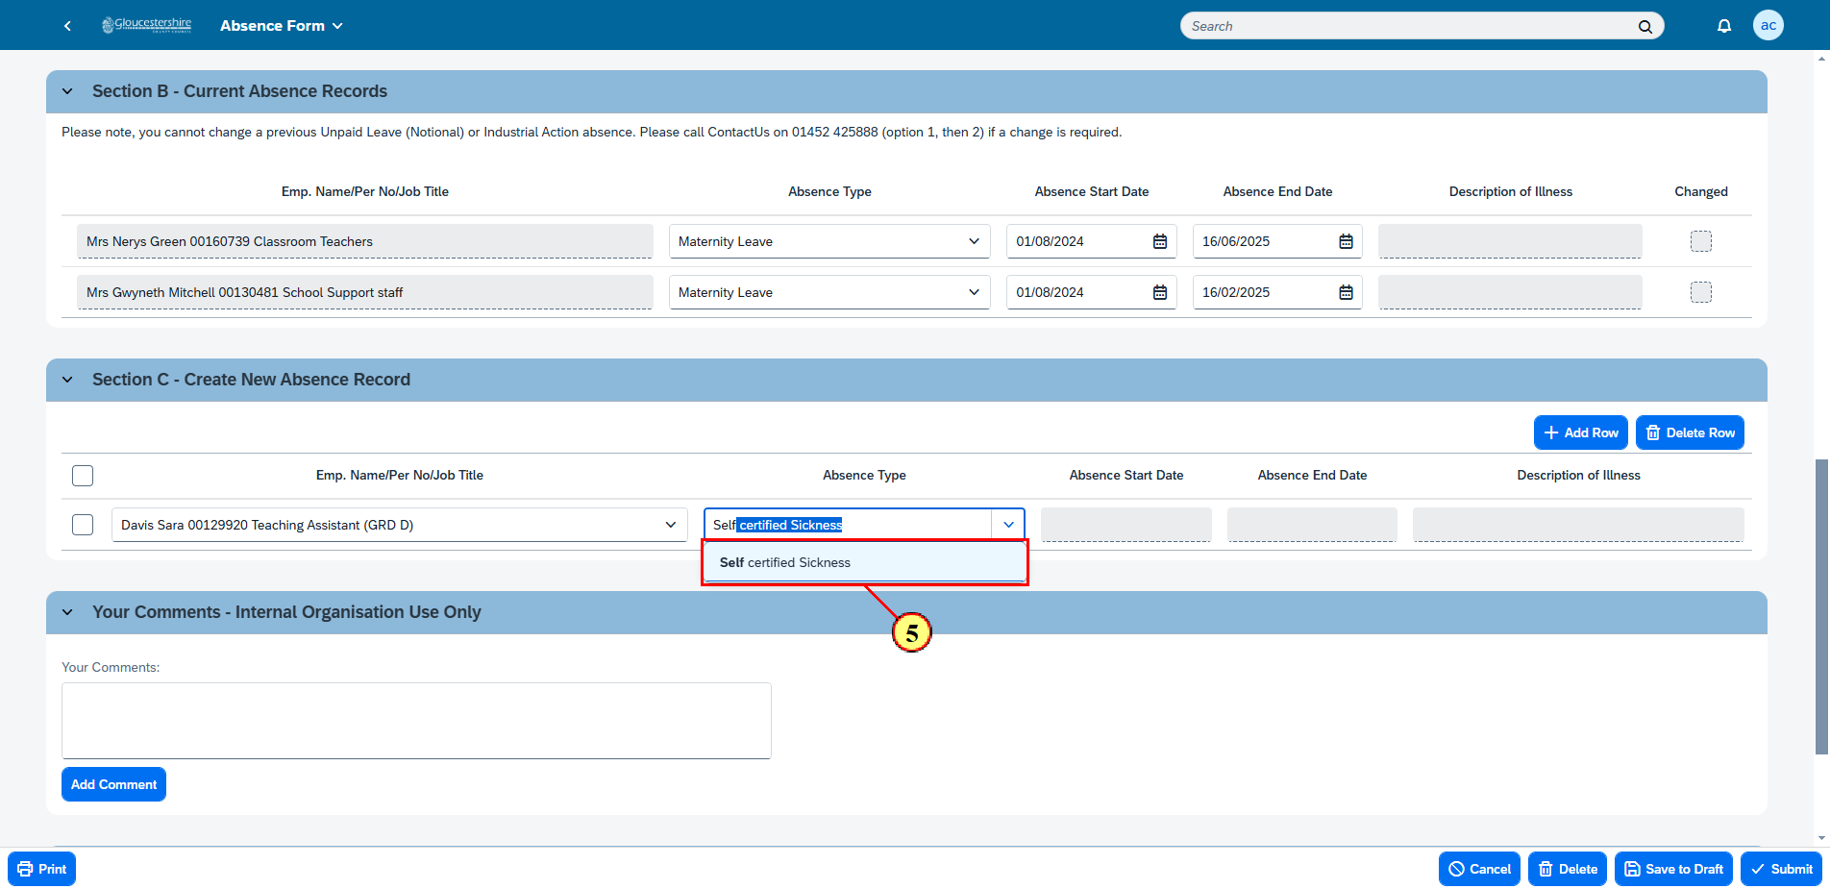
(5) Then select the filtered option.
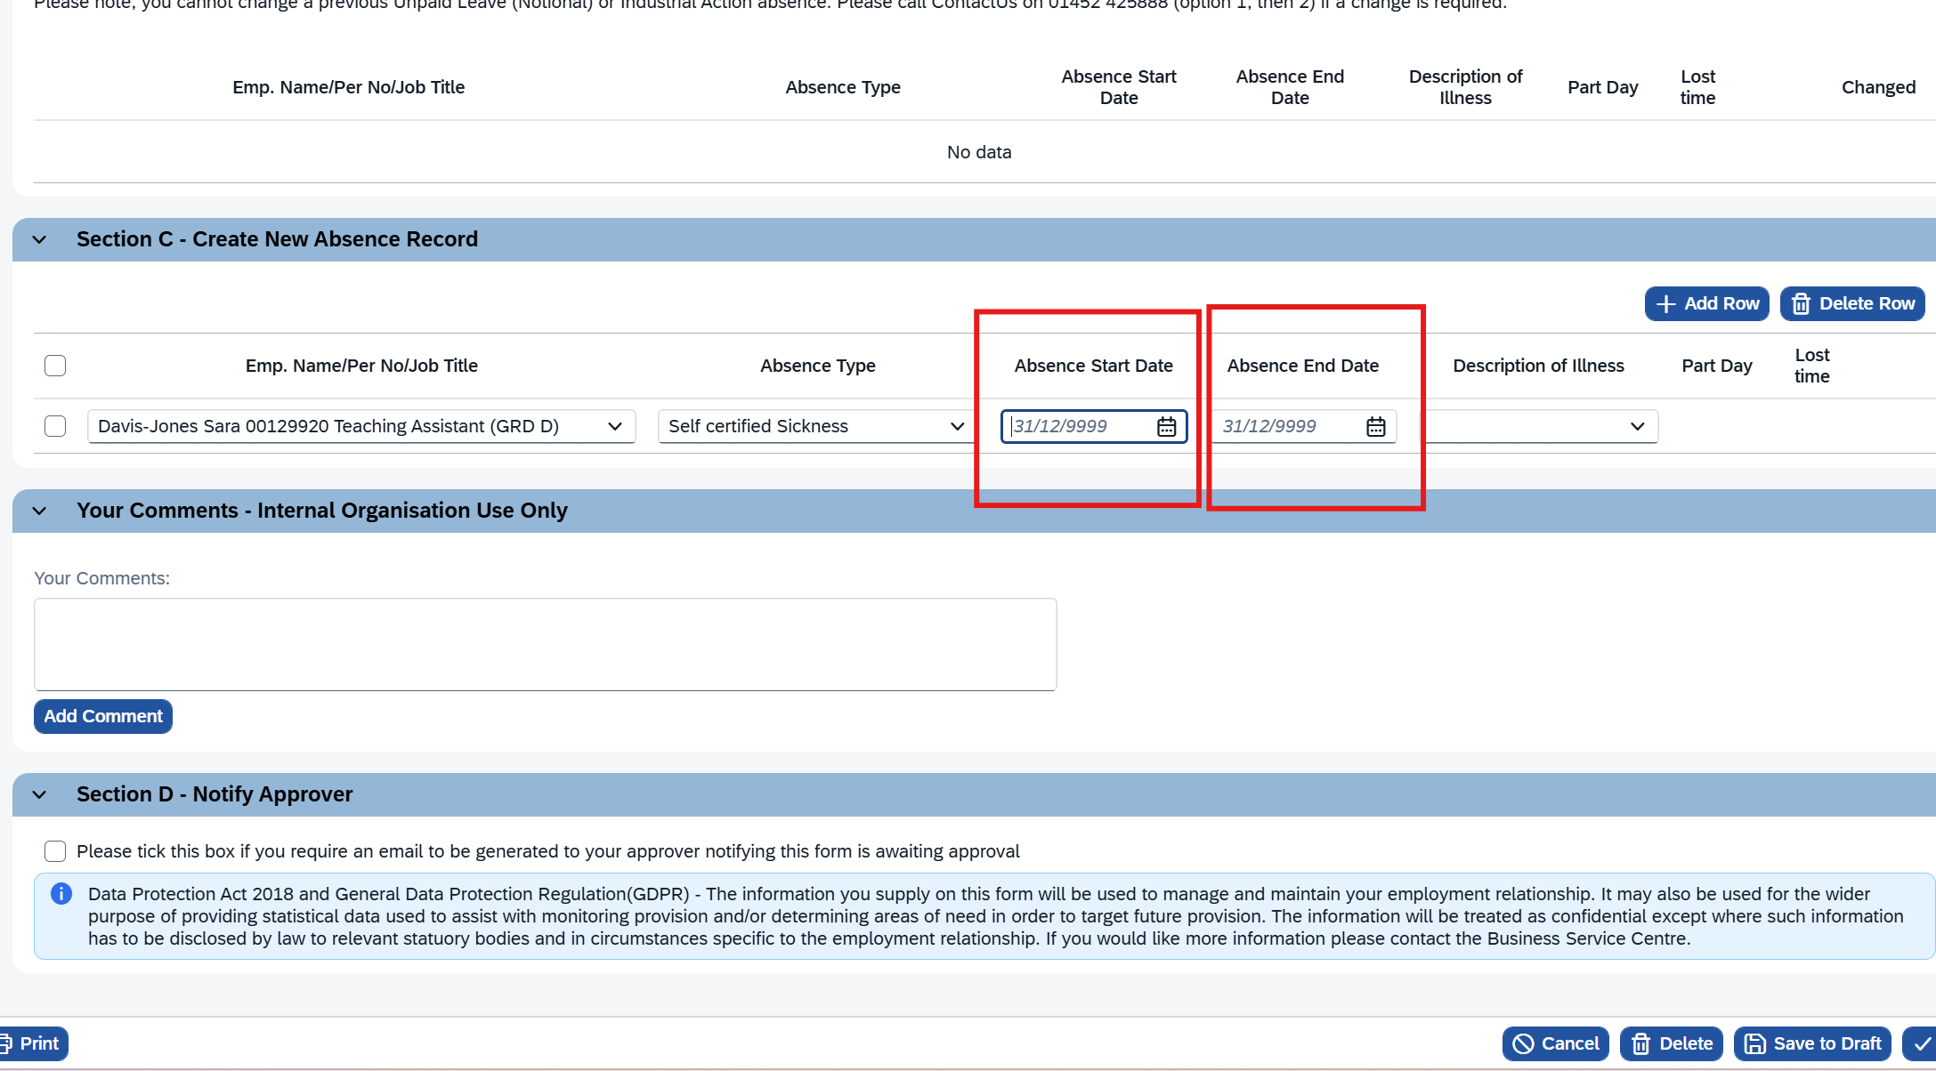
The Absence Start Date is then added by either using the calendar button or by typing the absence start date.

Note: If typing the date this must always use the format dd/mm/yyyy.

Important: In the new Absence E-Form, an Absence End Date must ALWAYS be added to ensure the form is processed correctly even if this is only a possible Absence End Date.

If required the Absence End Date can be changed in Section B - Current Absence Records at a later point once the correct Absence End Date has definitely been established.

If the same date Absence Start Date and Absence End Date is selected, user can see Part Day checkbox enabled. If user wants to enter Part Day absence, user may select the Part Day checkbox and add Lost time.
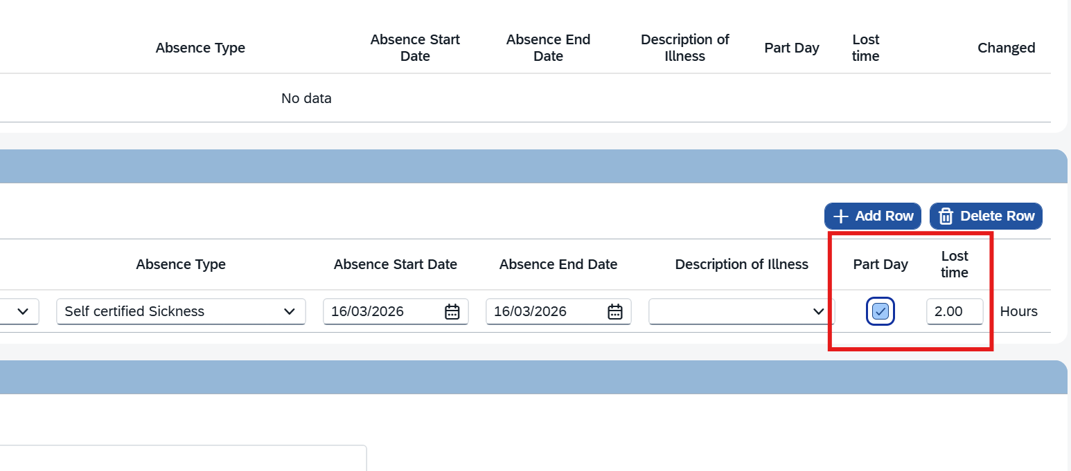
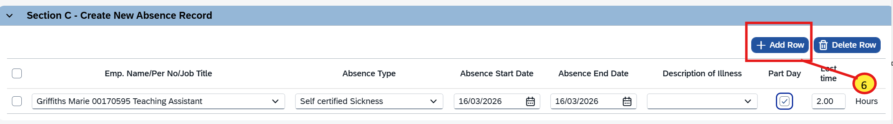

(6) If more than one Absence needs to be added for the same person, this can be done using the + Add Row button.
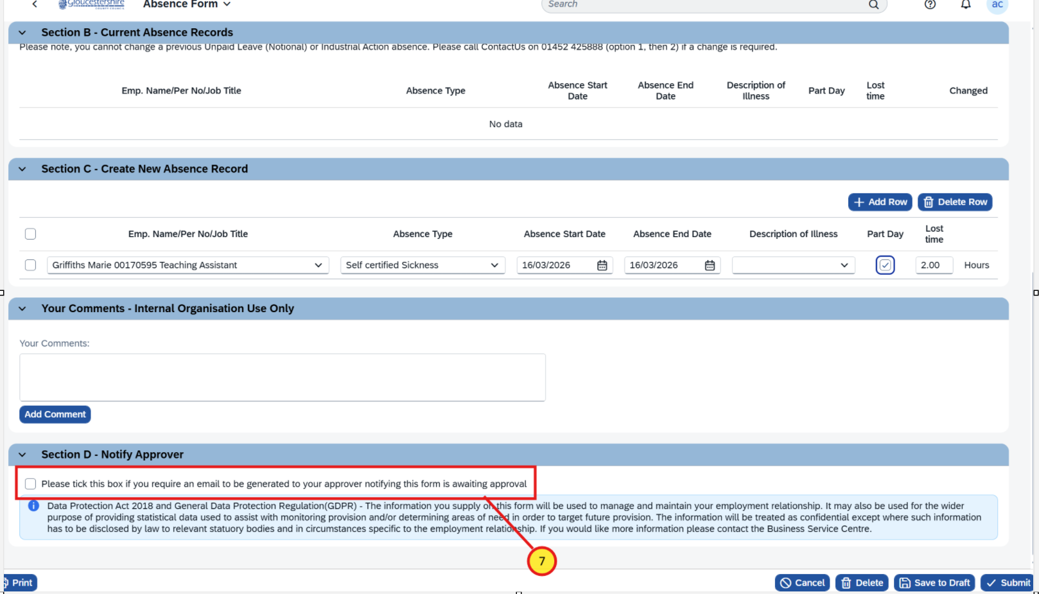
(7) If the form needs to checked by an Approver, tick the box in Section D - Notify Approver.

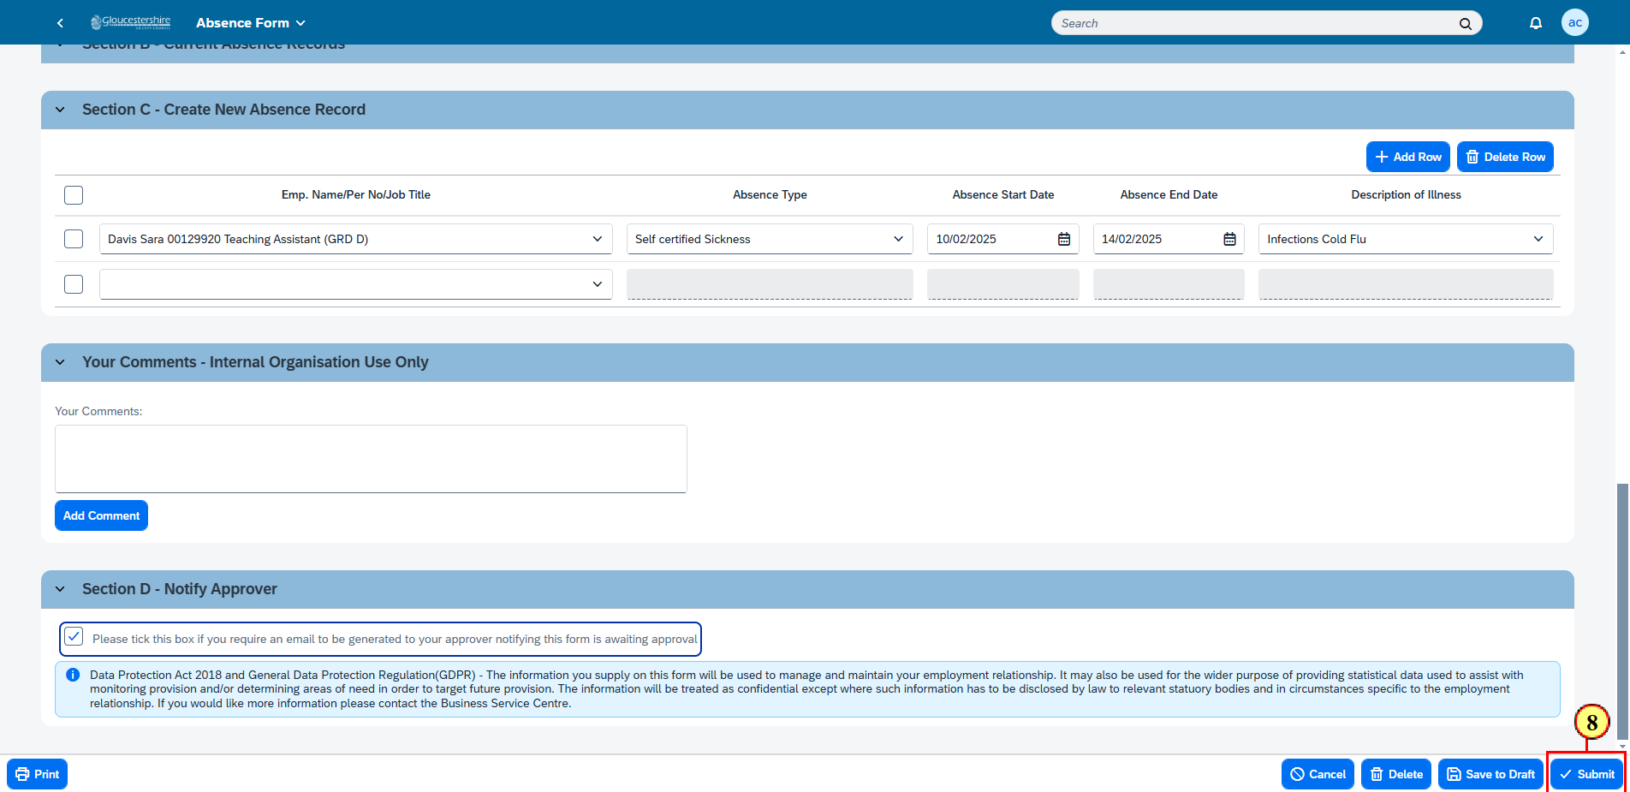
(8) Then click on Submit to complete the Absence form.
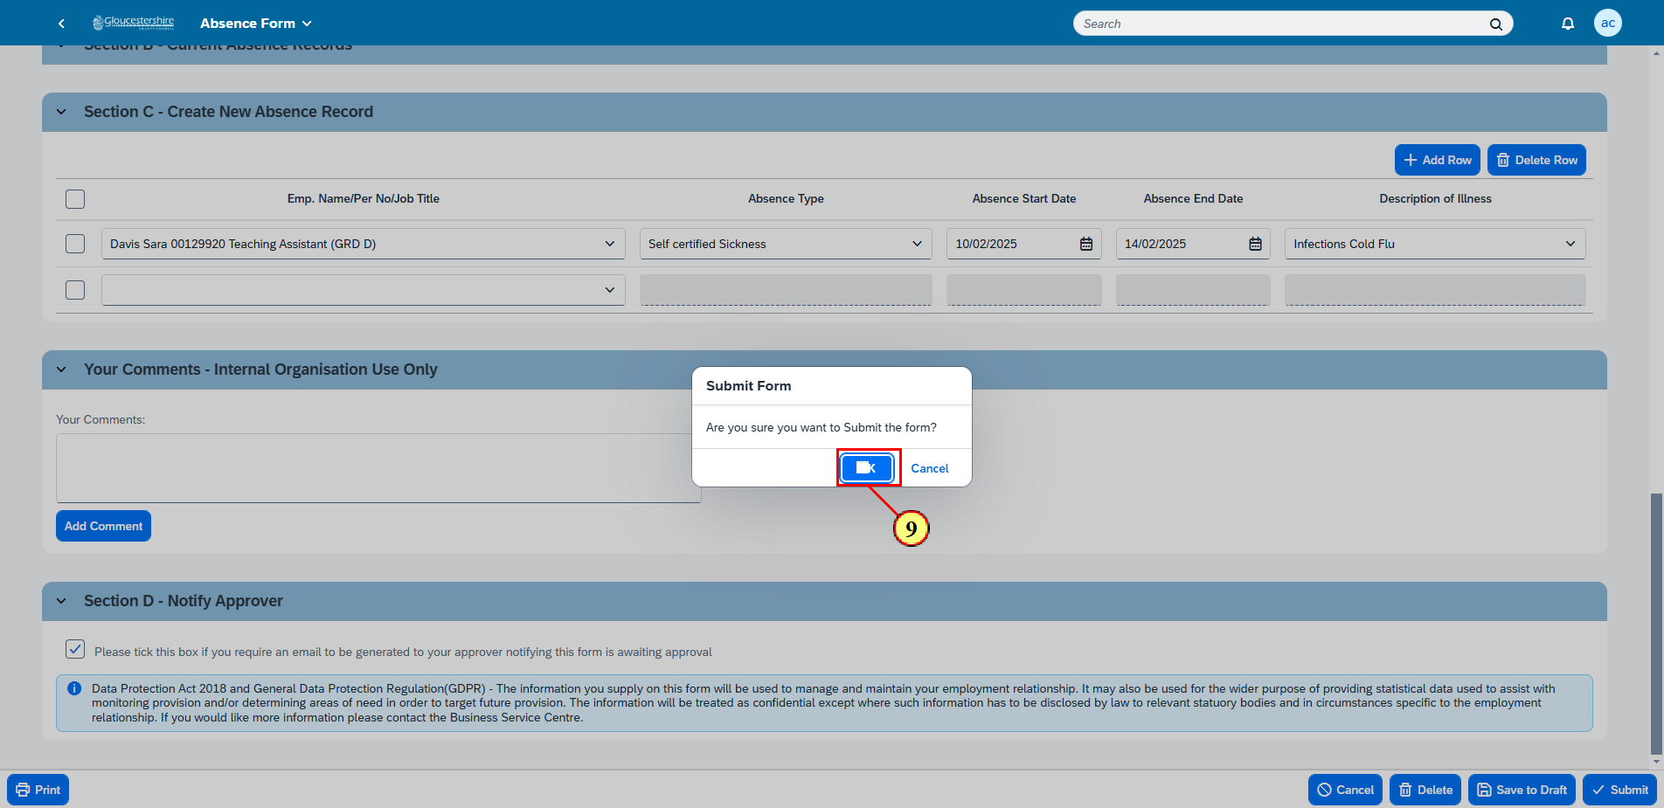
(9) Click on Ok to submit the form.
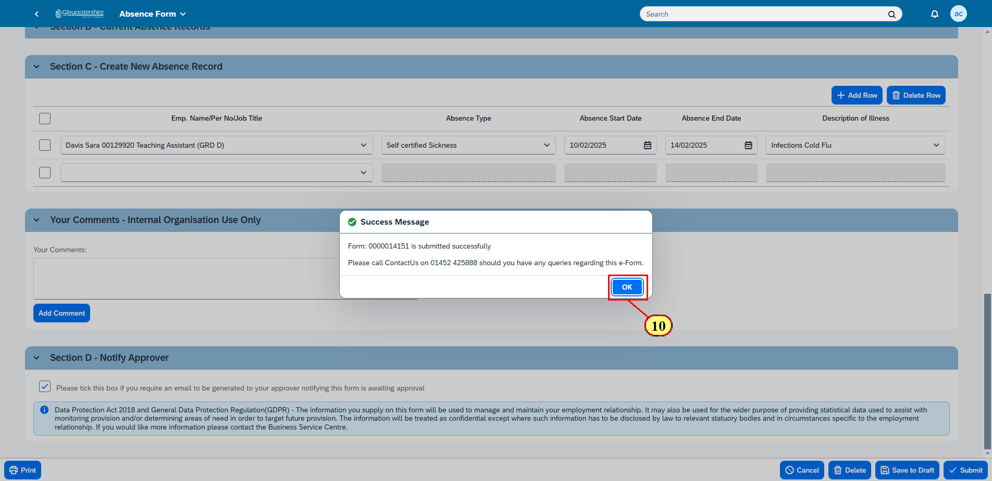
(10) Click on Ok on the message confirming the form has been submitted.
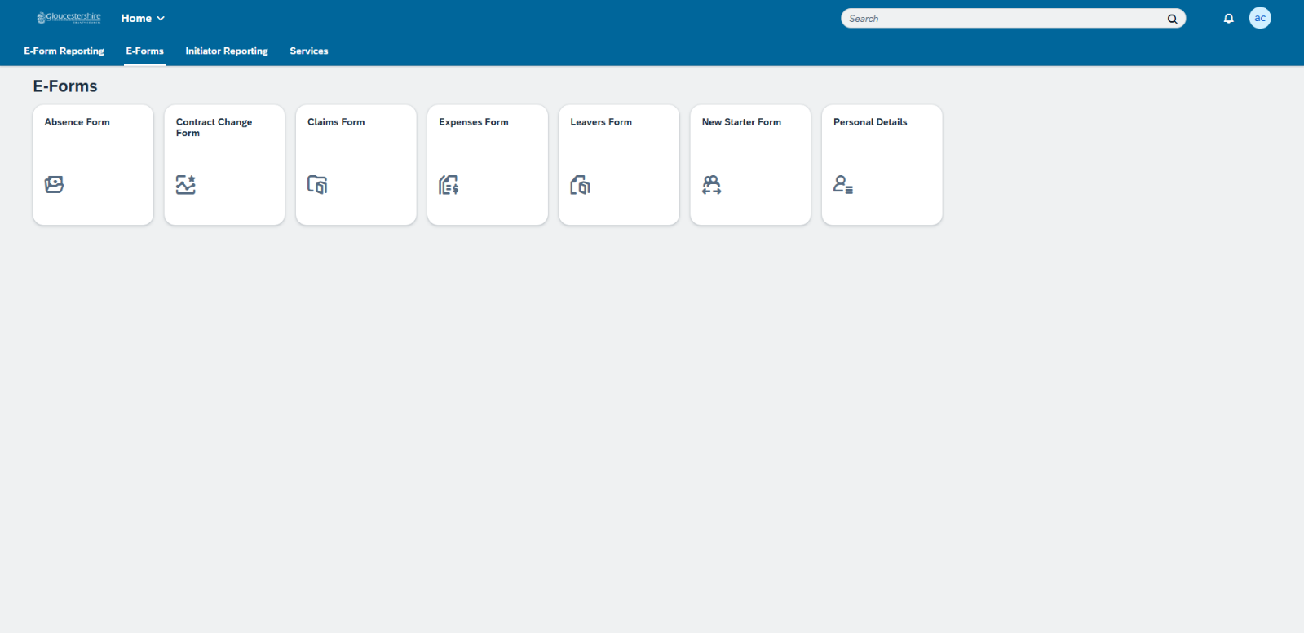
The Absence Form has now been successfully created.

