The Learning Environment: The Physical Environment
Storage and Organisation

It is important to consider how you contain and display your resources to ensure children’s learning opportunities are maximised, and their independence skills developed. Having clear systems in place, supports the resources to be well maintained, presented and children are able to know where to find items as they remain in the same place.
Things to consider
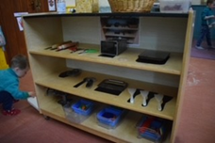
Open shelving - allows children to easily see what’s available and self-select their resources.
Shadowing resources – helps children to be independent when tidying up. The ‘shadows’ are cut from coloured card or paper and glued to the shelf then covered in sticky back plastic or painted directly on.
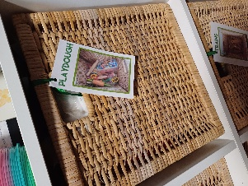
Labelling – Label all storage with clear photographs with words attached. Get the children involved in taking the photographs to create the labels giving them ownership over their space.
Shallow trays and boxes – allow children to easily find resources, without tipping everything out.
Colour coding – You could use colour coded storage for different areas, e.g. clear storage for messy play and wicker baskets for dry areas, green for food preparation or coloured ribbons on baskets that link to specific areas of the provision.
Front-facing bookshelves – organising books to face forwards allows children better access to scan and choose a book of interest. A book is also more likely to catch a child’s eye if they can see the cover whilst passing by!
Organise resources at different heights - Could you create learning spaces on the floor as well as on top of platforms positioned at different heights? You could use pallets, crates, cable reels, and shelving tops.
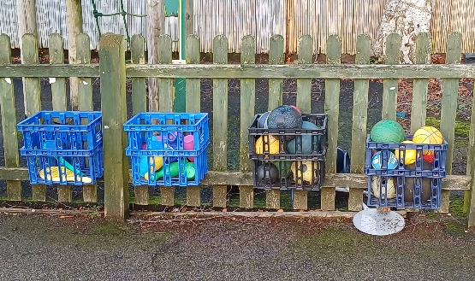
Loose parts – Think carefully about how you store your loose parts to maximise accessibility and creativity. You could use compartment boxes, cutlery trays or recycle egg boxes for smaller items!
Storage ideas - Crates can be used for storage, shelving and transportation of resources by children. Wheeled storage can be used when there is less space and are ideal for creative areas. Cutlery trays, tin cans or plant pots can be used for mark making resources. Trunks or suitcases can be used for grouping resources in themed play
Overflow space - Do you have space for a central store of resources? Such as a storage cupboard, secure shed or garage? Having an organised over-flow space makes it easier to quickly swap out resources in response to children’s play and interests. As well as to offer rotation of seasonal resources.
Quantity of resources – You need to consider if you have enough resources for the number of children in attendance, as well as if you have too many resources, which can cause children to become overwhelmed.
Top tips for inclusion
- If you have resources stored away from children, consider creating a photo book so that they can look, choose and request items to play with.
- Consider the developmental stage of your children; and if resources are easily accessible to all e.g. babies will need items lower down.

Partnership with Parents
- Could you ask parents to bring in resources to support with your storage, such as empty egg boxes?

