
Levelling Up Fund Application Form
This form is for bidding entities, applying for funding from the Levelling Up Fund (LUF) across the UK. Prior to completing the application form, applicants should read the LUF Technical Note.
The Levelling Up Fund Prospectus is available here.
The level of detail you provide in the Application Form should be in proportion to the amount of funding that you are requesting. For example, bids for more than £10m should provide considerably more information than bids for less than £10m.
Specifically, for larger transport projects requesting between £20m and £50m, bidding entities may submit the Application Form or if available an Outline Business Case (OBC) or Full Business Case (FBC). Further detail on requirements for larger transport projects is provided in the Technical Note.
One application form should be completed per bid.

Applicant & Bid Information

Local authority name / Applicant name(s)*:
Gloucestershire County Council (GCC)
*If the bid is a joint bid, please enter the names of all participating local authorities / organisations and specify the lead authority

Bid Manager Name and position: Alan Bullock, Team Leader Local Major Projects
Name and position of officer with day-today responsibility for delivering the proposed scheme.

Senior Responsible Officer contact details:
Colin Chick
Executive Director of Economy, Environment & Infrastructure
Gloucestershire County Council
Block 3 Floor 3, Shire Hall, Westgate Street, Gloucester, GL1 2TG
Chief Finance Officer contact details:
Steve Mawson
Executive Director of Corporate Resources
Gloucestershire County Council
Block 4 Third Floor, Shire Hall, Westgate Street, Gloucester, GL1 2TG
Country:
X England
Scotland
Wales
Northern Ireland

Please provide the name of any consultancy companies involved in the preparation of the bid:
Atkins

For bids from Northern Ireland applicants please confirm type of organisation
Northern Ireland Executive Third Sector
Public Sector Body Private Sector
District Council Other (please state)

PART 1 GATEWAY CRITERIA
Failure to meet the criteria below will result in an application not being taken forward in this funding round
1a Gateway Criteria for all bids  Please tick the box to confirm that your bid includes plans for some LUF expenditure in 2021-22  Please ensure that you evidenced this in the financial case / profile. | X Yes  No
1b Gateway Criteria for private and third sector organisations in Northern Ireland bids only  - Please confirm that you have attached last two years of audited accounts. | Yes  No
- Northern Ireland bids only Please provide evidence of the delivery team having experience of delivering two capital projects of similar size and scale in the last five years. (Limit 250 words)

PART 2 EQUALITY AND DIVERSITY ANALYSIS

2a Please describe how equalities impacts of your proposal have been considered, the relevant affected groups based on protected characteristics, and any measures you propose to implement in response to these impacts. (500 words)
The proposed Gloucestershire Sustainable Travel Corridor (GSTC) scheme, promotes equality of opportunity for all protected characteristics and will impact particularly positively on people with a disability and in specific age groups:

The improvements have the potential to impact on a wide age range with primary education, further education facilities and retirement living as well as residential properties being in proximity to the scheme.
However, by improving accessibility to and from Gloucester College, and by linking the College and Gloucestershire University to Gloucester’s city centre with it’s services, student accommodation and transport hubs, a specific benefit will be created for young people, a group particularly affected by the economic impacts of the Covid-19 related restrictions. In Gloucestershire, Gloucester has the highest proportion of 0-19 year olds (24.8%) of all districts, exceeding county and national figures.

Gloucester also has the highest number of residents with a long-term health problem or disability (40,563 people) in the county. According to ONS data, the areas that will be directly impacted by this project accommodate 2,578 of those residents (6.3%). The routes forming the GSTC have been disability audited and the chosen routes, based on LCWIP, were deemed most appropriate during the LCWIP consultation with vulnerable users.

The ongoing scheme design will also ensure it accommodates users with disabilities including appropriate footway widths, lighting, sign-posting, crossings and tactile paving, ultimately aiding accessibility once complete. Groups representing people with disabilities will continue to be key stakeholders in the consultation process. During construction due regard must be given to diversionary routes to maintain access for disabled users.

In addition to the above, groups with other protected characteristics, such as sex, race (incl gypsy & traveller), gender reassignment, marriage & civil partnership, pregnancy & maternity, religion/belief and sexual orientation have been considered and will continue to be considered through the design, consultation and implementation process.

For example, the improvements to cycle infrastructure will improve perceptions of safety and security ensuring that all users will feel comfortable using it. Potential diversions during construction must provide perceptions of safety such as sufficient lighting and passive surveillance.

An Equality Impact Assessment will be produced as part of the necessary Cabinet approval processes. :

In addition, the following actions will be taken:
- Monitoring scheme to ensure protected groups are well served.
- Prevent scheme construction from impacting the movement of protected groups.
- Providing access to relevant information to all protected groups.
- Ensuring that contractors adhere to appropriate codes of conduct and do not discriminate against any of the protected characteristics.
- Ensure that access to sites of worship is not significantly reduced during construction. Post construction, access to these sites may improve as a result of the scheme.

All of the above actions will be monitored on a regular basis and progress on these reported.

When authorities submit a bid for funding to the UKG, as part of the Government’s commitment to greater openness in the public sector under the Freedom of Information Act 2000 and the Environmental Information Regulations 2004, they must also publish a version excluding any commercially sensitive information on their own website within five working days of the announcement of successful bids by UKG. UKG reserves the right to deem the bid as non-compliant if this is not adhered to.
Please specify the weblink where this bid will be published:

https://www.gloucestershire.gov.uk/highways/major-projects/

PART 3 BID SUMMARY

3a Please specify the type of bid you are submitting | X Single Bid (one project)  Package Bid (up to 3 multiple complimentary projects)
3b Please provide an overview of the bid proposal. Where bids have multiple components (package bids) you should clearly explain how the component elements are aligned with each other and represent a coherent set of interventions (Limit 500 words).
GSTC

(Drawing removed)

The GSTC bid will deliver the transport infrastructure required to provide improved access to and from the docks area of Gloucester, a former industrial area which has transformed into a thriving and dynamic mixed community of businesses, visitors and residents. It will also link the Docks to the city centre and beyond through a sustainable travel corridor.

The cycle element will complete a ‘missing link’, connecting the recently upgraded Gloucester & Sharpness Canal Towpath through the city centre to Cheltenham via already committed funding. This will be enabled and complemented by addressing a pinch point on the Gloucester Southwest Bypass (GSWB) which will result in improved journey time reliance for the 25,000 vehicles that use it daily. Both the GSWB and the Gloucester to Cheltenham Cycle Route run parallel with the A40 Strategic Road Network providing alternative routes to the congested A40 corridor, which is currently not suitable for cyclists other than very competent on road users.

The proposals will provide connectivity to areas of low social mobility at Hempsted and Podsmead, the thriving suburbs of Quedgeley and Kingsway and areas with significant additional growth near Huntsgrove. The project will provide access directly to major employment and education sites such as the hospital, airport, GCHQ and associated cyber tech park, University of Gloucestershire and Gloucester College.

Providing access to education and employment is particularly important in Gloucester, which has a population younger than the county average and a high proportion of the workforce with low qualifications. The proposals will improve access by all modes to Gloucestershire College, with the proposed GSTC linking the college and its 14,000 full time and part time students to student accommodation, city centre facilities, transport hubs, rail station and the University of Gloucestershire.

The GSTC will be designed to the highest standards and the cycle elements will be in line with recent Government cycle design guidance. This will include the reallocation of road space along the corridor made possible by addressing a major pinch point on the GSWB, to ensure traffic stays to this route rather than divert to alternatives. The improvements on the GSWB will also include bus priority measures at a key junction, further increasing capacity of this travel corridor and supporting a shift towards sustainable modes of transport.

With a Benefit-Cost Ratio (BCR) of 9.19 for the GSWB improvements and 2.13 for the cycle element, the scheme is achieving high to very high value for money. The wider benefits of the project will be to reduce congestion and vehicular based carbon emissions whilst encouraging an active lifestyle and associated health and wellbeing benefits. Addressing a key transport pinch point on the GSWB will support the movements of people for wider/longer journeys along the strategically important A40 corridor, improving journey times, access to the Strategic Road Network (SRN) and the efficiency of goods and service delivery. By improving access to education, employment, health and other key services for all people, the project generates access to opportunities and prosperity in the local economy, providing a much need stimulus to growth as the city recovers from the Covid-19 pandemic.

3c Please set out the value of capital grant being requested from UK Government (UKG) (£). This should align with the financial case: |  | £12,822,000
3d Please specify the proportion of funding requested for each of the Fund’s three investment themes | Regeneration and town centre | %
 | Cultural | %
 | Transport | 100%

PART 4 STRATEGIC FIT
4.1 Member of Parliament Endorsement (GB Only)
See technical note section 5 for Role of MP in bidding and Table 1 for further guidance.
4.1a Have any MPs formally endorsed this bid? If so confirm name and constituency. Please ensure you have attached the MP’s endorsement letter. | X Yes  No
The following MP’s have been contacted and provided letters of endorsement.

Richard Graham MP – Gloucester
Alex Chalk MP – Cheltenham
Siobhan Baillie – Stroud
Mark Harper – Forest of Dean
Laurence Robertson - Tewkesbury

Letters of support are attached in Appendix K.

4.2 Stakeholder Engagement and Support
See technical note Table 1 for further guidance.
4.2a Describe what engagement you have undertaken with local stakeholders and the community (communities, civic society, private sector and local businesses) to inform your bid and what support you have from them. (Limit 500 words)
All elements of the GSTC are reflected in Gloucestershire’s recently adopted Local Transport Plan (LTP) 2020-2040 and were therefore included in the 2020 LTP public consultation.

The cycle related infrastructure improvements are also reflected in the Cheltenham and Gloucester LCWIP which was consulted on in public before its adoption. Again the LCWIP received a generally positive feedback with widespread support for improving walking and cycling infrastructure.

In addition, community engagement activities have been undertaken for the GSWB pinch point scheme, highlighting a high level of support. Regular briefings were held with key stakeholders including property owners, MP’s, elected members, the Gfirst LEP and the local press. All other statutory consultees were invited to comment on the proposals. As part of those community engagements formal letters of support were received from Gloucester City Council and Llanthony Secunda.

Public share events, advertised via letter to residents, were attended by over 250 people. Information boards were provided at a number of public locations and members of the public were invited to provide feedback of which 73% of respondents indicated that they believed the measures would reduce congestion and queues. The overall consensus of the feedback received was very positive with support for the scheme and many felt this improvement was long overdue. A list of key points raised by the attendees at the public share events was created and fed back into the design process. Richard Graham MP for Gloucester fully endorsed the scheme stating: “sorting out the A430 traffic bottleneck by Llanthony Priory is vital to our city. At the moment traffic queues extensively at this location and the overall increase in congestion has been captured by Stagecoach and forms their biggest concern.”

The elements that make this bid have therefore been previously publicly consulted upon so there is already a strong element of community involvement and support that can be evidenced.

As part of the preparation process for this bid, GCC officers also contacted a number of key stakeholders who are most likely to benefit from and/or be affected by the planned improvements. Following engagement, the following stakeholders sent us letters of support, as appended in Appendix L.

Gloucestershire College
University of Gloucestershire
Hartpury University & College
Gfirst LEP
Great Western Railway
Stagecoach
Gloucestershire Public Health
Gloucestershire NHS Trust
Sustrans
Highways England
Gloucestershire County Council Finance
Gloucester City Council.

Once funding for the project is secured, we will undertake a full public consultation and engagement on the cycling scheme elements. This will follow the example and consultation procedure conducted for Sections 2 to 4 of the B4063 (Gloucester to Cheltenham) cycle route (from Elmbridge Roundabout to Arle Court Roundabout) which received a DfT Active Travel Fund (ATF) allocation in 2020 and followed the ATF consultation guidance. To understand the extent of this consultation, please follow the link to the consultation website for the B4063 as below:

www.gloucestershire.gov.uk/B4063

In addition, a comprehensive communications plan will be developed in due course also based on the format for the B4063 cycle route and GSWB communications plans already in place.

4.2b Are any aspects of your proposal controversial or not supported by the whole community? Please provide a brief summary, including any campaigns or particular groups in support or opposition? (Limit 250 words)
GCC is not aware of any significant opposition to the proposals, which were generally well supported in previous rounds of consultation, as outlined above.

The below table shows strong support received in the public share events undertaken for the pinch point scheme on the GSWB.

Summary of results | Agree (%) | Neither Agree/Disagree (%) | Disagree (%)
Reduce traffic congestion and queues along GSWB | 73 | 7 | 20
Improve journey times along GSWB | 70 | 14 | 16
Increase capacity along GSWB to allow for future development | 75 | 20 | 5
Result in improved safety and reduce accidents along GSWB | 59 | 25 | 16

Similarly, the cycle routes identified were derived from the LCWIP consultation feedback and the recent LTP consultation shows overwhelming support for active travel infrastructure and improved connectivity.

Should the consultation bring up any issues, e.g. the removal of on-street parking, mitigation (e.g. offsetting parking nearby) will be considered.

Lessons can also be learned from the Spring 2021 B4063 consultation which received largely positive feedback, but highlighted the need to increase the level of LTN 1/20 compliance. As a consequence, the council undertook a comprehensive design review, including external experts, resulting in improved designs that are now fully LTN 1/20 compliant and have been well received by the DfT and Sustrans. The proposed GSTC LUF scheme has been reviewed by Sustrans, who are supportive of the scheme, and their detailed input will be incorporated as the design develops.

The council has since strengthened its own design capability and will continue to employ a “critical friend” process (as has been done for this bid) to ensure all future cycle schemes are fully compliant and designed to the highest standard.

4.2c Where the bidding local authority does not have the statutory responsibility for the delivery of projects, have you appended a letter from the responsible authority or body confirming their support? | Yes  No  X N/A
For Northern Ireland transport bids, have you appended a letter of support from the relevant district council | Yes  No  X N/A
4.3 The Case for Investment
See technical note Table 1 for further guidance.
4.3a Please provide evidence of the local challenges/barriers to growth and context that the bid is seeking to respond to. (Limit 500 words)
Gloucester is the most deprived district in Gloucestershire, the 138th most deprived district in England and has been identified as one of the places deemed in most need of investment through the Levelling Up Fund. At the same time, the population in Gloucester is younger than the county average and a high proportion of the workforce has low qualifications. It is therefore the aim of this bid to improve connectivity to key educational establishments and employment, while reducing congestion which can act as a barrier to growth and productivity, while enabling active travel modes, benefiting all parts of society.

Gloucester’s Economic Growth Strategy 2019-2022 identifies a number of opportunities to grow Gloucester’s economy, including:
- “improving connectivity, communications and travel infrastructure”,
- “attracting a greater number of shared shoppers and visitors to both Gloucester Quays and the City Centre”,
- “supporting the expansion of the University of Gloucestershire at its Oxstalls Campus” and
- “unlocking the economic and business value of green infrastructure”.[2]
Gloucestershire’s LUF bid will provide the infrastructure required to realise these opportunities, improving accessibility to and from the Docks area, and providing a continuous cycle link from the green infrastructure of the canal towpath in the southern Docks area of Gloucester through Gloucester’s City centre, past major employers and the University to Cheltenham, via already committed funding.
The proposed scheme will provide connectivity to areas of low social mobility at Hempsted and Podsmead and areas of planned future growth, including proposals in the Joint Core Strategy.
In recent years, Gloucester Docks have seen significant private investment. However, there are concerns that congestion on the GSWB will act as a limiting factor to future investment which is a particular concern for the Covid-19 economic recovery. The GSWB section subject to this bid is a significant congestion point and is under-designed with only two traffic lanes. Traffic to and from Gloucester College is also caught up in the delays - and the overall increase in congestion has been captured by Stagecoach as it also causes delays to Gloucester’s bus services.

The GSWB daily flow (ADT) is circa 25,000 vehicles and the relevant section has been recognised as a network pinch point in Gloucestershire’s Strategic Economic Plan (SEP) and Local Transport Plan (LTP) 2020-2040. Modelling shows that without improvements, the current problems of congestion and poor journey time reliability will continue and deteriorate, as outlined in more detail in section 5 of this document.
As a result traffic is forced onto alternative routes through the city centre causing congestion, and creating potentially unsafe environments. This creates a barrier to active forms of travel between the economically important areas of the Docks/Quays, the city centre and beyond, leading to increases in air pollution and CO2 emissions.

4.3b Explain why Government investment is needed (what is the market failure)? (Limit 250 words)

Transport is prone to market failures because of its significant negative externalities, such as congestion, air pollution and CO2 emissions. Externalities lead to market failure because the cost to transport users does not accurately reflect the true costs to society.

Congestion such as that experienced on the corridor pinch point acts as an economic dis-benefit due to its impacts on productivity. Every hour spent in traffic congestion is time that could otherwise be spent achieving productive outputs. Addressing the pinch point on the GSWB will create journey time savings, estimated to amount to in the order of 5-10 minutes during the peak periods equating to a Net Present Value (NPV) of approximately £62.40 million.

While it is vital, that the pinch point on the GSWB is addressed, long term and City wide congestion issues can only be addressed through significant shift towards sustainable modes. This aligns with Gloucestershire’s ambitions to reduce CO2 emissions and improve air quality, health and wellbeing. The proposals included in this bid will therefore combine the pinch point improvements on the GSWB with Bus Priority and create a GSTC which will increase cycling by doubling of existing cycle volumes. The benefits created through the cycle infrastructure improvements equate to approximately £8.94million.

As evidenced in section 5 both elements provide (very) high value for money.

4.3c Please set out a clear explanation on what you are proposing to invest in and why the proposed interventions in the bid will address those challenges and barriers with evidence to support that explanation. As part of this, we would expect to understand the rationale for the location. (Limit 500 words)
It is proposed to widen the A430 between St Ann’s Way and Llanthony Road. This section of the A430 is under-designed, with only two traffic lanes and it is a network pinch point, highlighted in Gloucestershire’s LTP and SEP. Approximately 25,000 daily vehicles use the GSWB and it is thought between 40,000 and 50,000 people would benefit from improvements to this section daily. Modelling shows that without intervention congestion would worsen further, evidencing that the intervention will maximise economic productivity and efficiency by reducing congestion and future prove the corridor to allow for future investment and growth. The pinch point is of particular strategic importance because of the GSWB’s role in providing access to key travel designations, including the Motorway, through traffic from the Forest of Dean, access to current and future growth areas and the regeneration hot spot of the Gloucester Docks. The intervention will therefore address the challenge of congestion holding back investment, growth and productivity.

To complement the road widening, it is proposed to optimise the signals at Spinnaker Road Junction, supporting improved bus priority as well as improvements to side road junctions to ensure improved access for local residents and businesses. Non-motorised users will benefit from pedestrian crossing improvements, widened footways and cycle facilities to link in with the Gloucestershire cycle spine discussed below. In combination with the proposed road widening, the interventions will create journey time savings of in the order of 5 – 10 minutes during peak times addressing the challenge of a congested transport network affecting reliability for all motorised transport, including buses and contribution to making sustainable modes of transport more attractive. Reduced congestion and stop starting will also reduce CO2 emissions and air pollution.

Note that the proposal also includes providing bus priority and a signal upgrade at the southern end of the scheme from the City Centre. The intersection of Southgate Street/Trier Way/ St Ann Way/ Bristol Road is a key junction for bus services in and out of the city, and will provide a material improvement for bus reliability.

The above interventions will also remove traffic from the city centre which will allow for road space re-allocation to complete the “missing mile” of the Gloucestershire central cycle spine.

The Llanthony Road/Bristol Road to Elmbridge cycle infrastructure element of the project will provide improved infrastructure to facilitate cycling for all users and abilities. It will deliver the Gloucester section of the strategic countywide cycle network, as outlined in Gloucestershire’s LCWIP and provide a connection to the GSWB cycle infrastructure improvements. This has the potential to increase cycling by doubling of existing cycle volumes and in combination with the improvements for pedestrians and bus priority, it will encourage sustainable mode shift, addressing issues of congestion long term and reducing CO2 emissions and air pollution.

Furthermore, these improvements will provide access to key employment sites, the services and onwards connectivity offered by Gloucester’s city centre and will improve access to Gloucester College and Gloucestershire University (see map in 3b). Improving accessibility to employment for people of all income groups while incentivising active lifestyles, with its associated health benefits and reductions in absenteeism, will help mitigate Gloucester’s high level of deprivation and reduced life outcomes, while the improved access to and from Gloucester College and the University will ensure Gloucester can capitalise on it’s young population, providing them with access to opportunities.

4.3d For Transport Bids: Have you provided an Option Assessment Report (OAR) | Yes  X No
4.3e Please explain how you will deliver the outputs and confirm how results are likely to flow from the interventions. This should be demonstrated through a well-evidenced Theory of Change. Further guidance on producing a Theory of Change can be found within HM Treasury’s Magenta Book (page 24, section 2.2.1) and MHCLG’s appraisal guidance. (Limit 500 words)
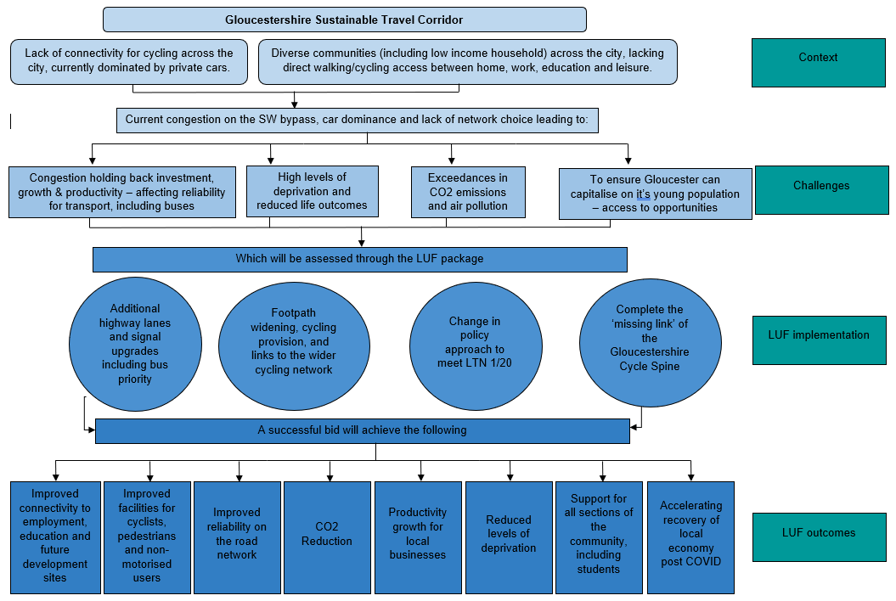

As outlined under 4.3a,b and c, the challenges facing Gloucester’s transport network are clearly evidenced with a lack of active travel infrastructure leading to a car dependent transport network that is often congested, provides poor journey time reliability, contributes to air pollution and CO2 emission and is socially exclusive. The bid identifies 4 distinct interventions that will deliver the outcomes the bid aims to achieve:
The road-based elements of the proposal will address the most pressing congestion bottlenecks in Gloucester, by providing additional highway lanes and signal upgrades, including bus priority. This will reduce congestion, improve journey time reliability, including for buses and thus contribute to increased connectivity to employment, education and future development sites. The recovery of the local economy post COVID will also be accelerated by future proving the road network so that it does not act as a blocker for future investment or growth. Reductions in congestion will mean less time spend in traffic jams, allowing for productivity growth for local businesses and through these overall benefits to Gloucester’s economy and the increased access to deprived areas in Gloucester, the scheme will also reduce levels of deprivation.

In addition to the above economic benefits, a reduction in the stop starting of traffic associated with congested conditions will also reduce CO2 emissions.

Alongside the road widening, we will deliver footpath widening, cycling provision and links to the wider cycling network from the GSWB and to and from Gloucester College. This will improve facilities for cyclists, pedestrians and non-motorised users in the area and further contribution to CO2 reductions.
In terms of the ‘implementation’, the publication of LTN 1/20 has provided a higher ambition for cycle provision in Gloucester. Gloucestershire’s ambition to deliver a change in policy approach to meet LTN 1/20 is reflected in the proposed road space re-allocation in the city centre enabled by addressing congestion on the GSWB. This will ensure that the improved facilities for cyclists, pedestrians and non-motorised users are of high quality, ensuring that the ambitions for long term mode shift and CO2 reductions can be achieved.

Completing the ‘missing link’ of the Gloucestershire cycle spine will enable all members of the community, including students, to cycle and walk, across the central spine from Gloucester College and the docks with their employment, leisure and retail facilities, to Gloucester city centre with its services, major employers and transport hubs to the Gloucestershire University Oxstalls campus and continue to Cheltenham.

Improved connectivity to employment, education and future development sites will allow Gloucester to develop an environment with a higher level of education, and where residents also have well-paid jobs locally without the need to travel outside of the County. It will therefore contribute to productivity growth, reduced levels of depravation and accelerate the recovery of the local economy post COVID

Improved facilities for cyclists, pedestrians and non-motorised users
will provide an alternative to the private car, thus also reducing congestion, air pollution and CO2 emissions.
4.4 Alignment with the local and national context
See technical note Table 1 for further guidance.
4.4a Explain how your bid aligns to and supports relevant local strategies (such as Local Plans, local economic strategies or Local Transport Plans) and local objectives for investment, improving infrastructure and levelling up. (Limit 500 words)
All scheme elements of the bid are reflected in Gloucestershire’s LTP 2020-2040

Improving the pinch point on the GSWB is a LTP scheme priority and will relieve peak time congestion; provide greater journey time reliability and associated productivity as outline in the LTP Highway Policy. The wider benefits of the GWSB element are the improvements to non-motorised user environment. Greater accessibility for walking and cycling will be provided which in turn encourages active travel and the health and wellbeing positivity’s that derive from that. Furthermore, the removal of congestion will improve air quality for those living and working within proximity to the scheme. These are all key considerations within the LTP.

The cycling element of the bid aligns with the ambitions of the LTP and policy PD2 as well as incorporates the outputs of Gloucestershire’s LCWIP. The Gloucester LCWIP has been subject to public and stakeholder engagement to ensure it addresses the needs of users. The routes identified are therefore seen as important for users and therefore inclusion within this bid is appropriate.

The cycling elements will deliver improvements to the strategic and primary corridors as established by the LCWIP. This are shown within Figure 3- Gloucester Network Map in the LCWIP document. These routes provide greatest access to a range of employment, educational, health care and transport facilities.

Furthermore, the delivery of the GSTC between Llanthony Road/Bristol Road and Elmbridge will deliver a significant section of the Countywide cycleway network as well as enable wider connectivity to settlements outside of Gloucester. This is shown with figure PD2c of the LTP.

The pinch point improvement on the GSWB is also recognised as a key growth enabling scheme in the key strategic priority projects as outlined in section 1.3.1 of the SEP for Gloucestershire 2.0 produced by the Gfirst LEP. To support the delivery of the SEP, the LEP approved £2m worth of investment funding towards the GSWB. Furthermore, the Gfirst LEP’s Draft Industrial Strategy highlights the need for a countywide cycling strategy to support more active sustainable choices and recognises that cycling will form part of a vibrant offering of sustainable travel options for the city region.

The cycling element also aligns with Policy G3 of the emerging Gloucester City Plan whereby it encourages comprehensive city-wide cycling initiatives in-line with the county council’s LTP. Furthermore, the overarching Joint Core Strategy outlines cycling as a key component of its Strategic Objectives, “Strategic Objective 7 – Promoting sustainable transport.” Strategic Objective 9 - “promoting healthy communities” also identifies the importance that GSTC provision has to the population.

Improved access to rail stations by car, bus and active modes is a priority in the Social Mobility theme of the Western Gateway SNTB’s Strategic Transport Plan and this project will help achieve that ambition. This will therefore provide users with greater travel choice and helps support sustainable travel on a regional level.

4.4b Explain how the bid aligns to and supports the UK Government policy objectives, legal and statutory commitments, such as delivering Net Zero carbon emissions and improving air quality. Bids for transport projects in particular should clearly explain their carbon benefits. (Limit 250 words)
In line with UK Government policy¹¹, and written into policy in the LTP, GCC has a target of reducing carbon emissions by at least 80% by 2030 and reaching ‘Net Zero’ and becoming a carbon-neutral county by 2050.

The proposed LUF scheme aims to improve access to Gloucester city centre whilst minimising emissions. The DfT’s Low Carbon Transport document recognises the benefits congestion reduction has on carbon emissions. Without combating congestion, the impacts would both be environmental and economic, with the economic impacts estimated at £22bn by 2025, UK wide. Furthermore, reducing congestion and associated emissions has direct synergies with other Government departments such as the Department for Health, and Department for Children, schools and families. By encouraging walking and cycling, it will reduce congestion, improving air quality but also encouraging an active lifestyle¹².

The scheme will be designed to improve access to the city centre for cyclists and pedestrians, encourage modal shift to such sustainable modes and discourage cars by reallocating road space away from motorised to non-motorised modes. Green public transport, cycling and walking form part of Governments 10 part plan for a green industrial revolution, as announced in November 2020, which will help Government with its Carbon emission reduction goals. To do this, Government wants to deliver 1000’s miles of safe and direct cycling and walking networks by 2025. Our LUF project will help towards this ambition¹³. At the same time, it will support integration and public transport access via Gloucester Railway Station and Bus Station/Transport Hub.

¹¹ Government announced in April 2021 that it aims to reduce emissions by 78% compared to 1990 levels by 2035 and this will form a key ambition in their 6th Carbon Budget. https://www.gov.uk/government/news/uk-enshrines-new-target-in-law-to-slash-emissions-by-78-by-2035#:~:text=The%20UK%20government%20will%20set,today%20(Tuesday%2020%20April).&text=Today's%20world%2Dleading%20announcement%20builds,a%2078%25%20reduction%20by%202035
¹² https://assets.publishing.service.gov.uk/government/uploads/system/uploads/attachment_data/file/228897/7682.pdf
¹³ https://www.gov.uk/government/publications/the-ten-point-plan-for-a-green-industrial-revolution/title#point-5-green-public-transport-cycling-and-walking

4.4c Where applicable explain how the bid complements / or aligns to and supports other investments from different funding streams. (Limit 250 words)
The scheme aligns with cycle improvements along the B4063 between Cheltenham and Gloucester and has been secured via funding from Highways England, including £1.165 million of design funding, and £5 million construction costs subject to a Value for Money Assessment,. The scheme has been supported by a contribution of £3 million from GCC, £322k of ATF Tranche 1 funds, £864,750 of ATF Tranche 2 funds and Gfirst LEP commitments allowing any underspend from the adjoining West Cheltenham Transport Scheme to be reallocated to the scheme.

The B4063 is a continuation of the £1.6 million Growth Deal funded improvements to the A40 in Cheltenham which will extend the cycleway to Cheltenham Station and the Cyber Park. The scheme also directly links to the Cheltenham Spa to Lansdown Bridge link with £1.0 million of committed funding.

The scheme aligns with improvements to the Canal to the south which received £435k contribution from the European Regional Development Fund, £300k from the Gloucestershire Environmental Trust and £440k of S106 contributions to improve the towpath for cyclists and walkers directly adjoining the GSTC.

The scheme will improve access to Gloucester station, which has been subject to LEP growth deal funding of £4.3 million to refurbish the buildings, improve the public realm and improve links to the Transport Hub and city centre. The proposed bid will improve access to the north of the station linking with the GSTC.

The GSWB scheme will provide a bypass for motorised traffic but also adjoin two cycle infrastructure projects to ensure a complete and comprehensive cycle network from Cheltenham to Gloucester. Contributions are already in place for this element of the scheme from £2 million of Gfirst LEP funding and £128k of S106 funding.

4.4d Please explain how the bid aligns to and supports the Government’s expectation that all local road projects will deliver or improve cycling and walking infrastructure and include bus priority measures (unless it can be shown that there is little or no need to do so). Cycling elements of proposals should follow the Government’s cycling design guidance which sets out the standards required. (Limit 250 words)
The pinch point improvements on the GSWB will include improvements to cycle infrastructure that accord with LTN 1/20 and Bus Priority measures at the Spinnaker Road junction. See General Arrangement in Appendix C. However, the second package of works will focus on improving cycle infrastructure that connects to improvements at the canal towpath and the GSWB pinch point scheme. These improvements will continue along Llanthony Road to the Bristol Road/Southgate Street corridor. Once the GSWB has been provided this parallel corridor shall see a reduction in car traffic as users no longer need to seek alternative routes.

This opens the possibility for enhanced cycle infrastructure with the creation of a GSTC through the centre of the city, embracing schemes and routes identified in the Gloucester LCWIP https://www.gloucestershire.gov.uk/media/2095888/cycling-and-walking-infrastructure-plan-20200302.pdf.

Furthermore, the GSTC is also recognised, in part, as a top ranked new cycleway and with the wider improvements providing a comprehensive network as identified by the DfT’s Rapid Cycle Tool (CyIPT) as shown below.

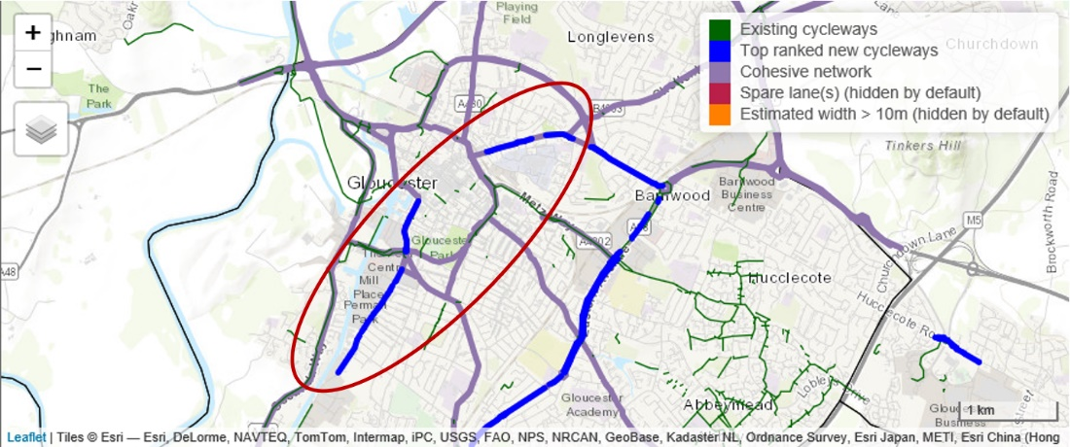

The cycle infrastructure improvements provides enhanced accessibility for all users, with direct, legible connections to key services and facilities such as Gloucestershire College, Gloucester Transport Hub and Railway station and University campus to the north before adjoining with cycle infrastructure improvements at the B4063 corridor.

(Drawing removed)

PART 5 VALUE FOR MONEY

5.1 Appropriateness of data sources and evidence
See technical note Annex B and Table 1 for further guidance.

All costs and benefits must be compliant or in line with HMT’s Green Book, DfT Transport Analysis Guidance and MHCLG Appraisal Guidance.
5.1a Please use up to date evidence to demonstrate the scale and significance of local problems and issues. (Limit 250 words)

The economic data supporting the need for the LUF application is split for the two discrete scheme elements. For GSWB, a robust case for change was completed as part of the Full Business Case submission, including the Economics and VfM statement. It was demonstrated through a series of surveys and traffic models that without the scheme intervention, the problems of congestion and poor journey reliability would continue, and deteriorate further. As a result, air quality would also decline and access to planned and potential future development would be significantly hindered. Initial site surveys were carried out in December 2016 at the time of the business case baseline, however, Journey Time Data for 2019 has also been sourced (the most appropriate with pre-COVID traffic flows).

Road traffic collision data for five years on the Cycle Spine, (2015 – 2019) shows pedestrian collisions of 24 total; 17 slight and 7 serious. For cycle accidents, there are 29 in total; 24 slight and 5 serious.

By releasing congestion on the bypass, the cycling elements of the scheme becomes possible, and part of the solution to the problem of very limited cycling facilities in Gloucester. The completion of a central spine (‘missing link’) of cycle infrastructure which links Gloucestershire’s two major conurbations, a distance of only 11km, will be a major catalyst to deliver change and pivotal to enabling a growing network of cycle routes outlines in Gloucestershire’s LCWIP. The A40 corridor is so congested that even the express bus service is scheduled to take over 50 minutes between Cheltenham and Gloucester in the peak period. Therefore a high quality cycle route will provide quicker journey times for cyclists than can be achieved by bus and at peak times by car.

5.1b Bids should demonstrate the quality assurance of data analysis and evidence for explaining the scale and significance of local problems and issues. Please demonstrate how any data, surveys and evidence is robust, up to date and unbiased. (Limit 500 words)
The scale of the problem for the GSWB is summarised in the Full Business Case, which is included as Appendix F, the VfM assessment for the GSTC, is in Appendix G. The FBC demonstrates the impact of a Do-Nothing situation where the problem is not fully addressed. The data for the PARAMICS model was fully checked and validated according to DMRB, and was from the GCC database of counts, with junction counts undertaken as required. Journey Time Counts and additional queue surveys were undertaken by consultants Amey on behalf of GCC.

The 2019 Journey Time Data (from TomTom datasets for unbiased results) is for appropriate weekday dates in May 2019, to support the full data gathered for the Business Case a number of years earlier. The problem has deteriorated for the NB direction compared to the previous date. Note that for the Southbound direction, there is a slight reduction in the journey times, but this may be due to a difference in the routes selected and/or changes to the signal timings since 2016. It is however clear that journey times are still a significant barrier for both vehicles and consequently hindering investment and economic development along the corridor.

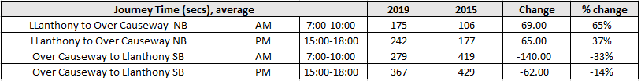

The figures below show the congestion and speeds from the TomTom data for the NB AM peak and SB PM peak respectively.

AM Peak, NB average speeds for May 2019

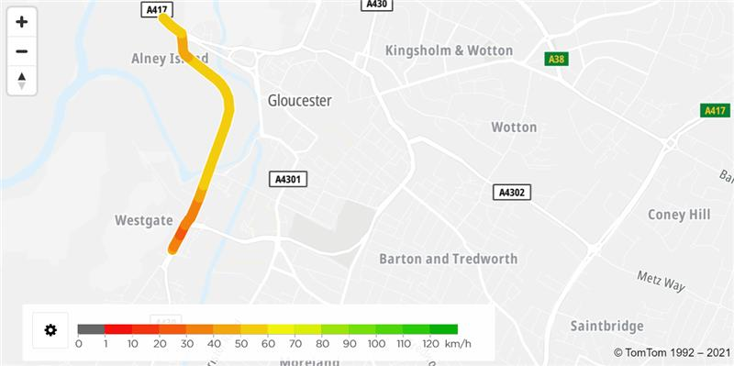

PM Peak, SB average speeds for May 2019

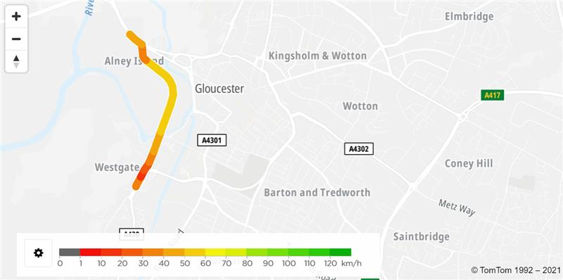

For the Cycle Spine, current cycle counts for the discrete sections of the route are included in the AMAT assessment. In addition, the consultation for the B4063 Cycleway scheme (2021) with circa 1400 responses provided key evidence with regard to the desire for cycling. Key statistics for the consultation included; 76% agreed that the Cycleway would be beneficial to the local community; 65% were dissatisfied /very dissatisfied with the current route; 68% would be keen to cycle/cycle more often to Gloucester / Cheltenham with a direct link; and 85% may commute (walk/cycle) with higher quality pedestrian and cycle infrastructure. The results have been checked by both the County Council and their consultants Atkins to ensure an unbiased assessment, and in accordance with the County’s GDPR policies. Further evidence of public consultation and support for cycling was in the LCWIP for Gloucester, with over 240 people invited to consult directly, with addition LTP consultation.

5.1c Please demonstrate that data and evidence chosen is appropriate to the area of influence of the interventions. (Limit 250 words)

The combination of evidence covers the extents of the bid area - with surveys and consultation from the FBC for Llanthony Road GSWB, cycle counts for the central cycle spine, and extensive public consultation for the cycle routes (LCWIP) and the B4063 proposals immediately east of Elmbridge Court roundabout. The interventions for GSWB and the road widening were supported through the consultation process – at the public share event 73% agreed that the scheme would reduce congestion and queues along GSWB, and 75% agreed that the scheme would increase capacity along GSWB to allow for future developments.

To confirm the area of influence for the bypass, the GSWB FBC includes a strategic SATURN model. The SATURN evaluation confirmed that the improvements were required to allow for the full level of housing in the JCS Strategy (2031), with impacts from additional housing sites in the County.

Due to the progress of the cycle spine, and the central sections being dependent on the completion of GSWB to release capacity, full consultation has not been undertaken on the drawings. However, extensive internal consultation for the scheme proposals has taken place, with stakeholders and an independent review/audit of the Cycle Spine plans to ensure compliance with LTN 1/20.

Effectiveness of proposal in addressing problems
5.2a Please provide analysis and evidence to demonstrate how the proposal will address existing or anticipated future problems. Quantifiable impacts should usually be forecasted using a suitable model. (Limit 500 words)
For GSWB, the FBC and modelling reports detail the PARAMICS model that was completed to assess the impact of the scheme. The model had a forecast year of 2031, and demonstrated that the scheme would reduce queues and journey times by 5 to 10 minutes (depending on the peak), which reflected in the Very High Value for Money assessment of benefit. Full results are in the FBC. Therefore, the GSWB highway element of the proposal did address the future issue in terms of highway congestion.

For the Cycle Spine, the evidence base is the drawings that have been developed for the scheme Interventions (included as Appendix C). The designs are LTN 1/20 design compliant, and are aspirational for a continuous uninterpreted design for the ‘missing link’. Further detailed design for all the cycle routes would be completed on confirmation of funding/when funding is secured. Based on the DfT Uplift tool, the scheme is predicted to approximately double the level of cycling for the route, and will be safer by design due to the LTN 1/20 compliance.

5.2b Please describe the robustness of the forecast assumptions, methodology and model outputs. Key factors to be covered include the quality of the analysis or model (in terms of its accuracy and functionality) (Limit 500 words)
GSWB
A technical note underpinning the S-Paramics modelling methodology for Llanthony road and the surrounding locale is provided in Appendix F. Note that for robustness, a strategic SATURN model was also referred to for the Business Case.

The modelled periods in the Paramics model are limited to the AM and PM peaks in the base year, and an assumed 2018 opening year and a 2031 forecast year. The base model has been developed using traffic data from surveys carried out in October 2014. A review of TEMPRO in the area, finds minimal growth in traffic between 2014 and 2016 and between 2016 and 2018 (opening year). Since the start of 2020, traffic flows are impeded by COVID-19 impacts.

As TEMPRO predicted minimal growth, the 2018 Do-Nothing matrices are the same as the base matrices. For the 2031 forecast traffic levels, the TEMPRO growth factors that are used are from 2014 to 2031. The table below shows growth factors applied for the 2014 base year, 2018 opening year and 2031 forecast year.

Forecast assumptions – Traffic Growth Factors (TEMPRO)
Year | TEMPRO Area | TEMPRO Growth
Year | TEMPRO Area | AM | PM
2014-2016 | Gloucester 2,4,5,8,9 | 1.001 | 0.998
2016-2018 | Gloucester 2,4,5,8,9 | 1.029 | 1.021
2014-2031 | Gloucester 2,4,5,8,9 | 1.153 | 1.145

The 2014 base year model was successfully calibrated against the 2014 surveyed junction turning count and Automatic Traffic Count (ATC) link flow data and successfully validated against blue-tooth journey time data from May 2015. Further validation was conducted via additional journey time and queue length surveys during a site visit in December 2016. As such, the model is well calibrated and validated, with GEH values of less than 5 in 100% of the hourly link flow comparisons, in 92% of all the hourly turncount comparisons, and 100% of all journey time comparisons.

For the purposes of the S-Paramics, a total of seven models have been developed for the core scenario during the AM and PM peak periods. To address the uncertainty around routing responses for the two modelled options, 4 sensitivity scenarios were also modelled, whereby trips were re-assigned from Severn Road to Castle Meads Way southbound. This is to account for improvement options reducing congestion on the A430, making Castle Meads Way more attractive for bypassing queues than Severn Road. Model outputs and journey time savings for Option 1 (preferred option) are presented in the table below for the 2031 forecast year under the Core scenario for specific links in the AM and PM peak period.

Modelled Average Journey Time, Journey time comparisons in 2031
Link | AM Peak Period (07:00 – 10:00) |  |  | PM Peak Period (15:00 – 18:00)
Link | 2031 Do-Min | 2031 Do-Som (Option 1) | Diff | 2031 Do-Min | 2031 Do-Som (Option 1) | Diff
Quayside to Westgate | 00:03:32 | 00:02:54 | -38 secs | 00:06:08 | 00:02:54 | -194 secs
Westgate to Quayside | 00:09:38 | 00:02:59 | -399 secs | 00:12:10 | 00:03:01 | -549 secs
Westgate to Llanthony | 00:06:43 | 00:01:21 | -322 secs | 00:09:16 | 00:01:23 | -473secs
Severn Road SB | 00:06:25 | 00:00:37 | -348 secs | 00:07:31 | 00:01:31 | -360secs
Severn to Llanthony road junction | 09:00:00 | 00:01:21 | -459 secs | 00:09:18 | 00:02:34 | -404secs
Note that negative numbers represent an improvement (reduction) in journey time

Cycle Spine
Baseline cycle data was provided to Atkins by GCC in the form of manual counts taken on various weekdays between April and November 2019. In line with DfT guidance, these counts have been adjusted using factors to take into account seasonal variation in cycling numbers. The DfT Uplift tool is used to forecast potential new users generated by the investment. An additional 10% increase in users is forecast based on the output of GCC monitoring data which shows during the Covid-19 pandemic, additional change in behaviour among transport users has boosted active mode use. The table below shows baseline count data, any uplift in cycling numbers from the DfT tool and the forecast counts from a change in behaviour towards active modes.

Forecast assumptions – Cycling counts
Link | Baseline Counts | DfT Uplift Tool | Behaviour Change (10% uplift)
Gloucester City Centre | 382 | 451 | 496
London Road | 134 | 290 | 319
Estcourt Roundabout to Elmbridge roundabout | 248 | 648 | 712

5.3 Economic costs of proposal
5.3a Please explain the economic costs of the bid. Costs should be consistent with the costs in the financial case, but adjusted for the economic case. This should include but not be limited to providing evidence of costs having been adjusted to an appropriate base year and that inflation has been included or taken into account. In addition, please provide detail that cost risks and uncertainty have been considered and adequately quantified. Optimism bias must also be included in the cost estimates in the economic case. (Limit 500 words)

GWSB
The Gloucester South West Bypass total scheme cost is £11.250m in outturn prices, inclusive of risk and inflation. Outturn costs (also known as ‘nominal’ or ‘cash’ prices) is the amount that will end up being spent at the time the cost is incurred and includes all inflation from the base cost value up to the date the cost is incurred. Real costs are calculated from outturn costs, according to the base year and discounted in line with Green Book guidance to present costs in 2010 prices, discounted to 2010 for the economic appraisal.

GDP deflator
For economic appraisal purposes, scheme costs expressed in outturn prices should be deflated to the correct price base, in this case 2010 prices, in line with HM Treasury and WebTAG guidance. The GDP deflator index is calculated from Table A5.3.1 of the WebTAG databook (July 2020) which measures the change in prices for all goods and services produced in the economy. Costs occurring in different years are deflated (background inflation removed) by multiplying them by the ratio of the inflation index for the desired base year (2010) to the index in the calendar year where the costs fall.

Optimism bias and converting to market prices
Optimism bias uplift is applied at 3% to total scheme costs to reflect the tendency of scheme promoters to under-estimate final values. A conversion factor of 1.19 is then used to convert factor prices to market prices for use in the economic appraisal i.e. (Factor Cost x 1.19).

Discounting
An annual 3.5% discount rate for each year within 30 years from the current year was applied to real values, with the effects of inflation removed. The economic appraisal of the options has followed best practice by first converting costs into real prices (adjusting for inflation and then deflating using the GDP deflator before discounting to 2010 prices, as required in WebTAG).

Total scheme costs
Total scheme costs for use in economic appraisal are estimated at £7.62m (2010 prices, discounted to 2010) for the Gloucester South-West Bypass (GWSB) project.

Cycle Spine
Scheme capital (construction, design and management, plus risk adjustments) costs have been estimated by the Atkins Engineering team in 2021 prices at £21.667m. Present Value Costs (PVC) derived by the AMAT Toolkit, and calculates the value for money of the scheme using the following adjustments:

- Values converted to 2010 prices;
- Real inflation added (e.g. Tender Price Index or Retail Price Index depending on the cost type less background inflation);
- Optimism bias at 15%. As scheme costs are based on preliminary design prior to the detailed design, an optimism bias of 15% was applied to total costs, in line with guidance set out in DfT TAG unit A1-2;
- Conversion to market prices (using a factor for the average rate of indirect taxation in the economy of 1.19); and
- Discounting at 3.5% per annum over a 20-year appraisal period starting in 2022.

The PVC at 2010 prices, discounted to 2010 is £18.847m.
5.4 Analysis of monetised costs and benefits
5.4a Please describe how the economic benefits have been estimated. These must be categorised according to different impact. Depending on the nature of intervention, there could be land value uplift, air quality benefits, reduce journey times, support economic growth, support employment, or reduce carbon emissions. (Limit 750 words)
GWSB
The economic case is primarily based on benefits derived from journey time reductions for existing and future users of the road network. The appraisal was executed using PEARS software (Program for the Economic Assessment of Road Schemes), specifically designed for use with outputs from traffic microsimulation (S-Paramics) models.

The table below presents Present Value Benefits (PVB) for two different scheme options and the two different sensitivity tests (relating to the re-assignment of traffic from Severn Road to Castle Mead Way southbound). The purpose of the sensitivity tests are to see how the route performs under different traffic scenarios and to test how robust the scheme is to different scenarios. All values are expressed in 2010 prices, discounted to 2010, over a 60-year appraisal period.

 | Core Scenario  Option 1 | Core Scenario  Option 2 | Sensitivity Test 1 | Sensitivity Test 2
Non-Business Travel Time | +£33.83M | +£32.20M | +£33.39M | +£18.58M
Business Travel Time | +£33.70M | +£31.77M | +£33.09M | +£19.45M
Non-Business Vehicle Operating Costs | +£2.34M | +£2.22M | +£2.08M | +£1.06M
Business Vehicle Operating Costs | +£3.35M | +£3.10M | +£3.16M | +£1.69M
Private Sector Provider Impacts | +£0.07M | +£0.08M | +£0.08M | +£0.06M
Greenhouse gases (Carbon Dioxide) | +£0.45M | +£0.42M | +£0.42M | +£0.22M
Indirect Tax Revenue | -£2.15M | -£2.01M | -£2.03M | -£1.07M
Total (PVB) | +71.59m | +67.78m | +70.19m | +39.97m

The table above shows the presents value of transport user benefits and business impacts or Level 1 transport impacts. The preferred option (Option 1) delivers a PVB of £71.6m, while Option 2 is less effective £3.81m less to road users. Under the sensitivity test, southbound trips are reassigned to the A430 mainline, as the journey time savings on the A430 would make this route more attractive. The increased flows on the mainline marginally reduce the effectiveness of Option 1, reducing the Present Value Benefits, PVB, to £70.19M, with £1.4M fewer benefits over the appraisal period.

Cycle Spine
The economic case for the cycling elements of the scheme are based on benefits derived from the Active Mode Appraisal Toolkit (AMAT). It quantifies the key benefits from active travel including improved health and lower workplace absenteeism, environmental and congestion benefits from reduced car miles and journey quality benefits from safer and more pleasant travel. Following the guidance, baseline data and Uplift Tool output data (plus a 10% increase in counts relating to behavioural change originating from the Covid-19 pandemic) is manually entered into the ‘User Interface’ input sheet, with ‘User Interface Costs’ also input. The toolkit automatically generates Present Value Benefits (PVB) and Present Value Costs (PVC) based on user inputs. The Benefit-Cost Ratio (BCR) is generated for individual cycle links and for all cycle elements as a whole.

Ref | Present Value Benefit (PVB) | Present Value Cost (PVC) | Benefit-Cost Ratio (BCR)
Link 2: Gloucester City Centre | £4,467,620 | £1,270,900 | 3.52
Link 3: London Road to Estcourt roundabout | £4,769,920 | £2,150,480 | 2.22
Link 4: Estcourt roundabout to Elmbridge roundabout | £7,625,740 | £4,505,830 | 1.69
All Links | £16,863,270 | £7,927,200 | 2.13

The overall BCR for the scheme (all links) has been calculated by comparing the cumulative costs against the benefits of component links for the scheme in its entirety. A breakdown of different monetised impacts from AMAT for all component links is provided in the figure below.

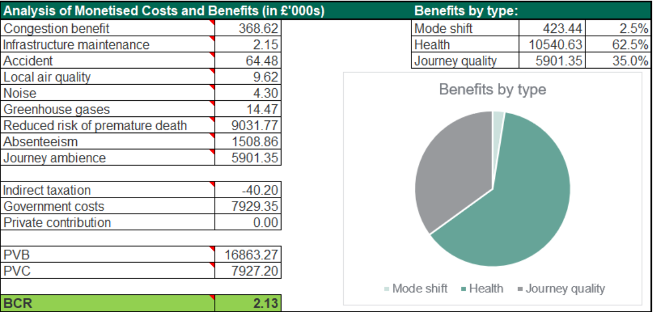

5.4b Please complete Tab A and B on the appended excel spreadsheet to demonstrate your:

Tab A - Discounted total costs by funding source (£m)
Tab B – Discounted benefits by category (£m)
5.5 Value for money of proposal
5.5a Please provide a summary of the overall Value for Money of the proposal. This should include reporting of Benefit Cost Ratios. If a Benefit Cost Ratio (BCR) has been estimated there should be a clear explanation of how this is estimated ie a methodology note. Benefit Cost Ratios should be calculated in a way that is consistent with HMT’s Green Book. For non-transport bids it should be consistent with MHCLG’s appraisal guidance. For bids requesting funding for transport projects this should be consistent with DfT Transport Analysis Guidance. (Limit 500 words)
GSWB
Overall assessment of economic costs and benefits generated by the project shows that the scheme achieves a Benefit-Cost Ratio of 9.19 with a Net Present Value (NPV) of approximately £62.46 million. The scheme can therefore be categorised as achieving very high value for money in the classification provided by the Department for Transport. The majority of monetised benefits arise from journey time savings to transport users from scheme implementation.

Cycle Spine
Overall assessment of economic costs and benefits generated by the project shows that the scheme achieves a Benefit-Cost Ratio of 2.13 with a NPV of approximately £8.94million. The scheme can therefore be categorised as achieving high value for money according to the DfT classification. The majority of benefits originate from health impacts originating from increased physical activity and wider impacts to businesses from a reduction in absenteeism (sickness) and a reduced risk of premature death.

5.5b Please describe what other non-monetised impacts the bid will have, and provide a summary of how these have been assessed. (Limit 250 words)

Noise
For the GWSB, the scheme is not located in a Noise Important Area (NIA). However, an increase in traffic flow and carriageway widening has the potential to increase noise levels, although there is a low density of sensitive receptors in the scheme area. For the Cycle Spine, a small percentage of road journeys will be converted to walking/cycling (modal shift from car travel to walking and cycling). The impact is qualitatively assessed as Neutral.

Air quality
For the GWSB, impacts on local air quality can be expected from changes to traffic flow and changes to signalisation. The Cycle Spine will lead to more active travel journeys and changes to traffic flow will allow traffic to flow more efficiently leading to an assumed minor reduction in NO_{2.} The impact is qualitatively assessed as Slight Beneficial.

Biodiversity
Surveys have identified potential for protected species in proximity to the scheme. The scheme will try to avoid impacts upon these species where practicable through design. Where this is not achievable, species specific surveys will be undertaken to confirm species presence/absence from site and identify any necessary mitigation. The impact on biodiversity is qualitatively assessed as Slight Adverse or Neutral with mitigation.

Severance
The introduction of dedicated walking and cycling infrastructure for the scheme will reduce severance for pedestrians and cyclists. Improved crossing points along the route (GSWB and the Cycle Spine) will contribute to reducing severance. The impact is qualitatively assessed as Slight Beneficial for walking and cycling.

5.5c Please provide a summary assessment of risks and uncertainties that could affect the overall Value for Money of the bid. (Limit 250 words)
Future risk and uncertainties can affect the choice between options and the Value for Money (VfM) of the bid. Sensitivity analysis is used to test the vulnerability of the scheme to future uncertainties. For GWSB, two sensitivity tests were conducted that re-assign traffic from Severn Way to Castle Meads Way to take account of potential changes in routing choice from implementation of the scheme. The FBC (Appendix F) reports the BCR for two options with the two sensitivity tests, with updated costs, to range from 5.35 to 9.39. This is very high value for money under DfT classifications.

For the Cycle Spine, one sensitivity test has been conducted to reflect an unexpected increase in prices / costs during the development, delivery or construction of the scheme – in addition to the average cost contingency of 25%. The analysis (Appendix G) assumes a 5% increase in costs as part of the sensitivity test. The BCR including the increase in costs of 5% is expected to reduce the BCR for the walking and cycling elements to 1.99. As such, we expect the BCR to range between 1.99 and 2.13. This represents high value for money according to the DfT classification, with a small risk that if costs did increase by close to or over 5% the cycle elements of the scheme would represent medium value for money.

5.5d For transport bids, we would expect the Appraisal Summary Table, to be completed to enable a full range of transport impacts to be considered. Other material supporting the assessment of the scheme described in this section should be appended to your bid.

PART 6 DELIVERABILITY

6.1 Financial
See technical note Table 1 for further guidance.
6.1a Please summarise below your financial ask of the LUF, and what if any local and third party contributions have been secured (please note that a minimum local (public or private sector) contribution of 10% of the bid costs is encouraged). Please also note that a contribution will be expected from private sector stakeholders, such as developers, if they stand to benefit from a specific bid (Limit 250 words)

Funding Information Removed

6.1b Please also complete Tabs C and D in the appended excel spreadsheet, setting out details of the costs and spend profile at the project and bid level in the format requested within the excel sheet. The funding detail should be as accurate as possible as it will form the basis for funding agreements. Please note that we would expect all funding provided from the Fund to be spent by 31 March 2024, and, exceptionally, into 2024-25 for larger schemes.
Within Tabs C and D and the spreadsheet.

6.1c Please confirm if the bid will be part funded through other third-party funding (public or private sector). If so, please include evidence (i.e. letters, contractual commitments) to show how any third-party contributions are being secured, the level of commitment and when they will become available. The UKG may accept the provision of land from third parties as part of the local contribution towards scheme costs. Where relevant, bidders should provide evidence in the form of an attached letter from an independent valuer to verify the true market value of the land. | X Yes  No
6.1e Please list any other funding applications you have made for this scheme or variants thereof and the outcome of these applications, including any reasons for rejection. (Limit 250 words)
In January 2020 GCC submitted a number of scheme Expressions Of Interest to the DfT Pinch Point Fund. This included the GSWB road widening and signal improvement elements of this LUF bid. As a result of the Covid-19 pandemic, funding announcements were delayed and the County was advised of a likely decision in early 2021. In February 2021 the County Council was notified that the DfT had superseded the Pinch Point Fund with the LUF and schemes were invited to be re-submitted to this new fund.

We have now updated the original Pinch Point Fund application and extended the scheme to include elements to strengthen active travel and public transport uptake on the same corridor. This is to strengthen overall alignment with the recently adopted GCC LTP and general policy objectives to reduce CO2 emissions and to promote the use of sustainable modes of transport. These elements have not been subject to any previous funding applications. As a coherent total scheme the GSTC has not been submitted for any funding.

6.1f Please provide information on margins and contingencies that have been allowed for and the rationale behind them. (Limit 250 words)
A contingency reserve has been added to the base cost estimate to cover the monetary impacts of project risks and uncertainties. The contingency amount is based on acceptable risk and the degree of uncertainty, with the aim of ensuring a high level of confidence for meeting the project budget. The value of the contingency has been arrived at by evaluating the risks in the project register. A range of likely costs have been assigned to the risks and a probability percentage applied.

6.1g Please set out below, what the main financial risks are and how they will be mitigated, including how cost overruns will be dealt with and shared between non-UKG funding partners. (you should cross refer to the Risk Register). (Limit 500 words)

Risk | Mitigation
Works impinge on third party land and require extended negotiation | Design process to ensure works remain within highway boundary.  GSWB extends beyond the highway boundary and the property has been purchased.
Scheme construction is delayed and/or costs increase. | Budget reviews to be carried out monthly and appropriate mitigation measures put in place
Delays from works by third parties (eg Statutory Bodies) | Engage with all effected third parties as soon as budget is confirmed, and scheme initiated.
Public not supporting the scheme | Early engagement with key stakeholders and the public
Environmental issues | Walk over surveys will be carried out and Environmental Impact report and mitigation plans produced.

GCC accepts the responsibility for cost overruns, as set out in the Chief Finance Officer declaration under 7.2 and should such overruns occur, they will be covered from existing budgets. To avoid cost overruns, financial risk will be reviewed regularly and in particular at the set gateway reviews. This will ensure that any emerging concerns can be dealt with appropriately and promptly, as well as through the procurement processes set out in section 6 of this bid. GCC’s experience in delivering transport schemes of this nature will also ensure, that scheme development, design, procurement and construction procedures are sufficiently robust to minimise likelihood of construction difficulties. Similarly, ongoing maintenance costs will be the responsibility of the Highways Authority, i.e. GCC and will be managed by ensuring that scheme design, materials selection and construction procedures are sufficiently robust to minimise likelihood of maintenance issues.

In addition to the above financial risk management strategies, a risk allowance of £removed has been allocated, which reflects the level of scheme development of each part of the bid and risks identified in the project risk register.

A further risk to the project is that some third party funding contributions still need to go through a final approval stage. GCC will do it’s utmost to secure these final approvals and as indicated in our stakeholder letters, we are confident that this can be achieved. Should any of the not yet fully secured contributions fall away, GCC will endeavour to seek alternative funding sources. In addition, the scheme is fully scalable, securing the benefits identified and the third party contributions identified by far exceed the proposed matched funding contribution of 10% indicated in the bid guidance.

6.2 Commercial
See technical note Section 4 and Table 1 for further guidance.
6.2a Please summarise your commercial structure, risk allocation and procurement strategy which sets out the rationale for the strategy selected and other options considered and discounted. The procurement route should also be set out with an explanation as to why it is appropriate for a bid of the scale and nature submitted.

Please note - all procurements must be made in accordance with all relevant legal requirements. Applicants must describe their approach to ensuring full compliance in order to discharge their legal duties. (Limit 500 words)

Commercial Structure:
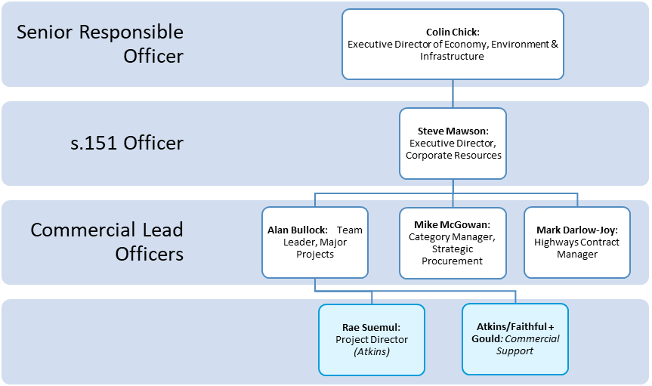
Procurement Strategy:

GCC have identified three procurement options for delivery on both the GSWB and the Gloucestershire Cycle Spine which support the Councils internal governance requirements and reflect the procurement route on other similar successfully delivered projects.

- Full ‘Find a Tender’ Procurement Exercise:
- GCC would opt for an ‘open’ tender or a ‘restricted’ tender. This process takes approximately 1 month and a 47 day minimum period for GCC to publish a contract notice on the ‘Find a Tender’ website.
- The tender period is approximately 6 weeks. Once tenders are received they will be assessed and a preferred supplier identified with a 10 day ‘standstill’ period for unsuccessful tenderers to challenge.

- Open tender:
- GCC would opt for an ‘open’ tender including pre-qualification criteria which will be used to select 5 tenderers.
- Schemes will be procured via ProContract and this would include prior notifications of the tender approximately 4 weeks before formal tender.
- Supplier engagement presentations will be held
- Minimum tender period would be 6 weeks. The 5 tenders will be assessed and a preferred identified.

- Delivery through GCC Framework Contract
- A GCC Highways Framework Contract is in the process of being setup
- Contractors will be assessed based on quality assessment criteria, successful contractors will tender spot prices for the works
- This route will reduce tender durations by removing the requirement to resubmit quality submissions for each phase of the works and allow for rapid tender evaluation

GSWB

The available procurement options reflect that the works value will not exceed the ‘Find a Tender’ thresholds and therefore only options 2 and 3 are applicable. The preferred procurement route for GSWB is ‘Open’ tender given this would align with works commencing in 2021/22. Any demolition works will be procured separately in advance of the scheme delivery.

Gloucester Cycle Spine

The scheme will be delivered alongside the B4063 Gloucester to Cheltenham Scheme, if the scheme was delivered in entirety it would exceed the thresholds for a Full ‘Find a Tender’ procurement exercise. However, it is anticipated that the works will need to be delivered under a series of lots given the length and value of the scheme. It is envisaged that the Framework Contract will provide the most efficient way of delivering these works ensuring programme agility and best value ..

Risk Allocation

The total project risk allocation amounts to £removed reflecting those risks appended in the project risk register.

Commercial risk assessment:

The below provides a summary of the identified commercial risks surrounding the scheme:

Scheme Commercial Risk Item | Likelihood of Risk Arising (ü) |  |  | Impact Severity (ü) |  |  | Predicted Effect on Scheme Procurement, Delivery & Operation (ü) |  |  | Immediate Bearer of Risk and Suggested Mitigation
Scheme Commercial Risk Item | Low | Medium | High | Slight | Moderate | Severe | Slight | Moderate | Severe | Immediate Bearer of Risk and Suggested Mitigation
*Scheme construction is delayed and/or costs increase. |  | ü |  |  |  | ü |  | ü |  | GCC, as scheme promoter, bears the risk.  Ensure that scheme development, design, procurement and construction procedures are sufficiently robust to minimise likelihood of construction difficulties.
Ongoing maintenance costs of scheme higher than expected | ü |  |  | ü |  |  | ü |  |  | GCC, as scheme promoter, bears the risk.  Ensure that scheme design, materials selection and construction procedures are sufficiently robust to minimise likelihood of maintenance issues.

6.3 Management
See technical note Section 4 and Table 1 for further guidance
Delivery Plan: Places are asked to submit a delivery plan which demonstrates:
- Clear milestones, key dependencies and interfaces, resource requirements, task durations and contingency.
- An understanding of the roles and responsibilities, skills, capability, or capacity needed.
- Arrangements for managing any delivery partners and the plan for benefits realisation.
- Engagement of developers/ occupiers (where needed)
- The strategy for managing stakeholders and considering their interests and influences.
- Confirmation of any powers or consents needed, and statutory approvals eg Planning permission and details of information of ownership or agreements of land/ assets needed to deliver the bid with evidence
- Please also list any powers / consents etc needed/ obtained, details of date acquired, challenge period (if applicable) and date of expiry of powers and conditions attached to them.

6.3a Please summarise the delivery plan, with reference to the above (Limit 500 words)

Roles and Responsibilities:
GCC have set up a clear and robust structure to provide accountability and an effectual decision-making process for the management of schemes. The scheme will have a designated project manager who will be an appropriately trained and experienced member of GCC staff. The scheme will be managed in accordance with the Council’s Code of Corporate Governance. GCC has a commissioning model that is well aligned and well-resourced to deliver projects of this type with wider support from within the transport planning, finance, strategic procurement, governance and communications functions. GCC’s Professional Services provider Atkins has a proven record of supporting the delivery of large infrastructure projects and will support on project management, design and project delivery. A project management structure is contained in the delivery plan.

Project Board Meetings:
Meetings will be held monthly to discuss project progress and will be chaired by the project manager. Progress is discussed in detail raising any issues for all to action. A progress report, meeting minutes and programme dates update are provided ahead of the meetings.

Management of Delivery Partners:
The scheme is to be delivered using a collaborative approach between GCC and their consultants Atkins. GCC have identified trained and experienced staff who will be responsible for the management of the scheme. There will be a number of consultant and support staff who are embedded within the contract in addition to scalable resource which can be drawn down as necessary. Consultants are instructed via Task Orders with deliverables and prices firmly agreed from the onset.

Scheme Communications:
Stakeholder management will be vital during the delivery of the scheme. A Communications Plan is already in place for the GSWB and B4063 Gloucester to Cheltenham Cycle Route and a further plan will be developed for the GSTC setting out stakeholder groups, communications activities milestones and key messages to be used.

The following sets out how communications will be used to influence the relevant stakeholder groups. Engagement has already taken place with public share events undertaken on GSWB.

Stakeholder | Stakeholder category | Engagement level | Engagement method
Property/businesses in works area | Affected | Intensive consultations | Direct contact
Local MP’s | Interest | Consultation | Briefings
Elected Members | Interest | Intensive consultation | Briefings/Progress reports
Scheme users | Beneficiary | Consultation information | Public share events/Public information posts
Media/Press/Radio | Interest | Information | Briefings/media updates
Local Enterprise Partnership | Beneficiary/ Funding | Information | Progress reports

Confirmation of any powers and Consents:
The GSWB project will require works to both within and outside of the highway boundary. The planning process is close to being concluded, and planning consents will be in place before September 2021. The scheme requires the purchase of land a majority of which has been obtained with only two landowners remaining that have been dealt with following the Compulsory Purchase Order process with completion expected in September 2021.

The Gloucester Cycle Spine is to be delivered within the extents of the public highway and will not require any 3rd party land or planning requirements.

Traffic Regulation Orders (TRO’s) will be required and studies of the sections of highway where changes are proposed will be undertaken to determine what orders may be required.
6.3b Has a delivery plan been appended to your bid? |  | X Yes  No
6.3c Can you demonstrate ability to begin delivery on the ground in 2021-22? |  | X Yes  No
6.3e Risk Management: Places are asked to set out a detailed risk assessment which sets out (word limit 500 words not including the risk register):

- the barriers and level of risk to the delivery of your bid
- appropriate and effective arrangements for managing and mitigating these risk
- a clear understanding on roles / responsibilities for risk
A risk register for the scheme has been regularly updated in line with the GCC Risk Management process, in order to investigate, manage and mitigate key risks and has been appended with this bid. The risks are well understood and are being eliminated or mitigated as the project moves forward. There are,several risks that could have an impact on the design and cost of the project. The key risks can be summarised as follows:

Delay to the confirmation of construction funding
Currently, funding has been secured by GCC from the DfT and Gfirst LEP which allows the procurement and construction to commence on part of the GSTC. Highways England (HE) have allocated £5 million construction funding to the scheme, subject to a further value for money assessment. The County are also investigating opportunities for additional funding streams. Funding for the scheme is being managed by the project team and senior officers with strong collaboration with HE to ensure the value for money case is completed to allow the HE construction funding to be available in 2022/23. The scheme is designated as HE’s priority Designated Funds Scheme and the value for money assessment is providing confidence that funds will be fully secured.

Land Purchase
The GSWB element of the scheme is subject to purchase of third party land, a majority of land has now been secured by GCC and the remaining two plots are now being progressed under a CPO process, GCC Officers and their land agents are proactively engaging with land owners. The CPO process is expected to be fully completed in September 2021.

Planning Process
The GSWB scheme element is subject to a planning application; the wider GSTC will be delivered solely within the extents of the public highway and has been confirmed as permitted development. The GSWB Planning Application is well progressed and the GCC/Atkins Project Team are actively managing the position, which is expected to be completed in Autumn 2021,

Change in scope of project
The GSWB is well developed and scope has been finalised, but the wider cycle improvements are subject to ongoing design development by GCC/Atkins. Until the final layouts are determined, there remains a risk that the scope and cost of the improvements necessary may vary. This risk is understood and being managed through the design process with appraisals undertaken by critical friends and Sustrans. Allocations have also been made within the budget estimates to ensure they allow the most appropriate solutions to be finalised.

Traffic Regulation Order (TRO) Approval
The scheme includes a number of TRO’s and notices that require approval prior to scheme implementation. Currently, engagement is underway with GCC Officers and key stakeholders ahead of the statutory process to agree the scope of any design. There is a risk that prior to the completion of the TRO process, further design changes and delays may occur.

Political Risk:
Political change at the Council results in withdrawal of support towards the project. GCC engagement with Members is being undertaken on a regular basis to manage support. Following the Local Elections in Spring 2021, there are no further elections scheduled which could change the level of scheme support.

6.3f Has a risk register been appended to your bid? |  | X Yes  No
6.3g Please evidence your track record and past experience of delivering schemes of a similar scale and type (Limit 250 words)
GCC continue to deliver a wide and varied range of highway schemes from design conception through to delivery. The following examples are selected from a range of schemes that demonstrate GCC delivery capability and support the success of the management and governance strategy used.

The A40 Gloucester Northern Bypass has seen significant junction improvements funded through both the GFirst LEP and the DfT focusing on supporting economic development and delivering additional network capacity at key pinch points, to alleviate congestion and improve journey times aligning with the objectives of GSWB. The £3.1 million Walls Roundabout and C&G roundabout improvements, £6.4 million Elmbridge Court roundabout and £2.35 million Over Roundabout Scheme have all delivered significant highway improvements. These schemes were managed by GCC from feasibility, through detailed design, procurement and construction and were successfully delivered within budget and on programme through the adoption of a robust management approach. The schemes were procured through an open tender process which will be the preferred method for the GSWB.

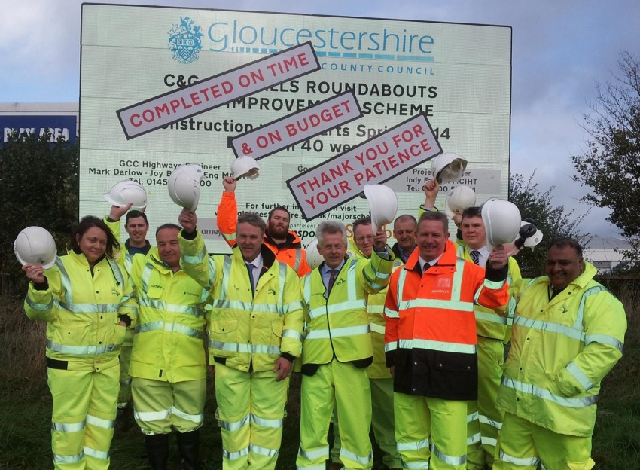

In addition to the major projects above, GCC has a proven track record of delivery of cycle and walking infrastructure schemes, this includes the £1.5 million Metz Way Improvements and £1million Lydney Cycle Improvements Scheme which supported modal shift from car use to walking, cycling and public transport aligning with the objectives of the GSTC.

GCC are also delivering the £1.6million West Cheltenham Walking and Cycling Improvements Scheme which incorporates improved pedestrian and cyclist access between Cheltenham Station and Arle Court. In addition, the design of the B4063 Gloucester to Cheltenham Cycling Scheme is being progressed comprising of 6 miles of new cycle infrastructure and represents one of the most ambitious cycle schemes in the country.

A full list of scheme delivery for major projects can be viewed here; https://www.gloucestershire.gov.uk/highways/major-projects/

6.3h Assurance: We will require Chief Financial Officer confirmation that adequate assurance systems are in place.

For larger transport projects (between £20m - £50m) please provide evidence of an integrated assurance and approval plan. This should include details around planned health checks or gateway reviews. (Limit 250 words)
Section 151 Officer Letter.

The delivery plan for the GSTC contains details of gateway reviews to be included within each of the component parts of the scheme, these differ due to the sequencing of the project but will essentially include:

- Funding secured by GCC’s Cabinet at key decisions above £500k e.g. to procure the works in an open tender exercise
- At the end of Preliminary Design Stage and prior to public consultation the scheme will be reviewed by senior Council Officers, this will be supported by sign off from critical friends..
- At the end of Detailed Design Stage and prior to public consultation the scheme will be reviewed by senior Council Officers, this will be supported by sign off from critical friends..

6.4 Monitoring and Evaluation

See technical note Section 4 and Table 1 for further guidance.

6.4a Monitoring and Evaluation Plan: Please set out proportionate plans for M&E which should include (1000 word limit):

- Bid level M&E objectives and research questions
- Outline of bid level M&E approach
- Overview of key metrics for M&E (covering inputs, outputs, outcomes and impacts), informed by bid objectives and Theory of Change. Please complete Tabs E and F on the appended excel spreadsheet
- Resourcing and governance arrangements for bid level M&E

Monitoring will be in proportion to the GSTC scheme delivered. The monitoring and evaluation process will help confirm that the desired outcomes are being realised.

Pre-scheme opening:

Before the scheme opens, a monitoring report will be produced setting out a baseline that will allow comparison once the scheme has been delivered. To assist this baseline a number of surveys will be undertaken. Monitoring will be undertaken using a mix of operational and one off data.

Operational data:

- Cycle Count Surveys:
To understand the performance of the active travel measures permanent cycle count surveys can be undertaken to determine whether there has been an increase in cycle use along the routes/corridor. Data can be extracted monthly to monitor usage levels and provide an indication of any behaviour change as people see the measures and feel more comfortable cycling.
- ATC Traffic Surveys:
In combination to cycle counts, permanent traffic ATC counts can also be taken along the same routes/corridors to monitor whether vehicular traffic flows have decreased as a result of the cycle interventions.
- Bus Journey times:
Impact on bus services is a key consideration in the GSTC. Information can be gathered from the operators regarding journey time and punctuality in order to also see if there are improvements to journey times as a result of the GSTC. Assessment will be on the GSWB corridor for buses.

One-off data activity:
One off data activities will focus around user questionnaires/surveys. This will allow for a qualitative assessment of the routes helping GCC to understand what works and what needs further improvement. The survey will allow data collection from all users of differing experience/confidence levels and mobility. Gathering this data will ensure that the scheme is inclusive for all.

Meetings:
Regular meetings will be held between GCC project staff during construction and delivery. Once delivered monthly meetings will be held with key stakeholders such as Local Highway Managers, Road Safety Officers and Police to discuss performance and any issues raised.
Meetings will be held with interest groups/vulnerable users groups to see how they consider the improvements and whether any alterations are needed.

This qualitative data will give GCC confidence in our monitoring abilities and help to ensure that the scheme is adapted for all users and will also provide benefit for future schemes as positives/negatives identified for this scheme can be considered in greater depth.

1 year study:
The information gathered through the monitoring undertaken will been analysed and discussed in a study paper after 12 months

Outputs and Outcomes

The summary below cross-references the two interventions (GSWB and the Cycle Spine) with the outputs, outcomes and indicators. The outputs and outcomes are in line with the Theory of Change/Logic Map for the bid. The monitoring is predominately data driven, with counts and surveys established before the schemes are started on the ground. As above, data will be augmented with surveys and questionnaires to assess the impacts of the schemes.

Intervention 1: GSWB Improvement Scheme:
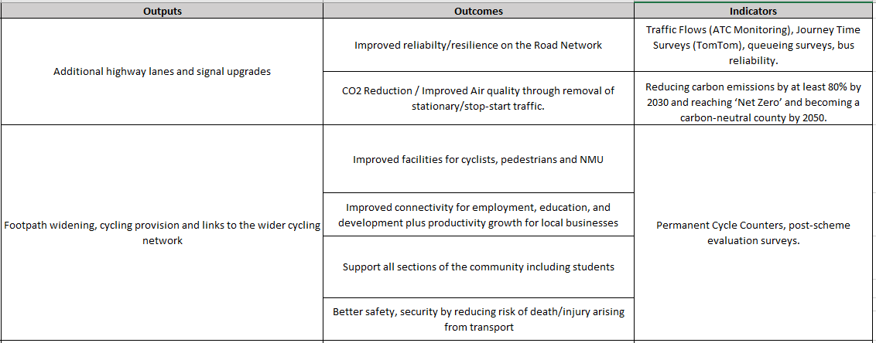

Intervention 2: Cycle Spine
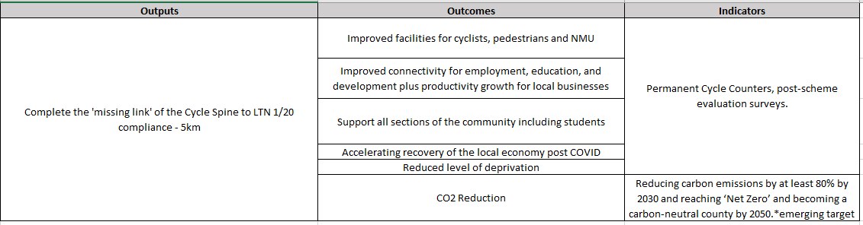

Table F has also been completed in the requested format for Monitoring and Evaluation. The resourcing for the MEP will be through GCC and their consultants, as has been successfully implemented on other Major Projects.

PART 7 DECLARATIONS

7.1 Senior Responsible Owner Declaration
As Senior Responsible Owner for the Gloucestershire Sustainable Travel Corridor (GSTC), I hereby submit this request for approval to UKG on behalf of Gloucestershire County Council and confirm that I have the necessary authority to do so.
I confirm that Gloucestershire County Council will have all the necessary statutory powers and other relevant consents in place to ensure the planned timescales in the application can be realised.
Name:  Colin Chick F.I.C.E. | Signed:  

X04: DECLARATIONS
7.2 Chief Finance Officer Declaration
As Chief Finance Officer for Gloucestershire County Council I declare that the scheme cost estimates quoted in this bid are accurate to the best of my knowledge and that Gloucestershire County Council
- has allocated sufficient budget to deliver this scheme on the basis of its proposed funding contribution
- accepts responsibility for meeting any costs over and above the UKG contribution requested, including potential cost overruns and the underwriting of any funding contributions expected from third parties
- accepts responsibility for meeting any ongoing revenue requirements in relation to the scheme
- accepts that no further increase in UKG funding will be considered beyond the maximum contribution requested and that no UKG funding will be provided after 2024-25
- confirm that the authority commits to ensure successful bids will deliver value for money or best value.
- confirms that the authority has the necessary governance / assurance arrangements in place and that all legal and other statutory obligations and consents will be adhered to.
Name: Steve Mawson | Signed:  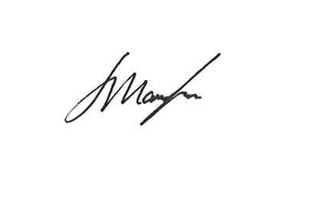
ECLARATIONS
0ECLTIONS

7.3 Data Protection

Please note that The Ministry of Housing, Communities and Local Government (MHCLG) is a data controller for all Levelling Up Fund related personal data collected with the relevant forms submitted to MHCLG, and the control and processing of Personal Data.
The Department, and its contractors where relevant, may process the Personal Data that it collects from you, and use the information provided as part of the application to the Department for funding from the Levelling Up Fund, as well as in accordance with its privacy policies. For the purposes of assessing your bid the Department may need to share your Personal Data with other Government departments and departments in the Devolved Administrations and by submitting this form you are agreeing to your Personal Data being used in this way.
Any information you provide will be kept securely and destroyed within 7 years of the application process completing.

You can find more information about how the Department deals with your data here.

https://inform.gloucestershire.gov.uk/media/2095686/iodfact2019_glos.pdf
Gloucester had the highest proportion of 0-19 year olds (25.0%) in 2016 and (together with Cheltenham) also the highest proportion of 20-64 year olds (58.8% and 58.9% respectively): https://www.gloucestershire.gov.uk/media/2082189/cyp_and_families_needs_assessment_2018-2.pdf
[2] https://www.gloucester.gov.uk/media/3745/egs-v3.pdf
JCS website: www.gct-jcs.org​
At the pinch point itself, queues of over 50 metres were recorded in both the AM and the PM peak in a 2016 survey.
https://www.gfirstlep.com/about-us/our-vision/strategic-economic-plan/
https://www.gloucestershire.gov.uk/transport/gloucestershires-local-transport-plan-2020-2041/transport-strategy-for-gloucestershire-to-2041/
According to Atkins estimates, the cost of delays on roads in Gloucestershire in 2005 were equivalent to £50m-£100m per year in GVA equivalence - Atkins. 2008. Economic Costs of Congestion in the Regions.
As per section 5 of this document.
https://www.gfirstlep.com/downloads/2018/sep-2-update2018v3.pdf
https://www.gloucestershire.gov.uk/media/2095888/cycling-and-walking-infrastructure-plan-final-20200828.pdf

