


Project Bulletin - Whitminster Canal Bridge

As the project progresses at pace, we have in the past weeks completed works on the culverts and installed back of wall drainage.
Kerb installation has started, and we have carried out work on the parapet over the bridge deck.
The carriageway has been reinstated up to sub-base level and we have applied waterproofing to the bridge deck. (photo below)

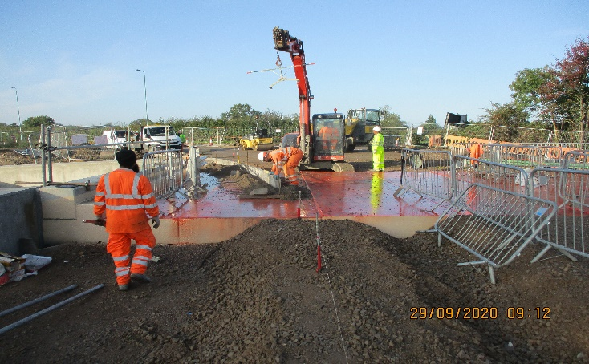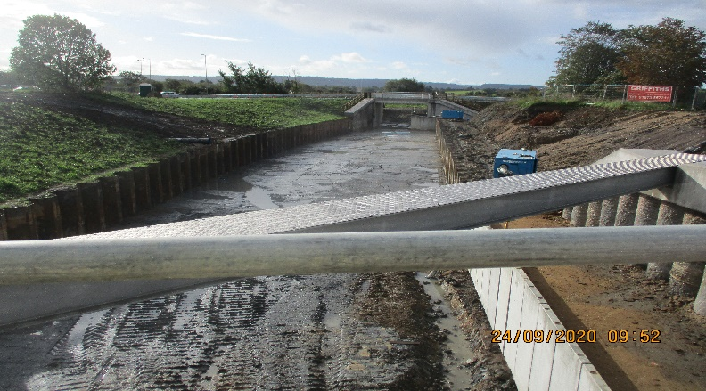
As these important improvements continue, your continued patience is greatly appreciated.
If you have any concerns or issues regarding the road improvement scheme, please contact me on 0300 041 4635*. I will be available throughout the construction phase to provide continuous engagement with businesses and residents within the local area.
Further information about the scheme can be found at
https://www.gloucestershire.gov.uk/highways/major-projects-list/a38-canal-bridges/

Neil Evans
Contract Liaison Officer
Alun Griffiths (Contractors) Ltd
0330 041 4635*

*Calls to this number are charged at national call rates and included in inclusive minute plans from landlines and mobiles

