The Learning Environment: The Temporal Environment
Movement and Rest
Why movement is important in the early years
Active children are healthy, happy, ready to learn, and sleep better. It is important that all under fives should minimise the amount of time spent being sedentary (being restrained or sitting) for extended periods (except time spent sleeping).
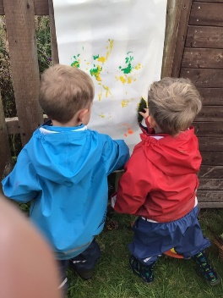
Physical activity:
- builds relationships and social skills
- contributes to brain development and learning
- improves sleep
- develops muscles and bones
- encourages movement and co-ordination
- maintains health and weight
- Supports sensory needs
The early years physical activity guideline
For children under one – aim for at least 30 minutes of movement per day
Children 1 to 5 years - aim for at least 180 minutes of movement per day
All under fives should minimise the amount of time spent being sedentary (being restrained or sitting) for extended periods (except time spent sleeping)
Ideas to promote movement
Under ones/infants who cannot yet walk unaided – floor-based play inclduing ‘tummy time’ and water based activities in safe environments.
Children 1 to 5 years - climbing, jumping, messy play, throwing and catching, skipping, object play, dancing, games, playing, swimming, walking, using a scooter, riding a bike, obstacle courses.
Why rest is important in the early years
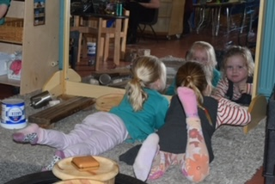
Rest is as important to growth, development and health as nutrition and physical activity. Getting enough rest and restful sleep is essential to growth, healing and developing a healthy immune system. Sleep is also crucial to brain function, and affects a child’s alertness, learning ability, memory, mood and behavior. Too little rest and sleep can lead to decreased attentiveness, decreased short-term memory, inconsistent performance, delayed response time, and an increase in negative behaviours.
Ideas to support rest
- Consider that children’s need for sleep, rest and relaxation will be unique to them, and will vary across the course of the day.
- Consider if children may have experienced disturbed sleep, or an early wake up, which may influence how soon or often they need to rest.
- Reflect on your daily routine and how this supports these variations of need for rest. Providing sleep, rest, or relaxation at specified times throughout the day may meet the needs of some children, however these times may not be appropriate for all children.
- Children’s transition to sleep can influence the quality of the sleep they have. Providing a predictable and calming routine, involving quiet restful activities such as reading a story or listening to soft music may help settle children gently into sleep.
Top tips for inclusion
- Provide a cosy place in your setting for children to access to rest.
- Ensure your sleep room meets the individual needs of all children requiring access.
- Provide opportunities for movement outside with a variety of activities.

Partnership with Parents
- Parents know their child best - involve them in the planning of your daily routines.

Helpful links/signposting
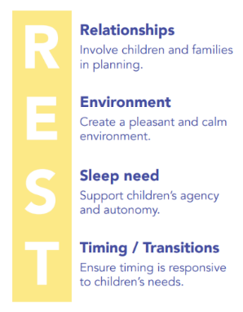
In thinking about sleep, rest, and relaxation practices, consider the 4 principles for R.E.S.T. shared within the Information for Educators and ECEC Services - The Sleep Program
Meeting Children's Sleep, Rest and Relaxation Needs in Early Childhood
Physical activity for early years: birth to 5 years
UK physical activity guidelines for early years (non-walkers)
Help for early years providers : Gross motor skills
The Importance of Sleep for Children - Early Childhood Development Initiatives
5 Ways to Support Babies and Children to Rest and Sleep in Early Years

