


Project Bulletin - Whitminster Canal Bridge
Construction work is progressing with the excavation and moving of the BT service into its temporary position.
The specialist contractors are now on site and we have constructed the piling platform.
In the coming weeks we will install the North wing walls and complete the installation of drainage to the East side of the site.

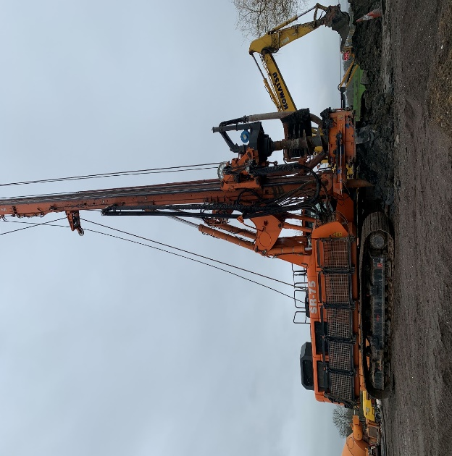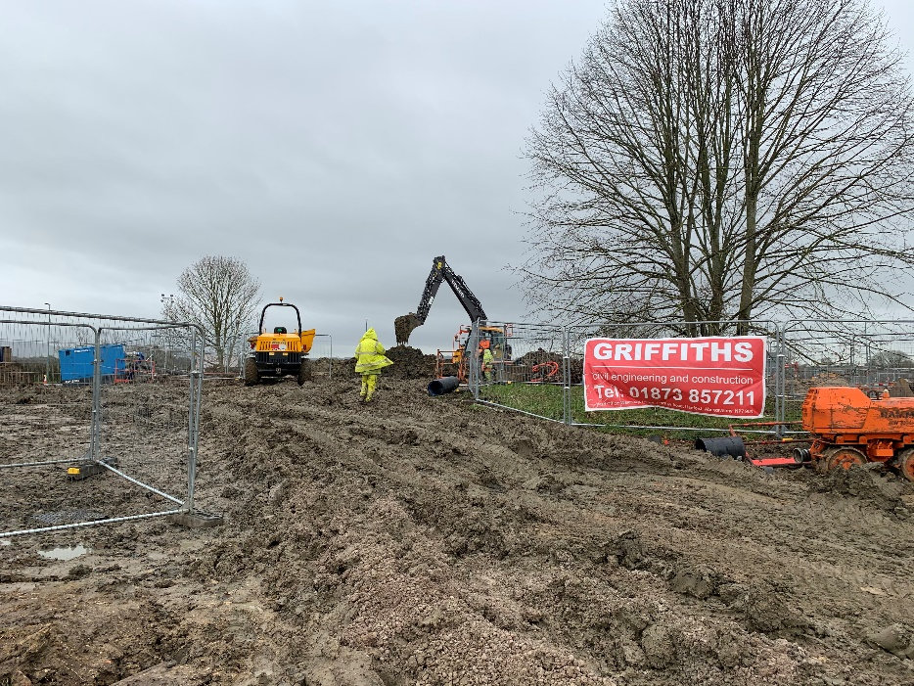
As we progress with these important improvements, your continued patience is greatly appreciated.
If you have any concerns or issues regarding the road improvement scheme, please contact me on 0300 041 4635*. I will be available throughout the construction phase to provide continuous engagement with businesses and residents within the local area.
Further information about the scheme can be found at:
https://www.gloucestershire.gov.uk/highways/major-projects-list/a38-canal-bridges/

Neil Evans
Contract Liaison Officer
Alun Griffiths (Contractors) Ltd
0330 041 4635*

*Calls to this number are charged at national call rates and included in inclusive minute plans from landlines and mobiles

