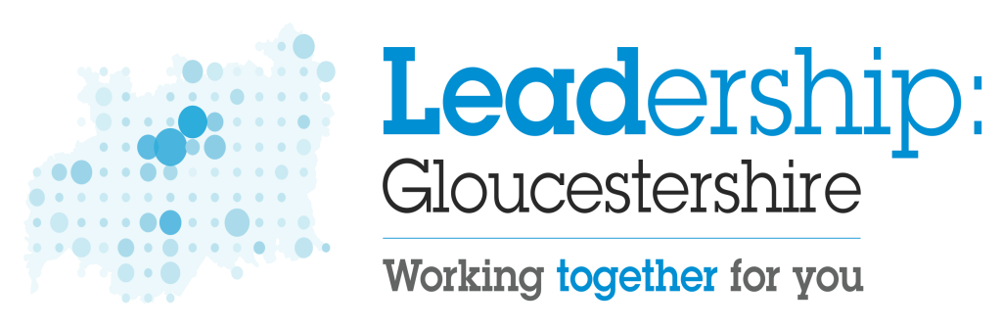

Leadership Gloucestershire – 13 December 2022
Remote meeting via Microsoft Teams

1 Welcome, introduction and apologies

Name | Organisation | Apologies
Cllr Mark Hawthorne (Chair)  Pete Bungard  Steve Mawson  Colin Chick | Gloucestershire County Council | Siobhan Farmer
Cllr Catherine Braun  Andrew Cummings | Stroud District Council
Cllr Richard Cook  Jon McGinty | Gloucester City Council
Cllr Bernie O’Neill  Pete Williams | Forest of Dean District Council | Cllr Tim Gwilliam
Cllr Rowena Hay  Gareth Edmundson | Cheltenham Borough Council
Cllr Joe Harris  Rob Weaver | Cotswold District Council
Cllr Rob Bird  Alistair Cunningham  Pete Tonge | Tewkesbury Borough Council
PCC Chris Nelson | Office of the Police and Crime Commissioner (OPCC)
CC Rod Hansen | Gloucestershire Constabulary
Mary Hutton  Dame Gill Morgan  Graham Jones | NHS Gloucestershire | Dr Andy Seymour
Ruth Dooley | GFirst Local Enterprise Partnership (LEP)
Anwen Jones | Area Lead for Gloucestershire,  Cities and Local Growth Unit

2 ACTION NOTES

The notes of the meeting held on 29 September 2022 were noted and agreed.
3 GLOUCESTERSHIRE STRATEGIC MIGRATION PARTNERSHIP

Pete Tonge, Head of Community Services at Tewkesbury Borough Council, outlined the terms of reference and governance proposals for the setting up of a Gloucestershire Strategic Migration Partnership. He advised that, if agreed at this meeting, the intention would be to establish the membership of the partnership by seeking nominations from senior representatives at partner organisations. It was acknowledged that, given recent changes in the numbers of refugees and asylum seekers arriving in Gloucestershire, there was a need for a stronger structure from which to support the vulnerable migrants living in the county.

In consultation with the Gloucestershire Strategic Housing Partnership and the Strategic Directors Group, and with the support of the Gloucestershire Health & Wellbeing Board, it was confirmed that the partnership would provide periodical reports to Gloucestershire’s Chief Executives. Working alongside the Regional Strategic Migration Partnership, the partnership to support vulnerable migrants, including refugees and asylum seekers, by seeking to maximise opportunities from which to live healthy, happy and successful lives.

Responding to a question on how elected members might become more informed in the work of the partnership, it was suggested that, in addition to receiving regular updates at Leadership Gloucestershire meetings, newsletters similar to those reporting on the Homes for Ukraine Scheme be produced. Cllr Mark Hawthorne suggested that the names of the lead members with responsibility for the wellbeing of vulnerable migrants at each authority be circulated to everyone for information. Actions by: Pete Tonge

Supporting the proposal, Leadership Gloucestershire agreed that the Gloucestershire Strategic Migration Partnership be established.

4 HEALTH UPDATE

- Covid and Flu Vaccine Programme Update

Providing an update on the Gloucestershire Covid and Flu Vaccine Programme,
Graham Jones from NHS Gloucestershire, reported the following information: -

- Commencing in mid-September, the Gloucestershire Autumn Booster Programme had been extended from the end of December until the end of February 2023.
- In Gloucestershire, approximately 310.5k people had been eligible for a booster vaccination.
- Predicted uptake rates had been anticipated at around 248k doses, (73% of the population). In spite of falling slightly below the 80% performance target level, Gloucestershire was the highest performing county in England.
- The number of people coming forward for the booster had fallen in recent weeks and not as high as that recorded at the same time the previous year.
- Priority cohorts during the first few weeks of the programme had been care home residents and the housebound. It was confirmed that 90% of care home residents and residents age over 80 had received their booster before the target date of 23 October 2022.
- The uptake in the number of people, including children, coming forward for the flu vaccination was increasing.
- Health and care workers had been offered the vaccine as a priority.
- The vaccination was in plentiful supply and available from a variety of locations throughout the county.

- One Gloucestershire - Integrated Care System

Mary Hutton and Dame Gill Morgan gave an update on the One Gloucestershire NHS Integrated Care System, including establishment of the Gloucestershire Health and Wellbeing Partnership.

Following the creation of the Gloucestershire Integrated Care Board in July 2022, extensive work and engagement had focused on the development of the Gloucestershire Integrated Care Partnership, (to be known as the Gloucestershire Health and Wellbeing Partnership). The first public meeting of the Partnership will be held on 22 December 2022, at which members will be required to consider and agree the Gloucestershire Interim Integrated Care Strategy, prior to publication as required by the Department of Health and Social Care.

Dame Gill clarified that the interim care strategy will set out the direction of the Gloucestershire Integrated Care System and how partner organisations, including NHS, social care, public health and other public voluntary and community sector organisations, will work together to deliver joined-up, preventative, and person-focused care for the population of Gloucestershire. It was explained that the work of the Health and Wellbeing Partnership will not duplicate, but will work alongside and in conjunction with the Gloucestershire Health and Wellbeing Board.

For more information on the Interim Integrated Care Strategy, please refer to the Gloucestershire County Council website at the link here.

Included in the update were references to the challenges being presented to NHS Gloucestershire, including, winter pressures being placed on the delivery of urgent and emergency care, the impact of the cost of living crisis on primary care services and the consequences of potential NHS strike action.

5. ECONOMIC GROWTH UPDATE

5.1 Levelling-up, County Deals and Investment Zones

Pete Bungard noted that changes in national government and world-wide events had altered the backdrop of the “levelling up” narrative.

In relation to County Deals, it was noted that the government’s current focus appeared to be limited to level 3 mayoral devolution proposals. However, the government’s thinking beyond level 3, was likely to be formed early in the New Year. Cllr Mark Hawthorne confirmed that a letter of intent would be drafted offering Gloucestershire as an exemplar level 2 devolution option, stressing our unique co-terminosity. The draft letter would be circulated for comment to Leadership Gloucestershire prior to the Christmas holiday and submitted to government in early January.

The merits of a County Deal and the concept of devolution were aired. Pete Bungard suggested that the draft letter was unlikely to contain any surprises as it was based on both our previous agreed devolution proposals and our draft County Deal paperwork from summer 2022.

It was suggested that a progress report be presented at the next meeting and this was noted. Action by – Pete Bungard.

In relation to Investment Zones, two bids had been submitted. Although it appeared clear that the new government was unlikely to take this initiative forward, the autumn statement made reference to research based Investment Zones. No guidance yet existed, but the Golden Valley was thought to be a strong offer for a cyber based proposition.

Pete Bungard also noted that the STEP Fusion Project submission for Oldbury/Berkeley had been unsuccessful, but that conversations would continue in terms of the potential strategic future use of these sites.

5.2 Western Gateway

. Pete Bungard gave an update on the Western Gateway Partnership and confirmed that a new director, John Wilkinson, had been appointed. The next meeting of the partnership would be held in late January.

5.3 Gloucestershire Economic Growth Joint Committee (GEGJC) and City Region Governance

Gareth Edmundson gave a brief update on the governance arrangement proposals for the Gloucestershire City Region Board and on the transition of responsibility and conclusion of the Joint Economic Growth Committee in March 2023.

It was reported that, at a recent meeting of the GFirst Local Enterprise Partnership, there had been general consensus on the governance structure for the new arrangement and on the decision to keep the name City Region Board rather than Future Gloucestershire.

Noting differing views on the appointment of Chair, it was suggested that an officer meeting be arranged in the New Year, initially between Chief Executives. Action by – Gareth Edmundson/Steve Mawson

Formal decisions by the various councils would be required in advance of March 2023.

6 FUTURE MEETINGS
Wednesday 1 March at 2pm
Tuesday 20 June at 10am
Tuesday 26 September at 2pm
Tuesday 5 December at 10am

