
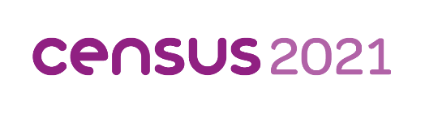

Ethnicity, Identity, Language and Religion– a briefing
Contents
1. What is the 2021 Census? 3
2. Caveats – Covid 3
3. What do the results tell us about Gloucestershire? 4
3.1 Ethnic groups 4
3.2 National identity 13
3.3 Language 19
3.4 Religion 26
4. Key messages 29
5. What’s next? 31
6. Where can you find out more? 31

- What is the 2021 Census?
The census is a survey of all people and households in England and Wales that happens every 10 years. It is designed to collect detailed information about where people live, what they do for a living, what sort of homes and families they have, their general health, their educational attainment and how these factors have changed over time. There is simply nothing else that gives so much detail about us and the society we live in. It tells us what our needs are now and what they are likely to be in the future. It also gives a snapshot of how we live, for future generations to look back on.
The information given by the public during the census helps local authorities plan and fund public services. It informs where billions of pounds are spent, for instance on things like roads, schools and hospitals.
The 2021 Census was conducted on the 21st March 2021, it is unique as it was conducted during national lockdown as a result of the COVID-19 pandemic.
This briefing provides analysis of the data around ethnicity, identity, language and religion, released by the Office for National Statistics (ONS) on the 29th November 2022.
- Caveats – Covid
The 2021 Census took place during national lockdown which was initiated in response to COVID-19. ‘For most of the population, the coronavirus pandemic would not have affected where they considered themselves resident.’ However, there is indication that some subgroups of the population may have changed where they lived during this time, mainly students and some urban residents:
Students- There is evidence to suggest there was a higher proportion of students not living at their term-time address on the 21st March compared with previous years. Also, usually resident international students may have returned to their home country early and not have been residing in the UK at the time of the 2021 Census. To combat the impact of this, the ONS asked students to complete the form for their term-time address which they ‘intended to stay at regularly during term time in this academic year, even if they are not currently there’. Furthermore, international students were counted if they were still present in the UK or had attended university during the Autumn 2020/Winter 2021 academic terms and were intending to return: up to the 21st March 2022.
Urban residents- There is some evidence to suggest that the population of Greater London may have fallen in the COVID-19 pandemic due to young adults leaving, higher mortality of over 75s and increased internal migration. However, there is also indication that the population has begun growing since then. This may also have been reflected in other urban centers.
- What do the results tell us about Gloucestershire?
  - Ethnic groups
    - Broad Ethnic group
The census collects information about the ethnic group that the person completing the census feels they belong to. This could be based on their culture, family background, identity or physical appearance.
In 2021 93.1% (600,314 people) of Gloucestershire’s population identified as “White”. Gloucestershire was less diverse than the national average, with 81.7% of residents across England and Wales identifying as “White”, however it was in line with the regional average where 93.1% of residents identified as “White”. All districts in Gloucestershire had a higher proportion of residents identifying as “White” than nationally. The urban districts of Gloucester and Cheltenham (84.9% and 91.4%) had the lowest proportion of “White” residents, while the Forest of Dean had the highest (97.5%).
Figure 1 shows the proportion of the population identifying as “White” at Lower Super Output Area Level (LSOA). In over half of LSOAs more than 95% of the population identified as “White”. However, in and around the urban districts of Gloucester and Cheltenham and around the market towns of Cirencester, Bishops Cleeve and Stroud the population is more diverse. The areas making up Barton and Tredworth in Gloucester are the most diverse in the county, with three LSOAs in this area having less than half their population identifying as “White”.
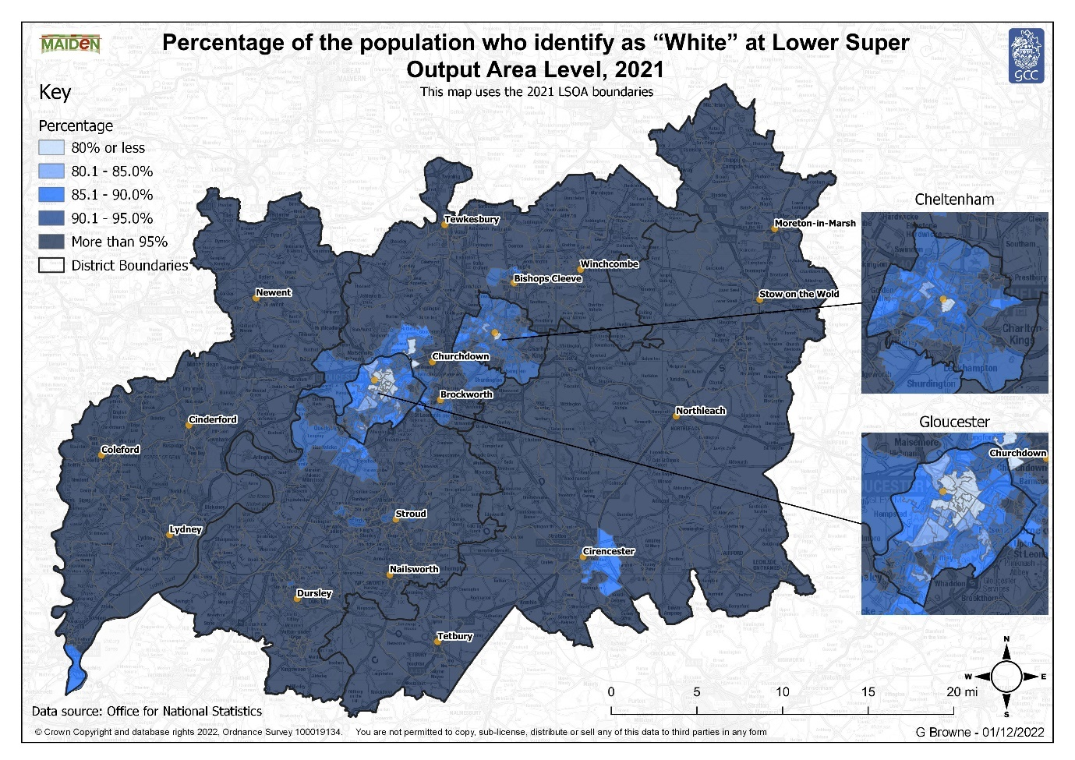
Figure 1: Percentage of the population who identify as “White” at Lower Super Output Area Level, 2021
"Asian, Asian British or Asian Welsh" accounted for the second largest proportion of Gloucestershire’s population at 2.9%. This group was also the second largest group at a national and regional level, although it accounted for a larger proportion nationally (9.3%) than in Gloucestershire, which is unsurprising given the high proportion of Gloucestershire’s population who identify as “White”. At district level "Asian, Asian British or Asian Welsh" accounted for the second largest proportion of the population in Cheltenham, Gloucester and Tewkesbury however in Cotswold, the Forest of Dean and Stroud “Mixed or Multiple ethnic groups” accounted for a larger proportion of the population.
The third largest ethnic group in Gloucestershire was “Mixed or Multiple ethnic groups”, this differs from the picture seen at a national level where “Black, Black British, Black Welsh, Caribbean or African” accounted for the third largest proportion of the population. At district level, Cheltenham, Gloucester and Tewkesbury follow the county average with “Mixed or Multiple ethnic groups” accounting for the third largest group while in Cotswold, Forest of Dean and Stroud "Asian, Asian British or Asian Welsh” accounted for the third largest group. In all districts “Black, Black British, Black Welsh, Caribbean or African” was the fourth largest ethnic group, followed by “Other ethnic group”.
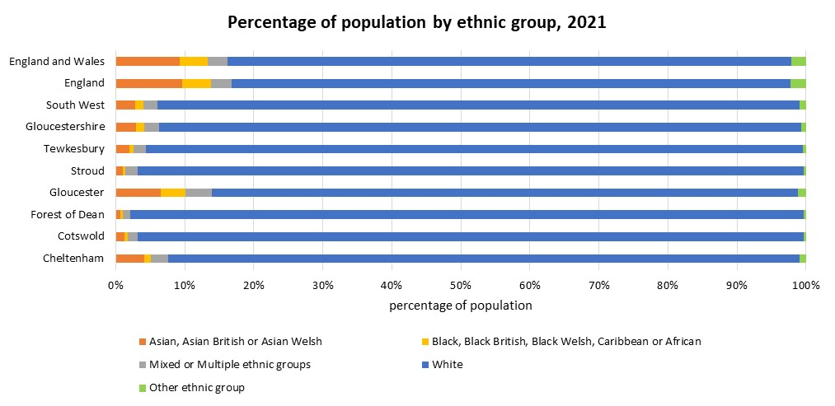
Figure 2: Percentage of population by ethnic group, 2021
Since 2011 Gloucestershire has become more diverse, with the proportion of people identifying as “White” falling from 95.4% in 2011 to 93.1% in 2021, conversely all other ethnic groups have seen growth during the same period. Figure 3 shows the proportion of people identifying as “White” has also fallen at a national level and in all of Gloucestershire’s districts, although the decline at a national level has been greater than in Gloucestershire and all districts apart from Gloucester. The greatest growth at a county and national level has been in the "Asian, Asian British or Asian Welsh" with this group accounting for 2.1% of Gloucestershire population in 2011 and 2.9% in 2021. However, while at a national level the growth in the proportion of the population who were "Asian, Asian British or Asian Welsh" was considerably higher than the growth in “Mixed or Multiple ethnic groups”, at a county level there was minimal difference, this is because the proportion of the population who were "Asian, Asian British or Asian Welsh" has not grown as much in Gloucestershire as elsewhere. At a district level the picture varies, in Cheltenham, Gloucester and Tewkesbury the greatest growth has been in the "Asian, Asian British or Asian Welsh" while in Cotswold, the Forest of Dean and Stroud the greatest growth has been in “Mixed or Multiple ethnic groups”.

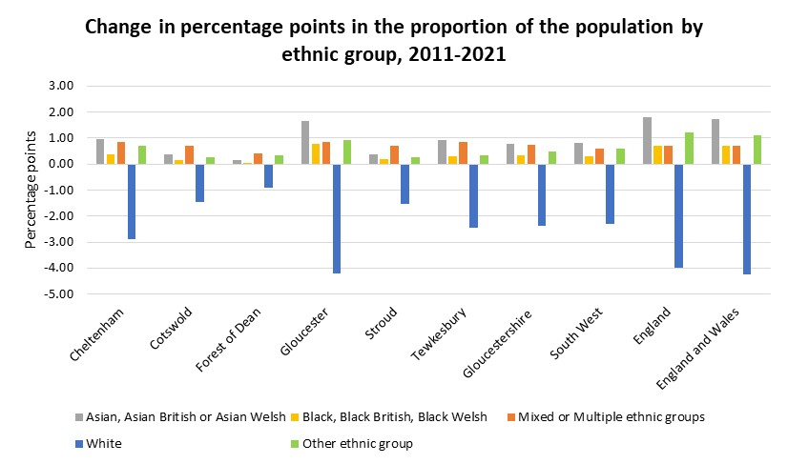
Figure 3: Change in percentage points in the proportion of the population by ethnic group, 2011-2021
    - 19 Ethnic Groups
The 5 broad ethnic groups discussed in the previous section can be broken down into 19 separate ethnic groups.
In 2021 87.7% of the total population Gloucestershire identified their ethnic group as "English, Welsh, Scottish, Northern Irish or British", this was considerably higher than the national average of 74.4% and reflects the picture seen when looking at broad ethnic groups which showed Gloucestershire was not as diverse as England and Wales. All districts in Gloucestershire had a higher proportion of residents identifying as "English, Welsh, Scottish, Northern Irish or British" than nationally. The urban districts of Gloucester and Cheltenham (78.0% and 83.3%) had the lowest proportion of "English, Welsh, Scottish, Northern Irish or British" residents, while the Forest of Dean had the highest (94.7%).
“Other White” was the second largest of the 19 ethnic groups, accounting 4.5% of Gloucestershire’s population. This group was also the second largest group at a national and regional level, although it accounted for a larger proportion nationally (6.2%) than in Gloucestershire, which is unsurprising given the high proportion of Gloucestershire’s population who identify as "English, Welsh, Scottish, Northern Irish or British". This group also accounts for the second largest proportion of the population across all of Gloucestershire’s districts. In Cheltenham the proportion of people that fall into this group exceeds the national average (7.0% compared to 6.2%).
Figure 4 shows the distribution of the “Other White” population at Lower Super Output Area Level. The areas with the highest proportion of people identifying at “Other White” are predominantly in the urban districts of Gloucester and Cheltenham or around the market towns. In Gloucester, the areas with a higher proportion of “Other White” residents are based around Westgate, Moreland and Barton and Tredworth. The areas with the highest proportion of “Other White” residents in Cheltenham are mainly concentrated around the town center in, St Peter’s, St Paul’s, and All Saints as well as Hesters Way.
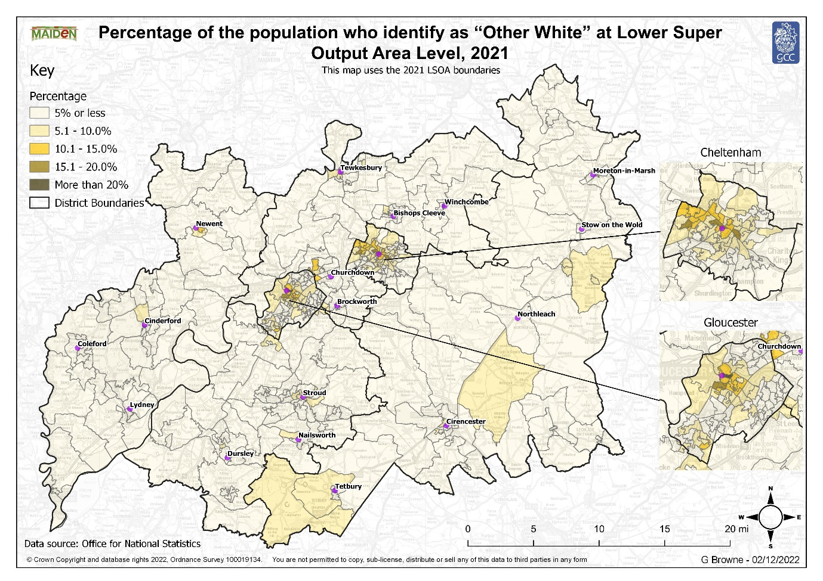
Figure 4: Percentage of the population who identify as “Other White” at Lower Super Output Area Level, 2021
Figure 5 shows Gloucestershire had a smaller proportion of the population identifying as all the other 19 ethnic groups than England and Wales, with the exception of “White: Gypsy or Irish Traveler” which was the same as the national average. The greatest difference was observed in the “Pakistani” group, with this group accounting for 0.3% of Gloucestershire’s population compared to 2.7% of the population of England and Wales.
At district level there are considerable differences, Cotswold, Forest of Dean, Stroud and Tewkesbury generally have lower proportions of all ethnic groups except “English, Welsh, Scottish, Northern Irish or British” than the county and national average. In contrast the urban districts of Cheltenham and Gloucester have higher proportions of most ethnic groups than Gloucestershire. Gloucester also has a higher proportion of people who identify as “Indian”, “Pakistani”, “Caribbean”, “Other Black”, “White and Black Caribbean” and “Gypsy or Irish Traveller” than nationally, while Cheltenham has a higher proportion of people who identify as “White and Asian” than nationally.

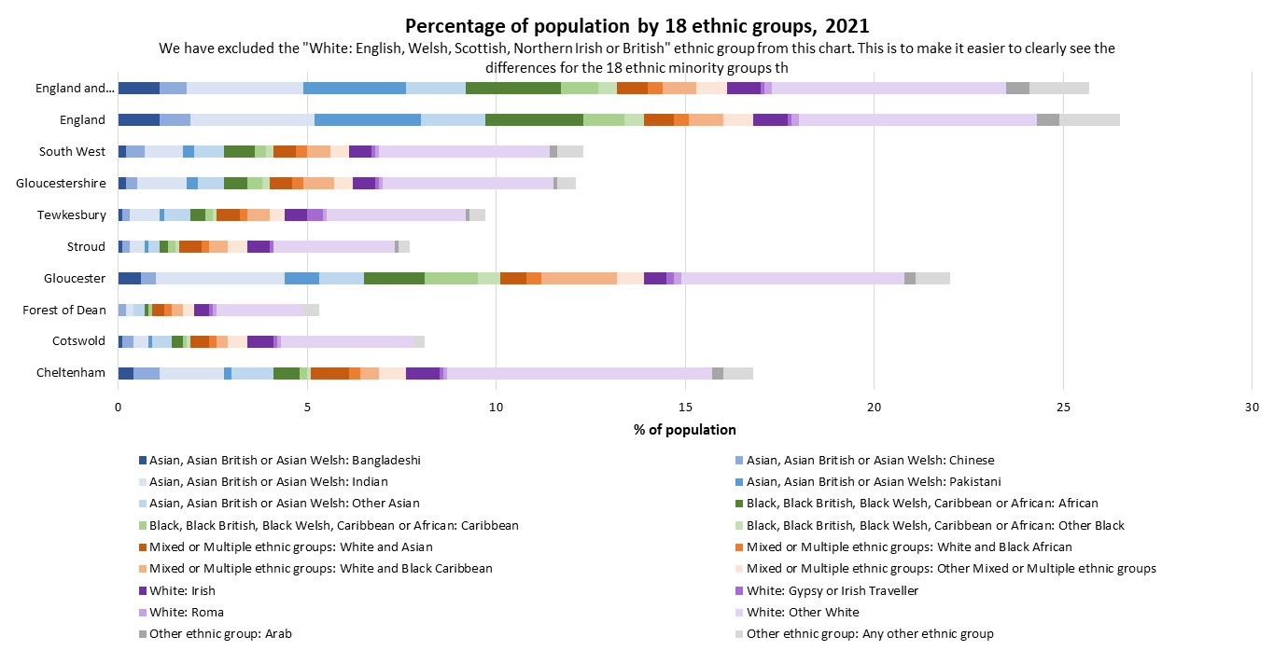
Figure 5: Percentage of population by 18 ethnic groups, 2021
Since 2011 the proportion of people identifying as "English, Welsh, Scottish, Northern Irish or British" in Gloucestershire fell from 91.6% in 2011 to 87.7% in 2021. Conversely the 18 other ethnic groups all saw no change or an increase in the proportion of the population identifying as that group. This was broadly in line with the picture seen at a national, regional and district level.
The greatest increase since 2011 was in those identifying as “Other White” with this group increasing from 3.1% of the total population in 2011 to 4.5% of the population in 2021. This group also saw the greatest growth across England and Wales, the South West and all districts in the county.
The group seeing the second largest growth in Gloucestershire was “Any other ethnic group” which increased from 0.1% of the population in 2011 to 0.5% of the population in 2021. This group saw the second greatest growth at a national and regional level and in Cheltenham, the Forest of Dean and Gloucester, while in Cotswold the second greatest growth was in “Other Mixed or Multiple ethnic groups”, in Stroud it was “Other Black” and in Tewkesbury it was “Other Asian”.
The proportion of people identifying as “Indian” saw the third largest growth across the county, this differs from the picture seen at national level where the “African” group saw the third largest growth but was in line with the picture across the South West.
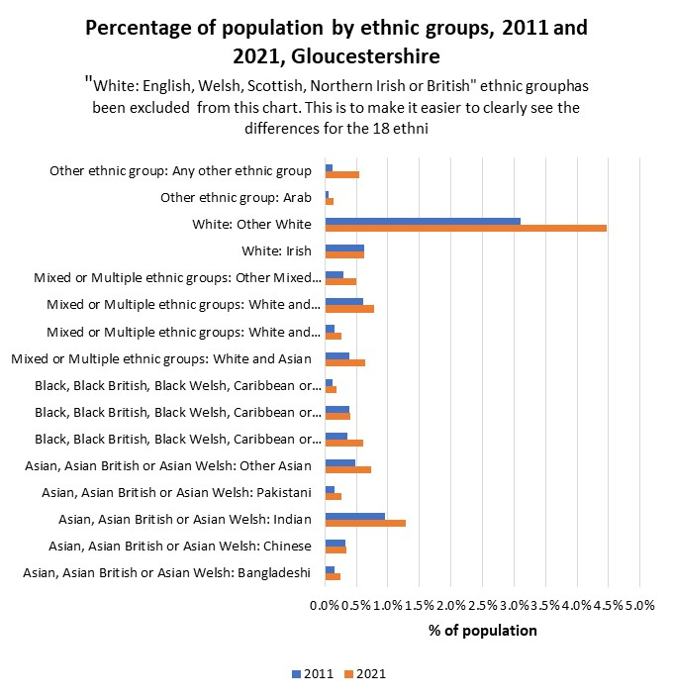
Figure 6: Percentage of population by ethnic groups, 2011 and 2021, Gloucestershire
    - Detailed ethnic groups
The census also collected information at a more detailed level, breaking the 19 ethnic groups down into 287 ethnic groups.
This section uses the detailed responses to explore the two broader groups which saw the largest growth.
The “Other White” ethnic group saw the largest growth between 2011 and 2021. The largest ethnic groups specified within "Other White" included "White: Polish", with 1.0% of the overall population identifying this way, “White: European Mixed (0.9%), “White: Irish” (0.6%) and “White: Romanian” (0.3%). This is broadly in line with the picture seen at a national, regional and district level.
The number of people choosing to specify their ethnic group through the "Other ethnic group: Any other ethnic group" option (0.5%) more than tripled since 2011 (0.1%). The largest ethnic groups within the "Other ethnic group" response option for Gloucestershire included “Any other ethnic group” (0.1%), “European Mixed, European unspecified, other European” (0.04%) and "Hispanic or Latin American" (0.03%). This differs slightly from the picture seen nationally where the largest groups were “Any other ethnic group” (0.1%), "Sikh" (0.1%), "Hispanic or Latin American" (0.1%) and "Kurdish" (76,000, 0.1%).
    - Ethnic groups within households
The census provides an insight into the ethnic composition of households. In Gloucestershire, 30.4% of households were one person households, 61.8% of households were made up of household members who all identified with the same ethnic group and 7.8% of households were made up of different ethnic groups. Figure 7 shows Gloucestershire has a slightly lower proportion of multi-ethnic households than England and Wales (10.1%) but is in line with the regional average (7.9%). At district level Cheltenham and Gloucester have a higher proportion of households made up of different ethnic groups than Gloucestershire but are in broadly in line with the national average.
The most common type of multi ethnic household was “Ethnic groups differ within partnerships”, with this group accounting for 5.1% of households within Gloucestershire, this was followed by “Any other combination of multiple ethnic identities” (1.5%) and “Ethnic groups differ between generations but not within partnerships” (1.2%). This reflects the picture seen at a national and regional level, although in all instances the proportion of households within these groups was smaller in Gloucestershire than England and Wales. At district level Cheltenham stands out as having a high proportion of households which are made up of “Ethnic groups differ within partnerships” (6.3%) exceeding the national average of 5.7%, while Gloucester stands out as having a high proportion of households which are classed as “Ethnic groups differ between generations but not within partnerships”, with this group accounting for 2.4% of households exceeding the figure for England and Wales which stands at 1.8% of households.
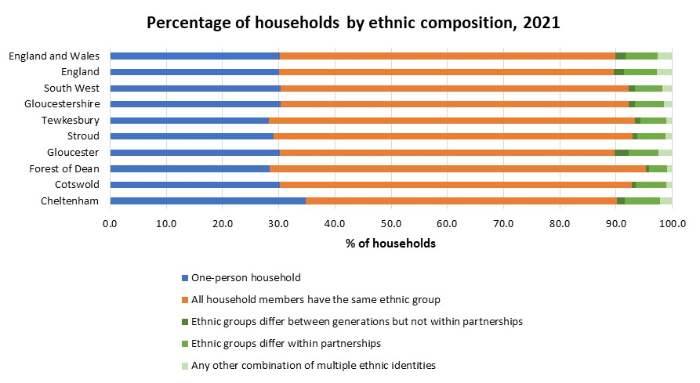
Figure 7: Percentage of households by ethnic composition, 2021
Given that the overall population has become more diverse since 2011 it is unsurprising the proportion of multi ethnic households increased during the same period. In 2011, 6.1% of households in Gloucestershire were made up of different ethnic groups, this increased to 7.8% in 2021. This growth was reflected at a national, regional and district level. The growth was primarily driven by an increase in households classed as “Ethnic groups differ within partnerships” with the proportion of households in Gloucestershire falling into this group increasing from 3.8% in 2011 to 5.1% in 2021. The proportion of households made up of “Any other combination of multiple ethnic identities” also increased from 1.1% of households in 2011 to 1.5% of households in 2021. The proportion of households made up of “Ethnic groups differ between generations but not within partnerships” remained unchanged between 2011-2021 at 1.2%. Figure 8 shows the picture is broadly similar at a national, regional and district level, although nationally and in Gloucester and Tewkesbury there was a decline in the proportion of households made up of “Ethnic groups differ between generations but not within partnerships”.

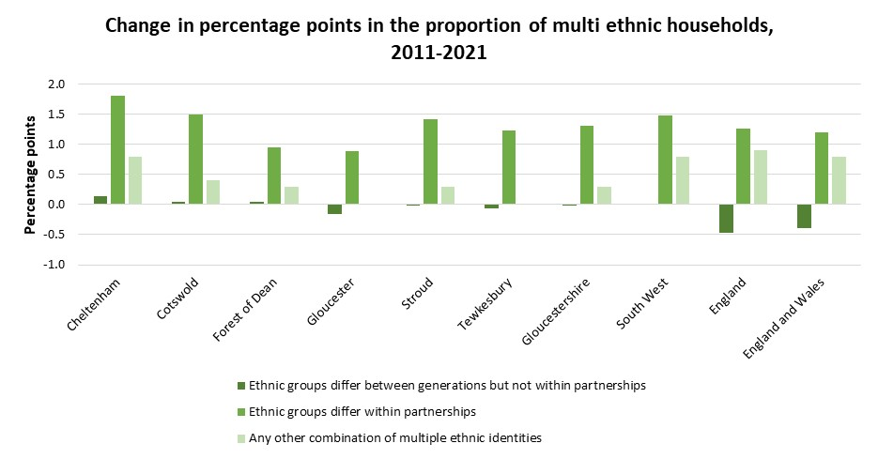
Figure 8: Change in percentage points in the proportion of multi ethnic households, 2011-2021
  - National identity
The census question on national identity was introduced in 2011 because of increased interest in "national" consciousness and a demand for people to be able to acknowledge their national identity. The question allows respondents to select all identities that apply.
In 2021 94.3% of Gloucestershire residents identified with at least one UK national identity (English, Welsh, Scottish, Northern Irish, British, and Cornish) and the remaining 5.7% of the population selected a non-UK identity. Table 1 shows when compared to the national average a higher proportion of Gloucestershire’s population reported a UK identity, reflecting the pattern seen in ethnicity data which suggested Gloucestershire was less diverse than England and Wales. Cheltenham has the lowest proportion of residents selecting a UK identity (91.2%) followed by Gloucester (91.6%), while the Forest of Dean had the highest (97.0%).

Table 1: Population by broad national identity, 2021
 | UK identity |  | Non-UK identity
 | Number | % of population | Number | % of population
Cheltenham | 108,393 | 91.2% | 10,441 | 8.8%
Cotswold | 86,885 | 95.6% | 3,959 | 4.4%
Forest of Dean | 84,388 | 97.0% | 2,616 | 3.0%
Gloucester | 121,302 | 91.6% | 11,108 | 8.4%
Stroud | 116,478 | 96.2% | 4,629 | 3.8%
Tewkesbury | 90,692 | 95.6% | 4,193 | 4.4%
Gloucestershire | 608,133 | 94.3% | 36,942 | 5.7%
South West | 5,346,899 | 93.8% | 354,289 | 6.2%
England | 53,773,706 | 90.2% | 5,823,838 | 9.8%
England and Wales | 53,773,706 | 90.2% | 5,823,838 | 9.8%

Figure 9 shows the distribution of the population with a Non UK identity at Lower Super Output Area Level. The areas with the highest proportion of people selecting a Non UK identity are predominantly in the urban districts of Gloucester and Cheltenham, around the market towns or around military basis such as Innsworth. In Gloucester, the areas with a higher proportion of “Non UK” residents are based around Westgate, Moreland and Barton and Tredowth. The areas with the highest proportion of residents with a Non UK identity in Cheltenham are mainly concentrated around the town center in Lansdown, All Saints, St Peter’s and St Paul’s.
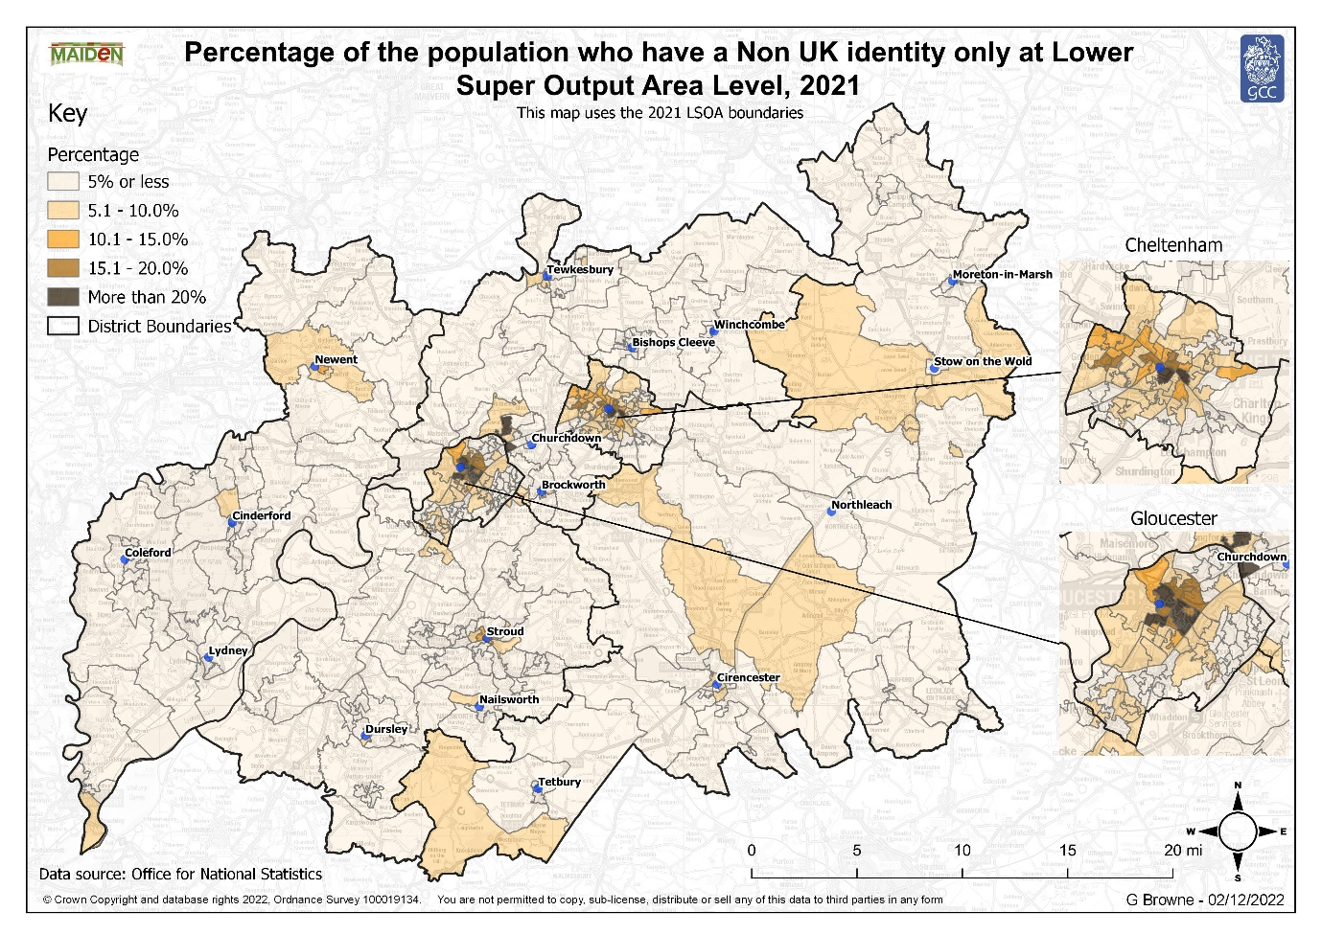
Figure 9: Percentage of the population who have a Non-UK identity at Lower Super Output Area Level, 2021
Since 2011 the proportion of Gloucestershire residents reporting at least one UK national identity has fallen from 95.6% in 2011 to 94.4% in 2021, conversely the proportion of people recording a Non-UK identity has increased from 4.4% in 2011 to 5.7% in 2021. A similar picture was reflected at a national, regional and district level.
    - UK identities
More than half of the usual resident population in Gloucestershire (56.5%) selected a “British only” national identity in 2021, this was followed by “English and British only” (16.9%) and “English only” (16.6%). Gloucestershire had a larger proportion of its population reporting they were “British only”, “English and British only”, “English only” and “Any other combination of UK identities” than nationally, conversely it had a lower proportion of people reporting they were “Welsh only”, “Welsh and British only” and “Cornish only”, which is unsurprising given its position within the UK. Figure 10 shows the districts generally followed a similar pattern to the county, the main exception being that in Cotswold, the Forest of Dean and Stroud the proportion of people reporting they were “English only” was greater than the proportion of people reporting they were “English and British only”.
In addition, around 1.5% of Gloucestershire’s population reported they had an “Other identity and at least one UK identity”. This was lower than the national average of 1.9%. Most districts were in line with the county average or had a lower proportion of residents selecting an “Other identity and at least one UK identity”, the only exception was Cheltenham with 2.3% of residents falling into this category, exceeding the county and national average.
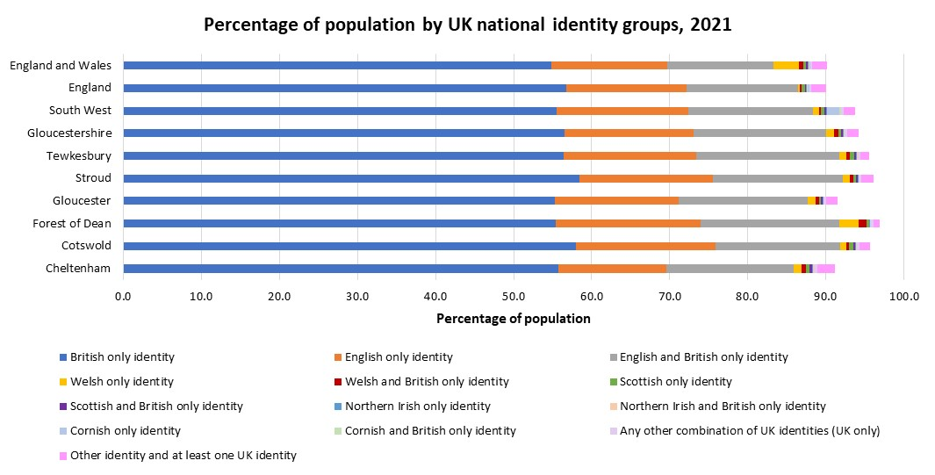
Figure 10: Percentage of population by UK national identity groups, 2021
Since 2011 the proportion of residents reporting they were “British only” increased from 16.6% in 2011 to 56.6% in 2021, conversely the proportion of residents reporting they were “English only” decreased from 64.1% in 2011 to 16.6% in 2021, similar differences were observed at a national, regional and district level. The ONS believe this change is likely to be “a result of the changes to the question structure where "British" became the top response option in 2021 for England only”, rather than a true change.
The other UK identities remained more stable across usual residents in Gloucestershire, the most notable change being that between 2011 and 2021, the percentage choosing "English and "British only" as their national identity rose from 10.6% to 16.9%, similar changes were reflected at a national level and across all districts. Conversely the proportion of people choosing “Welsh only” and “Scottish only” fell across all geographies.
    - Non-UK identities
Figure 11 shows the top 10 non-UK identities at a county, national, regional and district level. Of the 5.7% of Gloucestershire’s population who recorded a Non-UK identity the most commonly specified identity was “Polish” accounting for 1.0% of the population, this was followed by “Non-EU countries: Other European” (0.7%), “EU countries: Other member countries” (0.6%) and “Romanian” (0.4%). This is broadly in line with the picture at a national level, although Romanian was the second largest group nationally, followed by “Non-EU countries: Other European” and “EU countries: Other member countries”. At a district level the same countries make up the top 4 identities in most areas, although in different orders. The exceptions are Irish which enters the top 4 in Cotswold, Forest of Dean and Stroud, but is ranked 5th in Gloucestershire and 6th nationally and Indian which is the 4th most common non-UK identity in Gloucester but is ranked 8th in Gloucestershire and 6th nationally.

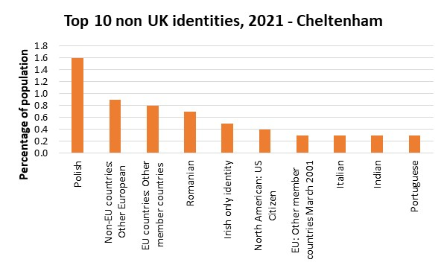
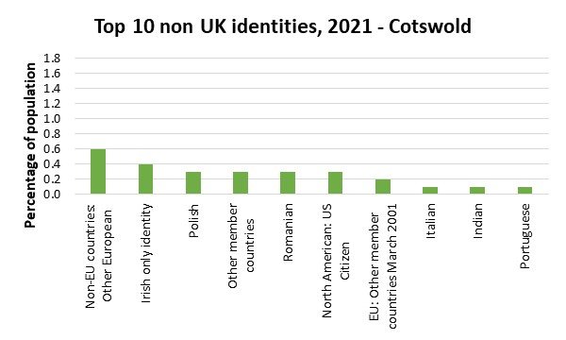
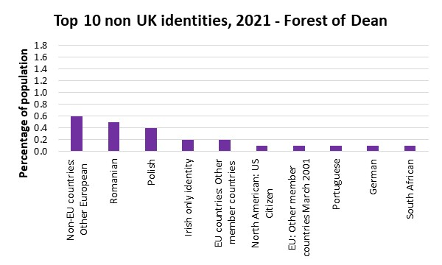
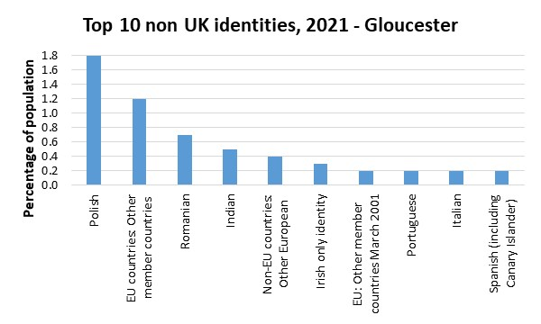
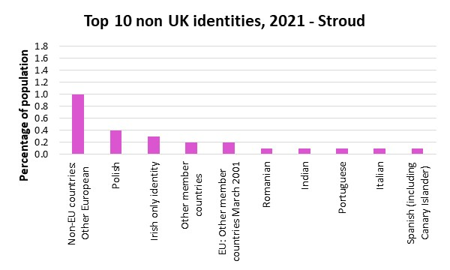
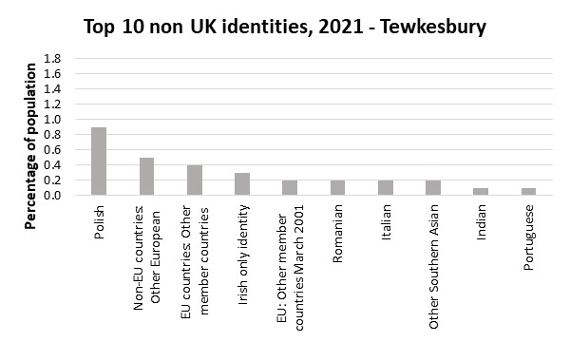
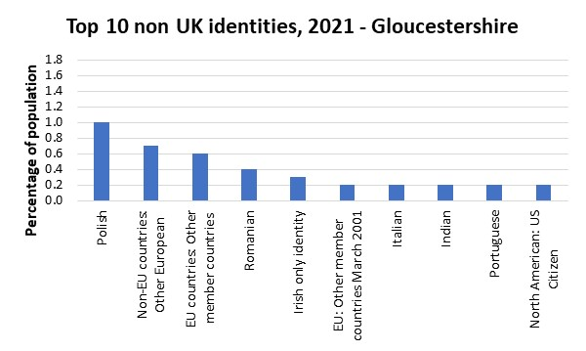
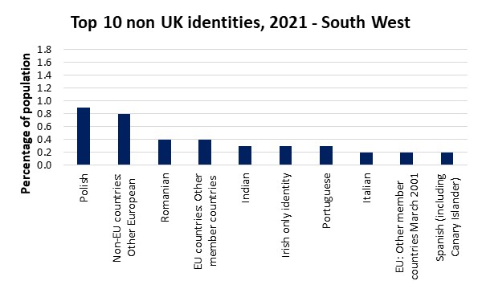
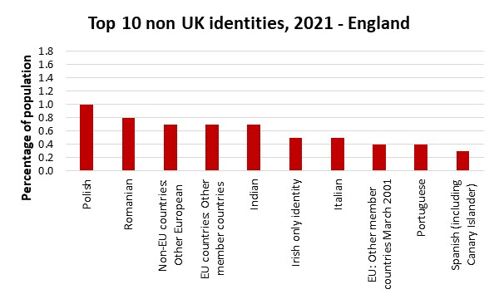
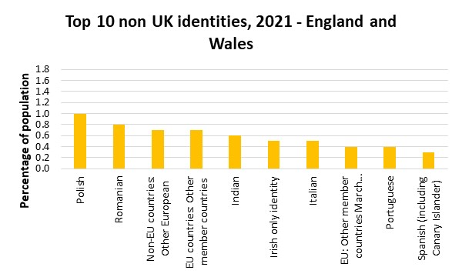
Figure 11: Top 10 non-UK identities, 2021
Since 2011 Gloucestershire, England and Wales, the South West and all of Gloucestershire’s districts saw growth in a number of non-UK identities. The greatest growth at a county and national level was in those identifying as Romanian, with this group increasing by 950.5% in Gloucestershire. Figure 12 shows this saw those identifying as Romanian increasing from the 24th most common non-UK identity in Gloucestershire in 2011 to the 4th most common non-UK identity in 2021. At a district level those identifying as Romanian saw the greatest growth in Cheltenham, Cotswold, Forest of Dean and Gloucester. In Stroud and Tewkesbury those identifying as “Non-EU countries: Other European” saw the greatest growth.
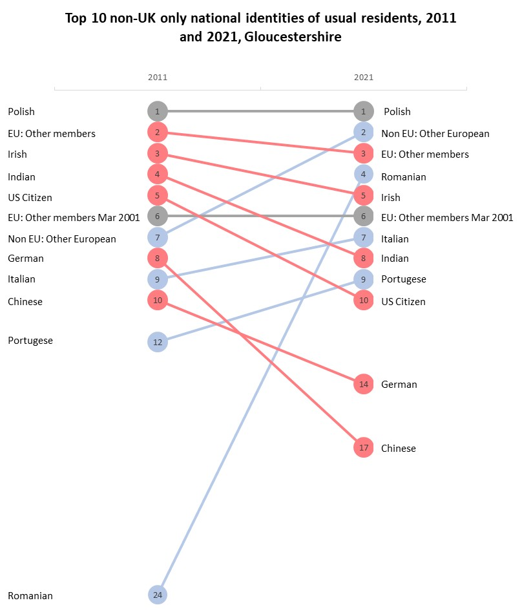
Figure 12: Top 10 non-UK only national identities of usual residents, 2011 and 2021, Gloucestershire
  - Language

English*- In the Language section, English* refers to the category English (English or Welsh in Wales)
    - Main language
The 2021 Census asked people what their first or preferred language to speak is, only people over the age of 3 were recorded. In 2021, 95.7% of Gloucestershire’s population (599,366 people) chose English* as their main or preferred language with the remaining 4.3% of the population (26,993 people) choosing other languages. In comparison, in 2011, 96.7% of the population (558,200 people) chose English* and 3.3% (18,686 people) chose other languages. In the South West, a slightly lower proportion of the population chose English* as their main language at 95.4% and a more significant lower proportion chose English* as their main language in England and Wales overall, 91.1%, shown in Table 2.
The number of people speaking English* as their main language in Gloucestershire increased by 7.4% in 2021, compared to 2011. This is similar to the South West (7.2% increase) and a greater increase than England and Wales where there was an increase of 5.5%.

Table 2: Proportion of the population who do and do not speak English* as their main language in England and Wales
 |  | English* as main language |  | Non-English as main language
 | Number |  | % of population |  | Number | % of population
Cheltenham | 107,474 |  | 93.1% |  | 7,964 | 6.9%
Cotswold | 86,541 |  | 97.8% |  | 1,963 | 2.2%
Forest of Dean | 83,112 |  | 98.1% |  | 1,571 | 1.9%
Gloucester | 117,816 |  | 92.0% |  | 10,258 | 8.0%
Stroud | 115,710 |  | 98.2% |  | 2,167 | 1.8%
Tewkesbury | 88,713 |  | 96.6% |  | 3,077 | 3.4%
Gloucestershire | 599,366 |  | 95.7% |  | 26,993 | 4.3%
South West | 5,287,113 |  | 95.4% |  | 254,385 | 4.6%
England | 49,652,172 |  | 90.8% |  | 5,033,915 | 9.2%
England and Wales | 52,569,816 |  | 91.1% |  | 5,134,454 | 8.9%

Out of Gloucestershire’s districts, the highest proportion of people choosing English* as their main language was Stroud with 98.2% of the population and the lowest proportion was in Gloucester with 92.0% of the population.
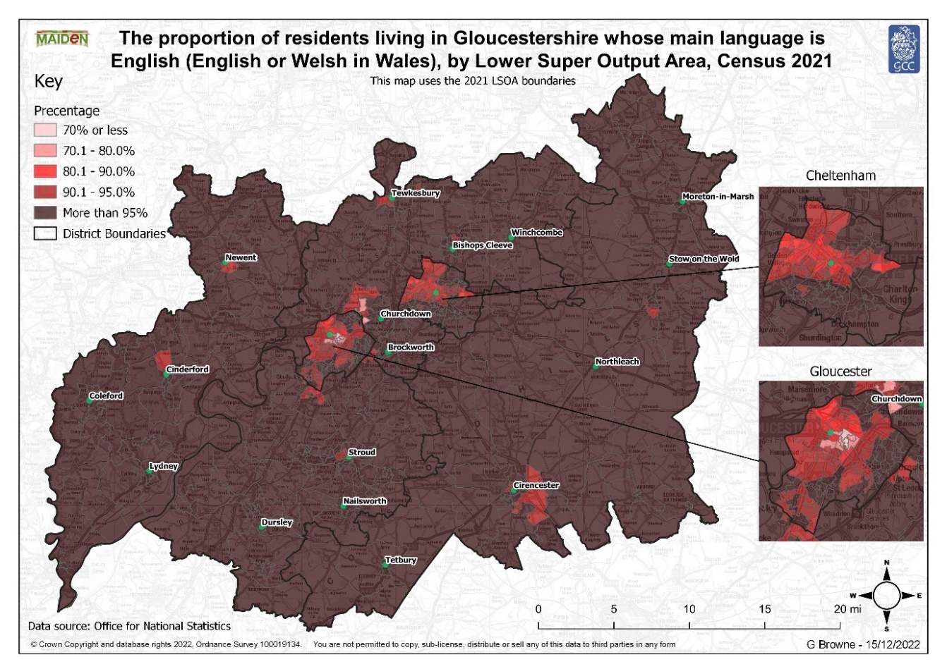
Figure 13 shows the distribution of LSOAs with the lowest proportion of the population choosing English* as their main language. Out of the 10 lowest proportions, 9/10 were located in Gloucester with the LSOA Barton and Tredworth 4 accounting for the lowest at 67.5%. Tewkesbury was the only other district to have an LSOA in the top 10 (3rd lowest) which was Innsworth 2 with a proportion of 70.1%. Overall, there is a clear pattern where most of the LSOAs with the lowest proportion of people with English* as their main language are located in the urban areas of Gloucester and Cheltenham. 62 (out of 393) LSOAs had a 99.0% or over proportion of the population selecting English* as their main language spoken.
Figure 13: A map showing the proportion of the population who speak English* as their main language, by LSOA, in Gloucestershire
The Census data also provides a detailed breakdown of the main languages spoken by residents. Figure 14 indicates the top 10 main languages spoken by people whose main language is not English* at district, county, regional and national level. Overall, in Gloucestershire, the most widely spoken preferred languages other than English* were Polish (1.1%), Romanian (0.4%) and Portuguese (0.2%). Figure 14 also indicates that in all areas, except for the Forest of Dean, the language with the highest proportion of people choosing it as their main language was Polish.
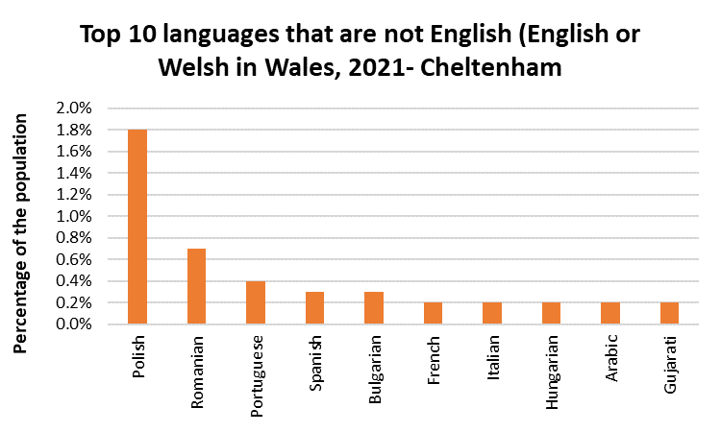
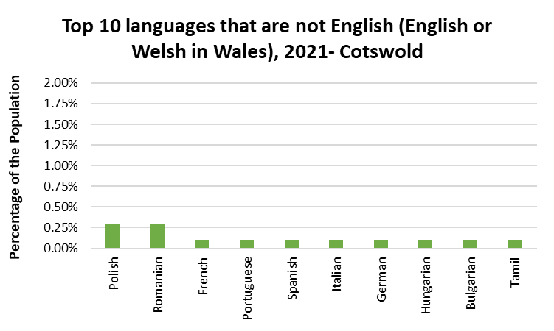
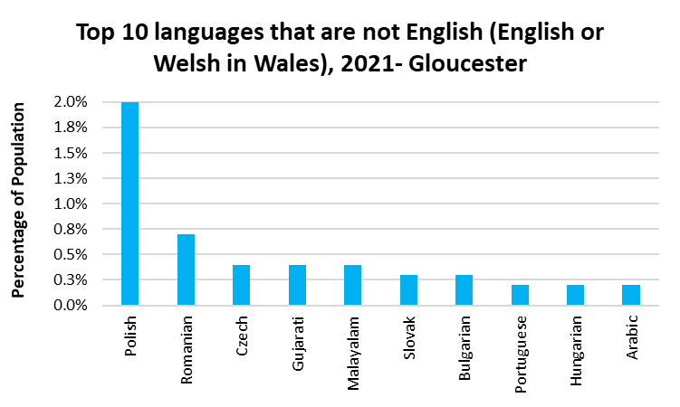
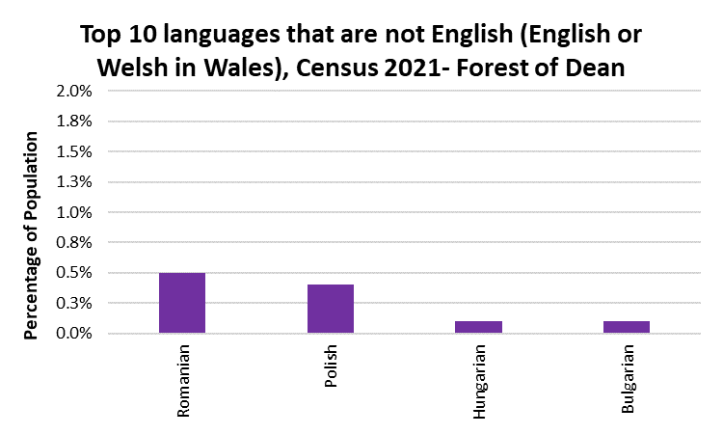
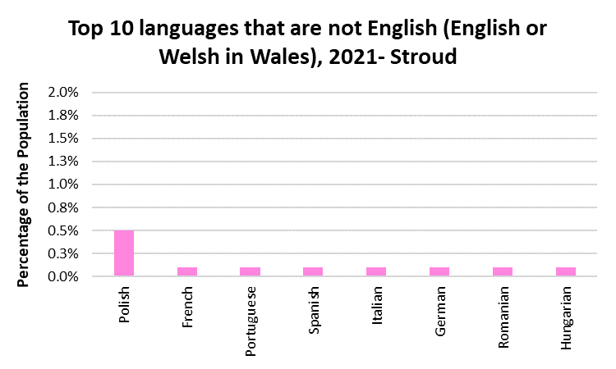
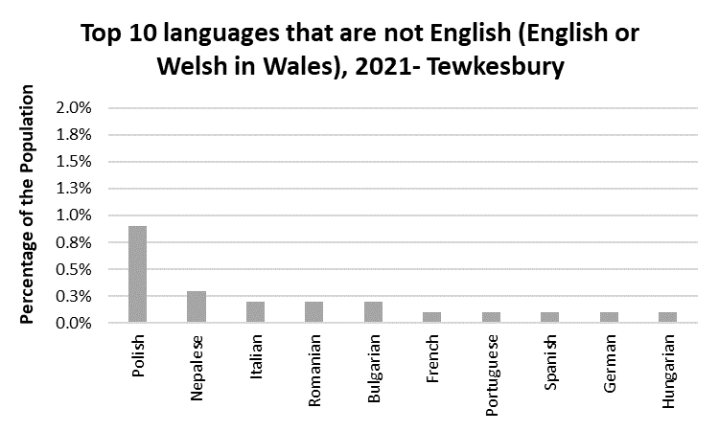
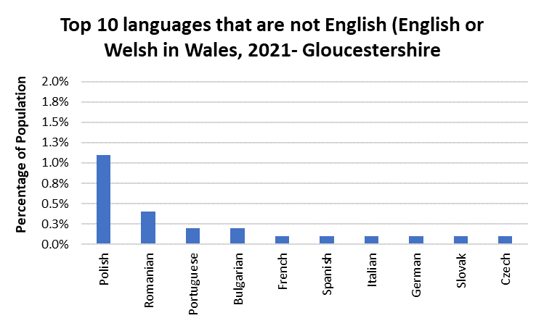
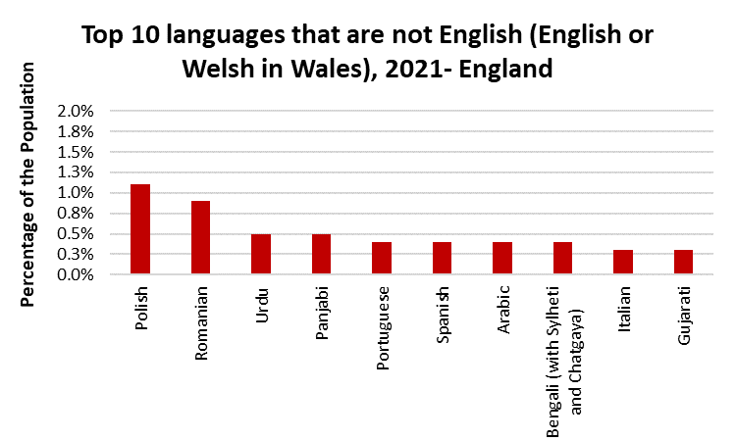
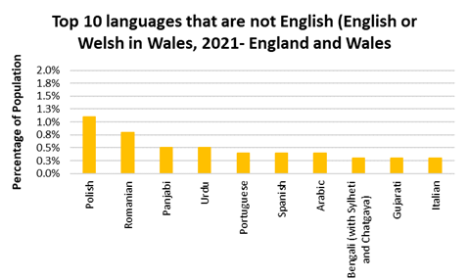
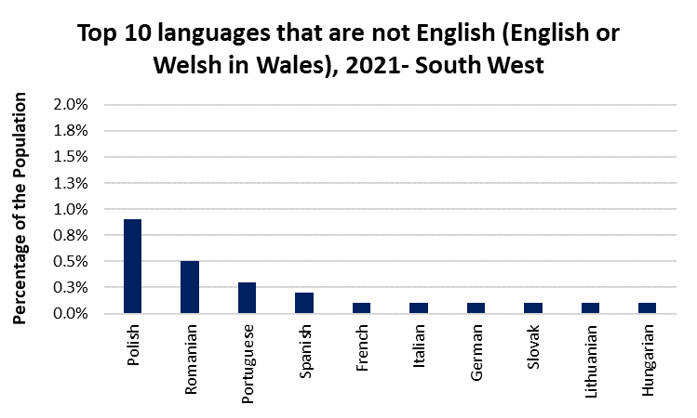
Figure 14: Top 10 languages spoken in each area, Census 2021
    - Proficiency in English*
English* proficiency is only recorded for people aged 3 and over, it asks people whose main language is not English* how well they can speak English. Out of the 27,000 people living in Gloucestershire (4.3% of the population) whose main language was not English, 0.7% (4,294 people) could not speak English well or at all. Similarly, in the South West 4.6% of the population did not choose English as their main language and 0.7% answered they could not speak English well or at all. There is a higher proportion for both of these categories in England and Wales overall, 8.9% did not choose English as their main language and 1.8% could not speak English well or at all, shown in Table 3.
Between 2011 and 2021, there was an increase in the number of residents whose main language was not English by 43.7% (equivalent to 8,216 additional people), this is a slightly lower percentage increase than in the South West (44.0% increase) but higher than England and Wales overall (23.6% increase).
Furthermore, between 2011 and 2021 there was a 26.1% increase in the number of residents whose main language was not English and cannot speak English at all in Gloucestershire (equivalent to an additional 127 people). There was a higher proportional increase in the South West (30.2% increase) but a lower increase in England and Wales (16.8%).

Table 3: Proportion of residents who speak English* as their own language and how well those who don’t have English* as their main language can speak English
 | Main language is English* | Main language is not English: | Can speak English very well | Can speak English well | Cannot speak English well | Cannot speak English
Cheltenham | 93.1% | 6.9% | 3.4% | 2.5% | 0.8% | 0.1%
Cotswold | 97.8% | 2.2% | 1.3% | 0.8% | 0.2% | 0.0%
Forest of Dean | 98.2% | 1.8% | 0.8% | 0.6% | 0.4% | 0.1%
Gloucester | 92.0% | 8.0% | 3.4% | 3.0% | 1.3% | 0.2%
Stroud | 98.2% | 1.8% | 1.0% | 0.6% | 0.2% | 0.0%
Tewkesbury | 96.6% | 3.4% | 1.8% | 1.2% | 0.4% | 0.1%
Gloucestershire | 95.7% | 4.3% | 2.1% | 1.6% | 0.6% | 0.1%
South West | 95.4% | 4.6% | 2.3% | 1.6% | 0.6% | 0.1%
England | 90.8% | 9.2% | 4.0% | 3.3% | 1.6% | 0.3%
England and Wales | 91.1% | 8.9% | 3.9% | 3.2% | 1.5% | 0.3%

Gloucester has the highest proportion of people whose main language is not English at 8.0% and Forest of Dean and Stroud the lowest at 1.8%. Gloucester also has the highest percentage of people who either cannot speak English well or English at all (1.5%) and Cotswold and Stroud the lowest with 0.2% of the population.
Figure 15 shows the distribution of people who do not speak English* as their main language and cannot speak English well or at all. Five LSOAs had a proportion of more than 5% of its population which were all located in Gloucester. The highest proportion was in Barton and Tredworth 2 where 9.3% of the population answered that they do not speak English* as their main language and cannot speak English well or at all. The LSOAs with the highest concentration of non-English speakers are located in the urban areas of Cheltenham and Gloucester, as well as Cinderford.
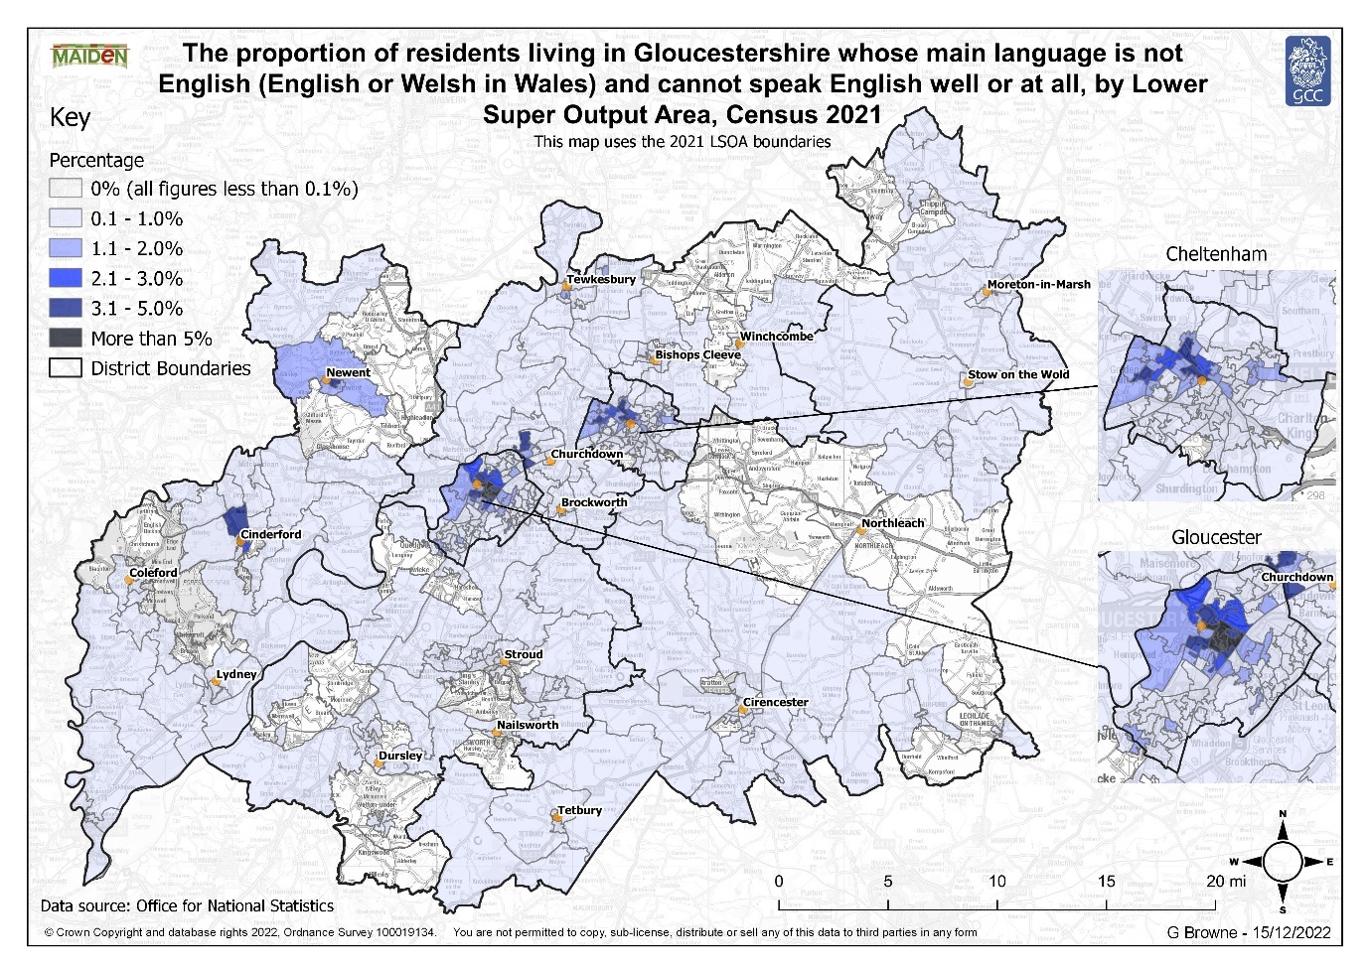
Figure 15: A map to show the distribution of LSOAs with the highest proportion of the population whose main language is not English* and they cannot speak Englsih well or at all
The increase in the number of people who do not speak English well or at all may lead to an increased demand for translation services to help non-English speaking residents communicate within the community for example, when attending a doctor’s appointment or filling out application forms.

    - Household language
Household language denotes whether the combination of adults and children (aged 3 to 15) living within a household have English* as their main language. Table 4 shows that in Gloucestershire, 94.9% of households have all people living within them speaking English* as their main language, this is slightly higher than the South West proportion (94.6%) and significantly higher than the overall proportion for England and Wales (89.6%). In comparison, 2.4% of households in Gloucestershire do not contain anyone in the household who have English* as their main language, which is lower than the South West and England and Wales (2.5% and 4.8% respectively). There was also a lower or equal proportion of households in Gloucestershire, compared to the South West and England and Wales, for the categories: at least one but not all people have English* as their main language and no people aged 16 and over in the household have English* as their main language but at least one person between the age of 3-15 years does.

Table 4: Household language in England and Wales, Census 2021
 | All people aged 16 and over in household have English* as a main language | At least one but not all people aged 16 and over in household have English* as a main language | No people aged 16 and over in household but at least one person aged 3 to 15 has English* as a main language | No people in household have English* as a main language
Cheltenham | 92.1% | 2.9% | 1.0% | 4.0%
Cotswold | 97.2% | 1.5% | 0.3% | 1.0%
Forest of Dean | 97.8% | 0.9% | 0.2% | 1.0%
Gloucester | 90.7% | 3.1% | 1.4% | 4.8%
Stroud | 97.4% | 1.4% | 0.3% | 0.9%
Tewkesbury | 96.1% | 1.5% | 0.7% | 1.7%
Gloucestershire | 94.9% | 2.0% | 0.7% | 2.4%
South West | 94.6% | 2.2% | 0.7% | 2.5%
England | 89.3% | 4.3% | 1.4% | 5.0%
England and Wales | 89.6% | 4.2% | 1.3% | 4.8%

    - Multiple main languages in household
The census records whether people living in a household speak the same or a different language and presents the data at household level. This is a new variable for 2021 and is not comparable to 2011.
Out of Gloucestershire’s households, in 2021, 66.7% have all household members speaking the same main language, this compares to 66.6% in the South West and 63.8% in England and Wales. Single households accounted for 30.4% of all households in Gloucestershire which is very similar to the proportion in the South West and England and Wales. In comparison, 2.9% of Gloucestershire’s households contain members who speak different languages which is lower than the South West and England and Wales proportion (3.1% and 6.0% respectively).

Table 5: Proportion of households speaking the same or a different language, Census 2021
 | One-person household | All household members have the same main language | Main language differs between generations, but not within partnerships | Main language differs within partnerships | Any other combination of multiple main languages
Cheltenham | 34.8% | 60.9% | 1.2% | 1.9% | 1.1%
Cotswold | 30.2% | 67.9% | 0.3% | 1.1% | 0.4%
Forest of Dean | 28.4% | 70.3% | 0.3% | 0.7% | 0.3%
Gloucester | 30.2% | 64.8% | 1.7% | 2.0% | 1.3%
Stroud | 29.1% | 69.0% | 0.4% | 1.1% | 0.4%
Tewkesbury | 28.2% | 69.5% | 0.7% | 1.1% | 0.5%
Gloucestershire | 30.4% | 66.7% | 0.8% | 1.4% | 0.7%
South West | 30.3% | 66.6% | 0.8% | 1.4% | 0.9%
England | 30.1% | 63.7% | 2.0% | 2.2% | 2.0%
England and Wales | 30.2% | 63.8% | 1.9% | 2.2% | 1.9%

Table 5 indicates that the highest proportion of households which speak the same language is in Forest of Dean with 70.3%, this can mostly be accounted for by it having one of the lowest proportions of one-person households. In comparison, Cheltenham has the lowest proportion of households speaking the same language with 60.9% but a high proportion of one-person households (34.8%). Gloucester has the highest proportion of households whose household members speak differing main languages with 5.0% whereas, Forest of Dean has the lowest at 1.3%.
  - Religion
Religion was a voluntary question which asked what religion people connect or identify with, whether or not they practice or have belief in it. When comparing percentages, the proportions are calculated for the whole population of an area, not just the people who answered the question to aid with comparability between areas and over time as varying proportions of the population answered the religion question in each of the areas. Whilst comparison can be made with the 2011 data, caution should be taken as there are some data quality issues.
Out of Gloucestershire’s population, 266,959 people said they had no religion (equivalent to 41.4% of the population). This is a higher proportion than in 2011 when 26.7% of the population answered that they had no religion. The biggest change in proportion out of the categories given was the Christian category which decreased from a 63.5% share of the population in 2011 to a 49.2% share of the population in 2021 (equivalent to 61,534 fewer people).

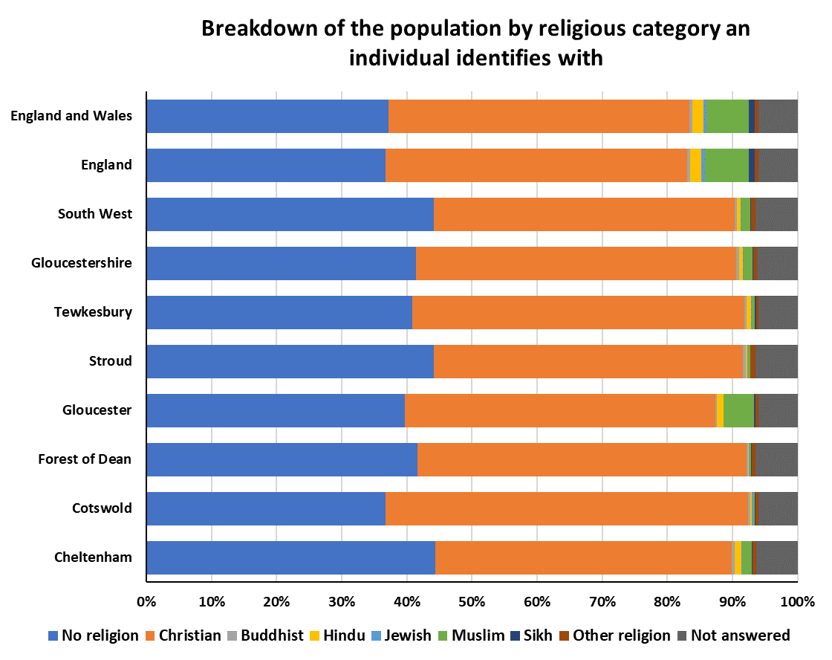
Figure 16: Distribution of the proportion of the population identifying with each religion in England and Wales, Census 2021
In 2021, Cheltenham had the smallest proportion of people identifying with Christianity at 45.5% whereas, Cotswold has the highest at 55.7%, indicated by Figure 16. Conversely, Cheltenham had the highest proportion of people stating they had no religion.
Figure 17 shows the distribution of the population who identified their religion as Christianity in the 2021 Census. The highest Christian proportion of the LSOA populations was in Churchdown Brookfield with Hucclecote 1, Tewkesbury accounting for 65.1% of the population, this is followed by The Ampneys and Hampton 2, Cotswold (63.7%) and Isbourne 1, Tewkesbury (62.5%). The lowest proportions were located within Cheltenham and Gloucester.
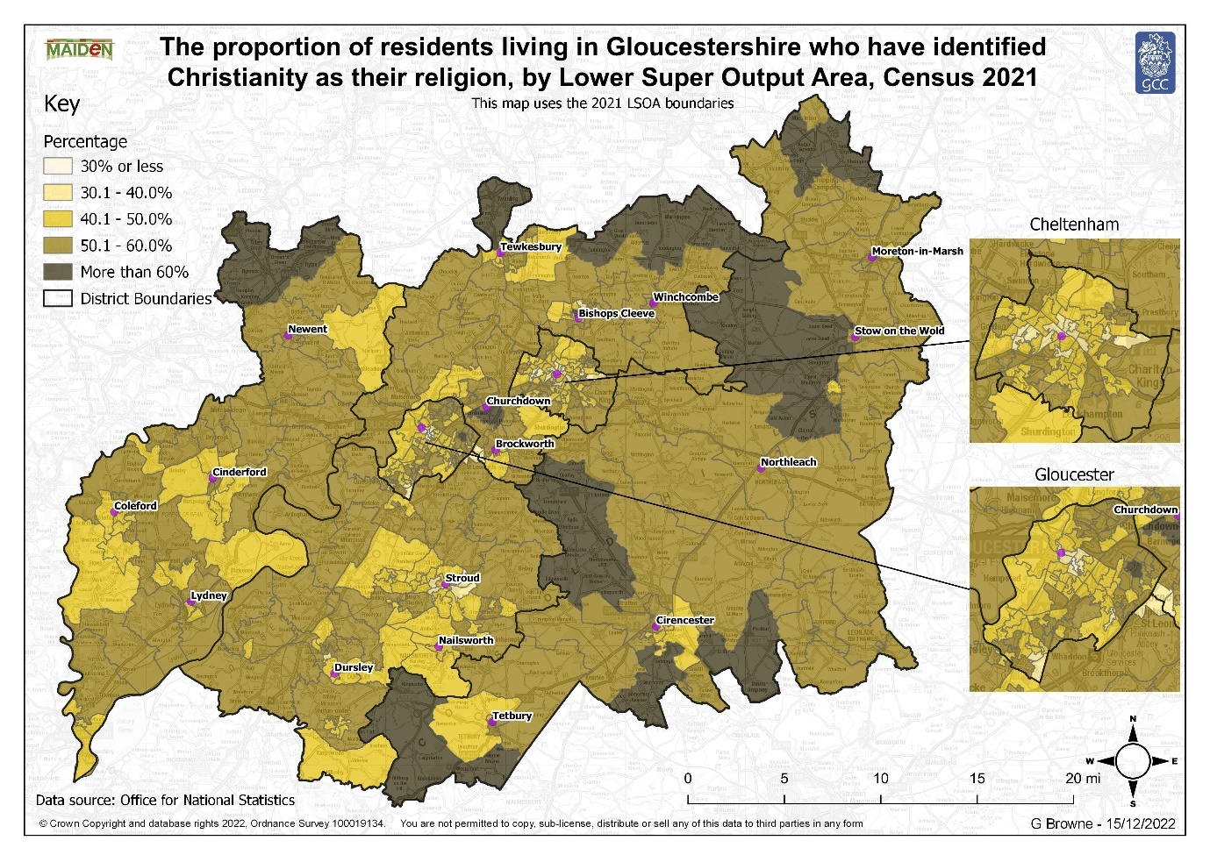
Figure 17: A map of the proportion of Gloucestershire's residents who identity themselves as Christians by LSOA
The religion question is also broken down into more detailed No religion and Other religion categories. In Gloucestershire, out of the detailed categories within the No religion categories, the most common categories being chosen were: No religion: no religion (41.3% of the population) and Agnostic (0.1% of the population) category. Furthermore, in the Other religion categories Pagan (0.2% of the population) and Other religions, Spiritual and Spiritualist (each of the three accounting for 0.1% of the population) accounted for the most frequent responses.

    - Multi religion households
The census classifies whether people living in the same household identify with the same religion, no religion, did not answer the question, or a combination of these options.
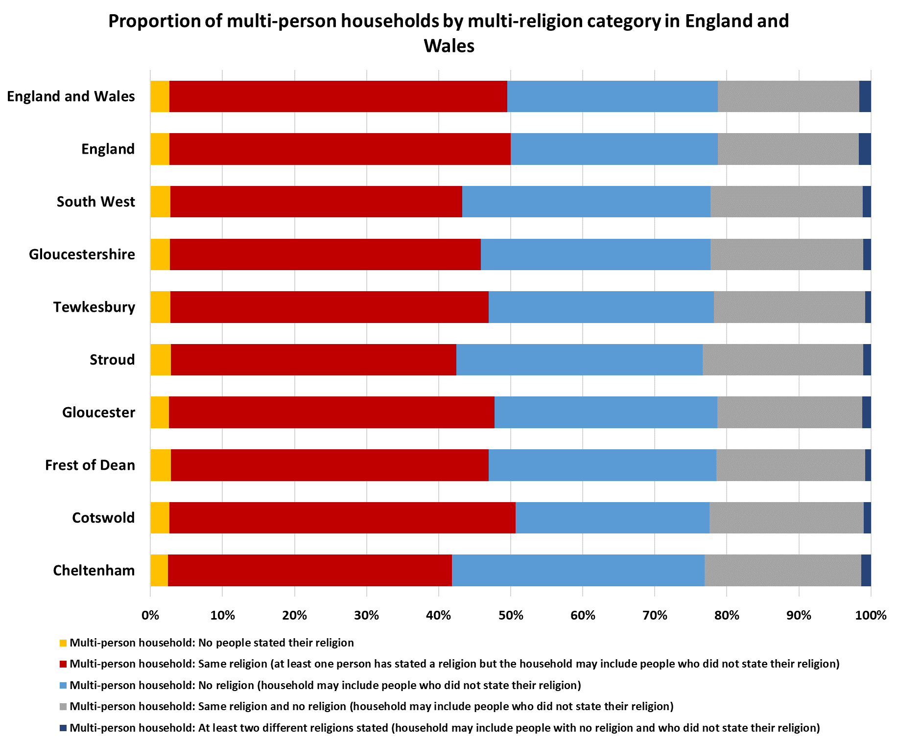
In Gloucestershire, 30.1% of multi-person households stated that all members identify with the same religion, 22.2% stated that no members in the household were religious and 14.8% of households contained members who have the same religion and no religion, shown in Figure 18. The South West follows a similar trend with a slightly higher proportion of households (1.8 percentage points) where all members had no religion. In England and Wales overall, 32.7% of households contained members who identified with the same religion and 20.4% stated that all members do not have a religion.

Figure 18: The distribution of multi-religion households in England and Wales, Census 2021

Out of Gloucestershire’s six districts, the highest proportion of residents who answered that all members identify with the same religion was in Cotswold, accounting for 33.5% of the population. In contrast, Cheltenham had the lowest proportion (25.7%). Stroud had the highest proportion of households stating that no one in the household has a religion (24.2%) and Cotswold the lowest with 18.8%. Furthermore, Stroud accounted for the highest percentage of households containing members who have the same religion and no religion (15.8%) whilst Gloucester had the lowest (14.0%).
- Key messages
- In 2021 93.1% (600,314 people) of Gloucestershire’s population identified as “White”. Gloucestershire was less diverse than the national average, with 81.7% of residents across England and Wales identifying as “White,
- The urban districts of Gloucester and Cheltenham (84.9% and 91.4%) had the lowest proportion of “White” residents, while the Forest of Dean had the highest (97.5%).
- There is significant variation across the county, in over half of Lower Super Output Areas more than 95% of the population identified as “White”. However, in and around the urban districts of Gloucester and Cheltenham and around the market towns of Cirencester, Bishops Cleeve and Stroud the population is more diverse. The areas making up Barton and Tredworth in Gloucester are the most diverse in the county, with three LSOAs having less than half their population identifying as “White”. This means there may be distinctive communities within these areas, that have different needs to other less diverse parts of the county.
- Since 2011 Gloucestershire has become more diverse, with the proportion of people identifying as “White” falling from 95.4% in 2011 to 93.1% in 2021, conversely all other ethnic groups have seen growth during the same period.
- The greatest increase since 2011 was in those identifying as “Other White” with this group increasing from 3.1% of the total population in 2011 to 4.5% of the population in 2021.
- Given that the overall population has become more diverse since 2011 it is unsurprising the proportion of multi ethnic households increased during the same period. In 2011 6.1% of households in Gloucestershire were made up of different ethnic groups, this increased to 7.8% in 2021. The growth was primarily driven by an increase in households classed as “Ethnic groups differ within partnerships” with the proportion of households in Gloucestershire falling into this group increasing from 3.8% in 2011 to 5.1% in 2021.
- In 2021 94.3% of Gloucestershire residents identified with at least one UK national identity (English, Welsh, Scottish, Northern Irish, British, and Cornish), this was higher than the national average of 90.2% reflecting the pattern seen in the ethnicity data which suggested Gloucestershire was less diverse than England and Wales.
- The areas with the highest proportion of people selecting a Non UK identity are predominantly in the urban districts of Gloucester and Cheltenham, around the market towns or around military basis such as Innsworth.
- Since 2011 the proportion of Gloucestershire residents reporting a Non-UK identity has increased from 4.4% in 2011 to 5.7% in 2021.
- Of the 5.7% of Gloucestershire’s population who recorded a Non-UK identity the most commonly specified identity was “Polish” accounting for 1.0% of the population, this was followed by “Non-EU countries: Other European” (0.7%), “EU countries: Other member countries” (0.6%) and “Romanian” (0.4%).
- Since 2011 the greatest growth in Non-UK identities was in those identifying as Romanian, with this group increasing by 950.5% in Gloucestershire. This growth may have created new and distinct communities with additional needs.
- In 2021, 95.7% of the population chose English* as their main language in Gloucestershire which was in-line with the South West figure but higher than the national data.
- Polish, Romanian and Portuguese were the most widely spoken languages in Gloucestershire other than English*
- The number of Gloucestershire’s residents who could not speak English at all increased by 127 people between 2011 and 2021 therefore, there may be an increased demand for translation services to help non-English speaking residents communicate within the community for example, when attending a doctor’s appointment or filling out application forms.
- A lower proportion of households in Gloucestershire contain members who do not have English* as their main language than regionally and nationally.
- The proportion of people who answered that their religion is Christianity reduced between 2011 and 2021 in all areas whilst the proportion of people answering they were not religious increased.

- What’s next?
In 2023 the Office for National Statistics will release multivariate data which will allow us to combine variables and explore relationships between the data.
- Where can you find out more?
For further information please visit: https://www.gloucestershire.gov.uk/inform/population/census-of-population/census-2021/
Or contact us by emailing informgloucestershire@gloucestershire.gov.uk

See https://www.ons.gov.uk/peoplepopulationandcommunity/populationandmigration/populationestimates/methodologies/qualityandmethodologyinformationqmiforcensus2021#quality-summary for further information
ONS, 2022
Ibid.
2021 Census, ONS
Ibid.
2011 Census and 2021 Census, ONS
2021 Census, ONS
2021 Census, ONS
2011 Census and 2021 Census, ONS
2021 Census, ONS
2011 Census, ONS and 2021 Census, ONS
2021 Census, ONS
2021 Census, ONS
National identity, England and Wales - Office for National Statistics (ons.gov.uk)
2021 Census, ONS
2021 Census, ONS
2021 Census, ONS
Where less than 10 languages are shown on the graph, all other languages accounted for less than 0.1% of the population.
2021 Census, ONS
Census 2021, ONS
Census 2021, ONS
2021 Census, ONS
2021 Census, ONS
2021 Census, ONS
2021 Census, ONS

