Disability, Neurodivergence and Mental Health in Gloucestershire
Autumn 2026 - Issue 12
Easy Read version

Autumn in Gloucestershire
This Easy Read version gives the main information from the full newsletter. It does not include every detail.

About this Easy Read version
This version uses shorter sentences, larger text and pictures.
It gives the main points from the Autumn 2026 newsletter.
Some long articles have been shortened so they are easier to read.
Important dates, contacts and links are included where they are useful.
You can use the contents page to jump to a topic. Screen-reader users can also move through the document by headings.

Contents
Co-production and community hospitals
Adult Social Care co-production roadshows
Getting help with social care
Children and young people: The One Plan
News that may affect disabled people
Voice assistants and independence
Surveys and training
Neurodivergence Partnership Board
Employment support
Making sport more neuroinclusive
Understanding AuDHD
AuDHD support ideas
Creative sessions and resources
What young neurodivergent people told us
Sensory needs in adulthood
Counselling and national neurodivergence news
Dates for your diary
Learning Disability Partnership Board
Mental Health and Wellbeing Partnership Board
Occupational Therapy
Neurology Subgroup
Support for unpaid carers

News for all

Co-production and community hospitals
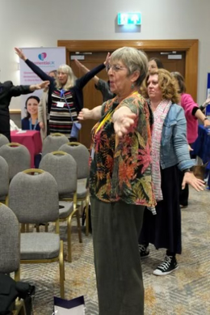
Activity Session
Co-production means people who use services work with staff to plan and improve those services.
Katie Peacock and Jan Marriott spoke about Gloucestershire co-production work at a Community Hospital Conference in May 2026.
Community hospitals are local hospitals. They can provide beds, clinics, minor injury services, X-rays, rehabilitation and other care.
Examples of local co-production work include:
- Work with people with ME to improve care.
- A new Adult Social Care Practice Framework.
- Oliver McGowan training.
- A citizen-led panel helping with a local service decision.
The main message was simple: services work better when people with lived experience help to shape them.
More detail is in the full newsletter on pages 2-4. Back to contents

Adult Social Care co-production roadshows
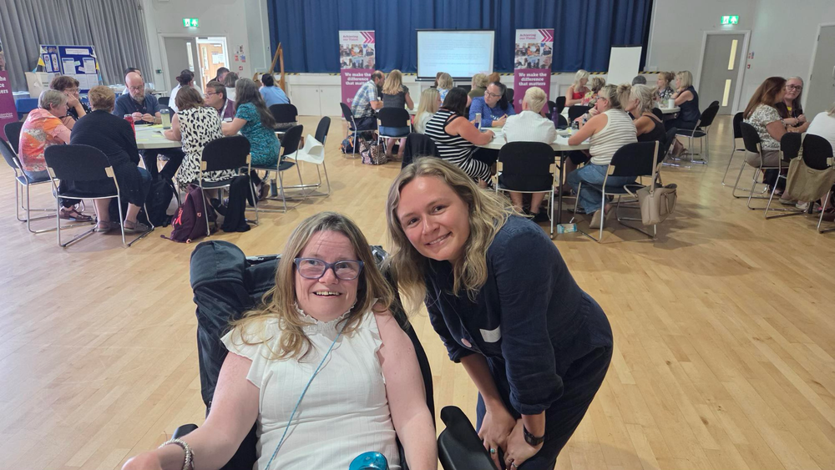
Katie and Amy At the Roadshow
More than 300 people took part in Adult Social Care co-production roadshows across Gloucestershire and online.
People included staff, carers, partners and people with lived experience.
Across five events, people gave almost 700 comments about what Adult Social Care does well and what needs to improve.
The feedback is already being used to shape improvement work.
People also talked about listening to feedback, a new care home in the Forest of Dean and what good Adult Social Care practice should look like.
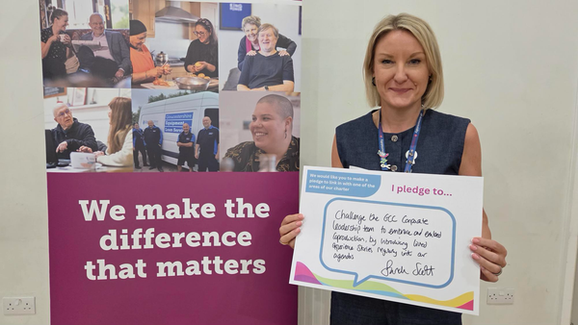
Sarah Scott Co-production Pledge
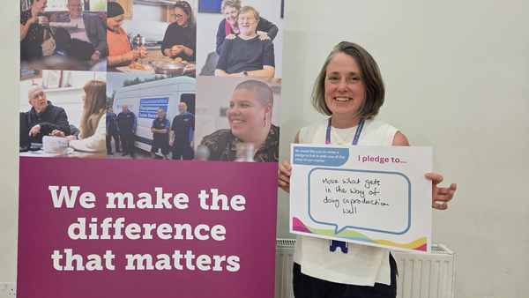
Emily White Co-production Pledge
More detail is in the full newsletter on pages 5-6. Back to contents

Getting help with social care
The Care Act explains what people can expect from Adult Social Care.
The law can be hard to understand.
Access Social Care has a free online tool called AccessAva. It can help people understand their social care rights.
Open AccessAva support
Access Social Care also has Peer Navigators for unpaid carers.
Peer Navigators have lived experience. They can help carers understand rights, use AccessAva and communicate with the local authority.
They do not give legal advice.
Email: enquiries@accesscharity.org.uk
More detail is in the full newsletter on page 7. Back to contents

Children and young people: The One Plan
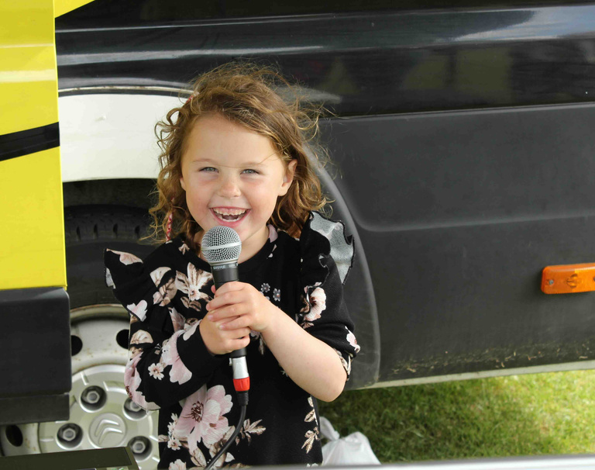
Child with Microphone
Gloucestershire has a plan for all children and young people. It is called the One Plan.
The plan runs to 2030.
It is built around 4 principles:
- Equity.
- Access.
- Inclusion.
- Quality.
The plan talks about children starting well, growing well and being well.
Local groups bring services together in each area of Gloucestershire.
The One Plan also helped to develop Neurodiversity Guidelines.
The guidelines say children and young people should get useful support and adjustments without always having to wait for a diagnosis.
Read the Gloucestershire One Plan
More detail is in the full newsletter on pages 8-10. Back to contents

News that may affect disabled people

Bus travel
There were several national and local updates in the summer.
- From 1 April 2027, disabled bus pass holders in England will be able to use their pass for free bus travel at any time of day, 7 days a week.
- Local transport authorities must publish a Bus Network Accessibility Plan by 1 April 2027.
- Government departments are providing more information in British Sign Language.
- A Pathways to Work Innovation Fund of up to £60 million was launched to test better employment support for disabled people and people with health conditions.
- A new cross-government plan for unpaid carers was published in July.
- Several Gloucestershire Adult Social Care services moved back under direct council management during 2026.
More detail is in the full newsletter on page 11. Back to contents

Voice assistants and independence
Katie Peacock wrote about how voice assistants can help with everyday life.
She uses Alexa. Other voice assistants include Siri and Google Assistant.
Examples of useful voice commands include:
- Set a reminder.
- Set a timer or alarm.
- Make an announcement to another room.
- Call someone using your voice.
- Play music or other sounds.
For some disabled people, voice control can remove the need to reach for a device, type or use a screen.
Voice assistants will not meet everyone’s needs. They are one possible tool for independence.
More detail is in the full newsletter on pages 12-13. Back to contents

Surveys and training
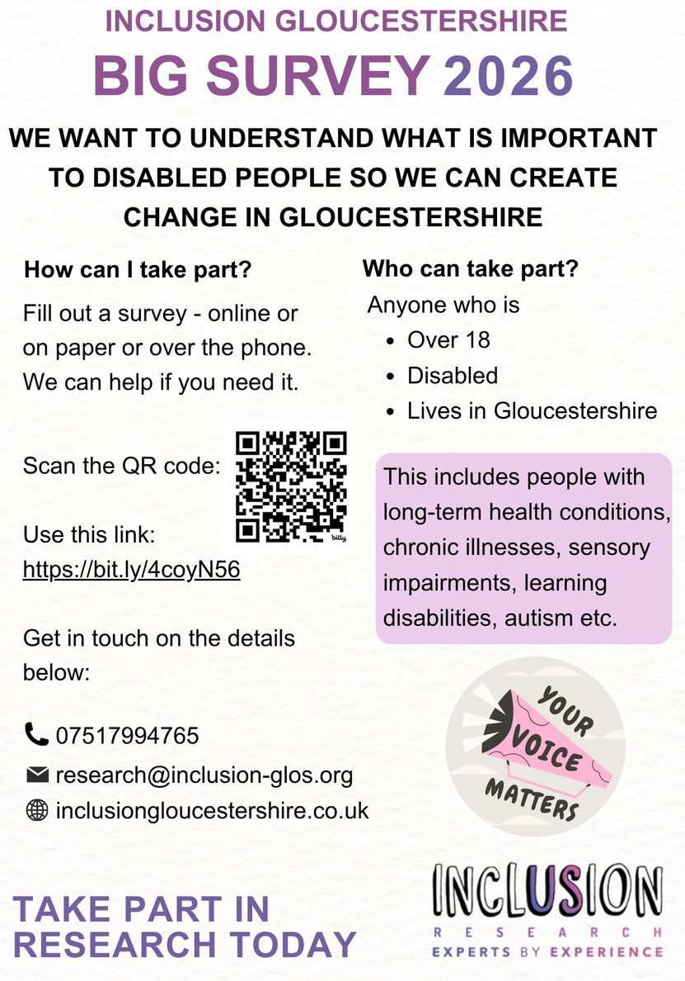
Inclusion Gloucestershire Big Survey 2026
Inclusion Gloucestershire is running the Big Survey 2026.
The survey asks disabled people what is important to them and what should change in Gloucestershire.
You can take part if you are over 18, disabled and live in Gloucestershire.
This includes people with long-term health conditions, sensory impairments, learning disabilities and autism.
Take part in the Big Survey 2026
Telephone: 07517 994765
Email: research@inclusion-glos.org
Healthwatch Gloucestershire also has surveys about AI in health and social care and about GP referrals.
Healthwatch survey about AI
Healthwatch survey about GP referrals
The full newsletter also lists training from Active Gloucestershire and a Making Walks Sensory workshop from Sense.
More detail is in the full newsletter on pages 14-16. Back to contents

Neurodivergent news

Neurodivergence Partnership Board
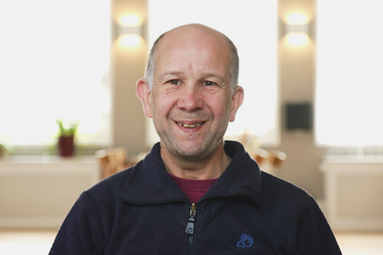
Andrew, Partnership Board Chair
The June Neurodivergence Partnership Board looked at mental health and neurodivergence.
The Board considered findings from Gloucestershire Mental Health Forums and lived-experience case studies from CASA.
Members agreed that many of the problems described were familiar.
They discussed changes that could happen quickly and bigger changes that need longer-term work.
The learning was then shared with the Mental Health and Wellbeing Partnership Board.
The September meeting focused on children and young people.
The next meeting is Tuesday 1 December 2026, from 10.00am to 12.30pm at Shire Hall.
To ask about joining the Board, email: neurodiversity@gloucestershire.gov.uk
More detail is in the full newsletter on page 17. Back to contents

Employment support
The Forwards Education Team supports young people aged 16 and over with education and employment.
The newsletter gives 2 case studies.
One young person wanted outdoor work. Support included a vocational profile, a CV, interview preparation, education and work experience.
He later gained paid work experience with Cotswolds National Landscape and was offered a college place.
Another young person was supported after moving to Gloucestershire.
They received an autism diagnosis and an Education, Health and Care Plan. This helped them get an online education place focused on gaming and coding.
The case studies show how signposting, education support and work experience can help people move towards their goals.
Find out about Forwards Education
More detail is in the full newsletter on pages 18-19. Back to contents

Making sport more neuroinclusive
Neurodiverse Sport has resources for sports clubs and activity providers.
A free online course explains practical ways to make sport more welcoming and accessible to neurodivergent people.
A case study called “A Day in the Life of Maya” shows what joining a new sports club can feel like.
Helpful changes can include:
- Clear information about what will happen.
- Asking about support and communication needs.
- Offering a visit before the first session.
- Thinking about the sensory environment.
- Making it normal to take breaks.
Free Blueprint to Neuroinclusion course
Read the sports club case study
More detail is in the full newsletter on page 20. Back to contents

Understanding AuDHD
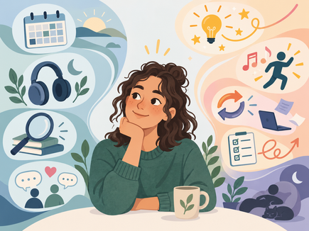
AuDHD person looking happily at Autism Leanings
AuDHD is a word some people use when they are both autistic and have ADHD.
AuDHD is not a separate clinical diagnosis.
Autism and ADHD can affect a person at the same time. Their needs may sometimes pull in different directions.
For example:
- A person may need routine but also become restless when everything stays the same.
- A person may seek movement or sound but also become overloaded by sensory input.
- A person may plan something carefully but find it very hard to start.
- A person may focus deeply on an interest but struggle to switch to another task.
People are different. There is no single AuDHD profile.
Since 2013, autism and ADHD have been allowed to be diagnosed in the same person.
Research suggests the overlap between autism and ADHD is common, but estimates vary between studies and groups.
More detail is in the full newsletter on pages 21-24. Back to contents

AuDHD support ideas
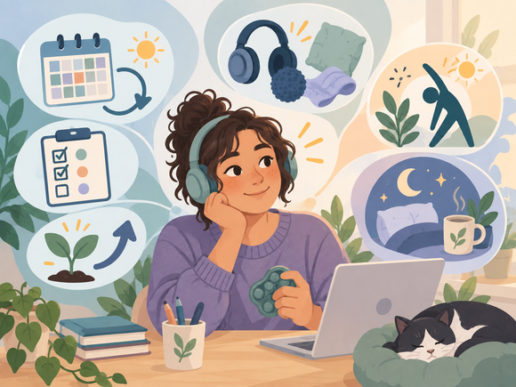
AuDHD person looking happily at ADHD Leanings
Support can work better when autistic and ADHD-related needs are considered together.
Things that may help include:
- A flexible routine with some predictable parts and some choice.
- Written instructions, reminders, timers, calendars and checklists.
- Breaking a task into a small first step.
- Quiet spaces and sensory adjustments when needed.
- Chosen movement, sound or fidgeting when that helps the person stay regulated or focused.
- Warnings before changes and enough time to switch between activities.
- Recovery time after demanding social, sensory or practical activities.
- Clear, direct communication and written follow-up.
Gloucestershire NHS diagnostic services can notice signs of the other condition during an autism or ADHD assessment.
With the person’s agreement, an internal referral can be made for the other assessment.
Support should respond to the person’s needs. Useful support should not always have to wait until every diagnostic question has been settled.
More detail is in the full newsletter on pages 24-25. Back to contents

Creative sessions and resources

Selected resources
The newsletter lists resources about autism, ADHD and AuDHD.
Autistica information about ADHD and autism
ND Hub Gloucestershire also runs Creative Strategy Sessions for neurodivergent adults.
The sessions are calm and structured. They use creative activities to explore wellbeing.
Topics can include emotional processing, reducing overwhelm, self-awareness and regulation.
Sessions are free and materials are supplied.
Future dates listed in the newsletter are 21 October, 18 November and 16 December 2026, then 20 January, 17 February and 17 March 2027. Sessions are 7.00pm to 9.00pm.
ND Hub Gloucestershire events and bookings
More detail is in the full newsletter on pages 26-27. Back to contents

What young neurodivergent people told us
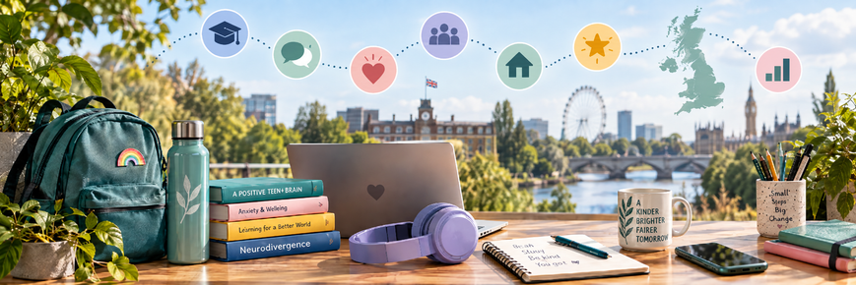
Young people and neurodivergence
In January 2026, people were asked about their lived experience of neurodivergence.
A formal diagnosis was not needed to take part.
44% of the responses came from people under 18.
A strong message from children and young people was: listen to us and believe us.
Young people also described being punished when they were overwhelmed, anxious or unable to regulate.
Noise and busy environments were common causes of sensory overload.
The findings suggest that distress can sometimes be treated as bad behaviour instead of a sign that a child needs support.
The findings will be used in local planning, including the Gloucestershire One Plan, and shared with partners.
More detail is in the full newsletter on pages 28-29. Back to contents

Sensory needs in adulthood
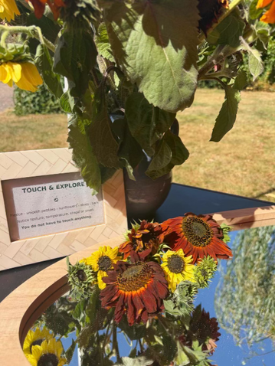
Nature-themed sensory space for adults
Zaphira from ND Hub Gloucestershire wrote about sensory needs in adulthood.
At a Barnwood Trust event, ND Hub created an outdoor sensory and quiet space for adults.
People could choose to sit, move, cool down, use sensory objects, be quiet or leave when they wanted.
The important point was permission.
- Permission not to talk.
- Permission to move or sit differently.
- Permission to use regulation aids.
- Permission to take a break without having to explain why.
Fidgets and other regulation aids should not be dismissed as “toys”. They may help an adult listen, think or stay in a meeting.
Different people need different sensory environments. There is no single sensory space that works for everyone.
Good accessibility information should explain things like surfaces, toilets, seating, noise, lighting, slopes, crowds and quiet spaces. This lets people decide whether a place will work for them.
More detail is in the full newsletter on pages 30-32. Back to contents

Counselling and national neurodivergence news
The newsletter highlights Gloucestershire Counselling Service as one local organisation trying to improve access. This is not an endorsement.
The service says it welcomes neurodivergent people and people with co-occurring mental health needs.
It says subsidised counselling can sometimes be available from £20 per session, subject to availability.
Gloucestershire Counselling Service website

National neurodivergence news
National updates in June to August included:
- “Experts at Hand” plans for earlier specialist support in mainstream education without waiting for diagnosis.
- More than £500 million a year for an Inclusive Mainstream Fund.
- New guidance on inclusion bases and more inclusive school environments.
- A replacement national Autism Strategy was still being prepared. The existing strategy was to remain in force until the new one was published.
- NHS England data showed very large numbers of open ADHD and autism assessment referrals.
- The Parliamentary and Health Service Ombudsman reported major problems in ADHD and autism services, including long waits and fragmented care.
More detail is in the full newsletter on pages 33-35. Back to contents

Dates for your diary

Dates for your diary
The full newsletter lists local groups, drop-ins and events.
- Churchdown Autism Group: first Thursday of the month, 2.00pm to 3.30pm at Churchdown Community Centre.
- CASA has support groups and drop-ins. Weekly updates are on its social media pages.
- ND Hub Gloucestershire has activities for young people and adults.
- Gloucestershire Parent Carer Forum runs “Listen To Me” social meet-ups.
- The next Neurodivergence Partnership Board is Tuesday 1 December 2026, 10.00am to 12.30pm at Shire Hall.
CASA on Facebook
ND Hub Gloucestershire
Gloucestershire Parent Carer Forum
More detail is in the full newsletter on page 36. Back to contents

Learning Disability News

Learning Disability Partnership Board
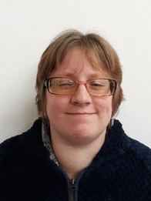
Tammie, Learning Disability Partnership Board co-chair
The Board heard about training to help staff support people with emotions.
Members thought of questions for the Direct Payments team.
They gave ideas about what makes a good life. These ideas are helping to shape a new Adult Social Care Practice Framework.
The Board watched a Camphill video about using buses safely. The video is part of a “Keeping Safe” series.
The Direct Payments team answered questions and shared information.
Inclusion Gloucestershire talked about research on women’s health and wants to hear from women with a learning disability.
The Board also heard about a new Health Action Group and more work on what people want social workers to be like.
Camphill Keeping Safe films
More detail is in the full newsletter on page 37. Back to contents

Mental Health and Wellbeing News

Mental health and neurodivergence
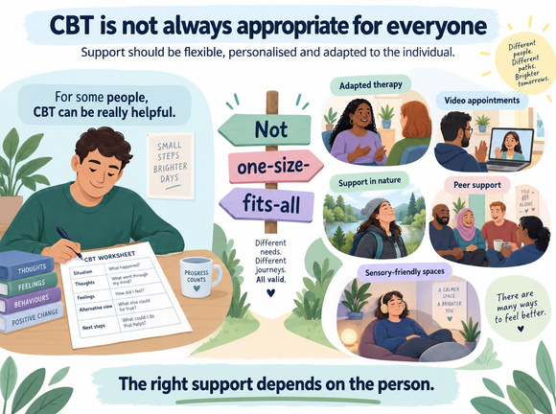
Therapy should fit the person
The July Mental Health and Wellbeing Partnership Board focused on mental health and neurodivergence.
The Board looked at evidence from Mental Health Forums, the Neurodivergence Partnership Board, Healthwatch and CASA.
People described several repeated problems:
- Mental health services can be hard to access.
- People can feel isolated and lonely.
- Some people reach crisis before they get the right help.
- Masking can hide how much a person is struggling.
- Long waits for diagnosis can delay support and reasonable adjustments.
- People may need better advocacy and better coordination between services.
- Peer support and co-production can help.
The Board also discussed therapy. The message was not that one therapy is always good or bad. Support should be adapted to the person.
More detail is in the full newsletter on pages 38-39. Back to contents

Turning mental health discussion into action
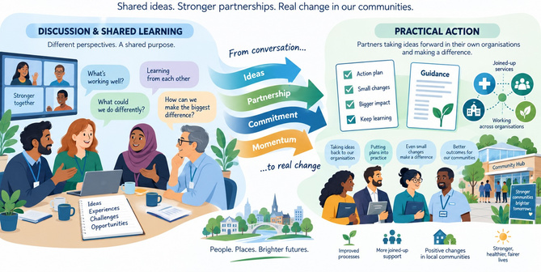
Shared ideas should lead to practical action
Transition from children’s services to adult services was a major concern.
Families described support ending at 18 and having to rebuild evidence and pathways.
The Board said support should fit the person rather than making the person fit the service.
This can include different places for support, video appointments and neurodivergent-friendly spaces.
The Board also discussed diagnostic overshadowing. This is when a physical or mental health problem is wrongly explained only by a person’s neurodivergence.
Other issues included the criminal justice system, inaccurate medical records and the need for more neurodivergent leadership.
Actions included better neuro-affirming support, better transitions, more suitable spaces and bringing evidence together for commissioning and service planning.
The key closing message was: Gloucestershire already knows a lot about the problems. The next step is to turn that knowledge into measurable change.
To ask about the Mental Health and Wellbeing Partnership Board, email: asc.co-production@gloucestershire.gov.uk

Physical Disability and Sensory Impairment News

Occupational Therapy
The Partnership Board held a detailed discussion about people’s experiences of Occupational Therapy, also called OT.
Occupational Therapy can help people do everyday activities more safely or independently.
People said good OT can make a big difference. They also described barriers.
The main issues were:
- It can be hard to know where to start or who to contact.
- People can wait a long time for assessments, equipment or adaptations.
- People need clear updates while they are waiting.
- Information must be accessible in different formats.
- People should not have to explain the same story again and again to different professionals.
- Solutions should be based on the person’s real life, goals and circumstances.
- People should be involved in decisions about their own support.
Positive experiences were also important. Some people described OT support that had greatly improved their independence and quality of life.
The discussion will help Gloucestershire County Council think about OT services as they come back in-house.
More detail is in the full newsletter on pages 43-45. Back to contents

Neurology Subgroup
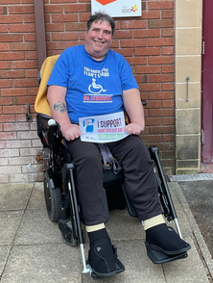
Dave, Chair of Neurology Sub-group
The Neurology Subgroup discussed work by the ME support group.
The group has been working with health services to make sure NICE recommendations for ME care are used in Gloucestershire.
Changes and reorganisation in health services caused delays and made it harder to know who was responsible for the work.
The Neurology Subgroup and the Physical Disability and Sensory Impairment group helped the work continue.
This showed why good communication and strong networks matter when organisations change.
For more information, email: asc.co-production@gloucestershire.gov.uk
More detail is in the full newsletter on page 46. Back to contents

Unpaid Carers News

Support for unpaid carers
You may be an unpaid carer if you regularly support another person because they need help.
You do not have to provide a certain number of hours of care.
Support might include:
- Emotional support by phone.
- Taking someone to appointments.
- Cooking, cleaning, shopping or other daily tasks.
- Helping with personal care.
- Checking on someone regularly.
Access Social Care has free Peer Navigator support for carers of adults.
Peer Navigators can help you understand social care rights, communicate with Adult Social Care, ask for assessments and create letters.
Peer Navigator email: enquiries@accesscharity.org.uk
Gloucestershire Carers Hub also provides advice, information, support and monthly activities for unpaid carers.
Telephone: 0300 111 9000
Email: carers@peopleplus.co.uk
Gloucestershire Carers Hub website
Self-refer to Gloucestershire Carers Hub
More detail is in the full newsletter on pages 47-48. Back to contents

End of the Easy Read version
Thank you to everyone who contributed to the Autumn 2026 newsletter.
This Easy Read version gives the main points. Please use the full accessible newsletter if you need the complete articles, all dates, all resources or more detailed explanations.
Feedback from people who use Easy Read can help improve future versions.

