Health inequalities strategic planning and review template – user guide

Introduction
A set of long-term outcomes (and measures) has been agreed that the Integrated Care System (ICS) can commit to delivering across the system to help reduce health inequalities, for example, reduced inequality in life expectancy.
The work of our ICS organisations’ and partnerships’ (ILPs) transformation programmes (for example, clinical programme groups) should be contributing towards these long-term outcomes.
Each of the organisations, partnerships (ILPs) and clinical programme groups should have their own objectives with measures (underpinned by a logic model) supported by projects/ activities influencing that change.
The self-assessment and peer review template is designed to:
- enable system organisations and partnerships to self-assess and understand their contribution to the wider system approach to addressing health inequalities.
- support system partners to reflect on their progress in operationalising the ICS health inequalities framework, including objectives under each of the themes.
- provide assurance to the ICB Board that each part of the system has a way of working that enables them to demonstrate how they are systematically contributing to the overall health inequalities framework.
- understand where progress is being made, where there are opportunities to stretch ourselves further, and what themes are emerging regarding system level support needed to have most impact.

FAQs

Who is the self-assessment and peer review template (the ‘Template’) for?
The Template intended to be completed by the following public sector organisations and partnerships: Gloucestershire County Council, Gloucestershire Health and Care Trust. Gloucestershire Hospitals Trust and NHS Gloucestershire Integrated Care Board (ICB), clinical programme groups (CPGs), and integrated locality partnerships (ILPs).

When should the Template be completed?
There are two stages to the process, and two corresponding sections in the Template (the second section is repeated to take account of there being two 6-montly reviews):

Strategic self-assessment and objective setting - to be completed annually in September/ October to feed into planning rounds

- Review of progress and learning - to be completed six monthly in March/April and September/ October

Where will the information go/where does strategic oversight sit?
Completed Templates should be submitted to the ICB Health Inequalities Improvement Manager (Sarah.Macdonald32@nhs.net)

These documents will feed into a summary report that will be presented to ICB Board in November and May. This report will include key themes, highlights and challenges, as well as recommendations to the Board on system level support needed for the successful delivery of our shared health inequalities ambitions.

Where should the template sit? E.g. business plan as a planning tool?
This is up to individual organisations and partnerships.

How much information should be included in the Template?
This is not a mapping exercise and does not intend to capture everything that is happening in the system to address health inequalities. The aim is to capture key high-level activities to help understand the balance of activity across the system and how it is contributing to our shared ambition to reduce health inequalities.

Are organisations and partnerships expected to complete the objectives that they set within the year?
No, we recognise that objectives will often take longer than a year to complete. You may need to carry some objectives over to your next annual review template if work to achieve them is on-going.

What are the benefits of completing the Template and how will it help organisations and partnerships to implement change?
Completing the Template will allow organisations and partnerships to assess where they are contributing to the wider system approach (and shared outcomes) for tackling health inequalities, and to measure the impact that they are making by linking objectives to specific indicators, ensuring that activities are evidence-based and effective.

As a system, this process will allow us to see where progress against health inequalities is being made, where there are gaps or duplication in our collective response to health inequalities, and where we can stretch to go further in the work that we are doing.

What is the role of the VCSE sector in the self-assessment and peer review process?
There are no expectations on VCSE organisations (or District Councils) to complete the Template. The self-assessment and review processes are aimed at public sector organisations who have a statutory duty around health inequalities, to help them to get their own house in order; it is not intended to burden VCSE organisations with bureaucracy.

How will the voice of the VCSE sector be fed in / integrated into the overall picture of Gloucestershire’s approach to tacking health inequalities?
The work that VCSE organisations are doing in partnership with statutory organisations will feed into the self-assessment and peer review process via the Templates completed by these organisations, ILPs and CPGs.

VCSE organisations will also be invited to be part of a wider community of practice, which will be an opportunity to highlight key pieces of work, share good practice and learn from one another about what is working well, key challenges and opportunities. More information on this will be circulated in the early Autumn.

What if the objectives fit into more than one theme?
There may be some overlap between the themes and some objectives might fit under more than one theme. Please choose the bucket that is most relevant to the objective.

How can we access quality data to measure outcomes?
Organisations, ILPs and CPGs have dedicated Business Intelligence leads who will be able to support you in understanding what data and information is available, and in analysing the data.

Will there be another programme board to oversee the completed Templates?
No, there will be no additional boards, project groups or meetings in association with the self-assessment and peer review process.

Does the self-assessment and peer review process allow an opportunity for reflection?
The review of progress and learning section of the template asks for organisations and partnerships to reflect on their progress with regards to the objectives that they set when they initially completed the Template, as well as key challenges, risks, and system-level support that would help them.

How does the self-assessment and peer review process relate to the delivery and monitoring of the Gloucestershire Health and Wellbeing Board (GHWB) priorities?
Currently the Health Inequalities Framework and the self-assessment and review process do not feature in the GHWB priority planning process. However, consideration is being given to how these two processes may align in the future.

What enablers are in place to support the design and delivery of interventions that tackle health inequalities?
We recommend that organisations and partnerships utilise the tools that are already available when designing interventions and activities that will support you in achieving your objectives. These include:
- Population Health Management (PHM) – bringing together health-related data to identify a specific population where health and care systems may want to focus collective resources to accelerate prevention programmes and tackle health inequalities.
- The PDSA improvement model – a framework for developing, testing and implementing changes leading to improvement.
- Quality, Service Improvement and Redesign (QSIR) - a programme of tools, techniques and approaches to support quality and service improvement projects.
- Inform Gloucestershire – an online repository of information on Gloucestershire’s population demographics and assets, our economy, environment, and the health and wellbeing of our residents.
- Gloucestershire's Prevention and Health Inequalities Hub – an online resource containing information and tools that aim to increase understanding of prevention and health inequalities in Gloucestershire.

Appendix 1: Health inequalities strategic planning and review process
September/ October (annually) | Step 1: Self-assessment and strategic objective setting  What: Identify high level commitments for contributing to a reduction in health inequalities and set strategic objectives towards delivery  Who: Statutory sector ICS organisations (ICB, GCC, GHFT and GHC) and partnerships (ILPs and CPGs)  How: Recommend using a logic model approach to help describe how your planned activities contribute to system ambitions and high-level shared outcomes. Populate the strategic self-assessment/ objective setting template, ensuring you have identified at least one objective under each of the themes or buckets in the Health Inequalities Framework.
Mid-October | Step 2: Submit completed strategic self-assessment/objective setting template  Where: ILPs, CPGs and Organisations to Sarah MacDonald (Health Inequalities Improvement Manger) at Sarah.Macdonald32@nhs.net.
Late October/ early November | Step 3: Review by appropriate boards to feed into ICB board paper  What: ILP, CPG and ICB Health Inequalities leads will review organisational and partnership responses and produce summary reports for peer review and discussion by EAC-I and CPB to identify key themes, risks and recommendations to steer discussion at ICB Board. ICB Health Inequalities Lead to draft ICB Board paper.
November | Step 4: Review by ICB board  What: ICB Board to provide support and constructive challenge to organisations and partnerships, help to unblock and influence, identify themes and areas that need system level support, and suggest ‘deep dive’ areas
March/ April | Step 5: Six-monthly reviews  What: Use the process and peer review template to review progress, impacts and challenges against the strategic objectives set in September/ October.  Tweak/ add to strategic objectives if necessary.  Who: Statutory sector ICS organisations (ICB, GCC, GHFT and GHC) and partnerships (ILPs and CPGs).  Where: ILPs, CPGs and Organisations to Sarah MacDonald (Health Inequalities Improvement Manger) at Sarah.Macdonald32@nhs.net.
Mid-April | Step 6: Submit completed progress and peer review template  Where: ILPs, CPGs and Organisations to Sarah MacDonald (Health Inequalities Improvement Manger) at Sarah.Macdonald32@nhs.net.
Steps 3 and 4 will be repeated with a review by the ICB Board in May.

The process will be repeated each year as follows:

- Sept/ Oct – Objective setting and review of previous six months progress and impact

- March/ April – Review of previous six months progress

Appendix 2: Logic model

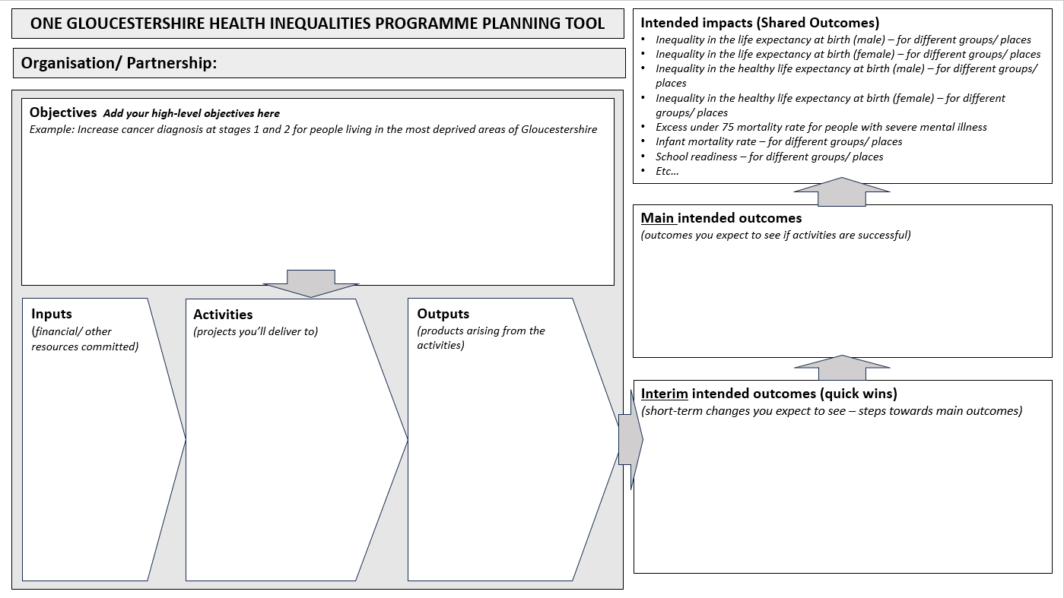

Appendix 3: Health inequalities framework examples – what are we doing to tackle health inequalities?
