

Highways Commissioning
Block 5, 6th Floor East
Shire Hall
Gloucester GL1 2TH

08000 514 514
highwaysstakeholder@gloucestershire.gov.uk

Our Ref: 70019949 – 866069

Date: 5th October 2026

Dear Sir/Madam

What: Temporary Traffic Order to close the road for carriageway patching.

Where: Parkend to Viney Hill Yorkley Slade. See page 3 for details of road closures.

New Road to George Road & Slade Road to Church Walk (both sections to be closed Wednesday 14th October 2026 until Friday 23rd October 2026 excluding weekends – Access to Yorkley Health Centre will be maintained along section of Bailey Hill via Lydney Road or Slade Road)

Bailey Hill including junctions of Lydney Road and Slade Road closed Saturday 17th October (see page 3 for map)

When: For approximately 9 Days (excl. weekends except Saturday 17th October 2026 07:00 to 19:00) between the hours of 09:00 to 15:00.

Keep an eye on the web page detailed below or the signs on site for any short notice changes.

Our patching programme is dependent on several factors. It can be affected by things like; heavy rain, changes in temperatures and other weather events as well as plant breakdown and unforeseen technical issues that arise once work has begun. All this means scheme dates and details can change at short notice. We appreciate this is inconvenient, and we will keep our online schedule and our social media feeds updated with more details if changes happen.

The most up to date information and more about this scheme is available via our:
- https://www.gloucestershire.gov.uk/resurfacing/patching-works/
- Signs in the area
Or via our website or our social media platforms.
- Facebook – Gloucestershire Roads
- Twitter - @GlosRoads

If you do not have access to the internet or social media, you may wish to ask friends or neighbours to help you access our website. If you know of neighbours who cannot access our website, please share this information with them.

ROAD CLOSURE
We will be patching the road at the above location. To ensure the safety of you and our work force we have, under Sections 14, 15 & 16 of the Road Traffic Regulation Act 1984 as amended, made a Temporary Traffic Order to close the road.

Due to the type of engineering activities required with carriageway patching, the road closure can cover an area greater than the area being resurfaced. This is to allow activities, such as movement and placement of machinery and material.
We appreciate road closures are inconvenient, but to keep you and the team working on the road safe it is necessary. We have planned the work so we can be in and out as quickly as possible and have tried to do it at a time that will minimise any inconvenience.
ACCESS
In accordance with the Temporary Traffic Order, we are not permitted to allow any person or vehicle to proceed along the closed roads; except for pedestrian access to properties where a designated footway is available, emergency vehicles, and statutory undertakers responding to an emergency.

Therefore, if you normally drive into or out of this area during the hours when the road closure is in place, we ask you to please make alternative arrangements.

In exceptional circumstances, some level of access may be considered. This will be on a case-by-case basis and only where it does not impact on our ability to carry out the work and where it is safe to do so. Any access during this time would be at the drivers’ own risk as it is a works site and may have raised iron works or a temporary surface.
DIVERSIONS
We have created an official diversion route which will be signposted and is suitable for all vehicles that would normally use the closed road. We appreciate you may know an alternative route, however, please be aware alternative routes which are outside of the road closure area are used at drivers’ discretion.

Contact Us
- Thank you in advance for your patience and co-operation. If you have any queries, please refer to the Frequently Asked Questions on our website.
- https://www.gloucestershire.gov.uk/resurfacing/patching-works/
- Or email us at highwaysstakeholder@gloucestershire.gov.uk

Below is a map showing the extents of the road closure.

Yours Sincerely

Structural Maintenance Department
Gloucestershire County Council Highways Commissioning

Follow us on social media for updates on this and other road schemes in Gloucestershire:

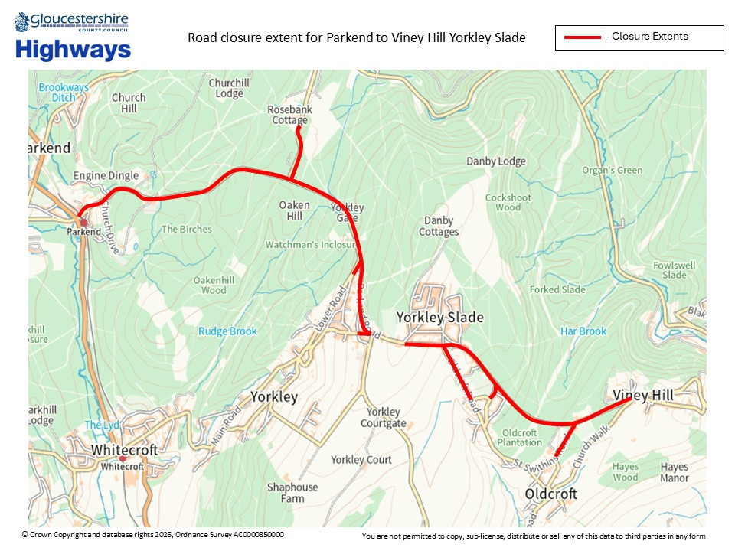
Wednesday 14th October 2026 until Friday 23rd October 2026 (Excluding Weekends)

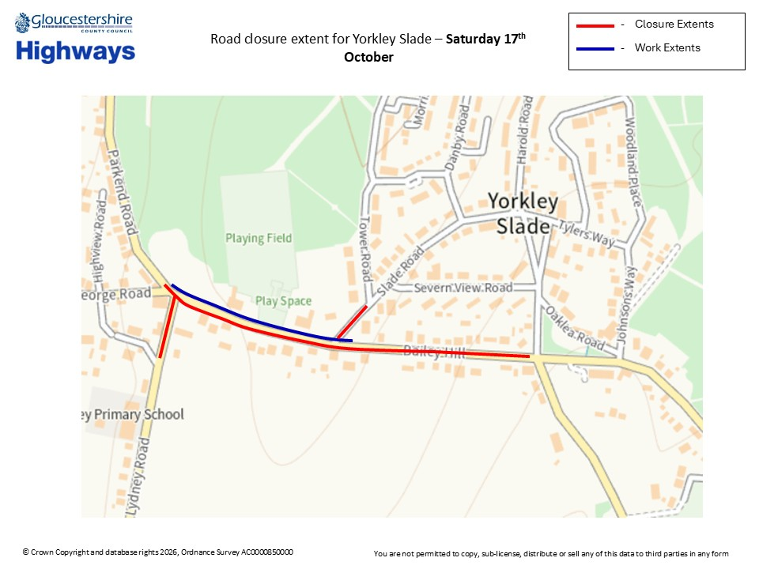
Saturday 17th October

