The Learning Environment: The Physical Environment
Outdoor spaces
“The outside world should be part of our classroom experience – there should be no dichotomy between the two. The outdoors must be given the same value as indoors…unbridled risk-taking, collaborative, expansive play, freely chosen explorations…” Can I Go and Play Now?’ Greg Bottrill
Things to consider
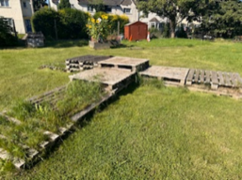
The weather – Consider how to overcome challenges relating to the weather such as providing canopies, tents, awnings. For sun protection, consider other ways to offer protection such as large cardboard boxes, sheets, material, pop up UV beach shelters etc.
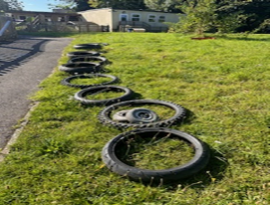
Resources in your outdoor environment should reflect your current cohort – consider children’s interests and developmental levels when planning the area and activities, regularly monitor and adapt, changing the environment flexibly to reflect current needs and interests.
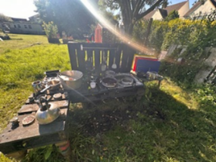
Your outdoor space should provide continuous provision – activities to promote mathematical exploration, creative and imaginative play, communication and social interactions, sensory exploration, fine and gross motor skill development. A variety of play opportunities such as solitary, small group, peer on peer and alongside adults.
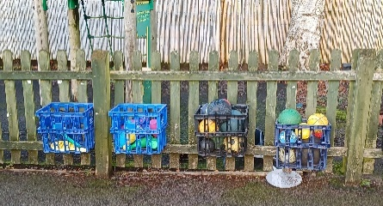
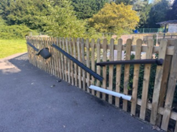
Open ended resource ideas – cable drums, planks and crates, tyres, pallets, guttering and drainpipes, pots and pans, logs.
Consider storage and accessibility – Consider storage areas and shelving, ensure that this can be accessed by all children independently. Add labels to boxes/baskets to help children take responsibility when tidying.
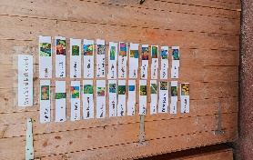
Top tips for inclusion
- Where resources are in storage consider the use of photographic choice books.

Partnership with Parents
- Children’s current interests (updated ‘All About Me’, discussions, online learning journal)
- Discuss activities which have been explored during session and provide ideas for how this can be continued at home
- Ensure parents are reminded and supported to provide appropriate clothing for their children to access outdoors at any time

Helpful links and resources
Gloucestershire’s Ordinarily Available Provision (OAP) | Early Years Service
Creating environments for children to play and learn – A Froebelian approach
Help for early years providers : Physical development

