Key Person approach
What does the EYFS tell us about the Key Person approach?
It became a statutory requirement in 2008 for all children to be assigned a Key Person.
1.19 Children need to build an attachment with their key person for their confidence and well-being. The key person also promotes children’s learning by developing a deep understanding of their individual needs and children can particularly benefit from their modelling and support. The requirements in relation to workforce training and responsibilities, including that of the key person, are outlined in Section 3 but they are equally important for children’s learning and development as they are for their safety and welfare.
3.34 Each child must be assigned a key person. Their role is to help ensure that every child’s care is tailored to meet their individual needs, to help the child become familiar with the setting, offer a settled relationship for the child and build a relationship with their parents and/or carers. They should also help families engage with more specialist support if appropriate
3.82 Providers must share the following information with parents and/or carers: The name of their child’s key person and their role.

The Key Person Approach is described as "a way of working
in early years settings in which the whole focus and
organisation is aimed at enabling and supporting close
attachments between individual children and individual
practitioners" (Key Persons in the Early Years, Elfer,

What is a Key Person?

A Key Person is an individual practitioner who builds a close attachment with an individual child and their family to understand what is best for the child, and how to personalise their learning.
Although all practitioners will contribute to children’s individual learning and care, the Key Person approach supports a child to feel known, understood and genuinely cared for by one significant person.
What is the Key person’s role?
- The Key Person will become a secondary attachment figure for the child to reduce the anxiety of separating from their parent/carer.
- The Key Person will support the child to become familiar with the provision and develop the confidence to explore.
- The Key Person will meet the child’s individual care and learning needs, providing genuine care and affection.
- The Key Person will tune in to the child’s feelings and support the development of their emotional resilience and regulation.
- The Key Person will support the child to build relationships with others.
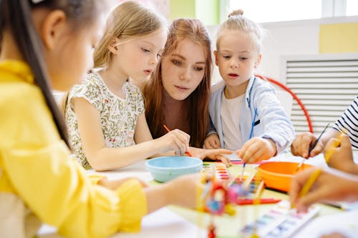
Reflective questions for the Key Person
Do you greet your key children every day on arrival?
Do you support your key children to settle into their session each day?
Do you chat with your key children’s parents at drop-off and home times?
Do you spend one to one quality time with your key children during sessions?
Do you take the lead on your key children’s nappy changing and toileting needs?
How well do you know the starting point for each of your key children’s learning in order to individualise their curriculum?
When and how do you stay up to date with parents about the progress your key children are making?

Top tips! Partnership with parents

Encourage parents to support their child by…
- Talking to their child about their key person so they know they can go to them for help.
- Keep the key person updated with any changes in routines or changes in the child’s home life e.g. moving house, expecting a sibling.
- Sharing any new interests their child may have or special experiences they may have taken part in.
- Telling their child’s key person about any ‘wow’ moments the child has had at home and when they meet developmental milestones. Together you can celebrate the child’s achievements and plan suitable next steps to support them. Take a look also at our ‘Partnership with Parents’ handout.

