GLOUCESTERSHIRE COUNTY COUNCIL
VIRTUAL SCHOOL
Moving Forward:
Your Future, Your Choice
Post-18 Pathways for
Care Leavers in Gloucestershire



Welcome to Your Post-18 Options Toolkit
Higher
Education
Apprenticeships
Employment
Further Study

& Training
Finance &
Funding
Care Leaver
Factsheets
This guide is designed to help care leavers explore education, training, employment, and funding opportunities after 18.
Need Help?
Talk to your teachers, support workers, carers, Leaving Care PAs, Youth Support Team or your Virtual School Education Adviser for additional advice and guidance.
Leaving Care Personal Advisers & Social Workers can refer young people to the Youth Support Team (YSTinfo@gloucestershire.gov.uk), who provide a wide range of support, especially around apprenticeships.
What’s Next?
A practical resource for planning your next steps after leaving school, with advice on further education, apprenticeships, training, and support services.

Higher Education
Higher Education offers degrees and qualifications that open career doors. Care leavers can access bursaries, year-round accommodation, and tailored support. This section covers applying, finance, and extra help.

PROPEL/BECOME
Propel is brought to you by 'Become', the charity for children in care and young care leavers.
Propel will provide you with information on care leaver support for every university and college across the UK

UNI OF GLOUCESTERSHIRE CARE LEAVER SUPPORT
Find out about bursaries, year round accommodation, and dedicated advice for care leavers at the University of Gloucestershire.

COMPLETE UNIVERSITY GUIDE
Applying to Uni as a Care Leaver Find out what support universities offer, how to apply, and tips for getting extra help with finance and accommodation. Applying to Uni as a Care Leaver

UCAS- APPLYING TO UNI
UCAS Care-Experienced Students
Get tailored guidance on applying to university if you’ve been in care. This resource explains the application process, financial support options, and the extra help available for accommodation and wellbeing.

UNIVERSITY SUPPORT OFFER
Compare universities, courses, and support in the South West and beyond. Includes tips on applying, finance, and care leaver help.
Care Leaver Uni Support List
SW CiC & Care Leavers HE
Support

THIS IS US PODCAST
Hear real stories and experiences from care-experienced young people. Inspiring conversations about education, life after care, and finding your path.
This Is Us Podcast
Apprenticeships
Earn while you learn with paid work and training. Care leavers may be eligible for a bursary and extra support.
This section explains how to find, apply, and succeed in apprenticeships.

SUPPORT FOR APPRENTICES
Learn about extra financial help, mentoring, and guidance available for care-experienced young people starting an apprenticeship.
Support for care experienced apprentices
UCAS APPRENTICESHIP

CARE LEAVER SUPPORT
Find guidance on applying for apprenticeships, financial help, and extra support available for care-experienced people.
Support for care experienced people taking apprenticeships

CARE LEAVER GUIDE TO APPRENTICESHIPS
Step-by-step advice on finding, applying for, and succeeding in apprenticeships, plus details on financial support and your rights as a care leaver.
Apprenticeship Guide
The Moving On Up Apprenticeship Buddy Your go-to resource for apprenticeship support.

APPRENTICESHIP CARE LEAVERS’ BURSARY
A simple visual guide showing how to access the £3,000 Care Leaver Bursary for apprenticeships and what steps to take.
Apprenticeship Bursary
Flowchart

CARE LEAVERS APPRENTICESHIP FACT SHEET
A practical 6-page guide with examples of how apprenticeship salary, Universal Credit, and housing benefit might be calculated. Great for understanding your finances. View the guide

SOUTH WEST APPRENTICESHIP COMPANY
The SWAC Apprentices helps you gain qualifications while you search and apply for current vacancies. It includes useful resources such as;
Writing a Winning Application, CV Guide, Apprentice Handbook & Interview Tips
South West Apprenticeship Company
Employment
Start work and gain independence. This section includes job search tips, CV and interview guidance, and links to employers and programs supporting care leavers.

PROPEL YOURSELF INTO WORK (BECOME)
Practical advice and resources to help care-experienced young people find jobs, build skills, and prepare for employment. Explore the guide
Applying for jobs

CARE LEAVER COVENANT
Connect with employers, training providers, and universities offering opportunities and support for care-experienced young people.
Visit Care Leaver Covenant

APPLYING FOR JOBS
Help Applying for Jobs and Apprenticeships (Become)
Step-by-step tips for writing CVs, completing applications, and preparing for interviews—designed for careexperienced young people.
Read more

GLOUCESTERSHIRE JOBS & OPPORTUNITIES
Browse local job vacancies, training programs, and opportunities for care-experienced young people in Gloucestershire.
Explore jobs

SKILLS PORTAL GLOUCESTERSHIRE
A one-stop hub for training, courses, and career advice. Find local opportunities to build skills, gain qualifications, and explore employment pathways. Learn More

CAREER OPTIONS (GROWS)
Explore different career paths, job sectors, and progression routes to help you plan your future after education or training.
Discover career options
Further Study & Training
Gain new skills or qualifications without committing to a degree or employment. Options include college courses, vocational training, internships and traineeships. This section highlights local providers and support.

FE & HE PROVIDERS IN GLOUCESTERSHIRE
Explore local colleges and universities offering courses and training: Gloucestershire College, Prospect
Training, Bridge Training, SGS, Hartpury,
Cirencester College and University of
Gloucestershire

CIVIL SERVICE CARE LEAVERS INTERNSHIP SCHEME
Paid internships for careexperienced young people, offering work experience, training, and career development within the Civil Service.
Learn more

ADULT EDUCATION IN GLOUCESTESHIRE
Offers flexible courses for post-18 learners, including English, maths, digital skills, and vocational training. Many courses are free or low-cost.
Learn More

STEP FORWARDS
A program helping care leavers and children in care move into paid work, apprenticeships, or traineeships. Offers 1:1 support, financial help for work-related costs, housing benefit assistance, and ongoing in-work support tailored to your needs.
Step Forwards

THE KING’S TRUST
Support for young people through training, mentoring, and programs to build skills and confidence for work or further study.
Visit The King’s Trust

CAREER PLANNING & EMPLOYABILITY (IMO)
Access tools and advice to help you plan your career, build employability skills, and explore future opportunities.

View resources
Finance and Funding
Care leavers can access bursaries, scholarships, and grants for education, training, and living costs. This section lists funding opportunities and how to apply.
CARE LEAVER
SCHOLARSHIPS &

BURSARIES
The Scholarship Hub lists the best funding options for care leavers, including grants, bursaries, and scholarships to support your education and training.
Education Grants
Explore funding opportunities
UCAS – FINANCE &

FUNDING FOR CAREEXPERIENCED STUDENTS
Information on scholarships, grants & bursaries available to care-experienced students, helping you access financial support for higher education.
Learn more

FUNDING FAQS
Become provides guidance on grants, bursaries, and financial support available to care leavers for education, training, and living costs.
Find funding help

CARE LEAVERS APPRENTICESHIP BURSARY
Amazing Apprenticeships explains how care leavers can claim a £3,000 bursary when starting an apprenticeship, with a clear stepby-step flowchart. View the guide

UNITE FOUNDATION SCHOLARSHIP
The Unite Foundation offers free university accommodation for care leavers and estranged students, helping reduce living costs while studying.
Find out more

UNIVERSITY OF GLOUCESTERSHIRE – CARE LEAVERS SCHOLARSHIP
The University of Gloucestershire offers a scholarship for care leavers to support their studies, helping with financial costs during higher education.
Learn more

Factsheets
Get clear, practical advice on the things that matter most:
Finances – Understand your money and what you’re entitled to.
Who’s Who – Know the key people who can support you.
Pathway Plans – Learn how to plan for your future and get the help you need.

ALL ABOUT THE MONEY
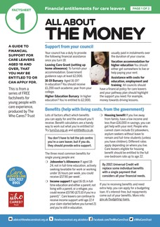
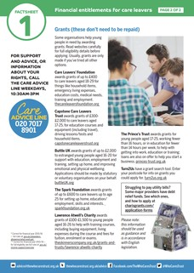
A Guide to Financial Support for Care Leavers Aged 18+
Find out what financial help you may be entitled to or can apply for as a care leaver aged 18 and over.

THE NAME GAME
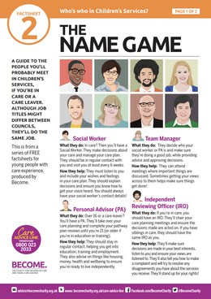

A Guide to Key People in Children’s Services
Learn about the roles you’re likely to meet if you’re in care or a care leaver and how they can support you.

PATHWAY TO SUCCESS
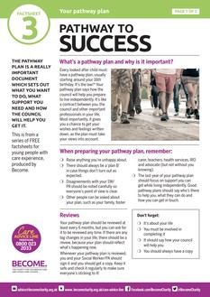

Your Pathway Plan is a plan you create with your Personal Advisor that sets out your goals, the steps you’ll take, and the support you’ll get as you move towards independence.
It covers key areas of your life: like education, work, health, money and where you live and is reviewed together.

