


Project Bulletin - Whitminster Canal Bridge
Further to the COVID-19 outbreak and associated government restrictions, Alun Griffiths (Contractors) Ltd took the decision to stand down its sites for 1 week in order to risk assess construction activities and establish whether or not it was safe for works to continue. After a review of operations at our Whitminster site, we were fortunate enough to be able to introduce social distancing measures and recommence works on 6.4.20.
Since our return we have completed construction of the capping beams to the North wingwalls, installed the BT service bridge, completed drainage works to the North side of the roundabout and commenced earthworks in the centre of the roundabout.
Unfortunately, due to COVID-19, some of our key suppliers still remain closed. This would have undoubtedly caused major delays to our project. In order to mitigate some of these delays we have re-phased our works slightly and early next week, we will be switching traffic to the North side of the roundabout. No road closures will be required whilst the Traffic Management switch takes place.
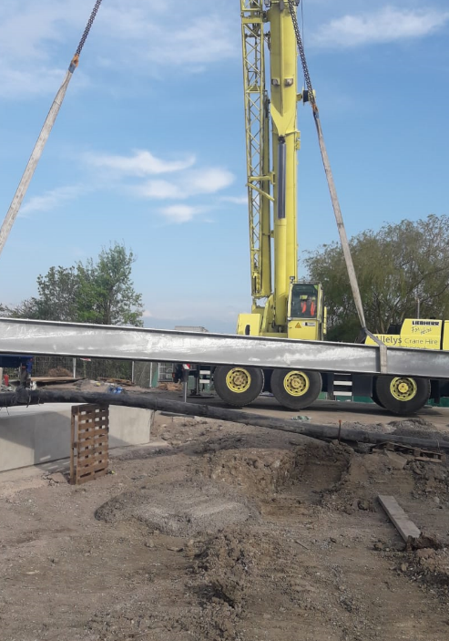

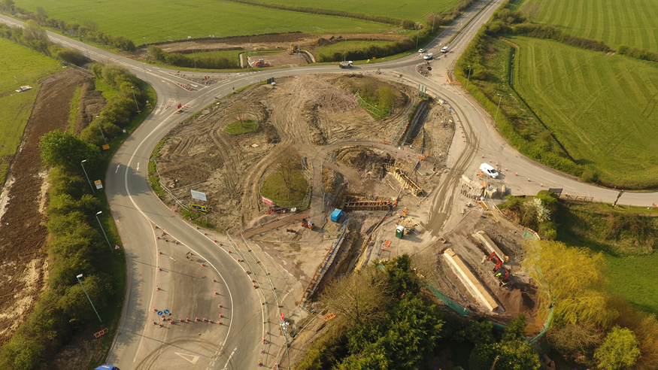
As we progress with these important improvements, your continued patience is greatly appreciated.
If you have any concerns or issues regarding the road improvement scheme, please contact me on 0300 041 4635*. I will be available throughout the construction phase to provide continuous engagement with businesses and residents within the local area.
Further information about the scheme can be found at
https://www.gloucestershire.gov.uk/highways/major-projects-list/a38-canal-bridges/
Neil Evans
Contract Liaison Officer
Alun Griffiths (Contractors) Ltd
0330 041 4635*

*Calls to this number are charged at national call rates and included in inclusive minute plans from landlines and mobiles

