Teacher’s Notes: Gloucester from Hempsted
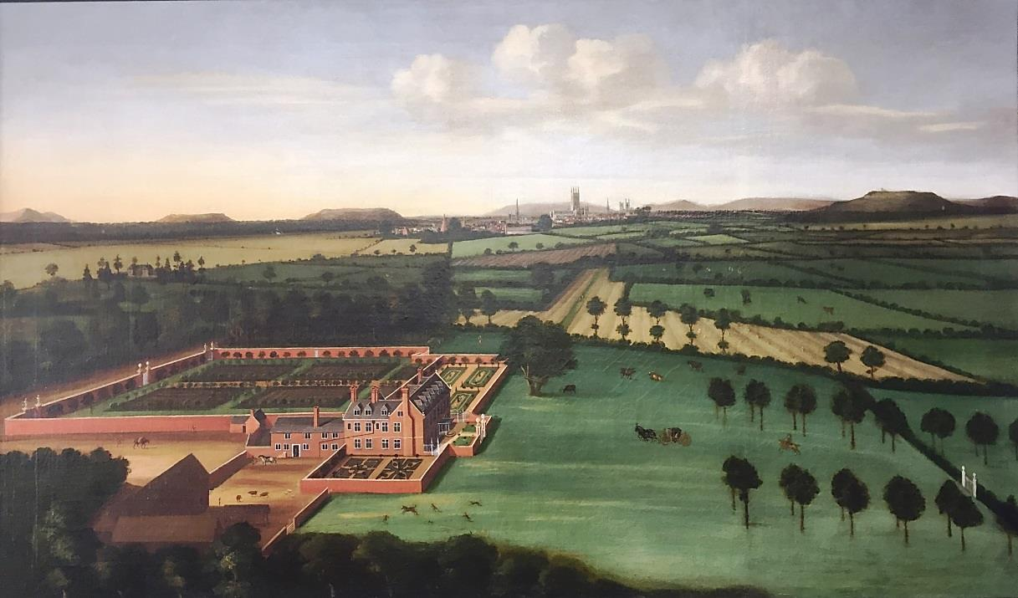
Gloucester from Hempsted, c1700 By Unknown Artist

About The Artist
The artist who painted this picture has not signed it as far as can be seen. However the painting has been attributed to Thomas Robins the Elder, 1716–1770. He had been born in Cheltenham, c 1716/16 and moved to Bath c.1740. Between 1747 and 1770, he produced a series of drawings and paintings of English country houses and, in particular, their gardens. His surviving drawings and paintings – often criticised as naïve - epitomise English rococo taste. Robins was either specially attracted to rococo gardens or had a reputation for painting them for he undertook commissions in Gloucestershire and occasionally further afield. He also painted the Georgian houses of Bath publishing a Prospect of Bath in 1757 and A View of the Baths and Pump Room in 1764. Robins and his work are of significant interest both topographically and aesthetically. His pictures of rococo gardens, with their vistas and ornamental buildings, are of great historical importance because they immortalise a fashion whose exemplars have disappeared. Robins, who was in many respects an 'amateur' painter, never succumbed to the influences of the artistic set and his views retain the charm and freshness of a personal discovery. Today Hempsted is known as Hempstead.

About The Painting
What Can You See?
The painting gives a view that is looking roughly north-east from an imaginary highpoint. It shows Hempstead Court with its elegant walled gardens (now all demolished) in the foreground; Gloucester, with its cathedral and churches, in the middle distance; and the Cotswold escarpment and it’s outliers beyond. Also visible is Newark House, which is still extant today. The picture depicts late-summer as there is plenty of foliage on the trees and in the nearest fields beyond the house stooks of harvested grain sheaves can be seen. Within the picture are a number of figures and incidents; the coach and horses being followed by a lone rider; a runaway horse with a number of figures trying to catch it; a laden mule and two farm workers; while the enclosed yard has a man and horse, a figure in the doorway of the service range and loose animals. There are also people walking along a track towards Gloucester (Hempstead Lane) and the masts and sails of ships on the River Severn (though the river itself is hidden).

Hempsted Court

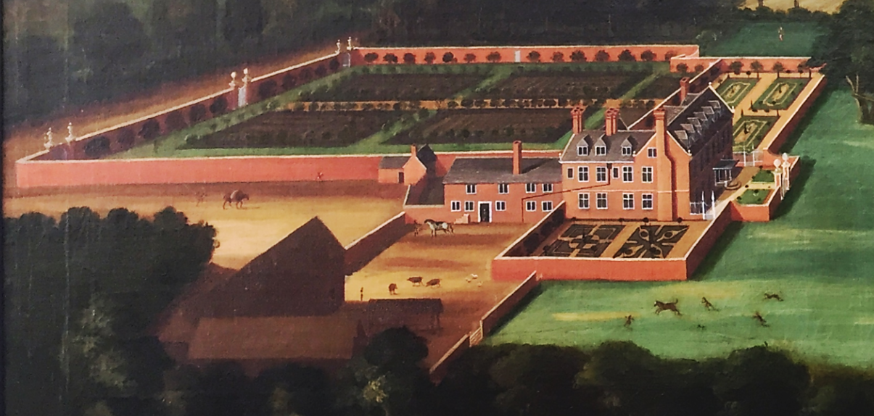

Hempstead Court was begun by Daniel Lysons the elder, a Gloucester draper who had been buying leasehold lands in Hempstead from the manorial estate in the years before his death in 1681. The house was completed by his trustees during the minority of his son, Daniel Lysons the younger. This Daniel went on to become the Lord of the Manor after 1721 when Lord Bathurst sold the manor to him, whereupon the court became the manor house.

The house itself was an L-shaped brick-built building of two storeys and attics with dormer windows, having a main (east facing) front of seven bays, a south-facing side wing of three bays attached to a low two storey service wing on the south-west. The court stood within a walled enclosure with three formal gardens around it and adjoining on the north-west was a large walled kitchen garden. On the south side there was an enclosed gated yard with a large barn running north-south on the west wall and a second barn running west-east along the south wall. Adjoining the larger barn is what appears to be a roofed workshop or animal pen.

The house was remodelled in the 1800s and remained in the hands of the Lysons family until 1887 when the house and grounds, and the manorial rights, were purchased by the Revd. Joseph Brereton. It briefly became a boys' school but passed again into private hands from 1891. By 1928 it was owned by Charles Brandon Trye, and after his death in 1961 the house was demolished and the site used for a housing estate.

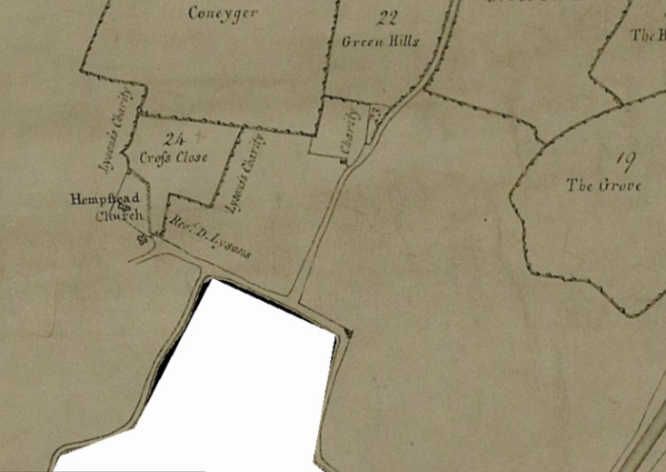
The footprint of the court & gardens on the 1815 inclosure map (Q/Ri/79) – the land was owned by the Rev Daniel Lysons and buildings were not shown.

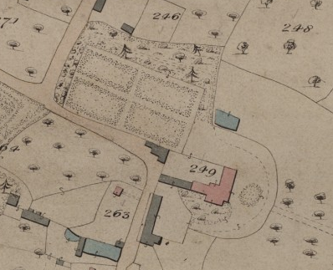
The house and remaining gardens on the 1839 Hempstead tithe map (GDR/T1/99)
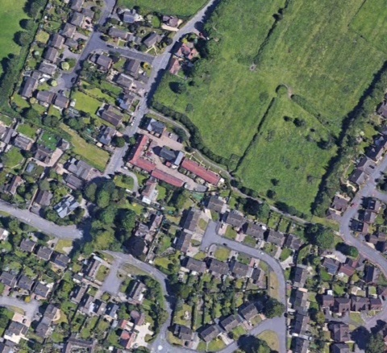
The site on Google Earth as at 05/05/2020

Gloucester – on the skyline

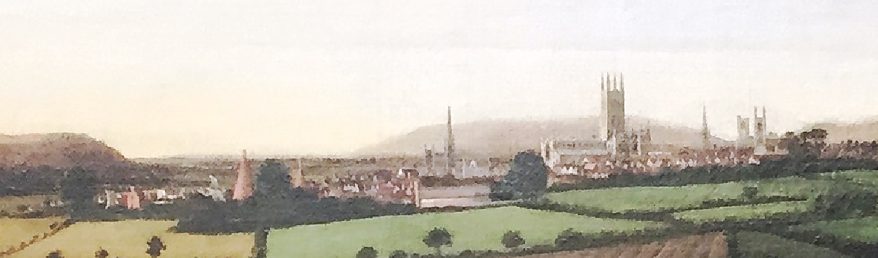

Not too many buildings are distinguishable apart from the following:
- Religious buildings (from R to L): St Mary de Crypt church, St Michael’s church, St. John’s church, Cathedral, St. Nicholas’ church and St. Mary de Lode church.
- Glass making kilns (tall conical structure); see on the left of the city - located on what is now called Westgate but was then known as the ‘The Island’. Two cones can be seen; a large one and a smaller one to it’s right. The trade began in Gloucester around 1674 and continued until around 1750. One of the main products was glass cider bottes for the Vale of Gloucester’s numerous cider makers.

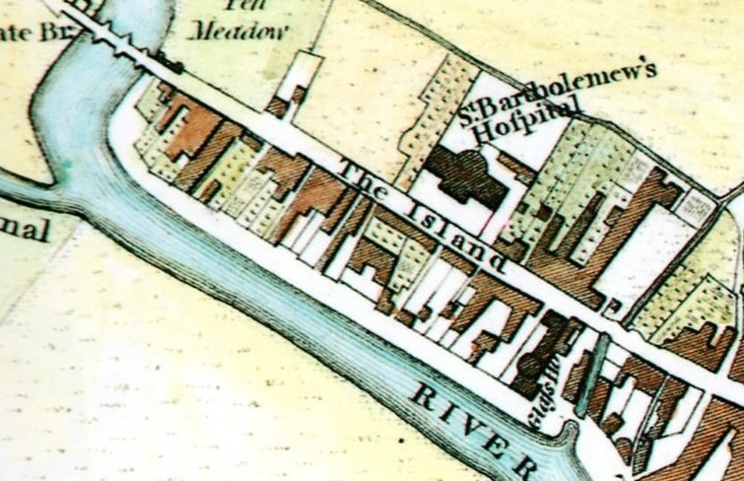
The large glass kiln shown on Cole & Roper’s 1805 map of Gloucester. The smaller kiln had been demolished by this point. c Gloucester Civic Trust/Ashley Baynton-Williams©

- Grey building: Visible in the centre of the spread of the city, this is the building today known as the Brick Range at Llanthony Secunda Priory grange. The priory’s records show that this building (which was built c1520) remained in existence after the Dissolution and was used for a number of purposes including stabling and other agricultural storage. This structure has now been restored and used as a venue.
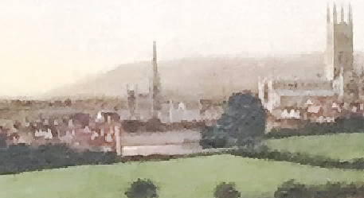

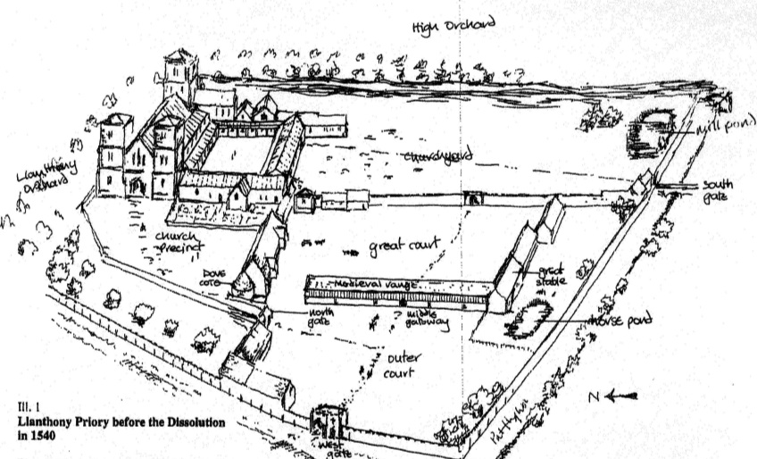
The Brick Range
Artists impression of the Priory showing the brick range visible in the painting. The painting shows the range as if viewed from the right. Courtesy Llanthony Secunda Priory Trust

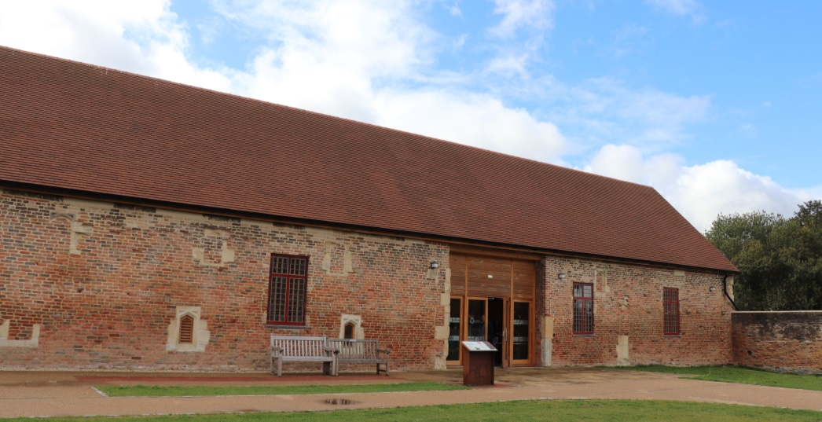
The restored Brick Range at Llanthony Secunda Priory. Courtesy Llanthony Secunda Priory Trust

Newark House

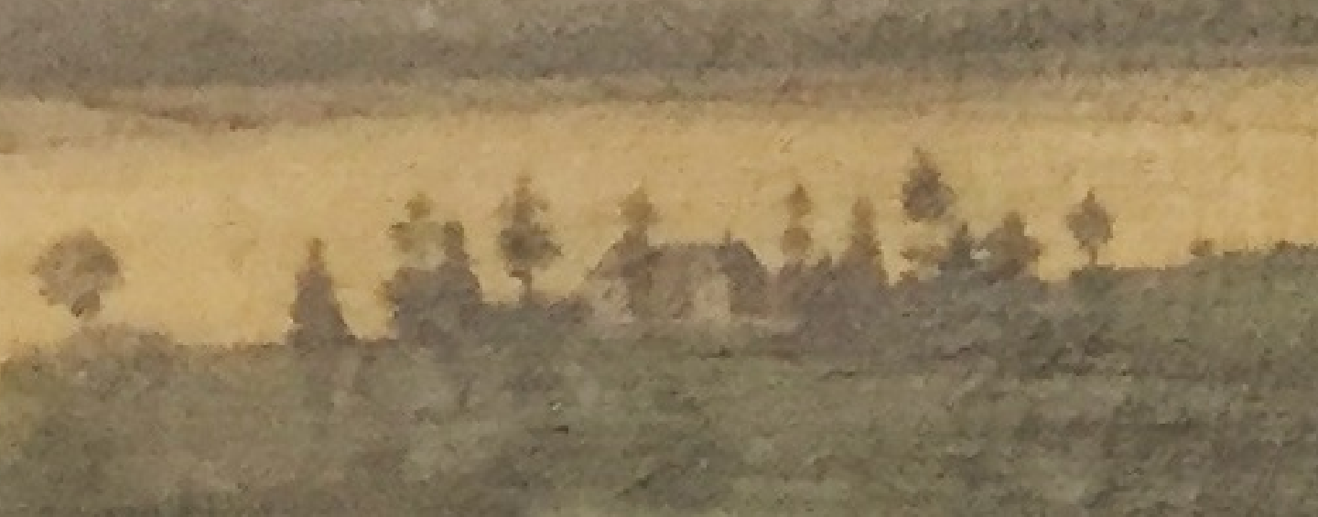

The only other building visible with any clarity can be seen to the upper left of the court complex. This building was originally called The Newark but was later known as Newark House. According to tradition, it was built in the 1300s by the Prior of Llanthony Secunda to rival the Vinyard, the house built by the Abbot of St. Peter’s Abbey Gloucester on a similar site at Over, west of the Severn. After the Dissolution the house with some lands in the parish descended with the Llanthony manor estate through various local families. It was partly rebuilt by Viscount Scudamore in the mid-1600s and was described in 1710 as a handsome, beautiful house. It was rebuilt again in 1830 by John Higford as a plain ashlar-faced mansion, incorporating part of the old foundations. In the early 1860s it was occupied by a private school and then from 1883 until c. 1910 it housed a branch of St. Lucy's Home, Gloucester, training girls for domestic service. In 1986 it was turned into flats and has now become the centre of a new housing development.

The Courtyard

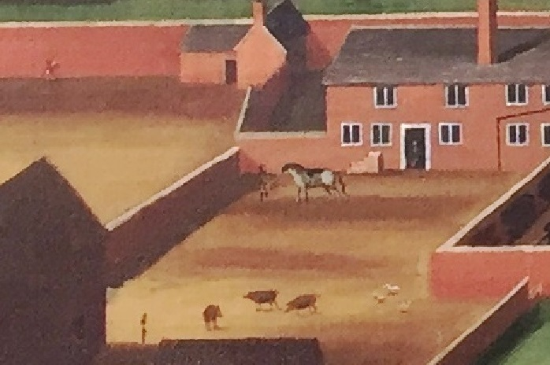

The courtyard has several details of interest figures. Firstly there is a seemingly well-dressed man standing in the white doorway. He may well be going out to mount the horse in the yard, which is being held by a groom and is saddled and ready to ride. A set of mounting steps can be seen built onto the service range wall behind the horse. There is a rather skinny figure at the bottom left of the yard, presumably an estate worker. Near to him are 3 pigs and a small flock of chickens.

The Runaway horse!
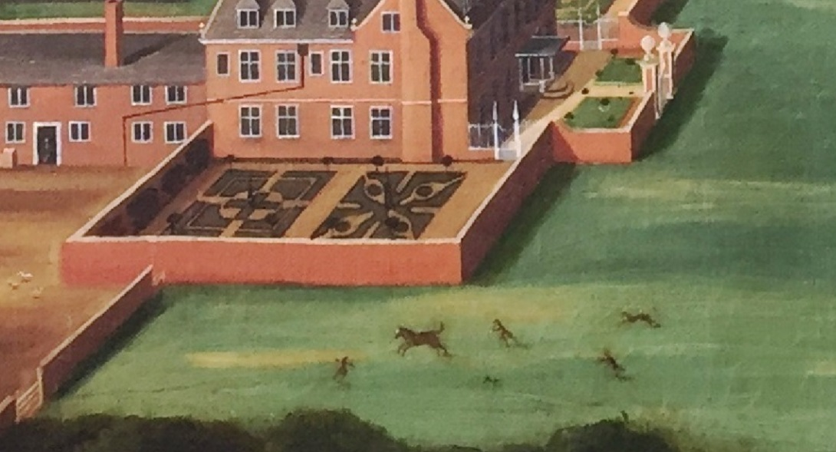

The picture has a moment of drama when you look at the runaway horse! It istrying to be recaptured and is being chased by 2 men and 2 dogs while a third man is tanding in front of the horse and appears to be waving his arms to try and stop it.

The Carriage & Rider
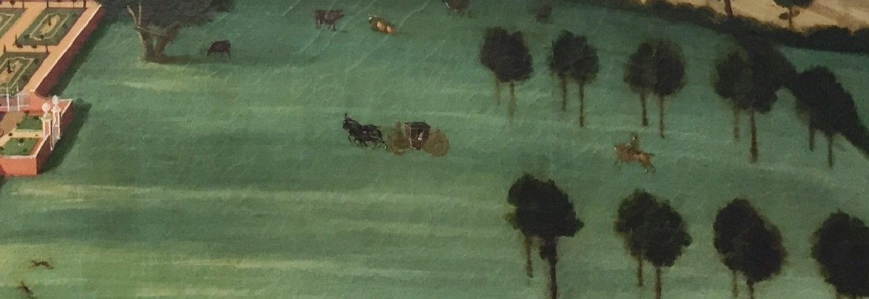

To the right of the house and approaching the white gates of the front garden is a carriage which is being followed by a lone rider who looks to be going at some speed. The carriage is a Berlin or Berline style of carriage with small front and large rear sprung wheels which is drawn by a pair of horses with a coachman is sat at the front of the carriage. Inside the carriage there is a passenger. When the house was built in the late 17th century a small park was laid out east of it with a broad double avenue of elms and a series of ornamental gates, leading down to the Bristol road. As well as the carriage and rider, there are 5 cows in the parkland.

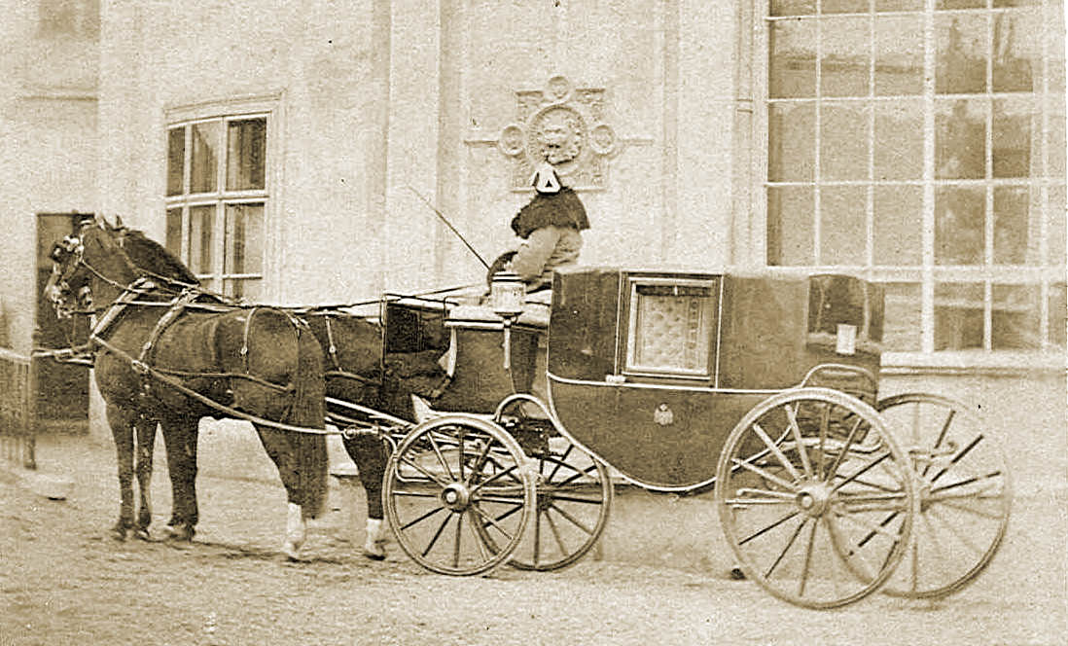
A Berline coach similar to the one in the painting, Wikipedia CCfree

The eastern end of this tree avenue was destroyed when the canal was built in the 1790s but the remainder of it survived in 1839, by which time a drive had been constructed branching from it to a lodge on the lane west of Hempstead bridge. Parts had been felled by the early 1880s but some trees survived until the outbreak of Dutch elm disease in the early 1970s.

The man & the pack-horse

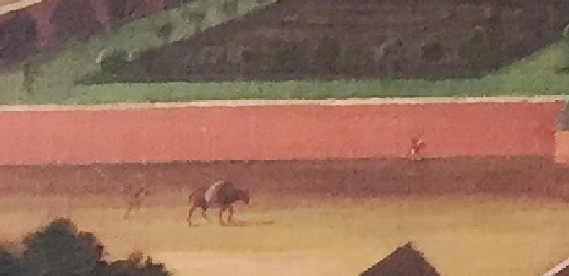

Outside the courtyard 2 figures can be seen, one walking behind a laden horse and the other walking along the wall. It is difficult to see what they are carrying although the horse’s load appears quite heavy but soft as it is draped over the animal’s back.

The Gardens

1) The Formal Gardens

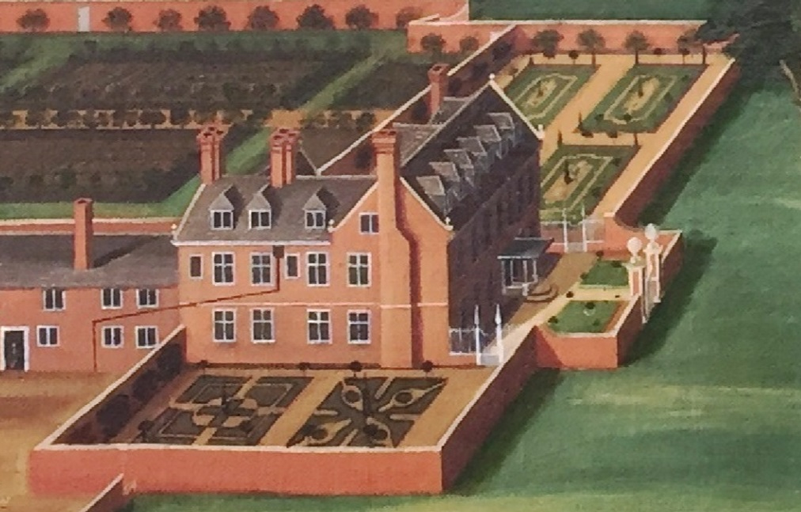

There are 3 formal gardens around the house. The pathways around these look like gravel. The front, east, garden is the smallest and is just 2 lawns with low box-bushes flanking the main entrance path. The north and south gardens are laid out in the formal ‘French garden’ (jardin à la française), based on symmetry and the principle of imposing order on nature, typified by parterre de broderie or embrodiery beds. The north garden has 4 long embrodiery beds with small conifer trees, while the south garden is the larger and is very formal being made up of 2 rectangular geometric embrodery beds. Note that the trees and shrubs in the formal gardens are all well clipped and of regular heights – all part of the formality of the layout. The enclosing walls of these two gardens also have espalier trained trees – these are probably ornamental rather than fruit-bearing.

2) The Kitchen Garden
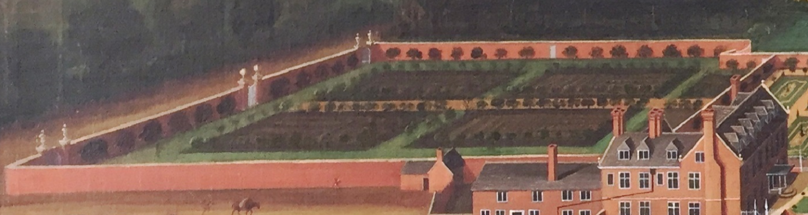

The kitchen garden was a source of herbs, vegetables, fruits (note the espalier fruits tress all around the inner walls) and flowers, but was also a structured garden space, based on repetitive geometric patterns. Estimating from modern mapping, the kitchen garden is roughly 80m square, giving it an area of 6,400 square metres (0.64 hectares) or about 1.5 acres – which could be expected to provide enough produce to feed 12-16 people, although other factors would contribute to how productive it was. The main aspects here would be the availability of water, manure, heat, wall space, storage space, workrooms, and most importantly, a dedicated team of gardeners.

Churchdown Hill

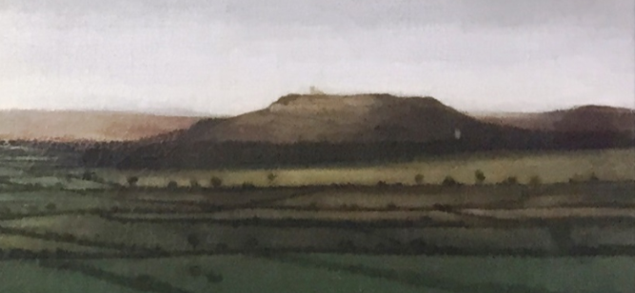

This is identified by the Church of St. Bartholomew on the top and St Lawrence's Church Barnwood in front of the hill at its lower right. Note that Robinswood Hill is just out of view to the right.

Ships on the River

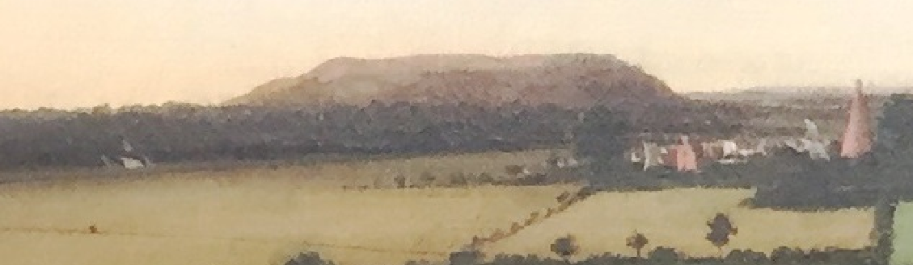

The Severn was busy at Gloucester with ships and barges carrying all manner of goods up and down the river. There are 2 ships – or sets of sails – visible in the painting, both appear to be sailing up river rather than down it. The first, carrying 4 sails, is to the left (west) of the city, while the second, with a single sail, is to the left of the larger glass kiln. The first vessel appears to be 2-masted brig with square sails (main and topsail) on the foremast plus a fore-and-aft sail between the foremast and mainmast. The second craft may be a trow with a single square sail.

Using The Picture Across The Curriculum - Ideas For Cross-Curricular Work
The following ideas are merely a starting point. Use the picture as a springboard for initiating dialogue to develop both creative and critical thinking by asking open-ended questions, such as:
- If you could jump into the picture how would what you see/hear/smell/touch differ from today? Where in the picture would you like to jump to?

- What would you like to ask one of the people in the picture?

- What time of day do you think it is? What season is it? Why do you think that?

- Who do you think is in the carriage and is the lone rider following or chasing the carriage?

- Have a close look at the figures. Try to make up identities for them and then write a short story or a play about them.

- Ask the students to think about what happens next? Does the horse get caught or escape? Is the lone rider a highwayman about to rob the coach? Perhaps they could turn it into a TV or radio news report?

- What do you think the inside of the Court is like? How many rooms do you think there might be? Could you draw a layout of the inside of the house? Would you like to live in it?

- What would a soundscape of the painting be like?

- How many people are in the picture? How has the artist shown them? What do you think each group of people are doing?

- Where do you think the man in doorway might be going? Why?

- What do you think is being grown in the kitchen garden? Who do you think will eat it?

- What do you think the person walking behind the pack horse is doing? Is he a salesman who is going to try and sell something or is he an estate worker?

- What are the people wearing? Can you tell who is who by their clothes? How many people are wearing hats? When do people wear hats today, and why?

- How do you think most people travelled? Was there any public transport? What are the advantages and disadvantages of using horses instead of cars, buses and lorries? How long would it take them to get to Gloucester do you think?

- What would be different in Roman, Medieval, Tudor or Victorian times?

- Try to recreate the painting or make a 3D model of it. How will you use perspective in these?

Take One Picture
Since 1995, the National Gallery has been promoting the use of a single image for cross-curricular work in primary schools through the Take One picture Scheme. The scheme enables teachers to share good teaching and learning practice where subject areas support and inform each other. Pupils engage with arts, culture and local history within their own environment using a holistic approach.

Gloucestershire Archives
Gloucestershire Heritage Hub
Alvin Street, Gloucester
archives@gloucestershire.gov.uk
www.gloucestershire.gov.uk/archives

