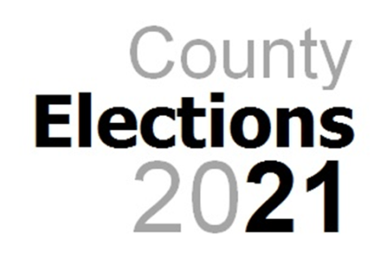


Induction Pack Contents

Congratulations on being elected to serve as a County Councillor for Gloucestershire.

As part of your induction process, this pack has been prepared to guide you through the first weeks and months of your role as an Elected Member.

Please take a few moments to read through this pack. It will help you in the weeks ahead. It contains:

- a welcome letter from our Chief Executive;
- a copy of our Member Induction Programme
- 5 colour-coded forms that it is important for you to complete and return to Democratic Services no later than Tuesday 11th May; and
- practical information to help you find your way to Shire Hall.

Pack Contents

- Welcome Letter from Peter Bungard, Chief Executive

- Councillor’s Check-list

- Councillor’s Code of Conduct

- Declaration of Acceptance of Office (Yellow)

- Register of Interest Form (Pink)

- Member’s Record Form (Green)

- BACS Form (Blue)

- Starter Checklist ( previously P46) Form (White)

- Map with directions to Shire Hall

- Map of Shire Hall

- Member Induction Programme

- Calendar of Meetings: 2021

- Overview of committees

- Division Profiles

- Useful contacts (including your Local Highways Manager)

- Corporate parenting pledge

