Gloucestershire County Council

Establishment of a new 200 place special school
for children and young people aged 4-16 years with
Complex Learning Difficulties (CLD) to open in September 2027

School specification: special free school presumption process

Deadline for applications: 12 noon on 23rd June 2025

April 2025



Section A - Introduction

Under Section 6A of the Education and Inspections Act 2006 (the ‘free school presumption’) where a local authority identifies the need to establish a new school it must in the first instance, seek proposals to establish an academy.

Gloucestershire County Council has identified the need to establish a new 200-place ‘all through’ special school for children aged 4-16 years with Complex Learning Difficulties (CLD) to open in September 2027. This is intended to be a school that will meet the needs of children with a range of complex learning profiles and able to cater for a broad range of needs. A significant number will have communication and interaction difficulties (including autism spectrum conditions) as part of their profile. We have identified an appropriate site in Cheltenham, on which to construct (subject to planning approval) a modern, carefully designed and purpose-built school.

The need to increase the number of special school places is underpinned by Gloucestershire’s Special Educational Needs and Disabilities (SEND) Strategy (PDF, 1.8 MB) 2022-25 and Gloucestershire’s SEND Commissioning Strategy. Gloucestershire County Council consulted widely with schools, parent carer groups, partner agencies as well as the wider public when these strategies were developed and, more recently, specifically on the issue of sufficiency of special school places. There continues to be a high level of support for increasing the number of special school places available in the area as an alternative to making placements out of area and in the independent non-maintained sector.

The following themes were identified as areas of concern and noted by respondents:
- High demand for special school places across Gloucestershire
- Lack of available special school places within the county
- Increasing transport costs and longer journey times due to lack of local provision
- Lack of appropriate facilities and resources in mainstream settings
- The need for a school to be able to cater for a range of needs alongside learning difficulties, including autism spectrum condition, speech, language and communication needs, social, emotional and mental health needs.

It is important to note that until now plans have not been sufficiently developed to include the proposed location of the school other than that it would be close to one of the urban localities of Gloucester and Cheltenham and within easy reach of other parts of the county.
There will be further engagement and consultation with local residents and key stakeholders in relation to the layout and design of the building as part of the pre-planning application activity and during the planning approval process.

Our intention to initiate a free school presumption competition to establish a special school of this type has also been widely publicised through the council’s communication channels; to schools, partner agencies and the public Information has been available on the Gloucestershire County Council website since March 2025.

The authority is therefore seeking proposals from strong, high performing and inclusive academy trusts to open this new school. The school would have a primary designation of Complex Learning Difficulties (CLD).

The pupils would have needs in more than one of the following areas, but not limited to:
- Cognition and Learning
- complex Speech Language and Communication Needs (SLCN)
- Autism Spectrum Conditions (ASC)
  - Challenging behaviour, arising from Social Emotional and Mental Health (SEMH) and/or conditions that impact on emotional regulation
- physical, sensory and medical needs that are commonly catered for within a mainstream school.

A significant number will have communication and interaction difficulties (including autism spectrum conditions) as part of their complex profile. It is not envisaged that children classified as having PMLD will be referred for places at this school. Physical and mobility needs in line with those commonly met within a mainstream school should be planned for.

All special schools in Gloucestershire are part of the Gloucestershire Association of Special School Headteachers (GASSH), which is a school-led association. We would anticipate that the successful academy sponsor will seek opportunities for early collaboration with this existing and well-established partnership.

If you would like further information or wish to discuss your application, please contact:
Nathan Roe, Education Planning Manager
Tel: 01452 427262 Email: Nathan.roe@gloucestershire.gov.uk
or
Tracy Oosthuizen, SEND Sufficiency and Development Manager
Tel: 01452 427200 Email: Tracy.oosthuizen@gloucestershire.gov.uk

Process the Local Authority will follow when assessing proposals

As per the DfE guidance on the commissioning of new free schools, the process will be managed by the Local Authority in consultation with the Regional Director’s office for the Southwest. Following a short-listing and bid assessment process, which will include a face-to-face interview on 16th July 2025, the Local Authority will provide a report to the DfE with the recommended sponsor and the reasons for the recommendation. The recommendation/decision will then be referred to the Regional Director for agreement. The final decision to appoint the trust rests with the Regional Director (in discussion with the Advisory Board) and this is taken on behalf of the Secretary of State. The Regional Director will be making this decision using the Commissioning High-Quality Trusts Guidance July 2023

Assessment

Only applications received by the published deadline of noon on Monday 23rd June 2025 and based on the model Free School Presumption application form (Annex B) documentation, will be considered for evaluation and presented to the shortlisting panel.
All bids received will be evaluated against the criteria set out in the (Annex B) application form and the key criteria set out by the DfE (Annex C), which are;
  - Vision
  - Education plan
  - Capacity and capability

Scoring criteria:
Each criterion is scored using a 4-point scale so that:
0 = The evidence and argument contained in the application is “inadequate”
1 = The evidence and argument contained in the application is “adequate”
2 = The evidence and argument contained in the application is “good”
3 = The evidence and argument contained in the application is “excellent”.

Each section and criterion will be scored equally, no weighting applies.
Shortlisted applicants will be invited to an interview, with a panel constituted by Gloucestershire County Council.

How to apply

Bids must be submitted using the Free School Presumption application form (Annex B). All guidance, criteria and forms can be found at: Free School Presumption application form (Annex B). All supporting documentation prepared by the Local Authority can be found at:
www.gloucestershire.gov.uk/chelt-special-school

Where to send your completed application

The completed (Annex B) application form and any supporting documentation should be sent, by the date set out in the table below, to:

Nathan Roe, Education Planning Manager, Education Planning and Infrastructure, Gloucestershire County Council, Shire Hall, Westgate Street, Gloucester, GL1 2TP
Email: nathan.roe@gloucestershire.gov.uk
Submissions by e-mail are preferred. Applicants are advised to assure themselves of safe delivery and receipt.
Arrangements and timetable for selection and appointment process

Notification e-mails to all trusts, from Premier Advisory Group, that a competition will launch later in the month – ‘Market Warming’: | Monday 7th April 2025
Start of the Free School Presumption competition: | Monday 28th April 2025
Expressions of interest requested by: | Wednesday 14th May 2025
Application deadline: | Monday 23rd June 2025 (noon)
Shortlisting: | Tuesday 1st July 2025 (outcome communicated by Thursday 3rd July 2025)
Interviews: | Wednesday 16th July 2025 to be held at Shire Hall, Gloucester  (likely to be required for 1.5 hours)
Recommendation sent to DfE for final decision: | by Thursday 31st July 2025
Decision by Regional Director (on behalf of Secretary of State): * | September/October 2025

*there is no specified timescale for this part of the process, but it is estimated at six to eight weeks from the LA making a recommendation. Once advised of the Regional Director’s decision the local authority will publicise this information on its website and via other media/communication channels and begin the process of working with the successful sponsor to establish the new school.
The Regional Director for the Southwest, on behalf of the Secretary of State, will consider the Local Authority assessments and recommendations before deciding which academy trust is in the best position to take the new school forward. The decision is made by the Regional Director, who will inform the Local Authority and the successful academy trust of its decision. The Local Authority will feedback the outcome to any unsuccessful applicants.

Section B - The school and the context of Gloucestershire

Our county

Gloucestershire is a large rural county with two large urban areas, several smaller towns and many villages. About 41% of 0-17 year olds live in the two urban districts of Gloucester and Cheltenham. We are currently a two-tier county in terms of local government administration, comprising of a county council and six district councils.

Whilst Gloucestershire is one of the 20% least deprived local authority areas in England, about 11.4% (13,000) of our 0-16 year olds live in low-income households. We are a geographically large and demographically diverse county with differing needs in different localities and contrasting characteristics in terms of affluence, deprivation, and concentration of population across the districts.

There are approximately 660,000 people living within the county, with approximately 130,472 of those being children and young people within the 0-17 age range.
In March 2025 there were 6540 children and young people aged 0-25 with an EHCP maintained by Gloucestershire County Council, with 5169 of these (79%) being in the 5-16 age range.

As a large county we have a considerable number of schools (300 state funded schools) situated within our area. This is made up of 244 primary schools, 41 secondary schools, 12 special schools and three providers of Alternative Provision. Approximately 54% of these are local authority-maintained schools and 46% are academies. The (interim) Ofsted framework introduced September 2024 discontinued single-word Ofsted judgements but as at August 2024, approximately 91% of the children who attend state funded schools in Gloucestershire attended good or outstanding schools.

Type of school and the children it will serve

This is a non-residential special school for boys and girls with Complex Learning Difficulties (CLD) aged 4-16 years. As a school with a primary SEND designation of CLD the school will be well equipped to meet the needs of children with a range of coexisting needs. The interplay between the needs will result in the children presenting with a complex profile of need.

The school will provide long-term special education provision to meet the needs of children with significant, complex and pervasive special educational needs including, but limited not to, more than one of the following:
- Cognition and Learning difficulties;
- Complex Speech Language and Communication Needs (SLCN);
- Autism Spectrum Condition (ASC);
- Challenging behaviour, arising from Social Emotional and Mental Health (SEMH) and/or conditions that impact on emotional regulation, for example, phobias, habit disorders, anxiety and depression;
- Hyperkinetic disorders, for example disturbance of activity and attention;
- Attachment needs, for example children who are markedly distressed or socially impaired as a result of an abnormal pattern of attachment to parents or care givers;
- Those living with trauma arising from traumatic experiences, Adverse Childhood Experiences (ACEs) or persistent periods of abuse and neglect;
- The school would be expected to be able to meet additional physical, sensory and medical needs alongside those (primary) needs listed above, especially where they are of a nature typically accommodated within a mainstream school.

It is not envisaged that children classified as having PMLD or those with physical disabilities as a primary need will be referred for places at this school.

A significant proportion of the cohort may have social care support under Early Help, S17 or S47 of the Children’s Act or may be looked after or adopted. A deep appreciation of how to support these children, and their families, is required.

Some of the pupils may be at risk of sexual exploitation, and they may present with harmful sexual behavior making them vulnerable to becoming both victims and perpetrators of peer-on-peer abuse. Pupils will have significant barriers to learning, may have experienced a disrupted pattern of education and will be at risk of disengagement from learning. Their needs may not have been fully and successfully met in previous school settings.

Where the school is to be located

The council will fund the design and delivery of a brand-new school building on land at Arle Road, Cheltenham. The site can be identified by the postcode GL51 8LB and Northing: 222986/Easting: 393418. The site is in GCC ownership and was previously used for educational purposes by the now closed St Benedict’s Catholic School. It is well situated centrally within the county, close to where there is the greatest level of demand for special school places (as shown in figure 1 below) and within reach of other parts of the county. The green triangle shows the location of a 200-place special school in Gloucester that is currently in the pre-opening phase (set to open in January 2027) and being established by the County Council through the same free school presumption route.

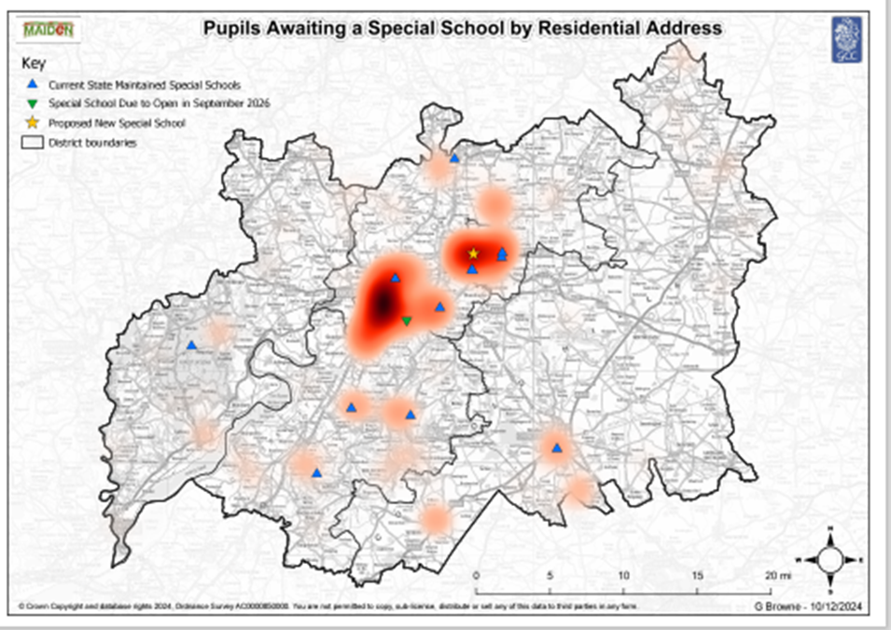
Figure 1 – geographical concentration of need

The location of the intended site is shown in the maps (figures 1 and 2) below.
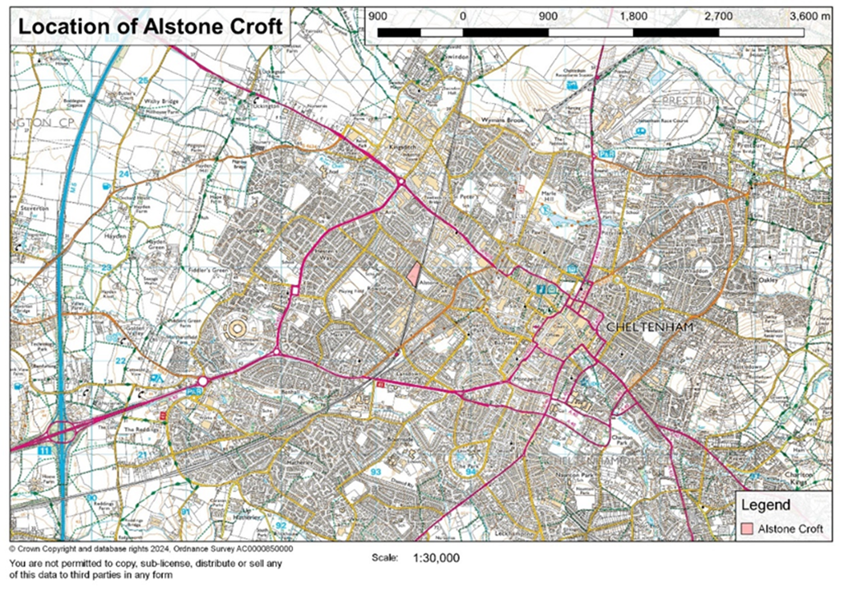
Figure 2 location of the site within Cheltenham

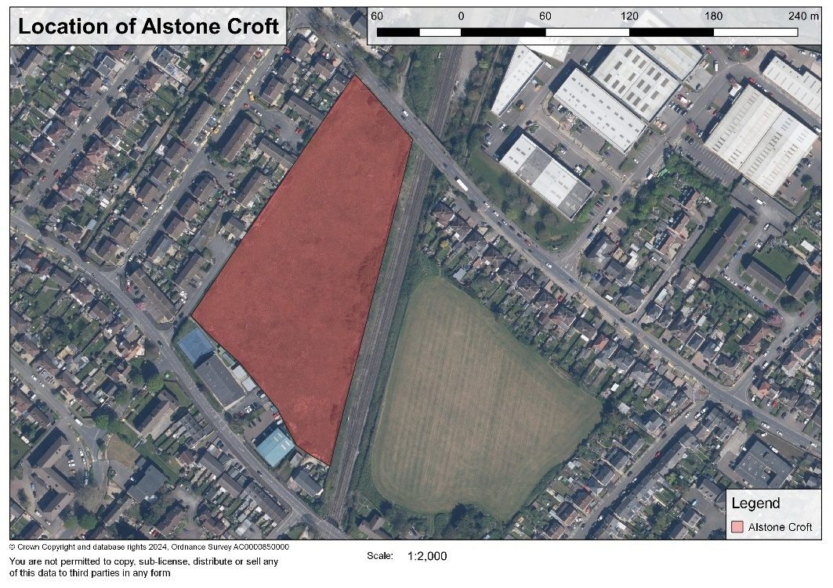
Figure 3 location of the site in relation to other features

The proposed site for the school is in a mature residential area in Cheltenham and is adjacent to The St George’s Centre (one of the centres assigned to The Altus School, a Pupil Referral Unit) to the south and a railway line to the east. It is approximately 1.5 miles from the centre of Cheltenham, 9 miles from the centre of Gloucester, 15 miles from Stroud and 16 miles from Cirencester. The nearby North Cotswold towns of Winchcombe, Bourton-on-the-Water, Stow-on-the-Wold are 8, 17 and 20 miles away respectively. Junctions 10 and 11 of the M5 are both approximately three miles away and Cheltenham Spa railway station is less than a mile away.

The academy trust that is appointed will be fully involved in the design stages of the building. However, some of the early and initial planning work will already be at an advanced stage by the time the Regional Director confirms the appointment, which is anticipated to be towards the end of October 2025. We will be working towards a planning application being submitted later this year, a completion and handover of the building in June/July 2027 with a view to the school opening as an institution in September 2027.

Close and careful liaison with local residents on the part of the academy trust, beyond the minimum requirements of the statutory Section 10 consultation, is required from an early stage, throughout the planning approval process and ahead of opening owing the proximity of residential properties. Local residents, along with the GCC divisional councillor for the area, should be viewed as key stakeholders.

Pupil capacity

When fully open and operational the school will offer 200 places, with the scope for modest expansion in the future (subject to the necessary approvals) being factored into the design and build where possible.

Proposed admission arrangements

Admissions will be determined by the Local Authority’s SEND Panel. All pupils will have an Education Health Care Plan (EHCP). The Local Authority will consult with the school before deciding to name it in the child’s EHCP (SEN Code of Practice 2015, paragraph 9.80). The trust will need to work in close collaborative partnership with the Local Authority in order to receive, consider and respond to referrals for places several months before opening, even though this may be before the appointment of the Principal Designate. The Local Authority would expect places to be available up to the number it has commissioned and a willingness on the part of the school to discuss the commissioning of additional places as the need arises.

Whilst it is anticipated that the building will be completed and handed over to the trust in June/July 2027, it is recognised that time needs to be invested in pre-opening mobilisation activity, high quality workforce development and individualised and carefully planned induction and transition planning for pupils. However, we expect the school to admit its first pupils no later than the end of October 2027 (the end of Term 1). It is not envisaged that the school will be full until the start of the academic year 2029/30. How the trust proposes to achieve this in a manageable way will be a key theme to set out the application and explored at interview.

The need to admit a new pupil could occur at any point within the year and flexibility on the part of the school is required. The sponsor will be required to abide by the Codes of Practice on Admissions and Special Educational Needs and admit any child whose EHCP names that school (after consultation with the school or as a result of direction to name the school by the SEND Tribunal or the Secretary of State).

Out of hours and ‘wrap around’ provision

To provide sufficient support for working parents, out of hours provision is a key priority for Gloucestershire County Council. Whilst there may not be dedicated accommodation provided for these facilities, it is anticipated that there will be the potential for these to be provided within the main school building and we would expect the school to secure opportunities for before-school and after-school provision where practical to do so. We would like to see a willingness on the part of the school to work in partnership with a local childcare provider to ensure before and after school provision is available if there is parental demand and if the school cannot accommodate this themselves.

It is important that the academy trust appointed to run the school works in partnership and collaboratively with the nearby schools, the other special schools in Gloucestershire (especially the neighbouring St George’s Centre) and the wider community to enable access to the school’s facilities, where practical and through a formalised agreement, when not being used by the school and for the benefit of the wider community. This arrangement may need to be formalised at an early stage of the process through a Community Use Agreement, or equivalent arrangement (such as that recommended by Sport England) if required.

Transport arrangements

The majority of children and young people who attend the school will travel to and from school using Local Authority arranged multi-occupancy taxis and minibuses. There will be some who do not qualify for transport assistance, who will travel to and from school by a different means. A close working relationship with Gloucestershire County Council’s Home to School Transport Team will need to be developed at an early stage and it is expected that the school will contribute to a detailed travel plan as part of the planning approval process. There is an intention, to ensure that all pupil pick-up and drop-offs occur within the school grounds to avoid taxis and minibuses waiting on the nearby roads.

Character/ethos of the school

It is expected that the school will:
- be welcoming to pupils of all world views, faiths and of no faith. The school will be sensitive to the cultural and religious views of all pupils and parents whilst preparing them for life in modern Britain;
- have a strong educational vision and a curriculum delivery based on high aspirations and standards for attainment and progress at all key stages, personalising the learning pathways for those who need this;
- plan carefully, thoughtfully and in a person-centred way for pupils’ transition into and from the school, risk assessing and pre-empting the full range of factors that might undermine the success of the placement;
- have a commitment to excellent outcomes and a high quality of teaching and learning based on well researched and validated pedagogy;
- have strong trauma informed practice underpinned by a deep appreciation of the impact Adverse Childhood Experiences (ACEs) can have on children’s learning. Gloucestershire is an ACEs informed county;
- be inquisitive about the needs of the children and young people who attend the school, and exercise curiosity in understanding the factors that influence the presenting behaviours and barriers to learning, seeking creative and innovative solutions;
- respond and adapt its offer as the needs of a child changes;
- be able to work in partnership, and take a coordinating role where required, with wider services (e.g. social care, health, police, and other schools) to enable each child to progress and succeed as set out in paragraph 1.37 of the SEND Code of Practice;
- plan for appropriate engagement with the local community, other schools, and parents from the earliest stage;
- be a learning environment in which physical intervention is rarely required;
- be a learning environment in which exclusion is almost never considered as a response to incidents of poor behaviour and in which a restorative approach is taken. Please provide information about the exclusion rates in the schools your trust runs and how these compare with other schools in those areas;
- be a learning environment in which part timetables are rarely used and in which high rates of school attendance are secured. Please provide information about the attendance and absence rates in the schools your trust runs and how these compare with other schools in those areas;
- work in partnership with parents to build trusting and mutually supportive relationships, planning carefully how to achieve this for parents who have had less positive working relationships with previous schools and those who live some distance from the school.

Section C - Vision

Applicants should take account of the relevant criteria in Annex C of the Free School Presumption Guidance.
Please ensure you include the following:
- A strong educational vision and a curriculum delivery based on high standards of attainment for each key stage;
- Plans for appropriate engagement with the local community, other key stakeholders and parents during the pre-opening period and any on-going engagement;
- Excellent support arrangements to meet the needs of all children, including children in care, those who have been adopted and those on the edge of care;
- Excellent support arrangements to meet the needs of all children, including those with non-binary gender identity;
- Excellent support arrangements to meet the needs of children with English as an additional language, those newly arrived in the UK and refugee and asylum-seeking families;
- A commitment to excellent outcomes and high quality of teaching and learning, informed by the soundest pedagogy and which actively plans for over-coming identified barriers to learning and the additional challenges this group of learners face;
  - How children and young people will be supported to include within mainstream settings for part of the week, where this is appropriate, and ultimately returning to mainstream school sor transition to mainstream Post 16 provision;
- How alternatives to exclusion will be developed and how regular school attendance will be promoted;
- How mainstream schools in Gloucestershire will benefit from the expertise of staff working at this school;
- How the school will take a central and coordinating role in effective partnership working amongst the multi-disciplinary team supporting the children and young people who attend and their families;
- How the school would personalise the learning programme for children who need it;
- How a sense of belonging and community will promote regular school attendance and address persistent absence;
- How the school will work holistically and in partnership with parents through, for example, the provision of a Family Support Worker;
- How the school will secure input from and work effectively alongside allied health professionals and therapists in order to meet the complex needs of its pupils, especially where resources may not be available from the local health trust.

Section D - Education plan

Applicants should take account of the relevant criteria in in Annex C of the Free School Presumption Guidance.
As a minimum please ensure you include the following:
- Approaches that would be used for measuring pupil performance effectively and setting challenging targets;
- Details of an ambitious, broad and balanced, deliverable curriculum plan, which is consistent with the vision and pupil intake and equips pupils to attain vocational qualifications as well as more traditional academic qualifications. The information provided could include a curriculum table and pupil build up chart;
- Approaches that would be used for baselining, measuring and tracking other skills, e.g. resilience, social skills, self-esteem, so that next steps can be identified and progress can be demonstrated;
- The philosophy underpinning the approach to behaviour management;
- The approach to be taken in ensuring strong trauma informed practice underpinned by a deep appreciation of the impact Adverse Childhood Experiences (ACEs) can have on children’s learning.
- A staffing structure that will deliver the planned curriculum within the expected income levels, with a focus on outstanding teaching (including strategies for effective performance management) and staffing to provide (non-intensive) therapeutic intervention as part of the school’s core offer. This could also include an organogram and staff build up chart;
- The approach to ensure that the needs of all children are fully provided for and how the school will be fully inclusive, thinking particularly about therapeutic intervention and support for families;
- How the school will work proactively with parents to support them to meet their responsibilities in securing their child’s regular attendance at school and reduce persistent absence;
- Details of enrichment and extended services, for example, breakfast clubs, sports clubs, homework clubs and music and art clubs;
- The school’s approach to: PHSE; the Prevent Duty; Safeguarding and welfare; and promoting fundamental British values (democracy, the rule of law, individual liberty, mutual respect and tolerance of those with different faiths and beliefs)
- Detailed information about school’s approach to all aspects of safeguarding.

Section E - Capacity and capability

Applicants should take account of the relevant criteria in Annex C of the Free School Presumption Guidance. As a minimum please ensure you include the following:
- The resources you would draw upon and/or deploy to support the development of the new free school by the opening date;
  - Clear evidence that you have the range of skills and abilities necessary to set up and then run a school effectively, including: managing school finances, leadership and governance, project management, marketing and community engagement, human resources, safeguarding and health and safety;
- How the school would be organised as it grows to full capacity and what the governance arrangements would look like, both at a school and Trust level, including a diagram of the proposed structures.
- Experience the trust has in establishing other new schools.
In addition to this, applicants who already run or lead more than one school should also provide a brief overarching vision for your trust, including:
- The number and types of any academies, free schools or independent schools you currently manage, or have in the pre-opening phase;
- The number and types of any state-maintained schools you lead;
- Your planned expansion strategy (including how many schools you plan to have in total, your planned geographical spread and timelines), and a summary of any discussions you have had with the relevant Regional Directors about this and information on how this new school forms part of that vision;
- Please provide information about the exclusion and suspensions rates in the schools your trust runs and how these compare with other schools in those LA areas;
- Please provide information about the attendance and absence rates, including the use of part time timetables, in the schools your trust runs and how these compare with other schools in those LA areas;
  - Please provide information about the reasons cited for children leaving the schools your trust runs, including where Elective Home Education is given as a reason, and how this compares with other schools in those LA areas;
- The Trust’s approach to and track record in redressing social disadvantage

Section F - Funding and costs

The Local Authority will fund the delivery and design of a suitable, new and thoughtfully designed school, funded from its High Needs and Basic Need Capital Grants. Gloucestershire County Council’s cabinet has approved an allocation of £20m to support the delivery of this new special school. The overall construction budget will include an allowance for furniture, equipment and ICT, for the trust to procure.

The DfE currently provides £25,000 for legal expenses to the successful sponsor, paid to the Trust in the pre-opening phase. The Local Authority will provide to the school a one-off lump sum of £125,000 as a contribution towards start-up costs. This is intended to be used towards costs such as, but not limited to:
- Funding salary costs of the designated head teacher, admin and finance support prior to opening;
- Recruitment and interview related costs;
- Any other incidental costs.
and would be paid to the Trust a term before the school admits its first children (based on a three-term year). It will be up to the trust how to use these funds. No further one-off funding prior to opening will be payable and any unspent funds can be retained by the school. Trusts will need to familiarise themselves with the differences between the funding models of the DfE directly delivered free school projects and the LA led presumption route free school projects.

The school will be provided with land and a building owned by the Local Authority and leased to the academy trust on a 125-year lease. The academy trust will be responsible for the ongoing maintenance and repairs of the facilities.

The school will receive the nationally agreed base place funding per pupil (currently £10,000) from the Education Skills Funding Agency. Top up funding will be provided in line with all other special schools in Gloucestershire using the new universal banded funding model that is in place currently (Bands 1 to 7) to identify a top-up amount, dependent on the assessed needs of the individual student. An annual audit takes place to ensure top funding is appropriate for the level of need of pupils. The current banding (top-up) rates in operation for special schools are:
Table 2: Current banding rates

Banding | Amount for financial year 2025/26
Band 3 | £2,245
Band 4 | £8,421
Band 5 | £14,696
Band 6 | £26,197
Band 7 | Bespoke arrangement where needs and provision exceed the Band 6 descriptors

The Trust will receive base funding for 80 places (i.e., £10,000 x 80 = £800,000 pro rata)
during the first year (September 2027). Base funding will increase to 150 pupils at the start Year 2 (September 2028) and 200 at the start of Year 3 (September 2029). The ESFA will only provide the base funding to the school up to the number of children it is intended will be placed in any given year and any further funding will be provided by the LA as start-up funding for the school (on opening) to address diseconomies of scale as the school builds to capacity at Year 3 (September 2029). Please see Table 3 below for further detail about the proposed funding model over the first three years, which will inform the funding balance between the ESFA and the LA.

Whilst there is a pressing need to increase the sufficiency of special school places at the earliest point that is practically possible, the Local Authority would wish to work collaboratively with the successful trust to determine the build-up rate in a way that is manageable for both parties and best meets the needs of the pupils.

 | Year 1  Sep 2027  (start of Term 1 | Year 1  Jan 2028  (start of Term 3) | Year 1  Easter 28  (start of Term 5) | Year 2  Sep 2028  (start of Term 1) | Year 2  Jan 2029  (start of Term 3) | Year 2  Easter 29  (start of Term 5) | Year 3  Sep 2029  (start of Term 1)
Number of pupils | TBD between LA and Trust | TBD between LA and Trust | TBD between LA and Trust | TBD between LA and Trust | TBD between LA and Trust | TBD between LA and Trust | 200
Base funding | Base funding equivalent to 80 places totalling £0.80m pro rata |  |  | Base funding equivalent to 150 places totalling £1.5m |  |  | Base funding for 200 commissioned places totalling £2.0m (£2.0m from ESFA and £0.00m from LA)
Banded top ups from LA | TBD between LA and Trust | TBD between LA and Trust | TBD between LA and Trust | TBD between LA and Trust | TBD between LA and Trust | TBD between LA and Trust | 200 x banded top-ups from LA

Section G - Impact and equalities assessments

As prescribed by Section 9 of the Academies Act 2010 and Section 149 of the Equality Act 2010, the Local Authority must assess the potential impact of any new school on existing educational provision in the area. The Local Authority must also consider whether the new school would impact on any groups with protected characteristics.

The school will be commissioned to provide places for children and young people aged 4 – 16 years) with Education Health Care Plans (EHCPs) whose needs cannot be met within a mainstream school. The addition of this school to the Gloucestershire educational landscape is unlikely to impact adversely on mainstream schools in the area. In fact, it is envisaged that the school will become another source of specialist advice and expertise that nearby mainstream schools can draw upon.

The establishment of this new school is unlikely to adversely impact on existing special schools given that the demand for placements is so high and, based on our analysis, is set to remain so. Existing special schools are at, or close to, capacity with very limited options for further expansion.

Whilst the school will be responsible for its own compliance with equalities legislation and the formation and lawful implementation of policy in this area, it is not considered that the establishment of this new school will impact particularly on people with protected characteristics. Some of the children and young people who will attend the school will likely fall within the definition of disabled as set out in the Equality Act 2010. The impact on the learners of Gloucestershire who require this type of SEN provision (and have complex SEND needs) will be a positive one. The establishment of this school will enable them to have their identified and complex special educational needs met closer to home and in the county in which they live, without the need to travel often long distances out of area.

Mid 2023 Population Estimates, ONS
Households with incomes below 60% of the median income in a base year (2010/11), adjusted for inflation
Fingertips, OHID
Mid 2023 Population Estimates, ONS

