
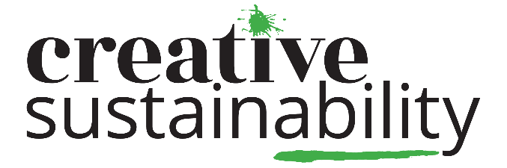
Feedback on Gloucestershire Climate Action Plan from Gloucestershire Youth Climate Group
October 2024

Introduction:
Gloucestershire Youth Climate Group is a youth led programme for 16-25 year olds who live, work or study in the county that are passionate about sustainability and the climate. Young people come together through opportunities to; lead climate action in their community, take part in fun activities/trips, have their voice heard through consultation on county council policy, participate in/act as youth voice representatives in decision-making spaces in the county and more. The group is run/facilitated by Creative Sustainability and is a partnership project with Gloucestershire County Council. More information on the group can be found here – https://cscic.org/programmes/gycg or contact Polly Gannaway-Pitts at: polly@cscic.org.
The group has previously submitted consultation feedback on Gloucestershire County Council’s Climate Action Plan in 2022 and 2023. In previous years, consultation has explored all 8 themes (*more information/links to previous submissions can be found at the end of this document). The group have consulted with a total of 3,254 young people in the county about Climate Change between 2022-24 (2,778 young people through ICN Youth Climate Action Survey Gloucestershire 2022 and 476 young people about the GCC Gloucestershire Climate Action Plan 2022-24).
This year, the consultation has been focused on starting to facilitate deeper conversations and understanding on three themes identified by young people; Buildings, Land Use and Transport. 77 young people aged 16-25 from Gloucestershire have taken part in facilitated activities and discussions developing/deepening understanding of the GCC Climate Action Plan themes and supported to give feedback and ideas. The report has information on consultation process, a one page infographic overview and has then been broken down into the same sections as the Climate Action Plan and their subheadings. Each of those section includes:
- Summary key findings from 2022 and 2023 consultation feedback
- One page infographic summary of key findings from 2024 consultation feedback
- Subheadings under each theme (and which GCC CAP actions these are linked to)
- Individual comments from young people recorded (split into either feedback or suggestion). If they do not fit into CAP subheadings they have been listed under ‘other’.

Consultation Process/Methodology Summary:
The GYCG Facilitator, GCC Sustainability Team collaborated to design interactive and engaging sessions to collect feedback. 3 online sessions plus an in person session for the GYCG Panel on these themes.
- First step, we did a reflection with young people on what feedback had been put forward in previous years and some discussion on what actions were being taken by GCC through the Climate Action Plan to respond to/meet the needs of the feedback raised. This is to avoid young people feeling like they are in ‘consultation/feedback loops’, address needs they have expressed to us in consultative processes and to develop understanding and awareness of the vast, complex and evolving GCC Climate Action Plan policy.
- We then brought in staff member working on specific theme area. They shared how the CAP was being delivered in their specific work area, could answer specific questions etc , or if in person, did a practical activity linked to theme which supported in facilitating conversations alongside Gloucestershire County Council staff member(s).
- Conversation together to gather ideas (with GYCG facilitator, GCC staff member and young people), with clearly worded and broken down subheadings under each theme – young people had different ways in which they could give their feedback (through jamboard, in discussions, through online chat functions, in groups, solo etc).
Young people also attended and took part in one online and one in person session as part of Gloucestershire Local Nature Recovery Strategy Public Consultations. Through these sessions, we gathered feedback from 22 young leaders. We also did additional consultation on the chosen themes with 55 young people who attended our ‘What Can I Do?’ Event – through facilitated conversation, post it notes and linking to the event’s workshop/programme.
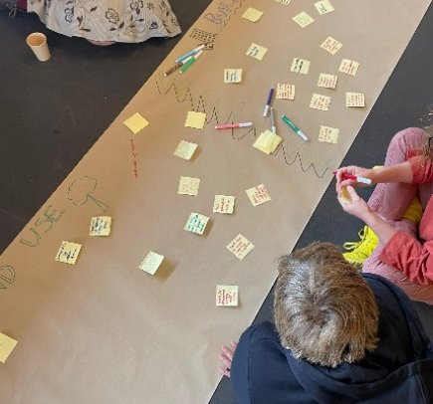
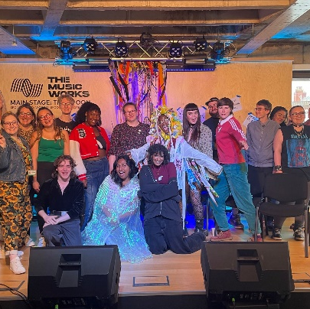
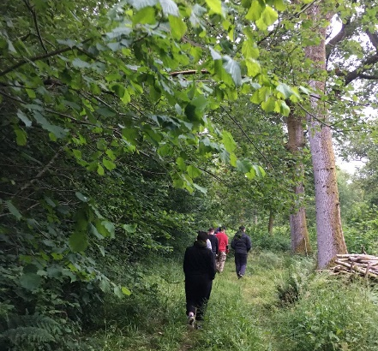
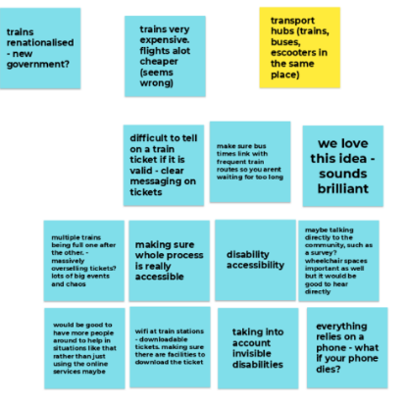
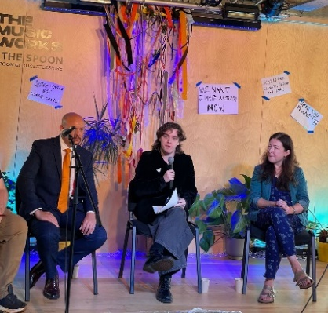

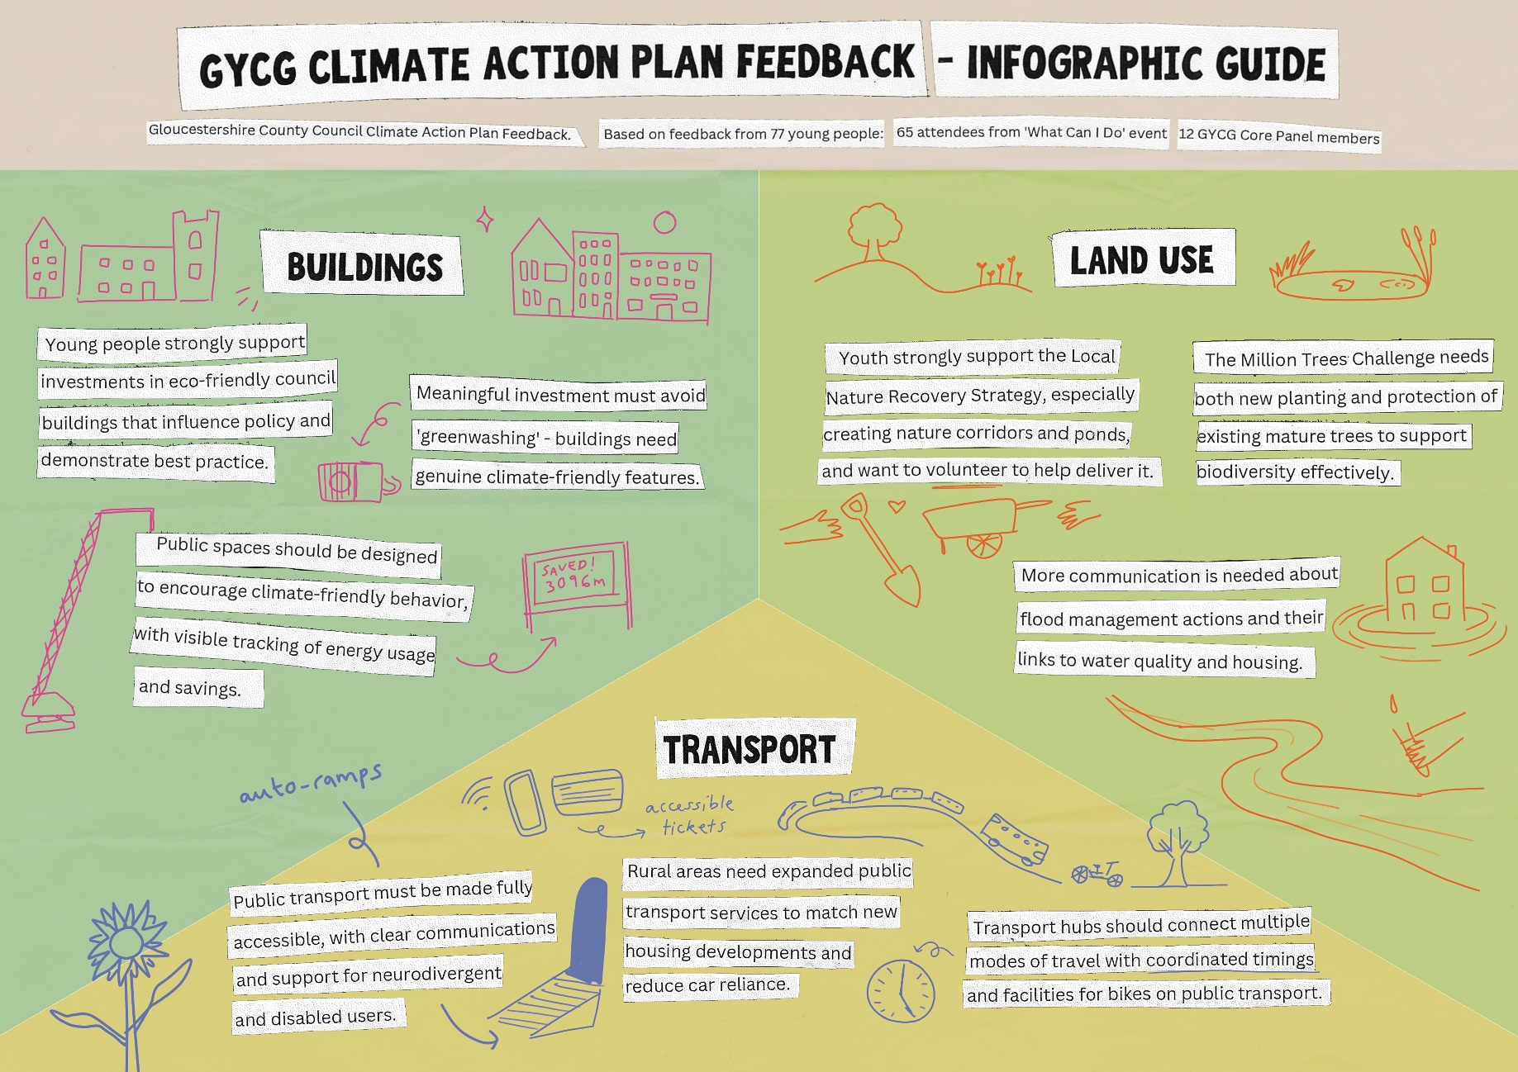
Infographic Summary of 2024 Consultation Findings

2024 Feedback: Buildings
What have young people said in previous years consultation? (2022+2023 Consultation main points summary):
- Behaviour Change: Young people have said key behaviour change focus should be building energy usage behaviours. They want to see awareness campaigns encouraging mindful use of gas/electricity. When surveyed, those young people already taking action, (or those asked what action they are willing to take), the top answer was to ‘Reduce Energy Use’. (Interclimate Network Survey Gloucestershire 2022).**
- Retrofitting: subsidising retrofitting measures, allowing listed buildings to be made more energy efficient and local authority to produce a guide for building owners/landlords to make retrofit changes.
- Housing: Although residential housing matters sit outside of Gloucestershire County Council’s remit (therefore is not discussed in the Climate Action Plan), young people have been keen to give feedback and discuss this topic. This highlights; it is a key discussion point young people want to be more heard on, the difficulty they have in identifying and navigating which relevant local authority they should approach with feedback and a need for a mechanism which ensures that this feedback is passed forward and shared to the relevant local authority/stakeholders.

2024 Consultation key points summary:
- Investments into making new council owned public buildings developments eco-friendly and energy efficient is supported: with a highlighted need for this to be done utilising a variety of methods. This process is seen as an opportunity to upskill building professionals and to influence policy and good practice.
- Linking installing Heating Decarbonisation and design of new public spaces to human behaviour change: Ensuring spaces are set up to encourage climate friendly behaviour. Collecting and publicly showing data on current usage of resource and what has been generated/saved through retrofitting and informing. Including and empowering everyone within a public space to consider and take action.
- Meaningful change in public spaces which is supported by leadership: Young people have highlighted the importance of meaningful investment in new buildings to ensure they are as climate friendly as they can be (raising an awareness and concern of ‘greenwashing’ in these processes). They also discussed the importance of leaders in local authority/public building spaces to support changes and carefully consider impact of their work as part of this process.

‘New Developments of Eco-Friendly Buildings (of council owned public buildings)’
Action 2.1 – All new developments support the move to zero carbon and improve resilience
Action 2.2 – New developments including sustainability aspects including Brockworth, Bishops Cleeve, Leckhampton, Wyatt House and Warden Hill
Feedback | Suggestion
Patch of land next to Leckhampton school will have housing on it and this has been flood audited. Good that they are building more houses and they are doing that in an environmentally friendly way | More windows and open areas so less artificial lighting is used
Make all buildings in the UK energy efficient | Greywater treatment systems – irrigation and toilets
All new builds have solar roofs | Builders changing materials legislation to stop bad materials
Eco friendly insulation | Train young builders about alternative materials that are sustainable
More investment in eco architecture but not greenwashing or eco-facism ideology | Encourage more roof planting projects on new buildings
Green moss on buildings and green clad building/walls

‘Heating Decarbonisation (within retrofit)’
Action 2.3 Decarbonisation of buildings
Action 2.4 Develop Heat Decarbonisation Programme and seek funding
Feedback | Suggestion
Retrofit is important | Rewards for keeping energy usage below a certain level (way to incentivise prioritising thinking about energy use)
There is a need to ensure those in charge of buildings (directors, execs, headteachers, site managers etc) are behind the changes and behaviour change | Visual showing (in entrance of building for example) – where it shows monthly, weekly, daily usage. Getting people to be more mindful and aware. Showing what has been generated or saved through retrofitting/solar panels and the positive impact
Good that all senior managers at GCC are being asked to consider how climate change is being considered in their department
Timed heating

Other
Topic | Comment
Housing (Structural – e.g Net Zero/Energy Efficiency/Retrofit) | Make all buildings in the UK energy efficient, (starting with social housing)
 | All new build flats have recycle shoots put in to increase recycling
 | All new builds have solar roofs
 | Heat pumps in all new homes
 | Net zero homes
 | Larger gardens
 | ‘affordable’ housing is made out of low quality materials and too rushed
 | Centre for alternative energy model in Glos
Housing (Models/Funding/Social Housing) | Container houses for single people (like KWMC Bristol)
Housing (Models/Funding/Social Housing) | Legalise squatting. Invest in social housing we need waaay more. 50% if housing in the uk to be co-operatives.
Housing (Models/Funding/Social Housing) | Funding for housing co-operatives
Housing (Models/Funding/Social Housing) | Social housing needs radical improvement. Built in a way that is not detrimental to human health. Mould free and energy efficient
Residential Building Ownership | Mandatory landlord training to help them understand their responsibility
Residential Building Ownership | Second home taxes for houses owned by landlords

2024 Feedback: Land Use
What have young people said in previous years consultation? (2022+2023 Consultation main points summary):
- Community/Youth Action: Young people identify importance of considering Land Use in Climate Action (ranked 3rd most important GCC CAP in 2023 consultation). ‘Helping to improve and protect nature’ came in top 5 actions young people are willing to support – but only 35% of those taking action are doing so in this way. (Interclimate Network Survey Gloucestershire 2022)***. Young people have expressed in conversations with us that they want more opportunities and support to take action in this area.
- Million Trees Challenge: Has lots of support from young people we have spoken to and they are keen to get more involved with supporting GCC in achieving this aim.
- Greening Communities and Urban Spaces: Take every opportunity to incorporate innovative green spaces (public growing projects, allotments, urban gardening, rooftop gardens). Lots of conversation about positive benefit for not only planet, but also people’s wellbeing

2024 Consultation key points summary:
1. Key interest in Biodiversity subheading and support of Gloucestershire Local Nature Recovery Strategy aims outlined in consultation period: particularly creation of nature corridors, ponds and supporting/reintroducing specific habitat. Young people want to help deliver this through supported volunteering opportunities and have also highlighted they want better access to being in local nature spaces. They have said this will develop appreciation/understanding of biodiversity/nature and support their mental wellbeing
2. Continued support for Million Trees Challenge and advocation for protecting mature trees: Young people continue to support planting of new trees, identify the importance of ensuring resource is there to care for million trees and have also raised the importance of protecting existing mature trees in the county due to the benefits they bring in supporting biodiversity
3. Want more understanding about Flood Risk Management actions being undertaken: advocating for more outreach on this. Also asking if considerations/links have been made on water quality and housing development. Asking what indirect influence GCC has on these two areas and if/how discussions are happening on those two topics.

‘Flood Risk Management’
Action 7.1 – Flood risk management and sustainable drainage schemes
Feedback | Suggestion
Not sure/haven’t heard about what is being done – can GCC do more outreach on this? | Work with GRCC – flood warden scheme
Beavers are important | Does GCC have any control/influence over water companies using overflows and polluting rivers?
Trees as a natural flood risk management | Concerns about water pollution
 | Limiting building in floodplains and building in other places instead

‘Tree Planting’
Action 7.2- Gloucestershire Tree Strategy – increase tree canopy cover to 20% and plant 1 million trees
Feedback | Suggestion
Protecting larger older trees as well as planting new ones | Who looks after the trees in the long term? is it land owner or GCC? (raised scenario where Gloucester City Council Trees planted died due to lack of resource in place to do care/maintenance)
Protection of older trees | More protected wooded areas (eg westonbirt)
Is there any initiatives GCC are involved with around protecting existing woodlands? | Is GCC on target to plant a million trees? If not, how can we help?
Planting trees that have qualities that will allow them to grow in the conditions they are being planted in (eg goat’s willow) | Is finding land and permission a barrier?
Planting climate resilient trees | Trees take up less C02 the older they get – cutting timber when trees reach said point
Considerations to impact of Ash Dieback (Devon has ash dieback resilience forum)
Creation of emergency tree plan – (want to highlight it more?)
Woodland Trust recommend creating an emergency tree plan, showing where trees are going to be planted and how they will be managed

‘Biodiversity – habitat, species and conservation’
Action 7.4 – Development of Gloucestershire’s Local Nature Recovery Strategy with the LNP
Action 7.5 – Research projects to increase and enhance biodiversity
Action 7.8 – Design and deliver a Biodiversity Week in line with the recent council motion of Biodiversity
Feedback – | Suggestion
7.4 - Local Nature Recovery Strategy
Connectivity between fragmented habitat – wildlife corridors | Learning from future generations act
Nature corridors: wildflowering, allotments, orchards | Health benefits of the community isn’t part of legal scope of LNRS plan – why has that decision been made nationally?
Reintroduction of species through LNRS is supported by GYCG | Will there be further legal framework/funding to focus on nature for mental health?
Introducing new animals/species to the county | Need more research and data on state of water quality in county – people know its bad but not understanding of how bad due to lack of data. – support to do this more.
More wildlife – hares, rabbits, otters, beavers | Improving soil health on farm land
More birds, mammals, insects. Otters, wolves, bears! | Soil health education for farms
ponds
Ponds important – more ponds
More water – streams, rivers, lakes, ponds
LNRS – sustainable farming practices important
Like the LNRS map
LNRS – interactive map was engaging
LNRS map was difficult for me to look at/decipher different colour coding due to being colourblind
Found LNRS public consultation hard to follow – some technical language. Lots of ‘experts’ / elected reps in the room
LNRS – young people felt like guidance from central govt was lacking
GYCG keen to learn more about LNRS work and to help with implementation how they can
7.8 - Biodiversity Week / raising awareness and behaviour change
More urban greening | Urban spaces – bus stop/roofs – solar power or gardens on top
Parks and green spaces
More green spaces and community gardens
Encouraging gardening for wildlife
Commissioning art to raise awareness about biodiversity loss and protection of nature – support to do more of this.

Other
Topic | Comment
Farming | Farming revolution – we need to invest in small scale local growers and farmers. Divest from ecologically harmful agricultural companies and make the UK pesticide free
Farming | Land justice now! All land should be in common ownership and its use should be decided upon by the local people through direct democracy models like ‘peoples assemblies’
Farming | Sustainable agriculture – lower meat production
Farming | Planting towers – reduce area of land and volume of water needed for farming
Housing Developments | Protecting nature over new developments
Housing Developments | More care in planning where houses go and how they are built – considerations to nature and biodiversity.
Access to Nature/Land Ownership | Youth club on canal in Gloucester – connecting young people from city to nature
Access to Nature/Land Ownership | Residential camp opportunities once a year that are inclusive, can go with my friends and connect to nature
Access to Nature/Land Ownership | Right to roam
Access to Nature/Land Ownership | Tackle lack of access to nature spaces and barriers to entry (e.g Bathurst Estate Cirencester)
Access to Nature/Land Ownership | Concerns about access to nature
Access to Nature/Land Ownership | Free open spaces for all

2024 Feedback: Transport
What have young people said in previous years consultation? (2022+2023 Consultation main points summary):
1. Behaviour Change: Young people already taking active travel/public transport options or willing to do so as an act of climate action ****. Young people ranked transport as second most important of GCC CAP themes in prioritisation exercise done in 2023.
2. Young people’s experience of Public Transport and Active Travel provision in the county is overall poor: Concerns about affordability, reliability, consistency, safety, convenience across active travel and public transport across the county. Young people in rural areas that don’t have any public transport service at all. Financial and lack of maintenance knowledge barriers to access cycling. Support for £2 bus fare scheme and research/projects happening on air quality, agreement that ensuring less transport emissions is key to improving air quality.
3.EV Charging Infrastructure: support for public vehicles, but deprioritise plans for private vehicles: First step young people want to see is ‘getting public transport sorted’ by addressing concerns listed above- which will enable behaviour change. Steps to make public transport vehicles/public service vehicles electric is supported. Infrastructure for private EV vehicle charging should be deprioritised, due to ownership of EV’s not being accessible to most (especially young people) and wanting more focus to be on behaviour change: getting people out of personal vehicles and into public transport/active travel methods instead – maximum resource saving.

2024 Consultation key points summary:
1. Support for Multi-Transport modes/shifting transport modes: Support in creation of transport hubs and ambition to encourage and connect multi-transport modes together: highlighting need to ensure times line up and facilities in place on public transport veichles to enable active travel/public transport use in same journey. Supporting work being done to collaborate with orgs in community (public health, nhs etc) – cargo bikes and identifying this collaboration is important
2. Accessibility needs key concern on public transport services: structural needs, ticketing, communications on services that are inclusive of neurodivergent and other disability needs, support from staff, safety + consultation and collaboration with community/those with accessibility needs
3. More provision for public transport access in rural areas: noting increase in new build housing/development but public transport service not meeting new demand/offer alternative to private transport, support for robin service (identified ways to improve and need for expansion). Lift share schemes and sharing/incentivising using eco friendly taxis rather than getting a lift in a petrol car
‘Local Public Transport Plan’
Action 3.3 Local Transport Plan
Action 3.6 Business Transport
Action 3.8 Arle Court Transport Hub
Action 3.9 Bus Service Improvement Plan
Feedback | Suggestion
3.9- Bus service experience – reliability timing needs
Public transport isn’t consistent/regular enough, especially rural areas | Need to make public transport quickest and easiest form of travel
Buses are late or early – not helpful
More buses on Sunday mornings my earliest is 9.30am
Better public transport across Cotswolds
3.9- Rural Transport/Community Transport
The robin booking was easy and was under the £2 bus fare scheme (under 7 miles). Communicative (driver text when arriving) | Bus stop/safe community space to wait in for robin
Robin service was half an hour late
Co-operation between communities and local authority important
3.8- Multi-transport modes/active travel – transport hubs
Make sure bus and train times link so you aren’t waiting for too long when using multiple modes of transport | Walk to school living streets campaign
Support for transport hubs! | Bike routes in nature connecting outskirts areas to city centre
All trains need a whole carriage with easy to use bike storage to encourage bike use | Multiple trains being full when events scheduled on same day (eg rugby and gig) its chaos
Trams, e-bikes
3.9- Electrification of Buses
Electric buses!
Create hybrid buses (as a start)
3.6- Taxis and Liftshare schemes
Eco friendly taxis (alternative to people using their own non eco friendly cars). Discount/ability to share taxis.
More lift share schemes
Organise car pools in neighbourhoods so everyone has access

‘Electric Vehicle Charging Points’
Action 3.1 Council Fleet expansion to include more sustainable vehicles
Action 3.2 Electric Vehicle (EV) Strategy
Feedback | Suggestion
Feel the benefits of electric vehicle charging points are debatable | Got to make sure the way electric cars are made aren’t harmful to the environment
Electric cars still have an impact eg tyre pollution bad for health with localised pollution
Lots of charging points seem to break/be temperamental – don’t always work
Great when there is no alternative (very rural place)
Are electric vehicle charging spaces big enough for disabled spaces and accessible to use
Does it just perpetuate individual transport – encouraging public transport and active travel better solution
Feels like an ‘easier win’ than behaviour change – but should focus more on behaviour change as positive impacts are greater

‘Carbon Reduction Pathway’
Action 3.10 Develop pathways to zero tonnes per capita from transport by 2045
Action 3.11 Improve Air Quality
Feedback | Suggestion
Support working with community, public health, nhs, gp’s and campaigning | Give people personal air quality monitors – giving people stats of their day to day activity
Support electric cargo bikes for nhs project

Other
Topic | Comment
Transport sector staffing | Need more staff in transport sector. Increased wages for railway staff. Give the transport staff what they want
Alternative modes travel | Travel by water - taxiboats
Housing developments | Keep building new houses in the Cotswolds but no services being added
Housing developments | When building new housing estates – no public transport service there being an option.
Rail Network System | Electrification of trainlines – is Cheltenham still on diesel? Is there work being done on that?
Rail Network System | Trains being renationalised under new govt? how will this impact?
Rail Network System | Comparison of train and flight costs (e.g. Edinburgh) – lots cheaper to fly, seems really wrong
Accessibility | Neurodivergent friendly maps and timetables and deaf and blind friendly
Accessibility | Making whole process of taking public transport really accessible
Accessibility | Disability accessibility important
Accessibility | Assistants to support people one-to-one if they want whilst travelling
Accessibility | More staff around to help rather than just having online service to update/get info
Accessibility | More talking directly to community – surveying – to hear experience directly
Accessibility | Downloadable tickets/tickets on apps – wifi at stations or on bus/near bus stops sometimes not working or avaliable. Making sure there are facilities to download the ticket
Accessibility | Difficult to tell on train ticket if its valid – clearer messaging
Accessibility | Free public transport non-negotiable
Accessibility | Everything relies on a phone – what if your phone dies?
Accessibility | Bus times are not clear – website, app, bus stops – all say different things
Accessibility | All trains need to have automatic disability ramps on EACH door – the same as in Switzerland!
Accessibility | All trains need to cater more to folks with disabilities. More space for wheelchairs and not overcrowded carriages

*Previous submissions for GCC Climate Action Plan Report –
2022 –
- Interclimate Network Gloucestershire Youth Climate Action Survey
- Key info/press release: https://interclimate.org/gloucestershire-climate-change/
- Key Findings Summary: https://interclimate.org/wp-content/uploads/2022/11/Gloucestershire-Council-key-findings.pdf
- Full Report: https://interclimate.org/wp-content/uploads/2022/12/Gloucestershire-Climate-Action-Survey-2.pdf
Within 2022 GCC CAP Doc p.11 + p.59-88
- Consultation and Creative Feedback Notes
- Page 37-57
- 2x Engagement Case Studies (featuring GYCG)
- Page 10+11 (Engagement Case Study 1+2)
- Page 12 (Engagement Case Study: https://glostext.gloucestershire.gov.uk/documents/b21829/Annual%20Climate%20Change%20Strategy%20Review%20Tuesday%2022-Nov-2022%2010.00%20Environment%20Scrutiny%20Committee.pdf?T=9
- Presentation to GCC’s Environment Scrutiny Committee Meeting November 2022
- Presentation Slides
- Video of meeting (from Xmins)
2023 –
- GCC CAP Headings Prioritisation and Feedback Activity
- Page 13
- Engagement Case Study
- Case Study 1 – Cutting Costs and Carbon Page 11
- Case Study 3 Page 12 :
https://glostext.gloucestershire.gov.uk/documents/s95759/Fourth%20Annual%20Report%20on%20Climate%20Change%20Action%20Plan%20-%20Environment%20Scrutiny_.pdf

Further info on numbers of young people involved
2022 – 1. Interclimate Network Gloucestershire Youth Climate Action Survey (2,778 young people 11-25 y/o in county), 2. Consultation Feedback and Creative Notes on GCC CAP Headings and Actions (102 young people), 3. 2x engagement case studies 4. Presentation to GCC’s Environment Scrutiny Committee Meeting November 2022. (Presentation delivered by 5 young leaders from GYCG Panel, plus support to write and collate presentation from an additional X panel members)
2023 – 1. GCC CAP Headings Prioritisation and Feedback Activity (292 young people) 2. 2x engagement Case Studies
2024 – 1. GCC CAP Engagement/Consultation Sessions (22 young leaders) 2. What Can I Do? (WCID?) Gloucestershire Festival of Youth Climate Action (55 young people)

Citation Further Info
https://interclimate.org/wp-content/uploads/2022/12/Gloucestershire-Climate-Action-Survey-2.pdf
** ‘Reducing Energy Usage’ is the top action listed in ICN 2022 survey that young people in Gloucestershire were already taking or are willing to take (those surveyed ‘already taking action’ – 87% doing this by reducing energy usage + those surveyed who don’t take action 71% are willing to reduce energy use). – (page 13 + 19)
*** ‘Help Improve and Protect Nature’ is in the top 5 action listed in ICN 2022 survey that young people in Gloucestershire were already taking and over half of those not taking climate action are willing to take part in (those surveyed ‘already taking action’ – 35% doing this by helping to improve and protect nature + those surveyed who don’t take action 57% are willing to help and protect nature). – (page 13 + 19)

*** ‘Walk, Cycle, scoot or use the bus/train instead of by car’ is the second top action listed in ICN 2022 survey that young people in Gloucestershire were already taking and over half surveyed who weren’t taking action were willing to do this (those surveyed ‘already taking action’ – 72% doing this + those surveyed who don’t take action 67% are willing to take this action). – (page 13 + 19)

