The Learning Environment: The Physical Environment
Risk-taking
Risk taking helps children build confidence, independence and resilience whilst supporting problem-solving skills.
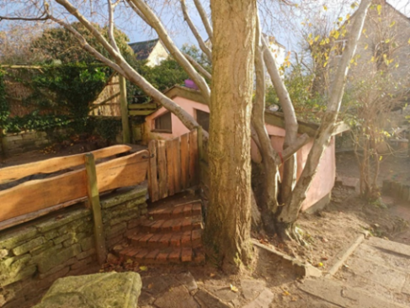
Things to consider
- Risk needs to be developmentally appropriate to the cohort of children
- Risk taking opportunities should be available both inside and outside
- Do you have risk assessments in place for ‘risk taking’ activities?
- Do staff model how to use outdoor equipment and space and show them the opportunities available?

- Do staff support children when things don’t go to plan? Do they encourage them to try again and support their resilience?
- Staff can build confidence by using positive language such as ‘show me how carefully you can use the scissors’ rather than ‘don’t do that its dangerous’ which can build anxiety
- Children need to be supported to understand their own limitations
Top tips for inclusion
- Are reasonable adjustments made so all children can engage in ‘risk taking’

Partnership with Parents
- Risk taking isn’t limited to outside – those who do not have access to green spaces can introduce water play, help with cooking, using scissors for crafts etc
- Encourage parents to support children to understand the safety boundaries of risky play at home

Helpful links and resources
What are the benefits of Risky Play? - BBC Tiny Happy People

