Forest Road, Lydney – Geotechnical Remediation Work

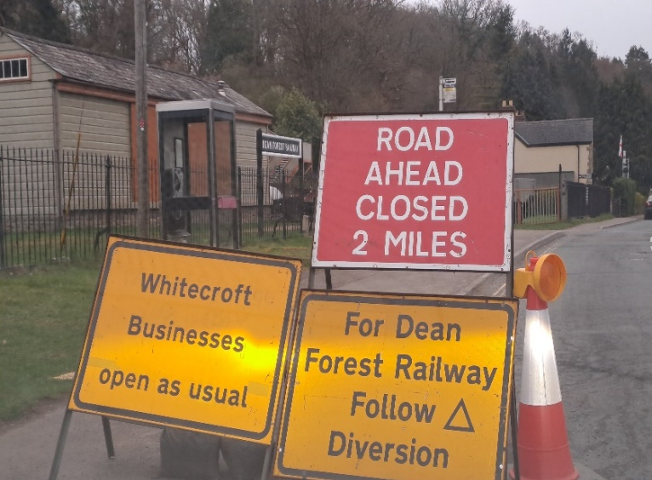
Montel Civil Engineering Ltd has been appointed as Principal Contractor by Gloucestershire County Council for the Forest Road, Lydney – Geotechnical Remediation Works. The project is needed in response to significant land subsidence on the B4234 Forest Road between Lydney and Whitecroft.

A full road closure will be required for the duration of the works. Access to properties and businesses will be maintained at all times; however, through-traffic will not be able to pass through the work area.

The signed diversion route was developed in consultation with local residents and businesses to minimise disruption as far as possible. It was introduced on Monday 9 February 2026 and has operated successfully to date. Additional signage has since been installed to provide clearer information for local businesses and to discourage HGVs from using unsuitable alternative routes.

By the end of April Openreach BT had diverted their cables out of the verge and into the existing carriageway. This was to avoid any clashes with the proposed sheet piling operations.
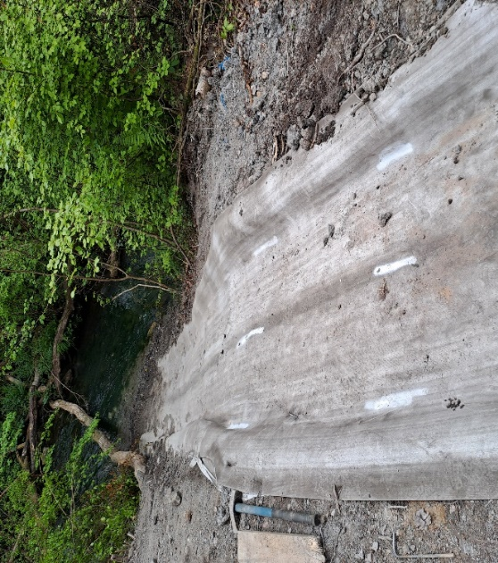
Drainage works continued throughout May, including the installation of a lined channel that discharges into the river. This channel will help prevent further erosion of the embankments in the future.

New kerblines have been installed from the western tie-in upto where the piling works start to reduce the amount of work required once the piling is complete. In addition, some carriageway reconstruction has been completed within the piling area where access is possible and safe to do so, taking account of the ongoing piling activities.

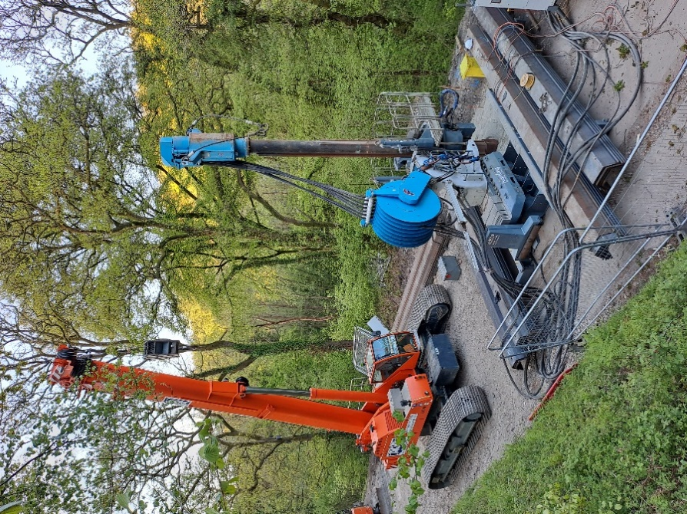
Piling activities were able to commence at the end of April following the diversion of the existing BT cables. A 65-tonne crawler crane and Giken piling rig have been used to install the sheet piles for the scheme.

The Giken piling rig was chosen instead of a traditional piling rig after consideration of the existing ground conditions where the ground slip has occurred. A traditional rig would transfer the loads through the existing ground whereas the Giken rig clamps onto the piles that have been installed and transfers the loading through the piles into the stable rock below.

Despite encountering some challenging ground conditions, the pilling operation has now been completed allowing works to reconstruct the carriageway to commence.

In the upcoming period, we will be able to connect up the outfall drainage channel to the higher section of drainage through the sheet piled area. Road reconstruction through the area affected of the original ground slip can then take place, followed by the installation of new kerbing, surfacing and verge works.

We apologise for any inconvenience caused during the course of the project and greatly appreciate your patience and cooperation while these important works are carried out.

If you have any questions, please contact us at forestroad@montel-group.com or Gloucestershire County Council at Highways@gloucestershire.gov.uk

Kind regards,

Montel Civil Engineering Team

