Cultural Capital
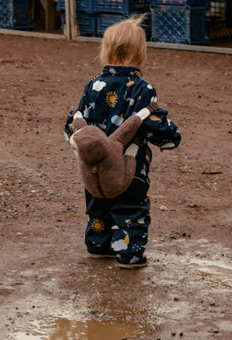
What is cultural capital?
“Cultural capital is the essential knowledge that children need to prepare them for future success”
This video from Ofsted may be helpful:
What does 'cultural capital' mean for early years?
How do we deliver it?
Do what you always do! The cultural capital you provide to children will be part of your curriculum, delivered through the seven areas of learning and your everyday practice – you don’t need a special display or theme!

Your cohort of children will always be unique. Children arrive at your setting having had different experience from others in life, learning and play. You will need to look at what experiences they have already had and build on these to give them those rich experiences they haven’t had yet and the best possible start to their early education!
To do this, use your curriculum to include, celebrate, acknowledge, and build on children’s current knowledge and interests and provide new opportunities and experiences to challenge, expand, and increase children’s knowledge, understanding and skills.
Top tips!
- Consider how you are helping children experience the awe and wonder of the world in which they live.
- Give special consideration to your most disadvantaged children.
- Research tells us there is a link between the number of words children know, and their future success. Consider how many words your children are exposed to during their time with you.

