Health inequalities strategic planning and review template

The purpose of this template is:
- to enable system organisations and partnerships to self-assess and understand their contribution to the wider system approach to addressing health inequalities.
- to support system partners to reflect on their progress in operationalising the ICS health inequalities framework, including objectives under each of the themes.
- to provide assurance to the Board that each part of the system has a way of working that enables them to demonstrate how they are systematically contributing to the overall health inequalities framework.
- to understand where progress is being made, where there are opportunities to stretch ourselves further, and what themes are emerging regarding system level support needed to have most impact.

Prior to completing this form, please refer to the Health Inequalities Framework user guide.

Strategic self-assessment and objective setting template (September/October 2024)

Which organisation and/or partnership are you reporting for?
Who is Executive Level Sponsor for Health Inequalities within the organisation/partnership? (name, job title)
Who is the Health Inequalities lead officer/programme manager within the organisation/partnership? (name, job title, email address)
Where do you report to within your organisation on health inequalities? (e.g., Board, Committee)
Report author (name, job title, email address)

User instructions
- If your organisation has already set objectives relating to reducing health inequalities, please use these to populate this section of the template.
- If you have not already set objectives, you may want to use the attached logic model template to assist you.
- Review your objectives against the three themes of activity in the Health Inequalities Framework (Appendix 1) considering the following:
- Have you got at least one objective under the three themes or are you focussed mainly on targeted activity (Theme B)?
- Have you considered how you will track progress, outputs and outcomes and how you will capture any learning?
- Are there any opportunities to stretch further, if so, what else could you do?
- You may wish to tweak your objectives or add new ones if you have identified an opportunity to stretch.
- Make sure all your objectives are SMART and that you know how you will track progress and outcomes - the objectives that you submit will be your commitment to the system’s collective efforts to reduce health inequalities.
Please read the FAQs for more detail.

Please send your completed template to Sarah.Macdonald32@nhs.net by 15 October 2024

Theme A – Contributory activity
What are your objectives under this theme?
Sub-category  (Please refer to the Health Inequalities Framework in Appendix 1 to identify which sub-category your objective aligns to) | What is your objective? | How will you achieve this objective? | How will you use data to plan and evaluate your objective? |  | What outcomes are you aiming to achieve?  (E.g. to improve an outcome by X% or explicit link to systemwide outcome measures) | Does this objective support prevention? If so, how?  For definitions: Prevention and Health Inequalities Hub - Prevention
Example:  Engagement with communities (inclusion groups & places) | Increase involvement of diverse ethnic communities in mental health research to understand how to make mental health services more accessible and improve uptake. | Recruit and train research champions from target diverse ethnic communities to promote and encourage participation in mental health research in their communities. | Identification of communities in Gloucestershire who are underrepresented in mental health services. |  | Reduce variation in uptake of mental health services between people from diverse ethnic groups and those from White backgrounds to 0%. | Yes – improved access to services will prevent mental health conditions from deteriorating.

Theme B – Targeted interventions to improve health and remove barriers
What are your objectives under this theme?
Sub-category  (Please refer to the Health Inequalities Framework in Appendix 1 to identify which sub-category your objective aligns to) | What is your objective? | How will you achieve this objective? | How will you use data to plan and evaluate your objective? |  | What outcomes are you aiming to achieve?  (E.g. to improve an outcome by X% or explicit link to systemwide outcome measures) | Does this objective support prevention? If so, how?  For definitions: Prevention and Health Inequalities Hub – Prevention
Example:  Initiatives to promote access to existing services to address identified barriers to entry. | Increase cancer diagnosis at stages 1 and 2 for people living in the most deprived areas of Gloucestershire | Delivery of a programme of public awareness campaigns in areas of deprivation and communities with high risk factors | Develop and embed the Cancer Health Inequalities Toolkit to identify cancer screening uptake and variation across the county by IMD quintile. |  | Reduce the variation in early diagnosis between the most and least deprived quintiles to 0.  Links to overall ambition to 75% cancers diagnoses at stages 1 and 2 by 2028. | Yes – early identification of cancer increases chance of survival.

Theme C – Improving the equity of mainstream service delivery
What are your objectives under this theme?
Sub-category  (Please refer to the Health Inequalities Framework in Appendix 1 to identify which sub-category your objective aligns to) | What is your objective? | How will you achieve this objective? | How will you use data to plan and evaluate your objective? |  | What outcomes are you aiming to achieve?  (E.g. to improve an outcome by X% or explicit link to systemwide outcome measures) | Does this objective support prevention? If so, how?  For definitions: Prevention and Health Inequalities Hub – Prevention
Example:  Data collection and quality | Improve coding for emergency department and emergency admissions activity | Training and awareness raising sessions for emergency department staff regarding collection and recording of ethnicity data | Review completeness of ethnicity data for people accessing the emergency department to understand gaps in data |  | Improvement in ethnicity coding of people accessing the emergency department or being admitted to hospital with ethnic category recorded in line with NHS Digital guidance | No

Progress and peer review template (six-montly review, March/April 2025)

Report author (name, job title, email address)
User instructions
- Please review the objectives that you have set under each theme – give a high-level summary of your progress and any output and outcomes achieved, and your planned activities over the next 6-months.
- If you want to add any objectives to those that you have identified above, please do so highlighting the new objective(s).
- Provide a brief narrative on key challenges/risks and any system-level support that would help you, or that you would like to be flagged to the ICB Board.
- Please share any learning that could benefit other parts of the system.

Please send your completed template to Sarah.Macdonald32@nhs.net by 11th April 2025

Theme A – Contributory activity

Objective |  | Progress |  | Outputs | Outcomes | Next 6-months

Theme B – Targeted interventions to improve health and remove barriers
Objective |  | Progress |  | Outputs | Outcomes | Next 6-months

Theme C – Improving the equity of mainstream service delivery

Objective |  | Progress |  | Outputs | Outcomes | Next 6-months
Key challenges/risks
Support needs
Lessons learned

Progress and peer review template (six-montly review, September/October 2025)

Report author (name, job title, email address)
User instructions
- Please review the objectives that you have set under each theme – give a high-level summary of your progress and any output and outcomes achieved, and your planned activities over the next 6-months.
- If you want to add any objectives to those that you have identified above, please do so highlighting the new objective(s).
- Provide a brief narrative on key challenges/risks and any system-level support that would help you, or that you would like to be flagged to the ICB Board.
- Please share any learning that could benefit other parts of the system.

Please send your completed template to Sarah.Macdonald32@nhs.net by 10th October 2025

Theme A – Contributory activity

Objective |  | Progress |  | Outputs | Outcomes | Next 6-months

Theme B – Targeted interventions to improve health and remove barriers
Objective |  | Progress |  | Outputs | Outcomes | Next 6-months

Theme C – Improving the equity of mainstream service delivery

Objective |  | Progress |  | Outputs | Outcomes | Next 6-months
Key challenges/risks
Support needs
Lessons learned

Appendix 1

Gloucestershire health inequalities framework

The Gloucestershire health inequalities framework (‘the framework’) has been developed by Integrated Care System (ICS) health inequalities leads as an aid to systemise local action to have the best collective impact on health inequalities in the county.

There are many examples of good practice in addressing health inequalities in the county. However, as a system we tend to focus more of our time and effort on targeted interventions (‘theme B’) with less emphasis on themes A and C, where the real transformational change is likely to happen. So, if we are to maximise our collective impact as a health and care system, we need to challenge ourselves to stretch a little further – and to do some of our mainstream activities a bit differently.

The Framework sets out a simple approach to help us to organise ourselves better - to understand the different types of activity on health inequalities that are taking place, and the contribution that different parts of the system are making to overall outcomes over time.

A framework for tackling health inequalities in Gloucestershire
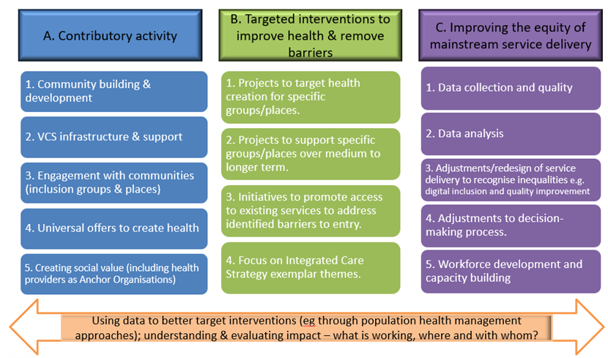
Theme A: Contributory activity – things we need to have in place in the system because they underpin and make a fundamental contribution to improving equity. However, we can’t necessarily directly attribute outcomes to these activities. Many of the activities under this theme also contribute to the prevention agenda.

Theme B: Targeted interventions to improve health and remove barriers – intervention might be targeted by place, people or condition. This is where we currently focus most of our time and effort as a system. These interventions are important but only part of the overall approach needed to make a difference.

Theme C: Improving equity within mainstream services and activities – this theme includes the fundamental underpinning things that we need on top of individual services. The theme is currently underdeveloped and is about changing / tweaking how we do the basics.

Each theme has a number of sub-categories.

What are we doing to tackle health inequalities? (Examples)
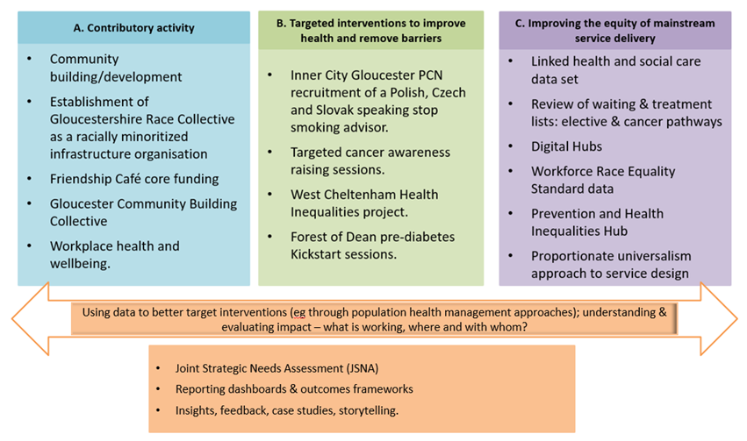
The image on the left gives just a few examples of work that is going on within Gloucestershire to contribute towards tackling health inequalities.

