The Learning Environment: The Physical Environment
Materials and Resources
High-quality, open-ended resources offer endless opportunities for children. A combination of natural and manmade, including ‘real’ resources add to the depth of experience.
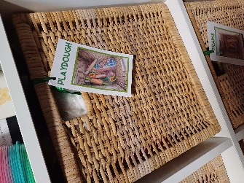
Things to consider
- Are all resources labelled?
- Do you consider the variations of resources you offer? for example do you have multiple different versions of the same item available?
- Do you reflect the cohort’s interests?
- Do you have the right amount of each resource to ensure regular access, but avoid unnecessary clutter
- Do you offer open ended materials which encourages children to be creative and take the lead in their play. For example loose parts (The Theory of Loose Parts was coined by an artist and architect, Simon Nicholson, who suggested that loose parts are materials which can be moved around, designed, redesigned and tinkered with freely.)
- Do you offer a variety of Treasure baskets for children to explore?
- Are toys and resources easily accessible and inviting? For example, does the mud kitchen have utensils?
- Do you offer a variety of resources at differing levels?
Top tips for inclusion
- If resources are not always available consider offer choice boards or a photo book for children to choose
- Provide a variety of diverse resources this can be books, posters, role play, small world toys, dolls, puppets etc
- Consider if a risk assessment is needed for individual children regarding specific resources.

Partnership with Parents
- If you need any resources, or something building consider asking your parents, carers or grandparents as they may be able to help.

Helpful links and resources
Understanding Loose Parts Play and its Benefits for Early YearsEarly Years Resources Latest News and Guides
What Is A Treasure Basket? The Essential Guide - Early Impact Learning
The Importance of Creative Play in Early Years Education | The Early Years Company
OAP resource: adequate-quantity-of-play-resources-and-space-to-play
OAP resource: embracing-different-cultures
OAP resource: learning-areas-resources-are-positioned-appropriately

