Gloucestershire Archives – reducing carbon footprint and revenue costs through building solutions

Overview:
Reducing our carbon footprint by installing solar panels and switching from high-cost HVAC (Heating, Ventilation and Air Conditioning) technology to simpler and more effective low-energy solutions for the management of our archive strongrooms environments.

As equipment was failing or reaching the end of its life, we worked with our Council property colleague Charlie Newman and specialist engineer, Nick Grant from Elemental Solutions to review our systems and gradually replace them with much simpler, domestic-scale solutions.

Measures:

- Removing air conditioning from our older strongrooms together with significant plant on the roof.

From this: HVAC plant on roof serving two interconnected older strongrooms
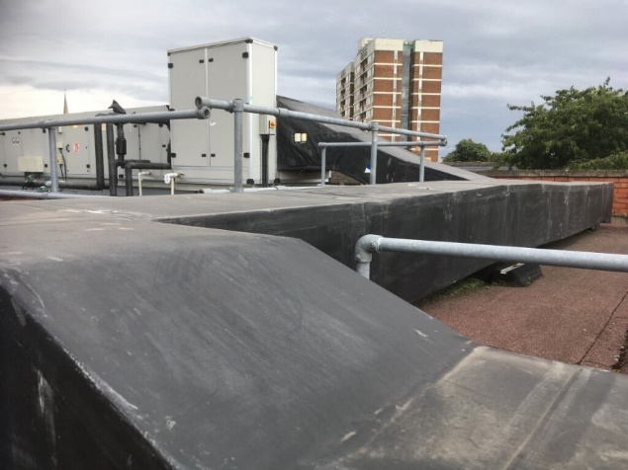

To this: a condenser type dehumidifier to supply dried air to the two interconnected strongrooms plus three new ones. Adapted for ducted supply, a very compact unit with an integrated chiller and air intake from the corridor.

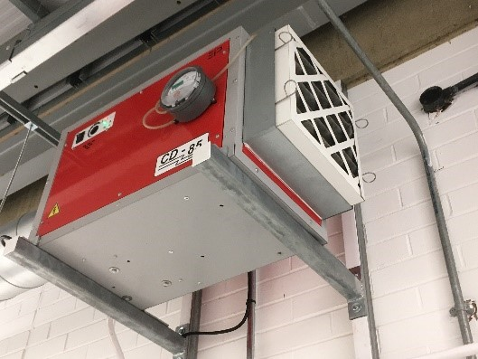
- Installation of major array of solar panels on three sets of strongroom roofs providing the energy required to meet our electricity needs. The panels also provide shade helping keep temperatures lower in the strongrooms in the summer.
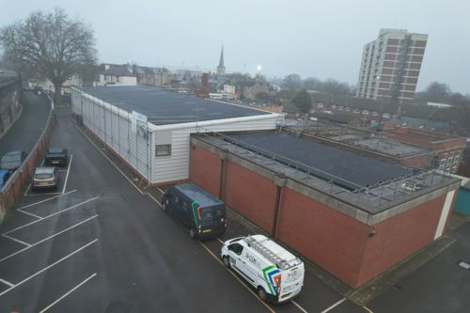

Since completing the installation in March 2025, to December 2025 we generated 138,660 Kwh of electricity. We are currently exploring the addition of batteries so we can use more of the electricity we are generating on site ourselves.

- Low-cost, low-energy solution for our specialist photographic store with required temperature of 10 degrees Celsius. The over-sized plant was nearing the end of its useful life and after years of providing stable conditions it began to fail more frequently and to severely test the ingenuity of the service engineers. Wine-cellar technology was commissioned instead and installed in 2025.
From this:
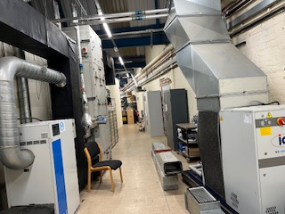
To this:
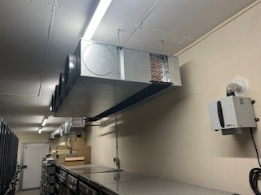
- In September 2025, we replaced 8 elderly stand-alone dehumidifiers in our 8 remaining strongrooms with another low-cost low-energy dried air system, this time using a small desiccant dehumidifier. This saves significant staff time (no longer need to empty dehumidifiers regularly), reduces running costs and eliminates a small inherent fire risk.
- In October 2025, four charging points for electric vehicles were installed in our car park, two specifically for disabled drivers near the front entrance.

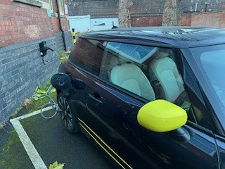

- We explored a rainwater harvesting system to avoid flushing drinking water down our toilets but decided not to pursue this option. Reasons included systems being deinstalled elsewhere in the county, legionella concerns and academic research: Rainwater harvesting systems for toilet flushing – do they ever make environmental sense? – A collection of thoughts about a low carbon future
- Longer term: gas boilers will be banned in the UK by 2050, so we anticipate moving from gas fired boilers to air source heat pumps when the current equipment begins to fail or funding becomes available.

The new system providing the required environmental conditions for the archives is not so reliant on complicated engineering. It has greatly reduced procurement and servicing costs, is much simpler, cost effective, stable and kinder to the planet.

The figures

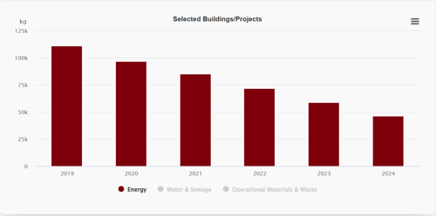

Our switch from HVAC technology to low-cost environmental management solutions, together with other measures has significantly reduced our carbon footprint from 111 tonnes of CO2e in 2019 to 46 tonnes in 2024. We are looking forward to seeing the power (electricity and gas) figures in early January 2026 following the completion of work on the photographic store, the updating of the dehumidification methodology in 12 strongrooms and the installation of solar panels in 2025.

We have further work to do on reducing our water consumption. The 2023 peak was due to showers installed for work to remove asbestos on site. So far all we have done is install water butts for watering the garden and explored (but chosen not to progress) a rainwater harvesting system.

Energy and Emissions | Gloucestershire Archives

We are grateful to Gloucestershire County Council, the National Lottery Heritage Fund (through our Green Pledge Project), and Salix funding to enable us to make these improvements.





