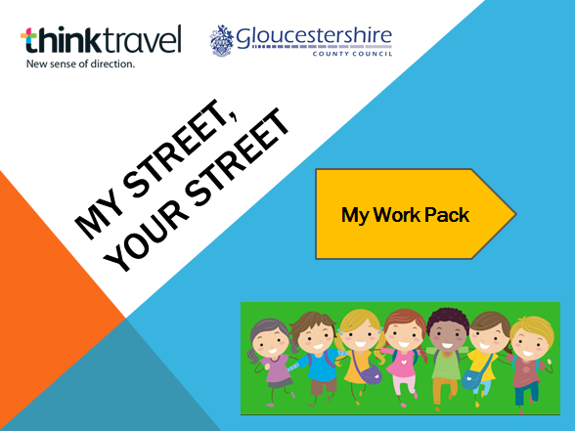
Either print this as a booklet or to save ink and paper, complete this on the computer. You can also just print the pages you need.

My Name:

My Street:

In this unit, you will discover more about the street you live in and those around you, use mapping skills and develop an understanding of what makes a street healthy.
Word Bank
My Pack 1 ongoing
https://kids.wordsmyth.net

Create your own word bank of words that are useful. Why not create your own dictionary with words and definitions? Use an online dictionary like:

My Ideas
My Pack 2 10 – 15 minutes
Thinktravel Big question:
What makes a street ‘healthy’?
What makes a street ‘unhealthy’?

:-

My Pack 3 15 – 20 minutes plus discussion time
What do you notice in the pictures?

My Pack 4
20 minutes
Key stage 2: sort statements into healthy and unhealthy

Healthy

Top three

Unhealthy

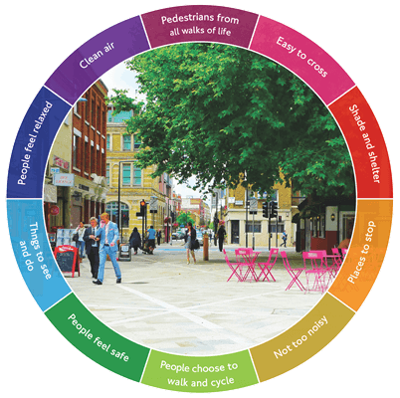
My Pack 5 – 15 minutes research including note-taking and 15 minutes writing bullet points

Fact File
7 out of 10 children walked to school a generation ago. Now it is much less.
The number of cars on the streets has increased year on year causing congestion and reducing the quality of the air.
Some communities have transformed their streets to make improvements that everyone can enjoy.

My Pack 6
After your walk – 30 minutes
Observational Walk Notes

Things I like in the street:

Things I don’t like in the street:

What can I see in the street and how it make me feel:

My Pack 7
After your walk – 30 minutes
Observational Walk Notes

My Notes:

How it makes me feel:

Places to cross? Safe to cross?

Shade and shelter?

Places to stop? Places to rest?
Quiet or Noisy? (Try closing your eyes for 5 minutes and stay quiet – write down what you could hear!)

Cyclists and other walkers?

Does it feel safe?

Interesting things to see and do?

Does it feel relaxing?

How clean does the air feel when you breathe?



W
My Ideal Street!
My Pack 8
Optional extension activity
If you could wave a magic wand, what would your ideal street look like? Sketch or create a poster of your imagined street making sure you include all the healthy things you might see, hear and feel!



When you have finished your map, created your ideal street and completed your work pack, contact your teacher for a certificate!
We would love to see your work too. Speak to your school and ask them to contact us on thinktravel@gloucestershire.gov.uk .

