


Project Bulletin - Whitminster Canal Bridge
As the project progresses, the past weeks have seen excavation areas backfilled and the commencement of the carriageway reinstatement.
We have also carried out installation work on culvert units and bridge handrails. (Photo below)
Ducting and kerb installation have also been undertaken and will progress through the next two weeks.
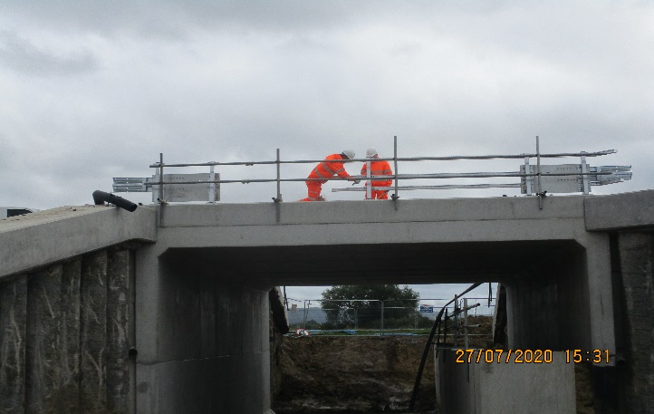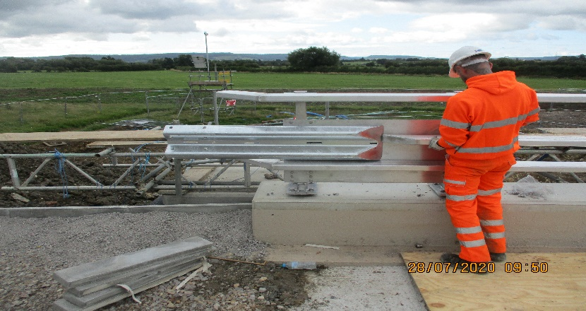

As we progress with these important improvements, your continued patience is greatly appreciated.
If you have any concerns or issues regarding the road improvement scheme, please contact me on 0300 041 4635*. I will be available throughout the construction phase to provide continuous engagement with businesses and residents within the local area.
Further information about the scheme can be found at
https://www.gloucestershire.gov.uk/highways/major-projects-list/a38-canal-bridges/

Neil Evans
Contract Liaison Officer
Alun Griffiths (Contractors) Ltd
0330 041 4635*

*Calls to this number are charged at national call rates and included in inclusive minute plans from landlines and mobiles

