Gloucestershire Fire and Rescue Service
Community Risk Management Plan (CRMP) 2026-2030

Contents
What is a Community Risk Management plan? 1
Our Mission is 2
Our Vision is to 2
Our Workplace Charter 2
Factors influencing the CRMP 3
Gloucestershire local community risks 5
Our current workforce 6
Operational insights 7
Our prevention, protection, and response functions 8
Prevention 8
Protection 12
Response 15
Demand: historic, current and potential future position 17
Our aims for 2030 and what is driving them 21
Our aims, and the objectives for achieving these 22
Managing our highest community risks 23
Flooding and evacuation from water 23
Dwelling fires 24
Road Traffic Collisions 26
Hazardous materials 27
Large and small vehicle fires 28
Other residential dwellings fires 29
National guidance: Wildfires 30
Summary of activities managing risks 31
How we will manage the delivery of this CRMP 34
Fleet, resources and premises 35
Asset management 35
Premises 37
Workforce 38
Succession planning requirements and future workforce needs 39
Finances 41
ICT, systems, and data 42
Communications and engagement 43
Monitoring and delivery 44
Transparency and accountability 45
Glossary 46

What is a Community Risk Management plan?
A Community Risk Management Plan (CRMP) is a statutory requirement for all fire and rescue services in England, as set out in the Fire and Rescue National Framework (2018). The CRMP establishes how Gloucestershire Fire and Rescue Service (GFRS) will strategically allocate resources and implement operational response, protection, and prevention measures to address fire and rescue-related risks across the county.

The plan is informed by a detailed Community Risk Profile (CRP), which assesses current and emerging fire and rescue-related risks affecting residents, businesses, and visitors. This profile enables GFRS to proactively manage those risks and enhance public safety through informed and targeted delivery of high-quality services.

In producing this document GFRS carried out wide ranging engagement and consultation with the residents of Gloucestershire, community representative groups, and partners in autumn 2024 and then again in winter 2025. This provided opportunity for its content and direction to be validated and informed by perspectives beyond GFRS.

Gloucestershire County Council (GCC) serves as the Fire Authority with an overall responsibility for our fire and rescue service (FRS). It sets direction and priorities and oversees governance and compliance. GFRS operates as the operational delivery arm for fire and rescue services, and benefits from shared skills and resources in this collaborative model. Working together we fulfil our legal obligations while driving continuous improvement and operational excellence.

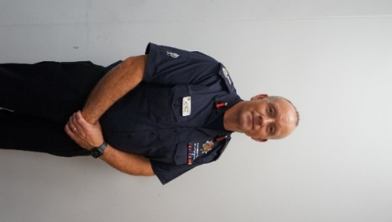
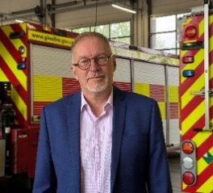

Councillor Paul Hodgkinson, Cabinet Member for Public Health, Communities and Fire
Mark Preece, Chief Fire Officer

Our Mission is
Working together for a safer Gloucestershire

Our Vision is to
create a positive workplace culture that empowers and supports our people to provide the highest standard of community safety and emergency response services to the communities of Gloucestershire

Our Workplace Charter
This sets out the behaviours, ethics, and values that, as a Service, we have collaboratively agreed upon. The Charter incorporates our Core Values, the National Fire Chiefs Council (NFCC) Core Code of Ethics and Leadership Framework, breaking down the themes into specific behaviours that resonate with the entire workforce on a personal level. We recognise that our people are our greatest asset. Holding each other accountable to uphold the behaviours, ethics and values that are set out in our Workplace Charter will help us achieve a positive workplace culture.
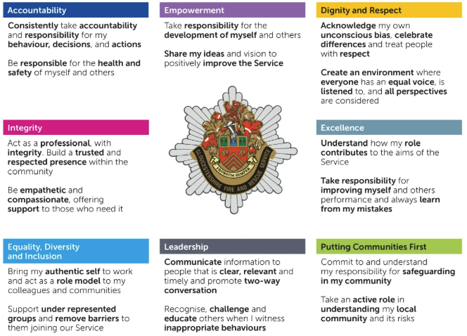

Factors influencing the CRMP
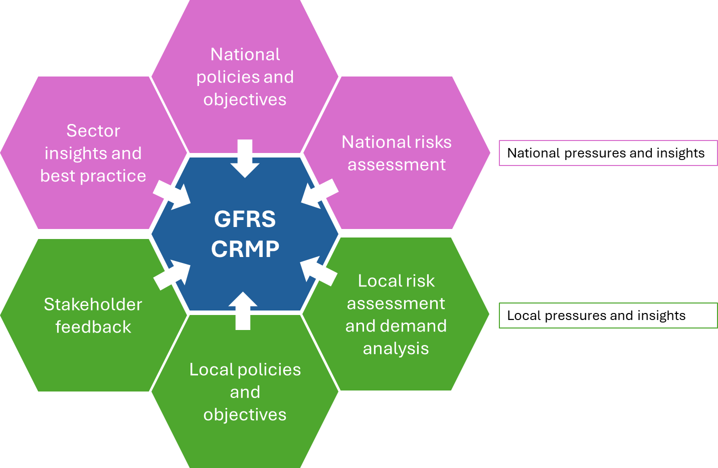
GFRS is delivering and planning within an operating environment that is subject to frequent and ongoing national and local changes. The diagram below shows the broad drivers and insights that shape and influence the CRMP. It is vital that these are regularly assessed and discussed to identify risks and opportunities ensuring we are well positioned to address either. Our Leadership Team regularly assesses our operating environment and maintains an assessment framework as part of its planning and delivery business cycle.

We make use of publications such as the National Risk Register and State of Fire and Rescue report; and external data sets concerning local demographics and socio-economic factors to better understand the communities we serve. Local knowledge, insights, and incident data support us to be able to understand and assess our local community risks and tailor the delivery of resources and approaches to respond to those effectively.

We carried out engagement activities on our CRP and CRMP. We did this publicly online, and directly with key stakeholders including community representative bodies, and held specific face to face focus groups across the six county districts. This ensured we had insight from residents and stakeholders to validate the CRP.

Taking all the above into consideration alongside our professional insight and knowledge has allowed us to prepare a range of aims and objectives to keep us focused on the things that matter most and ensure we are able to keep evolving and delivering a high-quality fire and rescue service.

The most significant factors include:

His Majesty’s Inspectorate of Constabulary and Fire and Rescue Services
The recommendations identified by His Majesty’s Inspectorate of Constabulary and Fire and Rescue Services (HMICFRS) as part of their statutory inspection and monitoring programme of fire and rescue services has generated an important transformation programme that requires ongoing management and effective delivery to help focus our improvement journey. Making good use of sector best practice and expectations, and HMICFRS inspection findings is vital to ensure GFRS maintains a clear direction of continuing improvement.

National recommendations and operational guidance
GFRS remains constantly vigilant regarding ongoing national recommendations and operational guidance to ensure residents, visitors, and places are as safe as possible, and the Service remains aligned with evolving best practice and regulatory requirements. For example, the Grenfell Tower and Manchester Arena tragedies have rightly generated substantial positive change to operating practices and legislation, and it is essential that these continue to be embedded in our Service.

Cultural improvement
We are on a cultural improvement journey and an important part of that is the Independent Review to look at claims of historic bullying and racism between 1991 and 2018, delivered by West Midlands Employers. Whilst the report acknowledges that GFRS is no longer institutionally racist, there are improvements still to be made to ensure we continue to move forward in this critical area and create a service that is inclusive and values-driven, where people can be themselves, whoever they are.

Ensuring efficiency
Making sure the Service is run as efficiently as possible whilst ensuring it remains an effective fire and rescue service is part of our day-to-day business and is the right thing for us to do. However, the ongoing and increasing pressure on public sector spending is exacerbating this situation and as a county council-run fire and rescue service we are responsible for supporting the council to achieve the efficiency savings it needs to make. This has re-focussed our efforts as we seek to attain the right balance of efficiencies and improving performance.

The impact of climate change
The impact of climate change is now being realised and the changing patterns of weather in terms of frequency and severity are affecting fire and rescue related risks. This requires an appropriate approach is taken through our prevention and response activities in terms of skills, vehicles and equipment to meet the challenges this presents, regarding flooding, water rescue, and wildfires.

Increasing challenges for an on-call service
An ‘on-call’ firefighter is defined as a person who serves their local fire and rescue station on a part-time basis, they are employed by GFRS and are 'on-call' to respond to emergencies when needed. The recruitment and retention of on-call firefighters has become increasingly difficult. As a rural county with most fire stations crewed by on-call firefighters this presents a challenge to keep fire engines and crews available at the right times and in the right places. It is essential that the on-call offer is reviewed, alongside how and where we recruit, and opportunities are taken to improve how effectively we can provide adequate fire cover in a dynamic operating environment.

Local Government Reorganisation
Local Government Reorganisation (LGR) in Gloucestershire is now formally underway following the UK Government’s programme of devolution and structural reform. The outcome of the current local government reorganisation programme of work may have significant impacts on GFRS depending on the outcome, which will not be known until later in 2026. Should that outcome require significant change to the governance model this will mean GFRS will have to re-prioritise all and potentially pause some of our delivery plans to accommodate this.

Gloucestershire local community risks
The Fire and Rescue National Framework for England outline the requirements for every fire and rescue authority to assess all foreseeable fire and rescue related risks that could affect their communities. GFRS carries out annual risk assessments at a fire station level, each hazardous event relevant to fire and rescue in Gloucestershire is assessed in terms of its likelihood and potential consequences, based on a ‘worst-case’ scenario to arrive at a risk score. Scoring matrices are in place to ensure clarity and consistency in the approach, and the risk score is a multiplication of the likelihood and consequences assessment.

Likelihood is scored between 1 (low) and 5 (high) and is informed by the number of relevant incidents per year, based on observations over a three-year period.
Consequence is also scored 1 (low) to 5 (high) across a range of relevant categories as listed below:

Casualties | Disruption to essential services | Economic | Environmental
Evacuation and shelter | Fatalities | Public perception

Risk is considered and maintained at an operational ‘station area’ level to enable a more specific and tailored approach to resourcing, equipment, and training of staff. Following assessment, the average score across all station areas is used to describe the county-wide risk level for each fire and rescue related risk.
risk area | risk level
flooding | very high
dwelling fire | very high
non-residential fire | very high
road traffic collision: large vehicle | high
road traffic collision: small vehicle | high
hazardous materials incident | high
large vehicle fire | high
small vehicle fire | high
other residential premises fire | high
evacuation and rescue from water | high

Public engagement activities were carried out in autumn 2024 ensuring there was opportunity for residents’ insights to inform our assessments as we began to build towards this CRMP. This has helped us to understand better where we may be able to make a specific difference. Following this we could see the highest scoring risks at a county level are shown in the table on the right. More risks and further detail against these are in place in our CRP, also available on the GFRS website on our ‘publications and reports’ page.

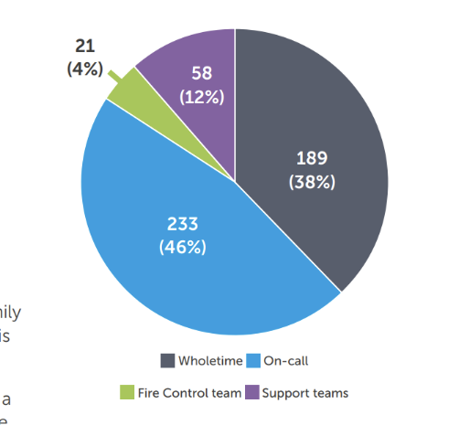
Our current workforce
At the end of March 2025 our workforce consisted of 501 employees delivering prevention, protection, response, control, and support functions. The chart on the right shows how these are distributed to broad role types.

Our workforce consists of wholetime and on-call roles. On-call firefighters serve their local fire and rescue station, and this role is often managed alongside full-time jobs, family commitments, and other activities. A wholetime firefighter is defined as a full-time firefighter, regardless of their rank.

GFRS is classified as ‘significantly rural’ by the NFCC and as a significantly rural fire and rescue service, we make good use of on-call firefighters in areas where the frequency of incidents is lower. Having full-time firefighters at every station is not the most efficient and effective use of resources when resourcing to risk and demand. This model remains valid but is subject to increasing recruitment and retention challenges for on-call firefighters that are affecting the availability of appliances and response times: this will be an area of significant focus for this CRMP and beyond.

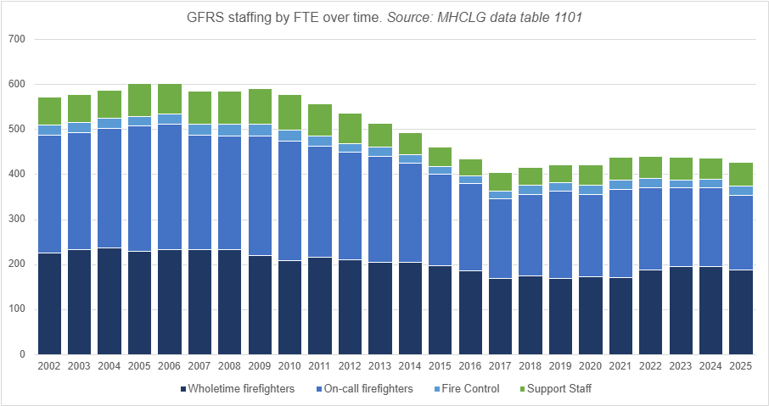
Our fire control staff provide the first point of contact for the public when an emergency occurs. They are well equipped and trained for a range of tasks including emergency call handling and provide calm reassurance while gathering vital information to support an emergency response. Our support staff provide essential core functions, making sure the service runs effectively on a ‘day to day’ basis. For example, ensuring the Service is well positioned to identify and respond in a timely manner to risk and opportunities as they arise, plan and spend budgets effectively, and support delivery of our aims and objectives.

Operational insights
The county has a service area of 1,044 square miles and a population of approximately 662,000 people. The service has been labelled as ‘urban with significant rural’ by the Department of Environment, Food, and Rural Affairs.
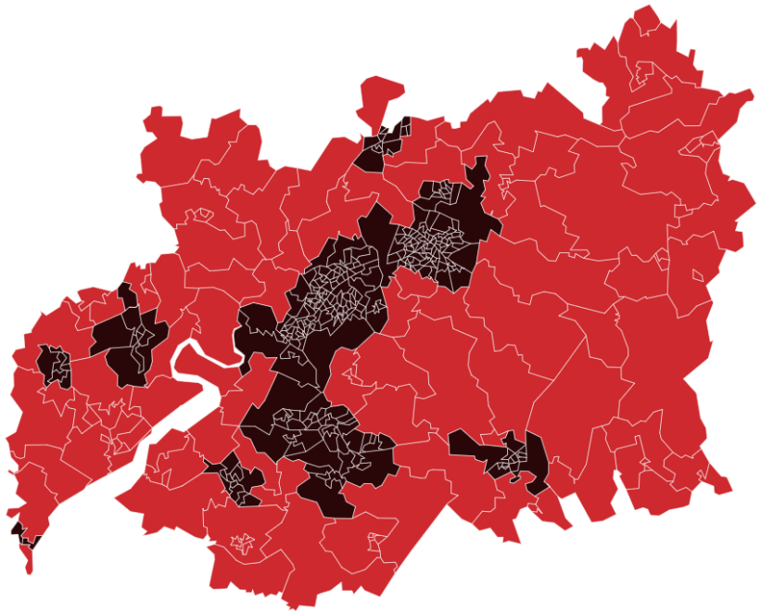
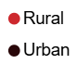
The map on the left (sourced from the latest online HMICFRS ‘digital analysis pack’) shows Super Output Areas (SOAs) and whether they are classed as ‘rural’ or ‘urban’: the map shows that almost 88% of the county is classed as rural, using Office of National Statistics definitions.

We have 32 pumping appliances across 21 stations throughout Gloucestershire and, as the county is largely rural, 16 of these are staffed entirely by on-call firefighters. Of the remaining five stations, two are staffed by full-time firefighters and three have a mixture of both wholetime and on-call firefighters. These five provide a more immediate response and cover those areas where there is a higher risk of incidents. Ensuring we have the right people, skills, and equipment in the right places is a key part of delivering an effective emergency service.

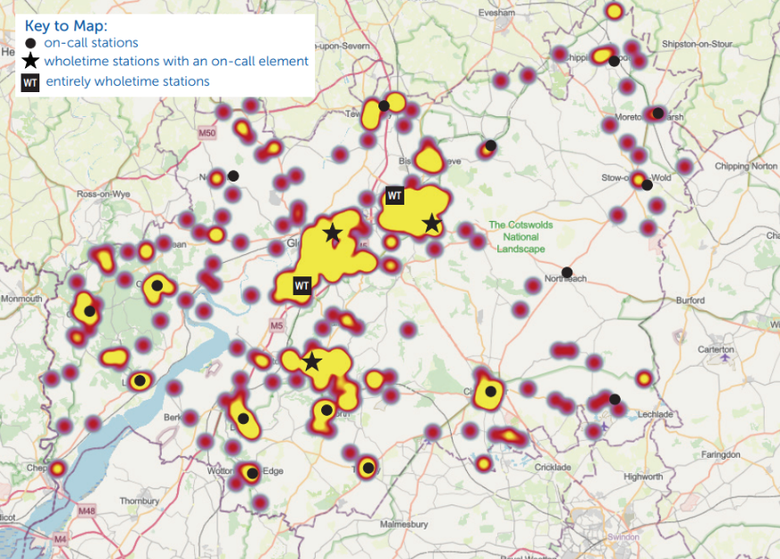
The illustrative map on the right shows the locations of fire stations overlaid on a heat map of dwelling fires from the past three years, illustrating the relationship between station locations and fire incidence.

Our prevention, protection, and response functions

Prevention
“Working with the people of Gloucestershire to prevent fires and other emergencies.”

Prevention is a critically important area of work and a statutory duty. The primary intention of the prevention team is to prevent fires and other emergencies from happening, and to reduce the adverse impact if they do occur. Our focus is to identify those who are most at risk of harm and target our prevention activities in an inclusive way. The team works hand in hand with our response and protection colleagues to provide a holistic approach to providing a high performing fire and rescue service for people living, working and travelling through the county, and businesses and communities within it.

Our priority is to engage with and adapt to the changing needs of our community and alleviate common risk factors which are present in a significant number of fires and other emergencies. We do this through
- our work in people’s homes,
- communicating educational/ behaviour-changes messages through our communications channels such as social media, the press, printed literature, and
- in innovative ways via SkillZONE, our interactive life-skills education centre, or
- the local community through our broader prevention work with partners.

Our activity includes preventing dwelling fires and deliberate fires, delivering education to improve road safety and water safety, reducing serious youth violence through interventions, community safety education and working with children who start fires, to change their behaviour.

The following principles underpin our offer to the residents and visitors of Gloucestershire, we will:
- use information from a wide range of sources to identify the factors that place people at the greatest risk of being injured in a fire and use this information to reduce risk.
- make every contact count by effectively using our resources and signposting to support when needed.
- ensure our staff are appropriately trained to understand the risk factors that increase vulnerability and know how to support the complex needs of vulnerable children, or adults with care and support needs.
- collaborate with partners from across statutory and third sector organisations to maximise the use of resources, and to ensure we are effective at identifying and reducing risk.
- work with communities to co-produce activity wherever possible; working “alongside” and “with” to build safer communities and recognise existing strengths.
- ensure that prevention activity offers equality of access, removing or overcoming barriers to access for underserved groups, and making sure that our offer is inclusive of our diverse community.

Data and insights
Demographic data is vital in identifying areas of risk, and the team uses information from the Office for National Statistics, Inform Gloucestershire, ACORN and the Home Office. This information allows us to better understand people and places across the county and improve service delivery.

Housebuilding in the county has been increasing, and housing need set out in ‘Local Plans’ suggests the policy need is for up to 66,000 homes across the county by 2040. Some of these homes will increasingly be using new techniques and materials that will require the Service to understand and train to the risk they may present to ensure we can respond quickly to dwelling fires and ensure residents’ and firefighters’ safety.

The population of Gloucestershire is projected to rise to 683,849 by 2028. This rate of growth is higher than the national growth rate with variations within the county. The county also has an ageing population across all six districts. The increase in the over 65 age group will impact prevention activity as data shows that people over 65 are at greater risk from fire than those under 65. The risk profile this informs requires nuanced management to direct resources to best effect, recognising the strengths and needs of people of all ages.

GFRS has clear methodologies for the assessment of risk to incidents so that resources can be targeted effectively. Deprivation can increase fire risk in several ways, and we make use of the government’s Indices of Deprivation (IMD) dataset, a relative measure, highlighting characteristics of deprivation such as unemployment, low income, crime, and poor access to education and health services. This provides an in-depth appreciation of variations in deprivation at a detailed local level using SOAs, the most recently available data for Gloucestershire and its districts are from 2025.

Dwelling fires
The Service focuses on three prioritisation categories for reducing dwelling fire:
- Risk of having an accidental dwelling fire.
- Risk of being a casualty in an accidental dwelling fire.
- Risk of being a fire related fatality – fatalities that would not have occurred had there not been a fire.

The personal and demographic characteristics that put people at greater risk of dying in a fire are different to those that put people at risk of having an accidental fire or being injured. These differences impact the way we target prevention activity, including the resources we allocate to each risk, how we direct our staff to achieve the objectives and the results we expect to see from engagement. In Gloucestershire, there were 248 accidental dwelling fires in the year ending March 2025, the majority occurring in urban areas such as Gloucester, Cheltenham and Stroud which corresponds with our understanding of risk.

Fatal fires
The following risk factors are identified by national and local data:
- Age 65+ | - Poor mental health
- Male | - Alcohol or drug use
- Living alone | - Single parent families and overcrowding
- Smoker | - Families with children under 11
- Deprivation | - Hoarding
- Disability or long-term health condition

Our statement of intent is to have zero fatalities. Each serious incident is investigated to identify any gaps in our prevention activity, explore what we knew or should have known about the person and to make sure we, and any other partners, learn from the tragedy.

Preventing dwelling fires and fire related fatality
Reducing dwelling fires across the county is driven mainly by strong central communication, information, and education campaigns both targeted and general, supported significantly by the council’s communications team. The Service supports the national ‘Fire Kills’ campaign plan and local GFRS priority campaigns throughout the year, with social media posts, articles in the media, radio/ TV interviews, awareness raising videos on social media and websites, printed literature and campaigns material and supporting community events with operational crews and community safety advisors at hot spot areas.

Reducing the risk to people at risk of having a serious or fatal fire is more targeted. This work is a collaborative effort with all agencies across the county, identifying people who fall into one or more of the risk factors previously mentioned to offer Home Fire Safety Visits (HFSVs). Our HFSV is comprehensive, including checks for health and mobility to support people to live safely at home, know how to avoid a fire starting, how to escape it or avoid injury if one does start. We use trained staff to carry out the HFSV, and the NFCC Person Centred Framework sets the standard for such work, enabling us to focus on the personal, behavioural and home factors that may lead to an increased risk of fire injury.

Reaching people who may be at high risk of fire is an intensive activity, requiring extensive partnership work, and a Service-wide understanding and application of risk data. We achieve this by working with other partners such as social prescribers, social workers, housing officers and family members to make people aware of the risk and how we can mitigate it. Our crews understand who may be most vulnerable to injury and are trained to use risk mapping to carry out prevention activity. We strive for a visible presence in targeted areas to knock on doors offering home fire safety advice, delivering leaflets or giving fire safety talks to community groups. This means we use our resources efficiently; using universal communications, advice and education where appropriate and intensive face to face work where needed.

Road safety
As a member of the Gloucestershire Road Safety Partnership, we take a lead for road safety education as part of the Safe Systems Approach, and we use both national and local trends to prioritise our prevention activity. The Department for Transport’s (DfT) local authority road traffic series indicates that traffic on Gloucestershire’s roads has risen each year since 2022, reaching 4,408 million vehicle miles in 2024, demonstrating sustained growth in road use beyond immediate post‑pandemic recovery. Gloucestershire’s strategic transport planning recognises the ongoing drivers of travel demand (including growth pressures and wider activity patterns), reinforcing that, without sustained demand‑management and mode‑shift interventions, traffic pressure is likely to persist and increase over the period of this CRMP and beyond.

The Service is planning for sustained or rising road traffic collision (RTC) demand, ensuring capability keeps pace through targeted prevention with partners, skills/equipment adaptation for evolving vehicle technology, and performance monitoring that is sensitive to rurality, peak‑period demand, and strategic network changes. Along with many smaller scale road works, strategic network change is ongoing at the A417 Missing Link scheme, and UK government funding has been recently secured for Junction 10 of the M5.

In line with the national data, males are more likely to be a casualty in an RTC, accounting for 60% of all casualties between 2019 and 2023, with many incidents occurring on A roads or unclassified roads. We also use data about collisions involving young car drivers to approach local schools, colleges, universities and employers in key areas for road safety interventions. Information regarding pedestrians is used to plan education programmes in SkillZONE. We use data about motorcycle collisions to enable targeting of Biker Down workshops, and we apply feedback from drink and drug drive campaigns to run events and campaigns in support of the enforcement efforts by Gloucestershire Constabulary.

Water safety
GFRS supports the aims and objectives of the UK National Drowning Prevention Strategy and campaigns to raise awareness of the risk of accidental drowning and to provide safety advice for people using local rivers, lakes and canals for business, recreation and living. Gloucestershire has few accidental drownings each year but continues to work to reduce all preventable deaths. National data show accidental drowning deaths in the UK fluctuated between 193 and 273 per year from 2022–2024, with final 2025 figures not yet published: Gloucestershire‑specific figures are not routinely released due to low numbers and data‑suppression rules.

Inland‑water drowning remains relevant to Gloucestershire due to the river, canal, and floodplain environment. Every year, we look to educate people on being water aware as 40% of people who accidentally drowned had no intention of entering the water. Males account for 80-85% of accidental drownings, particularly among ages 20-59; this is consistently linked to higher exposure to alcohol and drug consumption, and risk-taking behaviours around water.

Education about water safety takes place in SkillZONE for children of school age. Operational crews and the community safety team take part in summer campaigns, working in collaboration where possible, and the campaign messaging is shared across social media, press, television and radio with professional support from the communications team.

Unintentional injury
Unintentional injuries are one of the leading causes of mortality and morbidity in children, with a social and financial cost to families and local services. Many of these injuries can be anticipated and avoided so reducing the risk from harm and improving safety remains a priority. In addition, the research on adverse childhood experiences has led to focused action across Gloucestershire to identify children at risk of long-term health impact from trauma and intervene to overcome it. GFRS delivers prevention education at SkillZONE, with the aim of reducing unintentional injury from age 4 to 18.

The most recent data shows that for children aged 0-14 and young people aged 15-24, the hospital admission rate for injury is worse in Gloucestershire than the England rate. This will mean a renewed focus on delivering unintentional injury education for children by encouraging attendance at sessions at SkillZONE and identifying sources of funding to reduce transport costs for schools.

Serious violence duty
GFRS, in conjunction with other statutory organisations, is collaborating and planning effectively to reduce and prevent serious violence across local communities. We are doing this by implementing proactive strategies that address the root causes of violence and safeguard those at risk. The prevention team at SkillZONE delivers targeted education sessions to young people aged 10 to 18 across Gloucestershire. These interactive sessions, conducted within the Life Skills Centre, focus on preventing serious violence, covering anti-social behaviour (ASB) awareness, knife crime education, and county lines exploitation.

By engaging young people in a realistic, scenario-based learning environment, SkillZONE equips them with the knowledge and skills to make informed choices, resist negative influences, and stay safe. This approach ensures a coordinated effort in tackling serious violence and supporting the safety and well-being of communities across the county.

Protection
“Protecting the public, firefighters, property and the environment through
fire regulation in the built environment.”
Fire protection is a core function of GFRS. The Service plays a vital role in creating a safer built environment and reducing the risk of fire to people, firefighters, property and the environment. Through proportionate regulation, targeted engagement and robust enforcement, we work to prevent fires before they occur and ensure that those responsible for buildings fulfil their legal duties to keep occupants safe.

Our approach for 2026–2030 aligns with the Fire and Rescue National Framework, NFCC guidance, and significant legislative changes including the Fire Safety (England) Regulations 2022 and the Building Safety Act 2022. By focusing our resources on highest‑risk premises, improving data and intelligence, and strengthening our partnerships, we aim to deliver measurable improvements in compliance and fire safety standards across Gloucestershire.
Safer people, safer firefighters, and a safer built environment—delivered through evidence‑based interventions, proportionate regulation, and meaningful engagement with duty holders and communities.

Our statutory function
GFRS promotes and enforces fire safety standards in the built environment to protect the public from the dangers of fire. We enforce the Regulatory Reform (Fire Safety) Order 2005, which applies to nearly all non‑domestic premises as well as the parts of residential buildings used in common.
Our statutory responsibilities include:
- Delivering proactive interventions through audits.
- Providing fire safety advice and support to duty holders.
- Investigating fire safety concerns and complaints.
- Issuing formal enforcement notices where required.
- Supporting building control bodies and local authorities.
- Ensuring high‑rise and higher‑risk residential buildings comply with new national safety requirements.

We have invested in building a competent and resilient protection team, ensuring we have the right people, with the right skills, focusing on the areas of greatest risk. Our inspecting officers work to ensure that every premises they visit is safer when they leave, supporting businesses to comply while using enforcement powers proportionately and effectively where necessary.

Risk-based intervention programme
We target our protection activity where it will have the greatest impact on life safety.
Using NFCC methodology and our Community Fire Risk Management Information System (CFRMIS)‑driven Community Risk Profile, we focus our inspection and enforcement activity on the premises that present the highest risk due to building complexity, occupancy profile, or historic compliance concerns.
Our programme includes:
- Proactive audits of highest‑risk premises.
- Reactive inspections following intelligence, complaints or incidents.
- Graduated enforcement where required to secure compliance.
- Risk Based- Inspection Programme (RBIP) activity, integrating fire safety education, business engagement, prevention input and operational intelligence to provide a holistic risk‑reduction approach.
This ensures our resources are directed where they will save the most lives and reduce the most harm.

Residential building safety compliance
Residential building safety continues to form a central part of GFRS’s protection activity, with work focused on ensuring compliance with the Fire Safety (England) Regulations 2022 and the Building Safety Act 2022. The protection team places strong emphasis on safeguarding residents in high‑rise and higher‑risk residential buildings, working closely with ‘Accountable Persons’ and ‘Responsible Persons’ to understand how buildings are managed and maintained. This includes reviewing building safety case information, supporting external wall assessments that are compliant with the nationally recognise standard - PAS 9980, and facilitating proportionate approaches to identifying and addressing external wall risks. Officers also play an active role in supporting the national Cladding Safety Scheme, helping responsible entities navigate the process and encouraging timely, appropriate remediation.

Reducing unwanted fire signals
Reducing unwanted fire signals is an important element of daily protection work. Guided by NFCC principles, officers engage directly with businesses to understand the causes of false alarms and promote effective management arrangements. Call‑challenging protocols help prevent unnecessary mobilisations, and operational response policies are continually reviewed to ensure they support efficient and safe working practices. Where persistent false alarms occur, targeted engagement, support and proportionate enforcement help duty holders improve compliance. This approach strengthens business continuity and ensures operational resources remain focused on genuine emergencies.

Business engagement and building safety culture
Business engagement is woven throughout the protection function, with officers working to strengthen building safety culture across Gloucestershire’s diverse commercial and public sectors. This includes the delivery of targeted fire safety campaigns, provision of sector‑specific guidance for higher‑risk industries and occupancies, and close collaboration with business owners and industry partners to improve understanding of fire safety responsibilities. These activities support improved duty holder competence, promote safer workplaces and contribute to wider national priorities around resilient and sustainable economic growth.

National agenda and learning
National learning and sector developments significantly shape protection practice. The findings and recommendations from the Grenfell Tower Inquiry Phase 2 continue to inform local decision‑making, assurance activity and approaches to residential building safety. NFCC competency frameworks guide workforce development, while insights from national incidents, themed reviews and emerging risks feed into continuous improvement. This ensures GFRS remains aligned with best practice and evolving national expectations.

Heritage and environmental risk
Gloucestershire’s unique heritage and natural environment play an important role in shaping protection priorities. Work in this area focuses on protecting historic, culturally significant and environmentally sensitive buildings through proportionate interventions and strong partnership working. This approach ensures the county’s heritage assets are safeguarded while also supporting efforts to minimise environmental harm arising from poor fire safety management.

Data, digital and CFRMIS excellence
High‑quality data and digital capability underpin every aspect of modern fire protection. CFRMIS data is continually strengthened to ensure accuracy, consistency and intelligence‑led prioritisation of work. Analytical tools and dashboards support targeted inspections, trend analysis and more transparent performance monitoring. Protection data is integrated with prevention and response to enhance situational awareness and help coordinate activity across our prevention, protection, and response activities. Digital tools play a critical role in tracking workload, improving visibility of compliance, and supporting evidence‑based decision‑making.

Workforce capability, partnerships and enablers
Effective protection delivery relies on a highly competent and well‑supported workforce. Inspecting officers develop and maintain their competency through continuous professional development aligned with NFCC frameworks. Operational personnel contribute to fire safety assurance through fire safety knowledge and qualifications, enabling them to conduct safe, effective fire safety checks in simple and medium‑risk premises. Risks identified by protection officers are routinely shared with operational intelligence, control and firefighters to support safe operational decision‑making. Officers also contribute to organisational debriefs, supporting cross‑functional learning and improvement across prevention, protection and response. Strong partnerships with local authorities, housing providers, regulators and other enforcement bodies enhance the overall effectiveness of protection work and ensure a coordinated, multi‑agency approach to risk reduction.

Governance, performance and accountability
Governance arrangements ensure that protection activity remains targeted, effective and responsive to community needs. Performance is monitored on an ongoing basis within the team, and is reported monthly into the Fire Leadership Team, providing assurance and enabling timely adjustments to activity. Annual strategic reviews allow priorities to evolve in line with emerging risks, trends and legislative changes. Clear ownership of actions, transparent reporting and a focus on outcomes ensure that protection activity continues to drive improvements in compliance and fire safety across Gloucestershire’s built environment.

Response
“Delivering an effective, efficient and resilient response to emergencies.”

In line with our statutory responsibilities under the Fire and Rescue Service’s Act 2004, the Civil Contingencies Act 2004, the Fire and Rescue Services (Emergencies) Order 2007 and the Fire and Rescue Services National Framework, GFRS is committed to providing a range of response assets to ensure it is capable of dealing with the full range of emergencies that it could reasonably be expected to attend.

As a very rural fire and rescue service, our response model is a blend of wholetime and on-call crews. We make good use of on-call firefighters in areas where the frequency of incidents is lower, as a more efficient approach. Having full-time firefighters at every station is not the most efficient and effective use of resources when resourcing to risk and demand. This model remains valid but is subject to increasing recruitment and retention challenges for on-call firefighters which are affecting the availability of appliances and response times. This will be an area of significant focus for this CRMP and beyond.

GFRS maintain a fleet of vehicles, systems and equipment to meet these expectations ensuring that our people have the right equipment and are highly skilled and trained in delivering our service to the communities of Gloucestershire. We continue to ensure our resources meet the risk and this plan outlines how we ensure we deliver the right resources at the right time in the right place, responding to the needs of the community we serve. We do this through daily, weekly, and monthly monitoring of incident and availability data, and firefighter safety activities, protection and prevention activities. This is carried out at an operational level and strategic levels at our strategic performance meeting and Fire Leadership Team meetings Also, we periodically bring in external professional support to provide objective data analysis and modelling insights to inform our decisions and direction.

GFRS categorises incidents according to a list of national incident types, for each incident type GFRS has risk assessed the foreseeable hazards and likely control measures. This process produces a Pre-Determined Attendance (PDA).

GFRS is organised based on risk. Risk is defined as the likelihood of an event occurring multiplied by the severity of the impact, should that event occur. These risks can be generic or specific in nature. GFRS is also required to co-operate with other services and agencies within the Local Resilience Forum (LRF), in line with its responsibilities as a category one responder under the Civil Contingencies Act.

The LRF’s main responsibilities are to ensure that local risks are assessed and that preparedness, in terms of response and recovery arrangements are in place to deal with the range of potential emergencies that could affect the county. In addition, GFRS can potentially respond to incidents on a national scale and utilise the resources hosted by GFRS, which form part of the UK Government’s National Resilience Strategy and is delivered through National Coordination and Advisory Framework (NCAF) 2021.

Current response standards
The current response standard for GFRS set out below is also one of our ‘Strategic Key Performance Indicators (KPIs)’. These indicators are monitored and scrutinised within GFRS and are also monitored and scrutinised as part of the council’s performance processes.
- Average response time to dwelling fires (using the national definition) is 9 minutes or under.

The current response standards for GFRS set out below are part of our ‘Service Key Performance Indicators (KPIs)’ and are monitored and scrutinised within GFRS.
- Average response time to primary fires (using the national definition) is 10 minutes or under.
- Average response time to commercial fires (using the national definition) is 10 minutes or under.
- 100% of wholetime fire engines available.
- 75% of on-call fire engines available.

Response targets (above) are averages and based on responses from both on-call and wholetime stations. As the county is 88% rural, most of our stations are on-call, which means firefighters travel from home or work to the station before heading out to an emergency. This takes longer than at wholetime stations, where crews are ready to respond immediately.

We want to be clear about the services we provide, so that everyone knows what to expect from us and can hold us to account. Therefore, over the course of this CRMP we will establish realistic but challenging targets that reflect the different average response times possible from wholetime and on-call fire stations rather than only an overall response time. This will help us track our performance, take timely action, and provide the best service possible. We will also develop new RTC response measures.

Training and exercising
To ensure that all staff are competent in their operational role within response, GFRS has a planned exercise and training regime. Learning and development together with the operational assurance team set several annual exercises. The exercise policy sets out the numbers and annual planning for GFRS. When planning exercises GFRS will ensure that neighbouring services (cross border) are invited and involved ensuring emergency service interoperability is tested and reviewed.

We utilise sites identified by the risk intelligence team as ‘high risk’ and that have site-specific risk information assigned, and/or a tactical plan. This enables joint work between, protection, risk intelligence and response teams to provide quality training and exercising at Gloucestershire’s highest risk sites.

Continuous response improvement
The role of GFRS operational assurance team is to monitor and review operational incidents/exercises, gaining patterns of good practice and areas for improvement to share and learn from. These areas are shared service-wide through internal communication mechanisms and if the area of interest has a national impact, then the operational assurance team will share learning through the National Organisational Learning (NOL) and/or Joint Organisational Learning (JOL) portals.

Major incidents
As an active member of the LRF GFRS work to the Joint Emergency Services Interoperability Principles (JESIP). This clearly sets out who, when and how a major incident can be declared in Gloucestershire.

Through the Gloucestershire LRF, GFRS interact with both category one and two responders. Our Senior Response Officers are all qualified through the National Standard, Multi Agency Gold Incident Command (MAGIC) course which supports Major Incident Command competence.

National Operational Guidance and approved National Fire Standards
To assure and support operational competence, learning and preparedness we identify and implement National Operational Guidance.

Fire and Rescue incidents are wide ranging and varied. Historically we have created Standard Operating Procedures to deal with them, created from written risk assessments that inform our training and provide ongoing guidance for our incident commanders. Unfortunately, every Fire and Rescue Service in the UK has done the same and there can be some slight differences in approach and terminology.

Consequently, National Operational Guidance has been written that provides Fire and Rescue Services with a clear framework for attending and training for all operational activities. This ensures a more joined up approach when working at over boarder incidents or at national large scale multi-agency incidents such as flooding events, acts of terrorism and incidents that threaten our environment.

Finally, where we attend incidents, we will debrief and share our learning nationally. Aligning our guidance and training will not only help us to prepare and plan for emergencies but to contribute to improving firefighter safety and the safety of the much wider community.

Collaborate
By communicating with partners and building on ideas to innovate or do something differently in the public’s interest. GFRS has collaboration arrangements for its prevention, protection and response activities. For example, we share our buildings with Gloucestershire Constabulary, the South Western Ambulance Service and the Severn Area Rescue Association. Our protection teams inspect premises with local partners where applicable and we refer some of our clients to Social Services and other partners who can address and support with other issues.

Where the law permits, collaborative work can include the sharing of information in support of Children and Adult Services in the best interest of those affected. When collaboration works well it enables us to achieve more as a collective team and the benefits are tangible, but over time we may have arrangements that need reviewing to ensure they best serve the public interest.

The Policing and Crime Act 2017 requires the police, fire and rescue and ambulance services to keep collaboration opportunities under review and, where it is in the mutual interest of efficiency or effectiveness, to put new arrangements into practice.

Demand: historic, current and potential future position

Past and current trends
Using government data demand analysis of the total number of all incidents attended over time shows numbers increasing from the start of 2019-20 from 5,378 to 6,358 at March 2025. The visual below shows this trend. Our prevention, protection, and response functions are very well supported by proactive communications and engagement activities. These include support for national and local campaigns through social media, more traditional media such as local media, radio, posters and flyers etc, and physical community events.
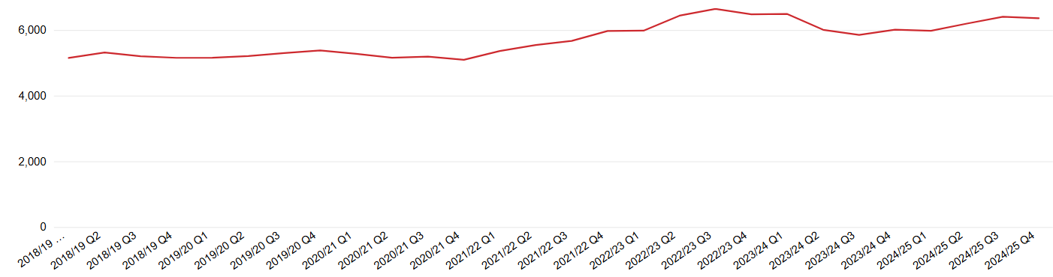

This total number of all incidents can be expressed as a more comparable ‘rate’ per 1,000 people and in Gloucestershire this is 9.5, slightly lower than the national average of 10.3. In March 2025, the three broad incident types that make up this total were as follows:
- ‘All fires’ = make up 18.2%, down from 30% in early 2019-20. A lower rate per 1,000 population than for England
  - ‘Primary fires’, which include dwelling fires are most frequently attended
  - Response times can be very different depending on if a wholetime or on-call station is responding. Over the past three years our average response time to primary fires is 10minutes 24seconds, average response time for wholetime stations is 8minutes 45 seconds, and for on-call is 13minutes 23 seconds
- ‘Non-fire incidents’ = make up 48.6%, up from 35.5% in early 2019-20. A higher rate per 1,000 population than for England
  - Assisting other agencies, flooding and RTCs are most frequently attended incidents

Potential future trend to 2030
The data in the table assumes a straight continuation of the 2020 to 2025 changes, there are no other variables considered in this scenario (such as demographic growth, or policy shifts for example). It is therefore a baseline planning scenario to be stress‑tested each year against real incident data. With that caveat the following can be seen:

- Total incidents increasing to approximately 7,343 (an increase of 1,970 compared to 2020; and an increase of 985 compared to 2025 figures), with the growth since 2020 driven predominantly by non‑fire incidents and fire false alarms.
- Non‑fire incidents increasing to approximately 2,438 (from 1,152 in 2020 and from 1,795 in 2025): remains the largest single growth area, now approximately 36% of total incidents. The biggest contributors within this category are ‘assist other agencies’ (around 1,037), flooding (around 463), and effecting entry/exit (around 355).
- Fire incidents decreasing to approximately 964 (down from 1,344 in 2020 and 1,154 in 2025): continued decline overall, with primary fires falling to 625, secondary fires falling to 315, and chimney fires falling to 0 if observed reduction persists.
- Fire false alarm incidents increasing to approximately 2,345, a modest increase from 2025, with growth concentrated in good intent (~1,067) and due to apparatus (~1,243) while malicious continues to fall (~35).

incident types | Mar-20 |  | Mar-25 |  | 2020 to 2025 comparison | 2030
incident types | number | % of total | number | % of total | difference in numbers | potential demand based on 20-25 change
non-fire incidents: | 1,152 | 21.4 | 1,795 | 28.2 | 643 | 2,438
assist other agencies | 491 | 42.6 | 764 | 42.6 | 273 | 1,037
effecting entry / exit | 157 | 13.6 | 256 | 14.3 | 99 | 355
flooding | 113 | 9.8 | 288 | 16.0 | 175 | 463
road traffic collision | 282 | 24.5 | 341 | 19.0 | 59 | 400
no action (not false alarm) | 41 | 3.6 | 70 | 3.9 | 29 | 99
non-fire false alarm | 68 | 5.9 | 76 | 4.2 | 8 | 84
other | 992 | 18.5 | 1,294 | 20.4 | 302 | 1,596
medical incident - co-responder | 430 | 43.3 | 467 | 36.1 | 37 | 504*
medical incident - First responder | 63 | 6.4 | 95 | 7.3 | 32 | 127
Other rescue / release of persons | 82 | 8.3 | 147 | 11.4 | 65 | 212
Other transport incident | 13 | 1.3 | 21 | 1.6 | 8 | 29
removal of objects from people | 76 | 7.7 | 74 | 5.7 | -2 | 72
Rescue or evacuation from water | 56 | 5.6 | 58 | 4.5 | 2 | 60
Spills and leaks | 23 | 2.3 | 19 | 1.5 | -4 | 15
Suicide attempts | 38 | 3.8 | 80 | 6.2 | 42 | 122
Advice only | 18 | 1.8 | 38 | 2.9 | 20 | 58
Animal assistance incidents | 81 | 8.2 | 91 | 7.0 | 10 | 101
Evacuation (no fire) | 2 | 0.2 | 13 | 1.0 | 11 | 24
Hazardous materials incident | 19 | 1.9 | 47 | 3.6 | 28 | 75
Lift release | 55 | 5.5 | 87 | 6.7 | 32 | 119
Making safe | 36 | 3.6 | 57 | 4.4 | 21 | 78
fire incidents: | 1,344 | 25.0 | 1,154 | 18.2 | -190 | 964
primary fires | 697 | 51.9 | 661 | 57.28 | -36 | 625
secondary fires | 543 | 40.4 | 429 | 37.18 | -114 | 315
chimney fires | 104 | 7.7 | 64 | 5.55 | -40 | 0
fire false alarms: | 1,885 | 35.1 | 2,115 | 33.3 | 230 | 2,345
malicious | 49 | 2.6 | 42 | 1.99 | -7 | 35
good intent | 759 | 40.3 | 913 | 43.17 | 154 | 1,067
due to apparatus | 1,077 | 57.1 | 1,160 | 54.85 | 83 | 1,243
totals | 5,373 | 100 | 6,358 | 100 | 985 | 7,343
*this figure is subject to ongoing discussions regarding the role GFRS plays with SWAST

Future positioning
Prevention
Targeted injury and vulnerability prevention should focus further toward non‑fire harms (e.g., water safety, road safety hotspots, entrapment prevention and suicide prevention partnerships), while maintaining urban‑focused dwelling‑fire prevention to sustain the downward trend in secondary fires and chimney fires. Expand community education and partner referral pathways tied to older and clinically vulnerable residents to reduce demand for assistance/entry and welfare‑related calls that frequently escalate to ‘assist other agencies.’ Respond to increasing risk of wildfires and support for more rural areas in terms of prevention activities.

Protection
False alarms ‘due to apparatus and ‘good‑intent’ alarms dominate the alarm totals. Priorities include system maintenance engagement with duty holders, smarter call‑challenging, and specific local campaigns to help reduce avoidable alarm activations without compromising life safety.

Response
Resource the rise in non‑fire incidents: ensure sufficient availability of units and skills for assists, technical rescue, water‑related deployments, and release from entrapment, especially during likely peak periods.

Flooding and water: sustain or strengthen water capability and equipment positioning to meet flooding and water rescue projections.

Wildfires: resource to this risk through enhancement of skills and knowledge, and investment in specific equipment. Ongoing watching brief on this area to be as well-positioned as possible in a timely way.

Workforce mix and availability
Growth areas are labour‑intensive but generally shorter‑duration incidents (assists, entry/exit, lifts). This suits flexible crewing and on‑call productivity models, provided turnout and daytime availability can be improved at on‑call stations. Workforce planning to be enhanced and data driven, linking into annual assessment of incident data, risks assessment, and training needs.

Skills
Prioritise refreshers in safe forced entry, casualty handling, water awareness/technician levels, lift/entrapment procedures, and mental‑health informed approaches at scene.

Equipment and fleet
Maintain/upgrade small tools for entry, water rescue Personal Protective Equipment (PPE) and pumps, and capability for frequent low‑complexity assists; keep a focus on PDA tuning for reduced fire load but higher non‑fire call frequency. Review fleet and equipment plans, to ensure they meet current and emerging areas of risk and demand and enables more flexible/agile responding. Link into annual assessment of incident data, risks assessment, equipment, and training needs.

Partnerships
The rise in assist other agencies, suicide attempts, and good‑intent alarms makes joint protocols with police, ambulance, housing, adult social care, and mental‑health services pivotal to reduce avoidable mobilisations and improve outcomes.

Our aims for 2030 and what is driving them
The diagram below shows how the most significant factors are driving our five aims for the period of this CRMP. The following page shows an overview of the key objectives we will deliver over the next four years to work towards achieving those aims.

E
Achieve outstanding assessments and be a partner of choice
Cultural improvement
Increasing challenges for an on-call service
HMICFRS
National operational recommendations

Ensuring efficiency and effectiveness
Increasing challenges for an on-call service
The impact of climate change
The impact of climate change
Ensuring efficiency and effectiveness
HMICFRS
Increasing challenges for an on-call service
National operational recommendations
Ensuring efficiency and effectiveness
The impact of climate change
Increasing challenges for an on-call service
HMICFRS
National operational recommendations
Cultural improvement
Ensuring efficiency
LGR
D
Become a greener and more efficient FRS, and make a difference in our communities
C
Adapt skills and assets to meet evolving risks, demand, and legislation
A
Create a highly skilled and inclusive values-driven workforce by putting people first
B
Modernise our rural response model and ensure it is fit for the future

Our aims, and the objectives for achieving these
B
Modernise our rural response model and ensure it is fit for the future
A
Create a highly skilled and inclusive values-driven workforce by putting people first
C
Adapt skills and assets to meet evolving risks, demand, and legislation
D
Become a greener and more efficient FRS, and make a difference in our communities
E
Achieve outstanding assessments and be a partner of choice

A1 Continue our cultural transformation journey, and successfully deliver the 2024 Independent Review recommendations
A2 Develop modern training facilities and ensure firefighters can meet current and emerging risks and keep themselves and others safe
A3 Refresh our on-call firefighter role, listen to our employees’ voices, and make GFRS an employer of choice
A4 Redesign our workforce planning approach to make it increasingly data-led and responsive to improve capacity and operational resilience
B3 Investigate sector-specific software to improve how efficiently and effectively we deploy available resources to live risks
C1 Meet challenge of increasing road traffic collisions and incidents involving alternative energy supply by adapting fleet, equipment and skills
C4 Increase productivity of firefighters and increase number and quality of prevention activities where we can make the most difference

B1 Carry out an in-depth review to ensure the number, distribution and staffing of stations aligns with demand and shows efficient use of resources
D1 Invest in greener and more efficient fleet and equipment that improves safety, capability, and reduces our environmental footprint
B2 Introduce a flexible crewing model at on-call stations to increase availability, reduce turn out times during busy periods and use resources efficiently
C2 Meet the challenge of climate-driven changes to flooding and wildfires by adapting type and distribution of fleet, equipment and skills

D3 Realise efficiencies, for example through appropriate changes to fire cover/shifts and numbers of firefighters responding to incidents
E2 Support local government reorganisation outcomes and maximise opportunity and minimise risk
E1 Deliver our Transformation Programme and achieve outstanding government assessments
D2 Support communities to become stronger and more resilient to improve quality of life of residents
D4 Leverage efficiencies from rationalised and increasingly interconnected IT systems and intelligent use of data
E4 Improve collaboration and data sharing with partners to support shared aims and increase effectiveness
E3 Develop new process and reporting to ensure national recommendations are identified and implemented effectively
B4 Establish a new day crewing model at Cinderford station and consider the potential for the same model at other stations
C3 Enhance protection activities to ensure safer buildings, businesses, and communities, and maintain compliance with emerging legislation

Managing our highest community risks

Flooding and evacuation from water
GFRS is aware of the devastating effects flooding has on the county’s communities, businesses and infrastructure. Gloucestershire hosts, amongst other water courses, the River Severn which at 220 miles in length is the UK’s longest river. Its extensive length means it navigates various landscapes and collects water from numerous tributaries, increasing the volume of water that can lead to flooding. Responsibility for flooding sits with multiple agencies and government departments who provide a joint approach to flood management within the county. Although there is currently no statutory duty for responding to flooding incidents, we know these incidents occur across the county, and from speaking with residents that this remains an important area that they believe GFRS should be responding to.

How we currently resource to flooding and evacuation from water risk | Future challenges
Prevention: GFRS supports the aims and objectives of the UK National Drowning Prevention Strategy working closely with partner agencies, the Service carries out regular prevention activities through awareness raising activities, providing specific advice, and regularly supports national campaigns across social media, press and radio. Education about water safety takes place in SkillZONE for children of school age. Operational crews and the community safety team take part in summer campaigns, working in collaboration where possible at planned events.  Response: We are equipped with specific assets to support water-related operations, including:  - inflatable and rigid boat teams,  - swift water rescue teams and swift water rescue equipment,  - three ‘wading stations’ to support specialist boat crews with evacuation from non-flowing water,  - specially trained officers with enhanced skills to manage water-related incidents, and  - High Volume Pumping (HVP) equipment enabling the rapid movement of large quantities of water from one location to another.  In addition to this every fire engine is equipped and trained to provide rescue and pumping at a flooding incident. We collaborate with multiple agencies and government departments, including the Environment Agency, Department for Environment, Food & Rural Affairs, Severn Area Rescue Association (SARA), and the LRF to provide advice, develop emergency plans, and make use of specialist skills to deliver effective responses to incidents. As a key collaborative partner SARA share space at strategic GFRS locations to support our response to water-based incidents. | Consequences of climate change are becoming a reality, specifically warmer and wetter winters, and hotter, drier summers with more frequent and intense rainfall. This is likely to result in: increased frequency of flooding, increased flood risk in urban areas, increased flood risk to property in some areas, increase risk of soil erosion and run-off from agricultural land leading to increase local flood risk and harm to water quality, river/coastal flooding and landslip threats, and changes in sea level will affect tidal ranges as well as storm surges with the Severn Estuary running through the centre of the county. The reasons behind instances of flooding are both complicated and often localised. Change in local rainfall patterns does not necessarily equate to an increase in the intensity, extent and harmfulness of flooding. Contributory factors can affect the severity of flooding can include (but are not limited to): land management, flood defences, population dynamics, tidal influences, geography, infrastructure, as well as other physical processes.

Dwelling fires
This is a statutory duty. These are fires in properties that are a place of residence, a home such as houses and flats, including non-permanent structures used solely as a dwelling, such as houseboats and caravans. This excludes hotels, hostels, and residential institutions. Dwelling fires make up approximately 42% of all primary fires in the county.

How we currently resource to dwelling fire risk | Future challenges
Prevention: We carry out thousands of activities each year aimed at preventing dwelling fires. We run strong awareness raising and education campaigns both targeted and general. The Service follows the ‘Fire Kills’ campaign plan throughout the year, with social media posts and videos driven by data, articles in the media, radio interviews, and physical community engagement with operational crews and community safety advisors present at hot spot areas. Comprehensive HFSVs are carried out by our specialist Community Safety Advisors (CSAs) and by wholetime crews, using data to target those people more vulnerable than others using established risk criteria. GFRS’s SkillZONE is the county’s purpose-built, interactive safety education centre. Designed as a life-size indoor village, it features realistic home, community, road, cyber, and criminal justice zones. Immersive, scenario-based learning experiences for people of all ages, are held here with a particular focus on children and young people. From here we deliver safety education and bespoke programmes for schools, community groups, and individuals. Topics include fire safety, road safety, water safety, online safety, criminal justice, and more.  - Response: Our response to a dwelling fire is two engines, unless it is known that the property is a specific risk. If there are people trapped in the property, then three engines are sent. Any property with additional risk will be identified by our mobilising team. Internal collaboration is crucial for keeping firefighters and the public safe and information sourced through visits undertaken by our CSAs and fire crews is shared quickly and accurately to ensure a timely, appropriate, and safe response. Externally we securely share information with partners such as district nurses, community teams. GFRS firefighters are trauma-trained, and every single fire engine has:  - Specialist equipment to gain access to tall buildings and fight chimney fires.  - Thermal imaging equipment.  - Breathing apparatus.  - Rescue hoods for casualties.  - Tactical ventilation of buildings on fire engines.  - Restricted access vehicles for more difficult to reach locations. | Recruiting and retaining ‘on-call’ firefighters is an increasing challenge faced by all FRSs, however as a predominantly on-call fire service the potential impact of this is high for GFRS. This can impact our ability to get fire engines on the road and to incidents quickly. The fire sector has seen an increase in dwelling fires due to the increasing use of alternatively powered vehicles that need charging at home, and the number of battery cells supporting solar installations in homes present significant challenges for firefighters. Fires involving this alternative energy supply are difficult to extinguish and is an emerging risk for the community and responders due to the batteries’ long burn time and the difficulty extinguishing the fire.  Since March 2020 the number of fire-related fatalities has shown an increase, and until recently the number of fire related injuries has also seen an upward trend. Deliberate fires have seen a fall since 2022, but there has been a slight upturn observed over the past 12 months. The county has an increasing population that is becoming ‘older’ on average, plus pockets of significant deprivation these are just two examples which increase the chances of accidental fires and fatalities, it is important to increase targeted prevention activities to meet this challenge in areas that are more difficult to reach within our target times and where populations exhibit higher numbers of people that meet one or more nationally recognised risk factors.

Non-residential fire
This is a statutory duty. Non-residential fires include properties such as offices, shops, factories, warehouses, restaurants, public buildings, and religious buildings. If a fire breaks out during working hours, these premises are governed by safety standards which ensures they have fire plans in place, which include evacuation, fire marshalling and reporting the incident to the fire service attending. Large fires can have serious financial and other strategic consequences of losing premises, including the potential for large loss of jobs, closing of businesses and the possible use of public money.

How we currently resource to non-residential fires risk | Meeting future challenges
Protection: We carry out regular protection and enforcement activities shaped by our understanding of risk across the county. We have positive relationships with our business communities and as such we find that businesses are happy to allow us to have access and exit details including key holder information and other details that assist in us in providing an efficient service. Our business fire safety team engages with businesses to encourage best practice and educate communities to operate in a safe manner and we actively support national campaigns as part of regular awareness raising activities. A risk-based intervention programme overseen by the business fire safety team enables high-risk premises to be identified. Identified properties can then be further selected for tactical planning considerations. Qualified fire safety inspectors provide 24/7 cover for fire safety advice. We enforce the Regulatory Reform (Fire Safety) Order 2005, which places legal duties on individuals and organisations to ensure fire safety in non-domestic premises. Our enforcement actions include:  - Fire safety audits of commercial and public buildings.  - Issuing enforcement notices, prohibition notices, or alteration notices where fire safety risks are identified.  - Prosecution in cases of serious non-compliance.  Response: Crews also undertake ‘familiarisation visits’ to those buildings where there is deemed a higher level of risk. Fire crews build positive relationships with individuals based at these premises and this helps to ensure crews are familiar with higher risk buildings in their area, meaning a more efficient response should an incident occur. We have the capability to access large non-residential buildings and fight fires using high-reach appliances. We have specialist equipment and vehicles, for example water carriers and foam-equipped units to deal with hazards associated with non-residential properties. We carry out Site Specific Risk Information (SSRI) visits which are pre-planned inspections to gather detailed information about specific premises or sites that may present unique or significant risks in the event of a fire or other emergency. This ensures fire crews can access up-to-date risk information in a timely manner via Mobile Data Terminals (MDTs). This keeps firefighters and the public safe. | There are ongoing challenges recruiting and retaining qualified fire safety inspectors to deliver not only the current workloads but also meet the challenge of an increasing remit driven by the evolving building fire safety legislation. This is not a local issue; it is acknowledged across the sector. There is a need to access increasingly detailed, accurate and base data relating to premises to enable effective risk assessment and enforcement action to be carried out. The increase in energy storage systems and the risks they pose needs to be better understood by firefighters and protection teams, and specific preventative work around this area needs to be carried out with businesses. The pandemic precipitated changes in staffing models for businesses which has seen employers provide more flexible working environments for their staff members, including home working. Many businesses have maintained these changes into the longer term, and this has reduced the number of people using office spaces and may increase the number of buildings becoming vacant. Empty premises increase the risk of an increase in fire-related incidents within non-residential properties. The current two Aerial Ladder Platforms (ALPs) are very large meaning certain parts of the county cannot be accessed with these due to the size and weight of the equipment, the secondary unit is underused. More modern building materials used for commercial premises pose a significant risk to firefighters, and new technology offers potentially more effective solutions to protect premises whilst keeping firefighters safer. Forthcoming changes in legislation require early positioning and a robust response to ensure we can meet the challenges posed.

Road Traffic Collisions
Responding to Road Traffic Collisions (RTCs) is a statutory duty. We attend more serious RTCs than serious fires; this area of service requires ongoing focus to ensure we are as effective and efficient as we can be and meet the challenges below. The number of RTCs attended is steadily increasing. Latest benchmarking shows that the rate of RTCs in Gloucestershire per 1,000 population is 0.5, equal with the national rate.

How we currently resource to RTC risks | Meeting future challenges
Prevention: As a member of the Gloucestershire Road Safety Partnership, we take a lead for road safety education as part of the Safe Systems Approach, and we use both national and local trends to prioritise our prevention activity. GFRS works closely with the Police and Crime Commissioner (PCC) and the NFCC to support preventative and educational road safety initiatives throughout the year. Run by GFRS SkillZONE is the county’s only purpose-built, interactive safety education centre. Designed as a life-size indoor village, it features realistic home, community, road, cyber, and criminal justice zones. Immersive, scenario-based learning experiences for people of all ages, are held here with a particular focus on children and young people. From here we deliver safety education and bespoke programmes for schools, community groups, and individuals. Topics include fire safety, road safety, water safety, online safety, criminal justice, and more.  The prevention team also reach out and visit local schools and sixth form with road safety and driver safety educational content and attend local community events. We actively support for national campaigns as part of regular awareness raising activities.  Response: Every fire engine is equipped with state-of-the-art specialist tools to assist in gaining access, extracting occupants, and working in difficult environments. GFRS provides an enhanced response to incidents involving large vehicles through the deployment of the Special Incident Support Unit (SISU). This is specialist vehicle equipped to support fire crews at complex or large-scale incidents and is equipped with enhanced heavy cutting, lifting and access platforms to meet the demands of such incidents.  Our firefighters are trained and skilled to deal with extrications and medical interventions. | Increasing numbers of alternatively powered vehicles, and new manufacturing techniques and materials pose different challenges for responding fire crews. The population continues to increase, and more people mean more cars on roads. RTCs were raised as a concern by residents of the county, with driving standards in more rural areas, younger people being more at risk, and lithium battery fires highlighted. Nationally, since 2014, there has been a general downward trend in the number of people killed or seriously injured in RTCs in Great Britain. The most recent data we have for Gloucestershire shows that what had been a declining trend in people killed and seriously injured increased in 2023 but fell again slightly in 2024. We have an aspiration as a county to achieve a 50% reduction in the number of people killed or seriously injured on Gloucestershire’s roads by 2032. There are ongoing and planned improvement to major road infrastructure over the next five years.

Hazardous materials
This is a statutory duty. Hazardous Materials (HAZMAT) incidents are defined as events involving the release or potential release of hazardous substances that can pose a significant risk to health, safety, property, or the environment. These incidents can occur due to accidents or deliberate acts and may involve chemical, biological, radiological, nuclear, or explosive (CBRN) materials.

How we currently resource to hazardous materials risk | Meeting future challenges
Protection: A risk-based intervention programme overseen by the fire safety team enables high-risk premises to be identified through inspection outcomes or the development of national trends. Identified properties can then be further selected for tactical planning considerations. HAZMAT risks are identified as a consequence and relevant information is shared with the rest of the service. We enforce the Regulatory Reform (Fire Safety) Order 2005, which places legal duties on individuals and organisations to ensure fire safety in non-domestic premises. Our enforcement actions include:  - Fire safety audits of commercial and public buildings.  - Issuing enforcement notices, prohibition notices, or alteration notices where fire safety risks are identified.  - Prosecution in cases of serious non-compliance.  Response:  We have a statutory duty to protect the environment to meet this requirement every fire engine carries an environmental protection pack to mitigate the risks of any chemical getting into the environment. For large incidents involving HAZMAT we have an Environmental Protection Unit (EPU). The EPU can contain or reduce the effects of chemical spillages. All our crews are trained on how to deal with HAZMAT incidents and information about chemicals is carried on all appliances. Some chemical incidents require the use of foam, and we have bulk foam, joint water and foam appliance, and for smaller incidents limited foam equipment is carried on each fire engine. We also have specialist trained Hazardous Materials Advisors (HMAs) that are deployed to relevant incidents. We work closely with other agencies when jointly attending chemical incidents, including the police, the NHS, and Environment Agency. The National Chemical Emergency Centre (NCEC) is also a contacted for advice on substance identification and handling. We carry out SSRI visits which are pre-planned inspections to gather detailed information about specific premises or sites that may present unique or significant risks in the event of a fire or other emergency. This ensures fire crews can access up-to-date risk information in a timely manner via MDTs. This keeps firefighters and the public safe. There are seven lower tier Control of Major Accident Hazards (COMAH) sites in the county about which GFRS holds tactical response plans. | The fire sector has seen an increase in dwelling fires due to ignition of battery powered devices, such as bikes and scooters. These devices and battery packs can catch fire rapidly, are difficult to extinguish when on fire, produce toxic fumes, and the water run off can be hazardous when it is applied. The number of battery energy storage systems (BESS) are continuing to increase across the country: these large containers of batteries are difficult to control when on fire. Smaller scale versions are also being constructed in domestic properties, fire crews turning up to these sites may not be aware of the risks posed by batteries in a property fire. The risk here is rapid fire spread to other properties, vehicles and the time taken to deal with these types of fires. Reallocate resources to provide equipment to move vehicles away from other hazards. Use of new techniques and equipment to deal with battery car fires. Our response needs to be mobile to enable us to reach incidents that can occur throughout the county due to our transport network (rail, road, air) being used to move hazardous materials. We have observed an increase in the number of chemical suicides, and this will need to drive not just our prevention, training, and response activities, but also shape the support we offer for our firefighters dealing with these incidents. The Berkeley nuclear site will be redeveloped to incorporate new nuclear technology, the timeline for this development is not currently available, but the sale and planning stages are already underway, and we will maintain close watching brief.

Large and small vehicle fires
This is a statutory duty. Large vehicle fires include a variety of incident types, including but not limited to, tankers, articulated lorries, agricultural vehicles such as tractors or combine harvesters and large commercial vans. A response will be made based on the type of vehicle involved following call questioning by Fire Control. Call questioning establishes specific details such as what type of large vehicle is involved, are they carrying a hazardous load and where the vehicle is located. Heavy Goods Vehicle (HGV) fires can pose threats to responding crews such as unexpected bursting tyres which can project debris at high speed in all directions.

How we currently resource to risk | Meeting future challenges
Prevention: As a member of the Gloucestershire Road Safety Partnership, we take a lead for road safety education as part of the Safe Systems Approach, and we use both national and local trends to prioritise our prevention activity. GFRS works closely with the PCC and the NFCC to support preventative and educational road safety initiatives throughout the year. SkillZONE is the county’s only purpose-built, interactive safety education centre. Designed as a life-size indoor village, it features realistic home, community, road, cyber, and criminal justice zones. Immersive, scenario-based learning experiences for people of all ages, are held here with a particular focus on children and young people. From here we deliver safety education and bespoke programmes for schools, community groups, and individuals. Topics include fire safety, road safety, water safety, online safety, criminal justice, and more. The prevention team also reach out and visit local schools and sixth form with road safety and driver safety educational content and attend local community events. We actively support national campaigns as part of regular awareness raising activities and work with local partners such as district councils and the Office of the Police and Crime Commissioner (OPCC).  Response: Our mobilisation team ascertain the fuel type of vehicles involved as this may affect the response, for example electric vehicles or dual fuel vehicles may attract an enhanced attendance of resources. Commonly one fire engine is allocated to a small vehicle fire, unless the vehicle is situated near others or to buildings. Fire spread is often rapid when associated with vehicles and as such an appropriate attendance of resources is important. Collaboration is a key aspect of any vehicle fires on highways. Incidents of this nature may require support of the police, National Highways and local authority highways to establish cordons, conduct traffic management and arrange recovery or repair of highways where necessary. Where we are aware of limited water supply nearby, we send our water carrier. | Any road closure has an impact on not only the vehicles and people involved but potentially all road users and the wider transport infrastructure with knock-on impacts for businesses and organisations in the county. More people mean more cars on roads, and the increasing number of alternatively powered and hybrid vehicles pose different challenges for responding fire crews. Electric charging stations at home or work are now attaching electric vehicles to buildings, working at high voltages and amps potentially adding additional risks. Electric vehicle fires can be more complex incidents and can cause significant hazards to crews attending these incidents and people and buildings nearby due to risks such as thermal runaway leading to rapid fire spread, sudden and unexpected vehicle propulsion, difficulties isolating electrical systems, moving and recovering vehicles and the potential for hazardous materials in water run-off and smoke. Lithium battery fires can currently only be ‘managed’ not extinguished and so can close road networks for a considerable time as the burn time is very lengthy. Lithium battery fires were noted by residents of the county as an area of concern. The road network in the county sees the movement of many larger vehicles, including international vehicles of varying load types. Fire crews may experience difficulties when dealing with incidents including international vehicles such as non-English speaking drivers or problems in identifying foreign load indicators.

Other residential dwellings fires
This is a statutory duty. Other residential premises include those buildings that are referred to as non-domestic properties. These include, but are not limited to hostels for homeless people, hotels and B&Bs, nursing/care homes, student halls of residence, children’s homes, towing caravans on site and other holiday residences. Owing to several factors, such as linked alarm systems, 24-hour waking duties and fire safety legislation, the likelihood of a fire in these types of premises are considered relatively low compared to those in domestic dwellings. However, these premises can present a higher risk of fire related injuries and fatalities due to factors such as reduced mobility among residents, the presence of children, and higher levels of alcohol consumption among some occupants.

How we currently resource to risk | Meeting future challenges
Protection: We carry out regular protection and enforcement activities shaped by our understanding of risk across the county. We have positive relationships with our business communities and as such we find that businesses are happy to allow us to have access and exit details including key holder information and other details that assist in us in providing an efficient service. Our business fire safety team engages with businesses to encourage best practice and educate communities to operate in a safe manner.  A risk-based intervention programme overseen by the fire safety team enables high-risk premises to be identified through inspection outcomes or the development of national trends. Identified properties can then be further selected for tactical planning considerations. Qualified fire safety inspectors provide 24/7 cover for fire safety advice. We actively support national campaigns as part of regular awareness raising activities. We also collaborate with Trading Standards landlords, local councils, and community safety partnerships.  We enforce the Regulatory Reform (Fire Safety) Order 2005, which places legal duties on individuals and organisations to ensure fire safety in non-domestic premises. Our enforcement actions include:  - Fire safety audits of commercial and public buildings.  - Issuing enforcement notices, prohibition notices, or alteration notices where fire safety risks are identified.  - Prosecution in cases of serious non-compliance.  Response: Other residential properties will have a response proportionate to the risk, and this will be calculated by our ‘Vision’ mobilising system. Tall buildings for example will automatically generate a response of six appliances and an aerial appliance, whereas other specific addresses may generate a more specific response. We carry out SSRI visits which are pre-planned inspections to gather detailed information about specific premises or sites that may present unique or significant risks in the event of a fire or other emergency. This ensures fire crews can access up-to-date risk information about the property in a timely manner via MDTs. This keeps firefighters and the public safe. | Gloucestershire’s growing population is driving a steady increase in other residential dwellings, including new care homes and a rising number of UK-based holiday properties. While the Regulatory Reform (Fire Safety) Order 2005 has significantly improved fire safety standards in multi-occupancy buildings, the county now faces a new generation of risks linked to modern construction methods, innovative materials, and increasingly complex building systems. Modern construction techniques, new insulation products, and lightweight structural systems can behave unpredictably in fire conditions. Fire safety inspectors and operational crews must maintain a current understanding of emerging building technologies. Recruiting and retaining technically knowledgeable inspectors and investing in their continuous professional development will be essential to high quality regulatory oversight and providing informed advice to responsible persons. Many of these premises incorporate advanced fixed installations such as sprinkler systems, smoke-control ventilation, and automated air-handling units. While these systems can significantly improve life safety and support evacuation, they also introduce operational considerations for attending crews, particularly around smoke movement, compartmentation, and system isolation. In parallel, the increasing adoption of green technologies such as solar/photovoltaic (PV) panels, battery storage, and heat pumps, creates additional hazards that require updated tactical awareness and safe-system-of-work procedures.

National guidance: Wildfires
This is a statutory duty. Nationally there have been several high-profile wildfire incidents that have originated on low laying scrub or heathland. GFRS have previously supported some of these incidents with the deployment of specialist rural resources, personnel and welfare support. Dry, parched vegetation requires a minimal ignition source to result in a prolonged and environmentally disastrous rural fire taking place.

How we currently resource to risk | Meeting future challenges
Prevention: Proactive awareness raising campaigns take place when risks increase due to hot and dry weather conditions. GFRS is a rural county with large areas of forestry and farmland. Effective collaboration with multiple agencies (including the Forestry England, police, LRF and landowners) to provide targeted preventative advice, share historic incident information, formulate emergency plans, and deliver effective response to incidents. Dedicated awareness raising campaigns support aims to reduce the risk of fires by advising people to avoid using BBQs, lighting fires, or using stoves in the woodlands, and to ensure cigarettes are safely extinguished and disposed of responsibly.  Response: The Service is equipped with standard firefighting equipment which enables fighting fires of various sizes in the ‘open’, including grass land, commons, fields and forests. There are varying sizes of hose which allow for supplying enough water to deal with an incident. The Service has bespoke wildfire equipment, including grass beaters and water knapsacks, which are recognised as effective firefighting options. All staff have received training on hazards and risks associated with wildfires, and fire officers have received advanced training to support command and control at these incidents. A water carrier vehicle is available to supply addition fire-fighting water to wildfire incidents. GFRS has a National Wildfire Tactical Advisor to help co-ordinate national responses that occur within Gloucestershire, or in other parts of the county. Regarding specific forestry risks – key fire stations have specific hose to help deal with these types of incidents and a fogging unit is strategically located. GFRS also has an off-road vehicle along with several 4x4s which can be used to transport firefighting equipment to hard-to-reach locations. | The consequences of climate change are now broadly recognised as a reality, and this is likely to increase the frequency and severity of wildfires. Although Gloucestershire does not have significant moorland and heathland it is a predominantly rural county, and the greatest risk currently is to farmland and agriculture. The Forest of Dean covers an area more than 110km² and is made up of mixed woodland, it is known for its rich history, wildlife, folklore, and offers various outdoor activities, it is a popular tourist destination. Studies have shown there is an increased risk, due to warmer winters, leading to greater vegetation growth (providing fuel), which then dries out during warmer summers. With such risks increasing through the effects of climate change, wildfires will become an ever-present threat to the communities of Gloucestershire in the years ahead. It also demonstrates the difficulty faced by responding fire and rescue services, in terms of remote locations, restrictions in access, lack of adequate water sources and the resources required to bring a major fire involving vegetation and scrub under control. The developing risk associated with wildfires will require GFRS to evolve to match the risks, this may require changes to prevention work, training technics, equipment and vehicles to meet the future challenge with greater efficiency.

Summary of activities managing risks
Potential activities identified with indicative timescales.

Managing Community Risk | Activity | Year 1 | Year 2 | Year 3 | Year 4
Dwelling fires | Breathing Apparatus replacement to improve firefighter safety
 | Decontamination following a fire
 | Develop a more flexible use of wholetime resources
 | Embed new software to enhance prevention activities
 | Enhanced tactical ventilation capability to improve safety and shorten incident duration
 | Fire cover optimisation to improve cover in line with risk
 | Full replacement of PPE
 | Increase tailored prevention work in areas outside of target attendance times
 | Increase the recruitment area for on-call firefighters
 | Increased ability to deal with new fire threats: battery storage systems, building materials
 | Establish resource deployment software
 | Review and update firefighting tactics
 | Review fire response targets
 | Training facilities project
 | Wholetime shift adjustment: establishment
Flooding and water rescue | Boat replacement
 | Boats, trailers, vehicles project
 | Enhance our rural prevention activities: flooding
 | Enhanced casualty location (drones and thermal imaging) and responder safety equipment
 | Establish a HVP tactical advisor role
 | Flood response capability: increased number firefighters trained
 | Improve the management of the command and control
 | Increase our prevention work in ‘rapid catchment areas’
 | Towing vehicles
 | Water incident manager training
Hazardous materials incident | Enhance HAZMAT skills and knowledge: radiation advisor role and training
 | EPU refresh
 | Improve HAZMAT advisor coverage per resilience group
 | Identification of BESS in homes and businesses
 | Improve working with partners to reduce and respond to chemical suicides
 | Improved notification at and inspection of relevant sites regarding hazardous substances
 | Specialist PPE project
Non-residential fires | ALP project
 | Embed new protection software
 | Enhance skills and capacity of the protection team
 | Evaluate and implement a new process for 24-hour, 7-day response to capture enforcement action learning.
 | Expand our business engagement programmes
 | Improve information management in protection team
 | Risk Based Intervention to replace RBIP
'Other' residential premises fires | Review and update firefighting tactics
 | Target deliberate fires
RTCs: large and small vehicle | Collaborate with GCC around road safety
 | Establish a response target and enhanced monitoring of RTCs
 | Establish specific training: alternatively powered vehicles
 | Foam strategy and Compressed Air Foam System (CAFS) integration
 | Improve clinical governance
 | New training and techniques: RTCs
 | Review SISU provision
 | Targeted road safety prevention work
 | Understand the impact of the ‘missing link’ A417 improvements
 | Understand the impact of the M5 junction 10 development
Vehicle fires: large and small vehicles | Establish specific training: large goods vehicles
 | Introduce appliances fitted with water-tower ‘spikes’ or lance nozzles
 | Investigate and adopt new techniques to deal with battery fires
Wildfires | Adapt equipment and vehicles: wildfire
 | Assessment of our existing water capability
 | Consider purchasing a telehandler
 | Enhance our rural prevention activities: wildfire
 | Front line appliances review project
 | Increase the number of firefighters with wildfire response capability
 | Light fleet review project
 | On-call second appliances repurposing
 | Raise awareness with residents and community groups of the risk of wildfires

How we will manage the delivery of this CRMP
The following diagram is a simple representation of how GFRS manages the flow of information shaping the CRMP, and the supporting structures that will enable and ensure the delivery of its aims and objectives.

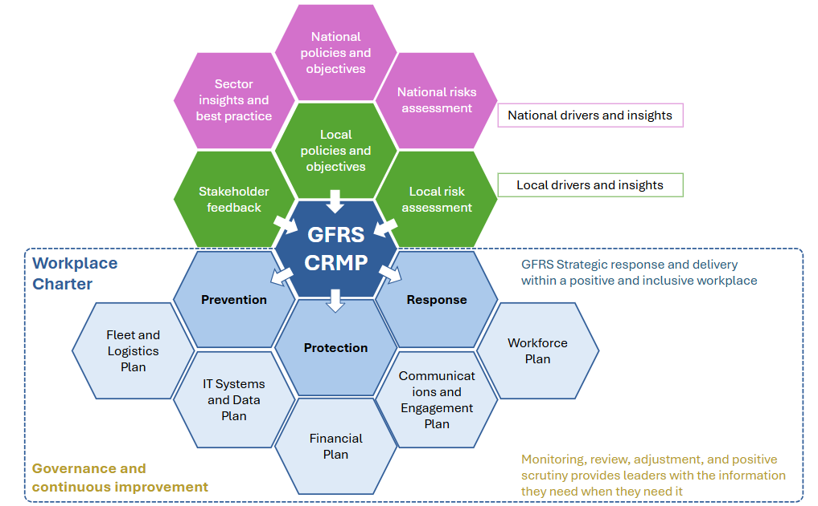
A suite of delivery plans supports the effective co-ordination of activities delivering the aims and objectives set out in the CRMP and the actions delivering change driven by the assessment of local community risk. These will be reviewed annually and progress against activity will be available at any time and provided monthly to our Fire Leadership Team as part of our planning and delivery governance cycle. Progress against aims and objectives is also provided to GCC for regular scrutiny by elected Members, officers, and public alike.

The aims and objectives of this CRMP and the day to day running of a high performing fire and rescue service cannot be successfully achieved without a range of enabling services. This requires the right people with the right skills in the right places, the right fleet and equipment in the right places, clear and consistent two-way communications and engagement, with reliable and resilient IT infrastructure and systems. This needs to be funded with prudent budgeting and rigorous spend management, with a constant vigilance for efficiency savings and/or increased productivity identified.

All of this is supported by a robust internal governance framework that ensures opportunity for scrutiny and positive challenge to work collaboratively towards better outcomes, driving quality and timely decisions and ensuring transparency and accountability. Our annual Statement of Assurance will always provide progress achieved against these objectives and performance against targets.

Fleet, resources and premises

The Fleet and Equipment Strategy (FES) set out a five‑year programme for vehicle and equipment assets while identifying longer‑term capital needs. Budgets are reviewed annually by GCC, with monthly financial management group and capital monitoring oversight to ensure compliance and manage pressures. An annual review keeps the FES flexible, responsive to regional and national drivers, and aligned with emerging issues, while its objectives promote innovation, continuous improvement, and strong service delivery for Gloucestershire communities.

The logistics and resources department manages majority of all GFRS equipment. The procurement, specification and maintenance of vehicles is jointly lead by the GCC corporate fleet unit and GFRS logistics and resources. Our vision is to maintain a safe, efficient, and adaptable fleet that supports firefighter readiness and community needs, embracing innovation and sustainability to ensure reliability, performance, and reduced environmental impact. We aim to deliver value through cost‑effective procurement, proactive maintenance, and extended asset lifespans, with flexibility to meet evolving risks. The five‑year FES, aligned with the CRMP, ensures assets remain fit for purpose and supports statutory duties under the Fire and Rescue Services Act (2004).

As the key framework for vehicle and equipment replacement, the FES drives productivity, efficiency, and future investment planning. Through fostering strong supplier and stakeholder relationships, staying aligned with industry standards, and investing in training, we will keep our fleet at the forefront of emergency response and deliver a service that exceeds expectations.

Asset management
We currently operate 32 appliances including smaller vehicles for narrow spaces, the map below shows the distribution across our stations, shaped by demand and risk. We will:
- Replace assets on time, taking into consideration the indicative life cycle.
- Purchase assets within the principles of value for money and whole life costs.
- Ensure assets meet the needs of the Service.
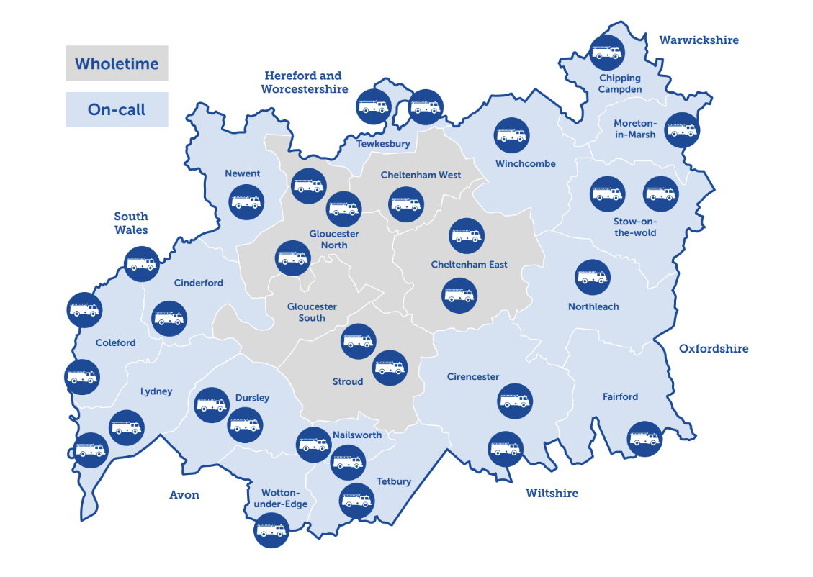

Life expectancy and replacement
To improve efficiency, the current nominal lifecycle for an operational fire engine will increase to 15 years with appliances being rotated across stations and teams supporting other functions. The rotation will balance out accumulated mileage and wear and tear, with vehicles reaching a higher mileage taking up a position of a second fire appliance on a station. With the increased length of emergency response driving courses, the driver training vehicle will be included in the fire engine rotation programme.

To achieve a smoother asset replacement programme, some flexibility regarding replacement is required to even out costs. However, equipment such as Breathing Apparatus (BA) needs to be replaced all at once due to the complexities of training introduced through having a wide product range. The strategy aims to smooth out vehicle purchases over the period to ease pressures on capital and maintenance costs.

Research and development
Climate change poses significant challenges for Gloucestershire, with rising incidents of flooding and wildfires. To address this, the Service is investing in specialist water rescue equipment, strategically positioned appliances, and water incident units, while hosting a HVP as part of the national response capability. Staff training continues to strengthen flood response. Work is underway to develop a robust wildfire strategy with bespoke assets and equipment, to address the identified emerging risk in the community risk profile.

The Service also recognises the benefits of Unmanned Aerial Vehicles (UAVs) and has agreements with partner agencies to deploy UAVs for wildfire operations, searches, and investigations. As technology advances, UAVs offer increasing potential, though licensing and training remain key considerations. Plans include exploring robotics for firefighting and rescue and improving ICT integration across the fleet to support mobile working and efficient service delivery.

The rollout of battery-powered RTC equipment will continue, enhancing rescue capability and versatility for crews. BA sets, now nearing the end of their operational lifecycle, will be replaced using a National Framework, incorporating the latest technology, including telemetry for improved firefighter safety. To address modern firefighting challenges, GFRS will introduce 22mm hose-reels on all fire engines, doubling water and cooling capacity for compartment fires.

Fire hydrants will be managed through the Fire Hydrant Management System, which integrates with appliance mobile data terminals, providing crews with real-time hydrant and risk information at incidents, significantly improving service delivery.

Appliance design
GFRS has developed a standardised appliance design through a cross-department working group to ensure vehicles are fit for purpose and meet community needs. These appliances will carry consistent equipment to address current and emerging risks. The design improves equipment stowage, creates a fully multi-functional fire and rescue appliance, and incorporates measures to reduce fire contaminants. New pumping appliance technology significantly lowers carbon emissions compared to previous models, supporting the Service’s transition toward net-zero. The design also provides additional locker space and will be supported by updated training packages aligned with evolving operational requirements, while the Service continues exploring electric and hybrid solutions for future fleet development.

Carbon footprint and environmental impact
Whilst the Service continues to reduce its own carbon footprint by implementing electric vehicles, switching from diesel-powered light vehicles to hybrid technology to eliminate nitrogen oxide (NOX) emissions, the environmental changes continue to affect operational demands.

Vehicle related emissions are a significant contributor to carbon emissions within the Service, and as part of our ongoing commitments, reducing emissions from vehicles and improving the environmental performance of fleet vehicles remains a key aspect of revised aspirations for GFRS, as such we will seek to expand our electric vehicle charging infrastructure across GFRS sites to support the continued transition of officer response vehicles to hybrid technology whilst considering options for full electric response vehicles.

Premises
The aim of our Service Estate Plan (SEP) is to provide buildings and an estate that are fit for purpose, support inclusive and positive working environments, encourage best practice and innovation and help support the right organisational culture.

It is vital that premises remain safe and secure, minimising the risk as far as possible of theft and destruction of property, and injury to staff or visitors.

The plan sets out the strategic objectives, priorities and actions required that will achieve this. Achieving these will enable us to deliver the best services and be an outstanding fire and rescue service for our communities, workforce, and visitors. Due to the complexities of property and estate assets, a long-term plan ensures the following is achieved:

- A clear understanding of the estate assets required to deliver CRMP priorities.
- Identifying the most effective and efficient locations for our estate assets.
- Prioritising works required to deliver CRMP priorities.
- Ensuring sufficient resources to achieve our objectives.
- Identifying new and current pressures within the Service, such as decontamination relating to property.
- Obtaining value for money.

Workforce
Our main people objectives for 2026 to 2030 are set out in this CRMP, under Aim A. Our Strategic Workforce (People) Plan will directly support the delivery of these and ensure we stay true to staff-driven target culture:

“GFRS will be an organisation that is excellent at looking after its people. We will promote a culture where everybody feels valued, seen and heard in a workforce which is well-resourced, well-trained and well supported. We will role model a new standard of passionate, energetic and inclusive leadership, which is driven by values and focused on improvement.

We will be clear about what we will and will not stand for and remain committed to the behaviours and conduct we expect to see from each other, which we have developed together. The way we treat each other will build a trust and respect which flows into our communities, helping us to be a responsive fire and rescue service, equipped to deal with change.”
Day to day, in everything we do,
“We will be intentionally inclusive, deliberately developmental and always prioritise professionalism.”

A key aim of our people plan is to ensure there are sustainable, fit-for-purpose leadership, that workforce capacity and skills are sufficient to deliver services effective in line with risk.
Our Strategic Workforce (People) Plan sets out how we will:
- Align workforce planning and organisational development with the CRMP.
- Attract, recruit, develop, and retain the right people.
- Create a healthy, inclusive, and high-performing culture.

Our Workforce planning approach aims to use a data led approach and will:
- Outline the organisation and our environment.
- Analyse the current workforce.
- Determine future workforce needs.
- Identify the gap between the current workforce and future needs.
- Put in place robust succession plans.
- Take actions to address shortages, surpluses or skills requirements.
- Ensure we attract and recruit people to better reflect the communities we serve.
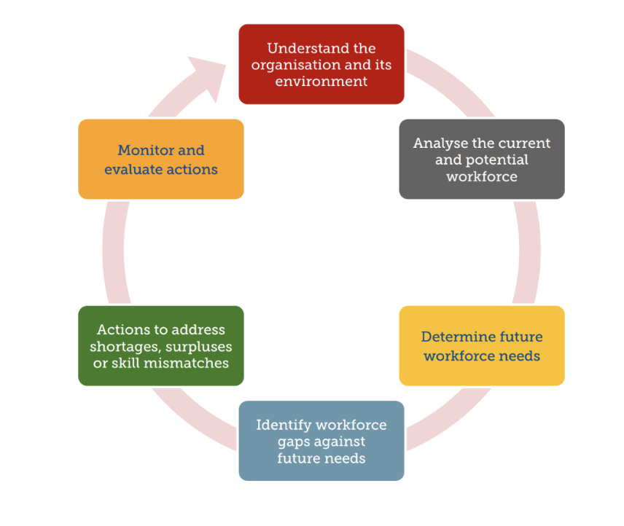
- Monitor and evaluate our actions.

Workforce planning is a process of analysing the current workforce, determining future workforce needs, identifying the gap between the present and the future, and implementing solutions so that an organisation can accomplish its mission, goals, and strategic plan. It’s about getting the right number of people with the right skills, employed in the right place, at the right time, at the right cost and on the right contract to deliver an organisation’s short and long-term objectives.

Succession planning requirements and future workforce needs

Wholetime
Wholetime staffing needs will be shaped by CRMP demand and station modelling.
Changes to stations, crewing models, and risk-based response requirements will influence:
- the number of wholetime firefighters required,
- distribution of roles across stations,
- specialist skills required at different locations, and
- future use of day-crewed or hybrid models if risk or resources change.
Retirement forecasts show substantial movement across supervisory and middle management roles. Future workforce needs include:
- sufficient firefighters to offset planned retirements and changes to stations and crewing models,
- robust candidate pipelines for crew and watch manager promotions, and
- development capacity for station and group managers.

On-call
On-call staff provide essential resilience to the Service’s response model, particularly in rural areas.
Strengthening the on-call pipeline to enhance availability, future needs include:
- improved daytime and weekday availability,
- increased recruitment in low-availability stations,
- enhanced community engagement to attract local talent, and
- employer engagement and support schemes.
A flexible range of contracts must continue to support:
- parents and carers,
- retired operational staff,
- students,
- self-employed residents, and
- shift workers.
Skills development, improvements are required in:
- access to training for on-call staff,
- monitoring of competence via on-call skills dashboards, and
- specialist skills coverage (e.g., water rescue, wildfire).

Control room
Control staff must maintain highly specialised capabilities in incident call handling, resource mobilisation, multi-agency coordination and emergency communications. It is important to maintain an appropriate mix of experienced staff in the control room to ensure continued high performance and manage the impacts of planned retirement of staff. Succession planning is critical as recruitment into control requires a focused attraction strategy due to the specialist skillset.

Non-operational
Robust succession planning needs to be in place for non-operational staff who provide critical professional and technical skills that enable operational and organisational effectiveness.
GFRS will need to maintain capability in areas including:
- data and performance analytics,
- protection and regulatory compliance,
- ICT, digital systems and cyber security,
- project management and transformation,
- finance and procurement,
- people and organisational development,
- health and safety, and
- communications and engagement.

Capacity and resilience
Some departments have small teams where turnover creates significant disruption. The Service must ensure:
- clear succession plans for specialist roles,
- career pathways to retain professional talent,
- resilience models that reduce single points of failure, and
- access to apprenticeships and external training.

Finances
GCC is the fire and rescue authority for Gloucestershire and is responsible for governance and oversight of GFRS. Fire and rescue funding is not ring-fenced. GCC sets the level of funding for GFRS each year through the council’s annual budget-setting process.

Each year, GCC sets a revenue budget for GFRS to support day-to-day service delivery, including staffing, equipment, training and ICT. In addition to core funding, the service receives a small number of government grants for specific purposes, such as community fire stations and the SkillZONE contract, firefighter pension costs and fire safety activity.

Given ongoing financial pressures across the public sector, the service is also expected to identify and deliver efficiencies over the life of this plan, helping to manage costs while continuing to deliver services in line with risk. The Service aims to achieve value for money and maintain appropriate stewardship of the public funds and assets entrusted to it.

The service has governance arrangements in place to monitor budget performance and provide financial assurance. These include:
- Monthly management accounts are produced and considered by the financial management group and Fire Leadership Team.
- Quarterly management accounts are produced and reported to corporate finance, and to performance, risk and scrutiny meetings.
- GCC prepares an annual Statement of Accounts in line with the relevant accounting code of practice. The accounts are subject to external audit and are reviewed by senior leaders, before scrutiny and approval by GCC in line with the council’s governance arrangements. These are published on GCC website annually.

ICT, systems, and data
GFRS’s Information and Communication Technology (ICT) is a critical enabling function underpinning the effective delivery of prevention, protection, response and business activities. The team is responsible for 24/7 support of all aspects of ICT within the FRS. The ICT function supports the organisation for both administrative technology and critical 999 infrastructure.

The Service has a mature, stable and well performing infrastructure which is delivered as a hybrid between on-premises and cloud based. It has fully adopted agile working for the mobile workforce and provides workspace on fire stations for external partners. The critical 999 infrastructure is built upon the latest version of our Vision mobilising system with a full airwave installation, unique within county council FRSs.

ICT infrastructure is located across the FRS premises and online for resilience purposes. The ICT team has regional and national relationships across the FRS sector and is linked in NFCC ‘Digital, Data and Technology’ and ‘Cyber’ initiatives.

Delivering our Statutory Duty is dependent on robust, effective and efficient mobilising and response. Our firefighters require accurate and timely mobile data and risk information on fire engines.

Our ambition is to use technology to build an effective, secure and collaborative digital and data environment to support intelligent decision making, strategic resource management, targeted community response and an informed approach to risk.

Over the duration of CRMP, we will use technology to become a fully digital and data enabled organisation. Our ICT plans consider HMICFRS inspection findings and the three pillars of effectiveness, efficiency, and people and has six key delivery areas that are listed below:
- Modern and resilient computing infrastructure,
- cybersecurity,
- improved business continuity,
- effective operational ICT,
- enhanced collaboration, and
- digital and data enablement and Artificial Intelligence (AI).

Communications and engagement
Our communications will support the delivery of a quality fire and rescue service by proactively engaging with and listening to, our communities, partners, and workforce. Through clear, honest and transparent communication, we will help shape positive perceptions, culture and behaviours. We will build trust, collaboration and pride by sharing the right information with the right people, in ways that are timely, accessible and easy to understand.
Communications and engagement will support the Service to achieve its mission, vision and CRMP aims and objectives by effective and targeted communications. We will:
- Warn and inform the public in the event of an emergency.
- Promote a positive culture and equality, diversity, and inclusion including delivery of the 2024 Independent Review recommendations.
- Support recruitment, retention and development needs of the Service.
- Provide the workforce with tools and training they need to effectively communicate with their local communities and colleagues and support them in being visible and accessible.
- Support prevention and preparedness through supporting new ways of working, deliver data led prevention campaigns and respond to emerging risk such as wildfire.
- Support the workforce with the sustainability and digital change through clear communications and engagement.
- Support the delivery of transformation programme and support the visibility and focus of the fire leadership team.
- End-to-end support for consultations, from planning and engagement through to analysis and reporting.
- Improve our workforce engagement and develop our two-way communications recognising where their input has added value.

Monitoring and delivery
GFRS has in place robust mechanisms for a range of assurance areas, including strategic planning, delivery and assessment of progress, service performance, risk management, financial management, operational learning, learning and development and more.

Performance is monitored through a suite of higher-level key performance indicators, supported by several more detailed local performance indicators. These are considered operationally on a daily and weekly basis and monthly and quarterly at a more strategic level. Our current suite of KPIs is shown below. These are reviewed annually to ensure they remain relevant and appropriate, and methodologies are being followed or are updated where necessary. This also includes an annual review of targets which are potentially updated each year. These will be expressed in our annual statement of assurance. Some proposed targets remain to be confirmed (tbc) in the table below because they are new and require methodologies to be finalised and baseline output understood before appropriate targets can be put in place.

CRMP Objectives | Area of Service | Indicator Title | Proposed Target 26-27
A4, 3  B1,2,3,4 | Response | Average response time to dwelling fires (National definition) | 9 mins
A2, 4  C3, 4 | Response | % of site-specific risk information visits (SSRIs) within revisit timescale | % progress through annual programme:  Q1- 26%, Q2 - 53%, Q3 - 76%, Q4 - 100%
C3  D2 | Protection | % of Annual Risk Based Intervention Programme (RBIP) completed | Q1 - 25%, Q2 - 50%, Q3 - 75%, Q4 - 100%  (375 per quarter)
C4  D2 | Prevention | Rate of Home Fire Safety Visits (HFSVs) undertaken per 1,000 of the population | Per year 5,000 visits at a rate of 7.47  Per Quarter: 1,250 visits at a rate of 1.87
C4  D2 | Prevention | % of HFSV undertaken to those deemed vulnerable | 89%
A4, 3 B1,2,3,4  C1, 2 | Prevention | Number of fatalities from all fires | Statement of intent of 0 fatalities
A4  B1, 2, 3, 4  D3 | Response | % availability of all wholetime appliance | 100%
A3, 4  B1, 2, 3, 4  D3 | Response | % availability of first on-call appliance | 75%
A2 | People | % of operational incident commanders (in role) within 2 yearly requalification targets | 100%
A2 | People | % of operational staff within 2 yearly requalification targets for breathing apparatus | 100%
C4 | Response | % of familiarisation visits completed | 100%
C1 | Response | Average response time to road traffic collisions (RTCs) | tbc
C3,4 | Response | Rate of incidents attended per 1,000 population, rolling year | tbc
C4  D2 | Prevention | Rate of deliberate fires per 100,000 population, rolling year | tbc
C4  D2 | Prevention | Number of hours spent on community engagement, in period | tbc
A1 | PSU | Number of grievances received, rolling 12 months | tbc
A1 | PSU | % of grievances completed within 60 working days | tbc
C3  D2 | Protection | % of relevant premises receiving interventions | 100%
A2 | Protection  (Health & Safety) | % of staff that have received an annual fitness test within the last 12 months | 100%
A1 | People | % of GFRS staff (green and grey book) appraisals on PDR Pro complete | 85%
A1 | People | Staff Turnover (staff leaving as a % of all staff) | Plan is best
A2 | Protection | Number of HSE reports completed (RIDDOR) community safety | 1
A1 | Response | Days lost to sickness/absence per FTE - rolling year | tbc
A1 | Response | Days lost to long term sickness/absence per FTE - rolling year | tbc
A1 | Response | Days lost to stress per FTE - rolling year | tbc

Transparency and accountability
Our annual statement of assurance is publicly available on our website and provides information to enable residents to hold us to account. This sets out delivery against aims, finances, and performance levels whilst providing context and direction. Quarterly in-year reporting is made public after it has progressed through GCC governance steps and can therefore be accessed through GCC’s website on the ‘council performance’ page.

Internally GFRS has a simple list of prioritised activities mapped to a range of key drivers, and delivery frameworks enabling the service to see at a glance how we are doing in terms of delivering against aims and objectives. Opportunity for positive scrutiny and solutions to challenges happens through team level progress checks and one to one meetings, monthly Fire Leadership Team meetings, and then through various mechanisms within the council’s governance framework.

Glossary

Term / abbreviation | Meaning
ACORN | A demographic segmentation dataset used to understand communities and risk factors.
ACE (Adverse Childhood Experiences) | Stressful or traumatic experiences in childhood that can affect health and outcomes later in life.
ALP (Aerial Ladder Platform) | A fire service vehicle with an extendable ladder/platform for working at height.
ASB (Anti-social behaviour) | Behaviour that causes nuisance, alarm or distress to others.
BESS (Battery Energy Storage System) | A battery installation that stores electricity for later use.
CAFS (Compressed Air Foam System) | A system that mixes foam, water and air to produce firefighting foam.
CBRN (Chemical, Biological, Radiological and Nuclear) | Types of hazardous substances that can cause serious harm.
CFRMIS (Community Fire Risk Management Information System) | A system used to manage and analyse risk information for prevention/protection activity.
COMAH (Control of Major Accident Hazards) | Rules for sites that store/handle large quantities of dangerous substances.
CRMP (Community Risk Management Plan) | The plan setting out how the service will assess and manage risk and allocate resources.
CRP (Community Risk Profile) | An assessment of current and emerging fire-and-rescue related risks in the community.
CSAs (Community Safety Advisors) | Specialist staff who deliver targeted safety advice and Home Fire Safety Visits.
DfT (Department for Transport) | UK Government department responsible for transport.
EPU (Environmental Protection Unit) | A specialist unit to help contain or reduce the effects of chemical spillages.
FRS (Fire and Rescue Service) | The organisation responsible for fire prevention, protection and emergency response.
GCC (Gloucestershire County Council) | The county council; acts as the Fire Authority for Gloucestershire.
GFRS (Gloucestershire Fire and Rescue Service) | The county’s fire and rescue service.
HAZMAT (Hazardous materials) | Incidents involving dangerous substances that can harm people or the environment.
HFSV (Home Fire Safety Visit) | A visit to a home to give fire safety advice and reduce risk (may include fitting smoke alarms, advice on escape plans, etc.).
HGV (Heavy Goods Vehicle) | A large lorry used to transport goods.
HMAs (Hazardous Materials Advisors) | Specialist advisors who support crews at hazardous materials incidents.
HMICFRS (His Majesty’s Inspectorate of Constabulary and Fire and Rescue Services) | The body that inspects fire and rescue services and publishes findings and recommendations.
HVP (High Volume Pump) | Equipment used to move very large quantities of water quickly.
IMD (Indices of Deprivation) | A government dataset measuring relative deprivation across small areas.
JESIP (Joint Emergency Services Interoperability Principles) | National principles for police, fire and ambulance services working together at major incidents.
JOL (Joint Organisational Learning) | A national system for sharing learning from incidents and exercises across services.
KPI (Key Performance Indicator) | A measure used to track performance against targets.
LGR (Local Government Reorganisation) | Changes to local council structures and governance arrangements.
LRF (Local Resilience Forum) | A partnership of local organisations that plan and prepare for emergencies.
MAGIC (Multi Agency Gold Incident Command) | Training to support senior multi-agency command at major incidents.
MDT (Mobile Data Terminal) | A device (often in vehicles) that provides crews with information and updates while responding.
NCAF (National Coordination and Advisory Framework) | A framework for national coordination during major emergencies.
NCEC (National Chemical Emergency Centre) | A specialist source of advice on hazardous substances.
NFCC (National Fire Chiefs Council) | A national body representing senior fire and rescue leaders and providing guidance.
NHS (National Health Service) | The UK’s public health service.
NOL (National Organisational Learning) | A national system for sharing learning from incidents and exercises across services.
On-call firefighter | A firefighter who responds when needed (often from home or another job), rather than being based full-time at a station.
OPCC (Office of the Police and Crime Commissioner) | The office that supports the Police and Crime Commissioner.
PAS 9980 | A national standard for assessing and managing fire risk in external wall systems.
PCC (Police and Crime Commissioner) | An elected official who helps set policing priorities and budgets locally.
PDA (Pre-Determined Attendance) | The planned set of resources sent to certain types of incident (e.g., number of fire engines).
PPE (Personal Protective Equipment) | Protective clothing and equipment used to keep firefighters safe.
PV (Solar photovoltaic) | Solar panels that convert sunlight into electricity.
RBIP (Risk Based Inspection Programme) | A programme to prioritise and plan fire safety inspections based on risk.
Responsible Person / Accountable Person | Legal roles with duties to manage building safety and fire safety in certain buildings.
RTC (Road Traffic Collision) | A collision on the road involving vehicles (and sometimes pedestrians/cyclists).
SARA (Severn Area Rescue Association) | A local rescue organisation that supports water rescue and related capability.
SkillZONE | GFRS’s interactive life-skills and safety education centre.
SISU (Special Incident Support Unit) | A specialist unit equipped to support complex or large-scale incidents.
SOA (Super Output Area) | A small geographic area used for statistical reporting.
SSRI (Site Specific Risk Information) | Pre-planned risk information gathered about a building/site to support safe response.
SWAST (South Western Ambulance Service) | The regional ambulance service for South West England.
Wholetime firefighter | A full-time firefighter (regardless of rank).
Wildfire | A large outdoor fire in vegetation such as grassland, woodland or scrub.

