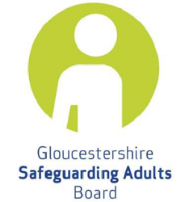

Gloucestershire Safeguarding Adults Board

Multi-agency Risk Management (MARM)
Agency Report for MARM Meeting

This form should be completed by Professionals in the event of being unable to attend a MARM meeting. The report will be used by the MARM chair to enable a full multi- agency discussion at the MARM meeting. Please submit your report to the MARM chair prior to the meeting or within the timescales agreed with the Chair.

Please note that every effort should be made to attend the MARM meeting where possible and actions may still be set for your agency in your absence.

Agency Details
Name of Adult
MARM Case Reference
Date of Meeting
Name of Chair
Name of professional completing this report
Agency represented by this Professional
Contact information

Summary of specific agency involvement with the adult

What is working well?

Areas of concern and other risks

Further actions or requests for support

What information has the adult shared with you or your agency about how they would like to be supported?

What information has the adult shared with you or your agency about what they would like to happen?

